Student Wellbeing and Positive Behaviour
  - Policy

Document title | Student Wellbeing and Positive Behaviour
Contact details | Student Wellbeing and Inclusion
Approved by | Operational Policy Subcommittee
Date approved | 27 November 2019
Document review | November 2021
TRM number | 50:D19:117274

Version | Date | Author | Changes made
1 | 21/02/2020 | Student Wellbeing and Inclusion | Business need changed to context

Acronyms | Full form
NT | Northern Territory
SAMS | Student Administration Management System

Contents
1. Policy 4
2. Context 4
3. Definitions 5
4. Roles and responsibilities 6
5. Checklist for developing a whole-school approach 7
6. Code of behaviour example 8
7. Related legislation, policy, guidelines and resources 9

This document should be read in conjunction with the Australian Student Wellbeing Framework.

Policy
All NT Government schools, preschool to Year 12, are to develop and implement a whole-school approach to student wellbeing and positive behaviour that:
- uses evidence, trauma and neuroscience informed and strengths based approaches to meet the diverse needs of students, families and staff
- enables all members of the school community to be active participants in the creation of a school culture that values wellbeing, diversity and inclusion
- cultivates positive, caring and respectful relationships
- consolidates a tiered response to intervention
- provides opportunity for students to express their views and be involved in decision making
- acknowledges and teaches the general capabilities of the Australian Curriculum and the principles, practices and outcomes of the Early Years Learning Framework.

Schools with a whole-school approach to wellbeing and behaviour are more likely to achieve:
- improved student and staff wellbeing
- improved student attendance and engagement at school
- reduced incidents of behaviours of concern, anxiety, depression and bullying
- increased teacher to student teaching time
- improved consistency of teaching and learning practices
- improved student academic achievement and success in later life.

Context
The Australian Student Wellbeing Framework (the framework) was endorsed by federal, state and territory ministers for education and released on 19 October 2018. The Department of Education is committed to implementing the framework through a whole-school approach to student wellbeing and positive behaviour.
The framework supports the Education Act 2015 (NT), which seeks to ensure schools are safe and supportive learning environments that provide all children and young people access to education programs that are appropriate and responsive to their individual needs and abilities (Part 1, section 3 (a-f)).
The need for a whole-school approach to student wellbeing and positive behaviour is recognised in:
- the National School Improvement Tool – a culture that promotes learning
- the Framework for Inclusion 2019-2029 – promotes an environment in NT Government schools that is inclusive, fair and focused on delivering learning to meet individual need
- A Share in the Future: Indigenous Education Strategy 2015-2024 – Element 4 Engagement: Goal 4.4 Schools provide a whole-system approach to behaviour management and wellbeing.

Definitions
Culturally, developmentally and linguistically responsive refers to recognising and valuing all cultural groups; respecting diversity, life experiences and strengths; and encouraging pride.
Evidence informed refers to combining information from research and academic studies with practice expertise and the views and experiences of the school community to inform decision-making and effective practice.
Parent refers to a child’s father, mother or any other person who has parental responsibility for that child, including a person who is regarded as a parent of the child under Aboriginal customary law or Aboriginal tradition.
Neuroscience informed refers to understanding the mental processes that are involved in learning.
Respectful relationships refers to relationships that are built on trust, respect, compromise and understanding of one another.
Restorative manner refers to an approach to behaviour management that builds connection, while encouraging children to take responsibility for their actions, and work towards reparations.
School community refers to all school staff, families, students and other persons who have direct involvement or interest in the school.
School representative body refers to an incorporated body, for example, school council, an independent public school board or a joint school representative body established under the Education Act 2015 (NT).
Strengths based refers to the importance of building on the existing strengths and abilities of students, families and communities.
Student refers to a person enrolled at a school and children who attend Department of Education early childhood services and programs delivered on school premises.
Student engagement refers to three elements:
- behavioural – students’ participation in education, including the academic, social and extracurricular activities of the school
- emotional – students’ emotional reactions in the classroom and school (a sense of belonging or connectedness to the school)
- cognitive – students’ investment in their learning (motivation and self-regulation).
Student wellbeing refers to a sustainable state of positive mood and attitude, resilience and satisfaction with self, relationships and experiences at school.
Trauma refers to an event resulting in severe mental or emotional stress or physical injury.

Trauma informed practice in education refers to a way of working that acknowledges the effect of trauma on cognitive and emotional development and social functioning. It strengthens teaching practice through recognition of the critical importance of relationships, perception of self and the mental and emotional states of complete engagement.
Whole-school approach refers to unified and systemic action, for example, policies and plans, across the school community for student wellbeing and positive behaviour that meets the needs of students, families and staff. There are many whole-school approaches that can be used to embed a culture of student wellbeing and positive behaviour. Schools may already be using School-Wide Positive Behaviour Support, Positive Behaviour for Learning or Respectful Relationships to assist with this.

Roles and responsibilities
General Manager Student Wellbeing and Inclusion is responsible for:
- ensuring student wellbeing and positive behaviour information provided to schools is based on best practice and sound evidence
- ensuring capability-building support is provided to school staff to effectively develop and implement a whole-school approach to student wellbeing and positive behaviour.
Senior Director School Improvement and Leadership is responsible for:
- providing leadership support to principals to implement the principles and practices of a whole-school approach to student wellbeing and positive behaviour
- supporting principals to make decisions in the best interests of their students
- ensuring schools have a documented whole-school approach to student wellbeing and positive behaviour.
Senior Manager Student Wellbeing and Behaviour is responsible for:
- providing advice, coaching and professional learning support to schools to develop and implement a whole-school approach to student wellbeing and positive behaviour
- providing support to school staff to deliver student safety and wellbeing programs in line with the Australian Curriculum
- assisting school staff to access professional learning opportunities that are appropriate to the school context.
School representative body is responsible for:
- working with the school to achieve the best outcomes for students
- assisting the school to be responsive to the wellbeing and behavioural needs of the school community.
Principal is responsible for:
- implementing and embedding the whole-school approach to student wellbeing and positive behaviour
- ensuring school staff comply with this policy and the whole-school approach to student wellbeing and positive behaviour
- familiarising school staff and the wider school community with the Australian Student Wellbeing Framework

- building a learning environment that is safe, supportive, respectful and inclusive
- monitoring, reviewing and evaluating each school’s capacity to address student wellbeing and positive behaviour issues and identifying areas of strength and those that require improvement
- informing school communities about their school’s priorities for student learning, safety, wellbeing and behaviour
- ensuring student suspension data is captured in the Student Administration Management System (SAMS)
- communicating with other agencies and non-government organisations as appropriate to support individual students and families.
Teachers and other school staff are responsible for:
- contributing to a learning environment that is safe, supportive, respectful and inclusive
- undertaking roles and responsibilities to support and implement the whole-school approach to student wellbeing and positive behaviour, including applying the school’s code of behaviour for students and staff in a consistent manner
- ensuring their own behaviour is consistent with the principles and practices articulated in this policy and the NT Public Sector Code of Conduct
- capturing student suspension data in SAMS
- planning, delivering and assessing student safety and wellbeing programs across all years of school in line with the Australian Curriculum
- building and maintaining collaborative relationships with families to develop understanding and support for student wellbeing and positive behaviour
- communicating with other agencies and non-government organisations as appropriate to support individual students and families.

Checklist for developing a whole-school approach
- develop the school vision and values
- consult with students, families and the school community
- clearly communicate expected behaviours and provide opportunities for students to learn these (including during school camps and excursions)
- develop responses to positive behaviours and behaviours of concern
- define roles, rights and responsibilities of staff, students, families and the school community
- teach social and emotional learning strategies
- teach bullying and cyberbullying prevention
- embed teaching and classroom behaviour support strategies
- develop, implement and review support plans, for example, educational adjustment plans, individual behaviour plans, transition from school plans, risk assessment plans and safety plans
- develop wellbeing support structures for students leading up to, and during, transition points in their schooling
- incorporate the National Principles for Child Safe Organisations
- include the needs of students with developmental, cultural and linguistic differences and students with additional needs
- include the needs of children participating in Department of Education early childhood services and programs delivered on school premises

- consider school data and information provided by professionals, relevant government departments and non-government organisations
- develop processes to monitor and assess progress for students
- develop processes for students and families to lodge complaints
- review and update the whole-school student wellbeing and positive behaviour approach every two years.

There are many whole-school approaches that can be used to develop and embed a culture of wellbeing and positive behaviour. Schools may already be using School-Wide Positive Behaviour Support, Positive Behaviour for Learning or Respectful Relationships to assist with this.

Schools without a whole-school approach can access a suite of resources from the Student Wellbeing Hub to develop their own.
Schools can email wellbeing.doe@nt.gov.au to request assistance from the Student Wellbeing and Inclusion team.

Code of behaviour example
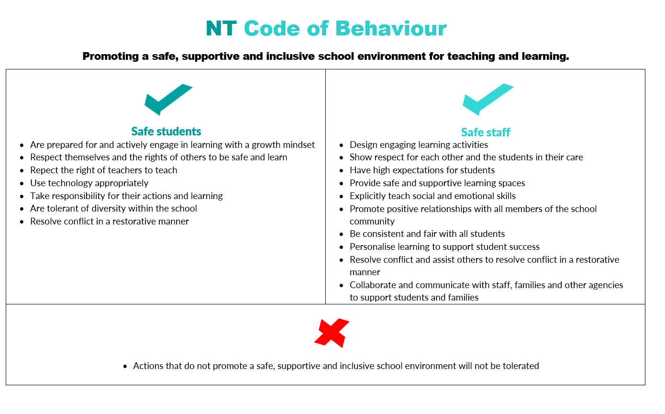
Schools should clearly communicate expected behaviours. A code of behaviour poster is provided below as an example.

Related legislation, policy, guidelines and resources
Legislation | Care and Protection of Children Act 2007 (NT) – promotes the wellbeing of children, protection of children from harm and exploitation and to maximise their opportunities to develop to their full potential.
Legislation | Disability Discrimination Act 1992 – to eliminate discrimination against persons on the grounds of disability, ensure people with disability have the same rights to equity before the law and promote recognition and acceptance that people with disability have the same fundamental rights as the rest of the community.
Legislation | Disability Standards for Education 2005 – makes explicit the obligations of education and training service providers under the Disability Discrimination Act 1992 and the rights of people with disabilities in relation to education and training.
Legislation | Education Act 2015 (NT) - promotes high-quality contemporary education to develop students’ potential and maximise their educational achievement.
Legislation | Education and Care Services (National Uniform Legislation) Act 2011 (NT) - sets a national standard for children’s education and care across Australia.
Legislation | Education Regulations 2015 (NT) – regulations under the Education Act
Policies/ Guidelines | Chaplaincy Services in Schools Policy and Guidelines
Policies/ Guidelines | Detention and Internal Suspension Guidelines
Policies/ Guidelines | Expulsion Guidelines
Policies/ Guidelines | Mandatory Reporting of Harm and Exploitation of Children Guidelines
Policies/ Guidelines | Police in Schools Guidelines
Policies/ Guidelines | Sexual Behaviour in Children Guidelines
Policies/ Guidelines | Suspension Guidelines
Policies/ Guidelines | Protective Practices Guidelines (NT Teacher Registration Board)
Resources | Australian Student Wellbeing Framework – provides Australian schools with a vision and a set of guiding principles to support school communities to build positive learning environments.  - Student Wellbeing Hub - underpinned by the Australian Student Wellbeing Framework, it is a one-stop shop for information and resources on strategies to build and sustain the wellbeing of the whole-school community and aims to assist educators, students, parents, specialist professionals supporting students, and pre-service teachers.  - School Wellbeing Check –helps to identify and analyse a school’s wellbeing. It contains 25 statements that encourage educators to think about how the school performs across the five key elements of the Australian Student Wellbeing Framework.
Resources | Northern Territory Social and Emotional Learning – supports the social and emotional learning of senior, middle, primary and early years’ students.
Resources | Supporting Student Wellbeing and Mental Health – online training that explores the kinds of issues that students may face, possible causes of mental stress and practical approaches that schools can adopt to better identify and support their needs.
Resources | Bullying. No Way! – provides information and resources to assist with talking and teaching about bullying from early childhood through to senior years.
Resources | eSafety – provides online education resources for schools, parents and communities, including lesson plans, web-based training and training providers.
Resources | Be You – a national mental health initiative delivered in partnership between Headspace and Beyond Blue that provides educators with knowledge, resources and strategies for helping children and young people achieve their best possible mental health.
Resources | Framework for Inclusion 2019-2029 – promotes an environment in Northern Territory Government schools which is inclusive, fair and focused on delivering learning to meet individual needs.
Resources | National School Improvement Tool (a culture that promotes learning) - assists schools to review and reflect on their efforts to improve the quality of classroom teaching and learning.
Resources | Belonging, Being and Becoming – The Early Years Learning Framework – provides a guide to the principles, practices and outcomes that support and enhance learning for young children from birth to five years of age including their transition to school.
Resources | National Quality Framework – provides a national approach to regulation, assessment and quality improvement for early childhood education and care and outside school hours care services.
Resources | National Principles for Child Safe Organisations – provides information on the 10 child safe principles that aim to drive a child safe culture across all sectors that provide services to children and young people to ensure the safety and wellbeing of children and young people across Australia.

https://studentwellbeinghub.edu.au/media/9310/aswf_booklet.pdf
https://australiancurriculum.edu.au/resources/curriculum-connections/portfolios/food-and-wellbeing/general-capabilities/
https://docs.education.gov.au/node/2632
https://legislation.nt.gov.au/en/Legislation/EDUCATION-ACT-2015#page=9&zoom=auto,88,328
https://www.acer.org/au/school-improvement/improvement-tools/national-school-improvement-tool
https://education.nt.gov.au/publications/framework-for-inclusion-2019-2029
https://education.nt.gov.au/statistics-research-and-strategies/indigenous-education-strategy
https://www.humanrights.gov.au/sites/default/files/National%20Principles%20for%20Child%20Safe%20Organisations.pdf
https://studentwellbeinghub.edu.au/educators/
https://legislation.nt.gov.au/Legislation/CARE-AND-PROTECTION-OF-CHILDREN-ACT-2007
https://www.legislation.gov.au/Details/C2018C00125/Html/Text
https://docs.education.gov.au/system/files/doc/other/disability_standards_for_education_2005_plus_guidance_notes.pdf
https://legislation.nt.gov.au/Legislation/EDUCATION-ACT-2015
https://legislation.nt.gov.au/Legislation/EDUCATION-AND-CARE-SERVICES-NATIONAL-UNIFORM-LEGISLATION-ACT-2011
https://legislation.nt.gov.au/en/Legislation/EDUCATION-REGULATIONS-2015
https://education.nt.gov.au/policies/chaplaincy-services-in-schools
https://education.nt.gov.au/policies/suspension-expulsion-and-detention
https://education.nt.gov.au/policies/suspension-expulsion-and-detention
https://education.nt.gov.au/policies/mandatory-reporting-of-harm-and-exploitation-of-children
https://education.nt.gov.au/policies/police-in-schools
https://education.nt.gov.au/policies/sexual-behaviour-in-children
https://education.nt.gov.au/policies/suspension-expulsion-and-detention
https://www.trb.nt.gov.au/system/files/uploads/files/2019/TRB%20NT%20-%20Protective%20Practices%20.pdf
https://studentwellbeinghub.edu.au/media/9310/aswf_booklet.pdf
https://studentwellbeinghub.edu.au/educators/
https://studentwellbeinghub.edu.au/educators/framework/school-wellbeing-check/
https://education.nt.gov.au/support-for-teachers/nt-social-and-emotional-learning
http://ed.ntschools.net/studserv/studentsupport/Pages/Online-Training-Courses.aspx
https://bullyingnoway.gov.au/
https://www.esafety.gov.au/
https://beyou.edu.au/
https://headspace.org.au/
https://www.beyondblue.org.au/
https://education.nt.gov.au/__data/assets/pdf_file/0010/662779/Framework-for-inclusion-brochure.pdf
https://www.acer.org/au/school-improvement/improvement-tools/national-school-improvement-tool
https://www.education.gov.au/early-years-learning-framework-0
https://www.acecqa.gov.au/nqf/about
https://www.humanrights.gov.au/sites/default/files/National%20Principles%20for%20Child%20Safe%20Organisations.pdf

