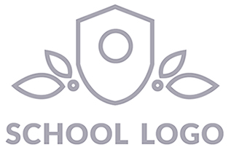 | Insert School Name
 | Student: |  | D.O.B:
 | Class: | Attendance percentage: | Date completed:

Child's strengths, motivations and interests |  | Suggestions to assist with transitioning |  | Additional information about further support required
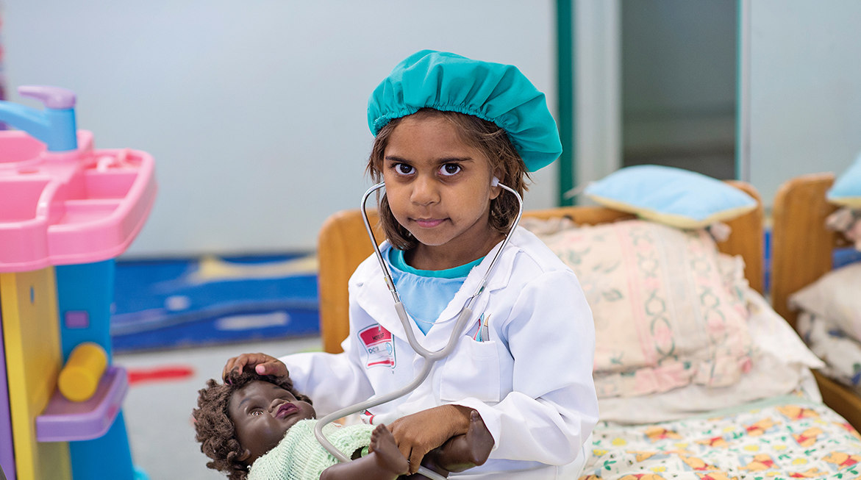
 |  | Early Years Learning Framework and Northern Territory Preschool Curriculum Learning Outcomes
 |  | Identity: EYLF Learning Outcome 1 |  | Connectedness: EYLF Learning Outcome 2
Wellbeing: EYLF Learning Outcome 3 |  | Learning and Thinking: EYLF Learning Outcome 4 |  | Communication: EYLF Learning Outcome 5

 | Teacher’s Name: | Signature: .............................................................

Family section: |  |  | Child section: (Teacher scribed)
Three wishes for my child... |  |  | Something I would like my new teacher to know is...
 ..............................................................................................................
..............................................................................................................
..............................................................................................................

 ..............................................................................................................
..............................................................................................................
..............................................................................................................

 ..............................................................................................................
..............................................................................................................
..............................................................................................................

 |  |  | Something I would like to know about my new school...
... to help them reach the stars as they start school.
Student:

Collection notice

The information collected in this form will only be used for the purpose for which it is being collected. All information will be treated confidentially, stored in a secure location, and destroyed in line with legislated retention and disposal schedules to ensure that every students’ right to privacy is maintained. For more information, go to the Department of Education’s Policy and Advisory Library and read the Privacy Policy.

