This document should be read in conjunction with the:
- Students with Disability Guidelines
- Diagnostic Assessment Guidelines .

- INTRODUCTION

Children and young people undertake a number of important transitions at key points in their education:
- starting school
- moving between schools (primary to middle to senior secondary)
- leaving school to pursue post-school pathways.
For students with disability and their families, there are often additional challenges and uncertainty when reaching these transitions, and there are additional considerations that schools must identify and address during those periods.
These guidelines, in particular, are designed to assist schools to implement quality processes and practices to ensure that students with disability are connected with and informed about appropriate post-school options as they approach school leaving age. Post-school pathways can include further education or vocational training, open or supported employment, or a community participation pathway.
All post-school programs will include a range of supports to assist school leavers to access the program and enhance their relationships, skills and networks within the program.

- DEFINITIONS

Disability, in relation to a person, means:,
- total or partial loss of a person’s bodily or mental functions, or
- total or partial loss of a part of the body, or
- the presence in the body of organisms causing disease or illness, or
- the presence in the body of organisms capable of causing disease or illness, or
- the malfunction, malformation or disfigurement of a part of the person’s body, or

- a disorder or malfunction that results in the person learning differently from a person without the disorder or malfunction, or
- a disorder, illness or disease that affects a person’s thought processes, perception of reality, emotions or judgment, or that results in disturbed behaviour;
and includes disability that:
- presently exists, or
- previously existed but no longer exists, or
- may exist in the future, or
- is imputed to a person.

Educational Adjustment Plan (EAP) refers to the development of appropriate adjustments for a student with disability based on the specific needs and abilities of the student which allows for greater participation and access to the curriculum.

Individual Transition Plan (ITP) involves developing short and long term goals and strategies to prepare a Senior School student with disability to transition to his/her chosen post-school pathway.

Parent
Parent, for the purpose of this document, includes:
- the child’s father, mother or any other person who has parental responsibility for the child and also for an Aboriginal or Torres Strait Islander child includes a person who is regarded as a parent under Aboriginal or Torres Strait Islander customary law or Aboriginal or Torres Strait Islander tradition
- a guardian/caregiver and is a person who has parental responsibility for a child or daily care and control of a child, is the person with whom a child currently resides, or is a person caring for the child at any given time.

According to the Education Act 2015 (NT) (sections 7 and 8) a person has parental responsibility for a child if the person has daily care and control of the child (i.e. is entitled to exercise all the powers, rights and responsibilities in relation to the day-to-day care and control of the child) or is entitled to exercise all the powers, rights and responsibilities in relation to the long-term care and development of the child, or both.

Post-school pathways include further education, vocational training, open or supported employment, and community participation pathways.

School refers to all education providers in the Northern Territory including Northern Territory government schools, Independent Public Schools, long day care and preschool facilities.

- ROLES AND RESPONSIBILITIES

Senior Director School Improvement and Leadership is responsible for:
- ensuring schools effectively plan and implement transitioning from school processes for all students with disability.

Principal is responsible for:
- supporting the access and participation of students with disability in transition from school activity and reflecting this in school planning
- ensuring students with disability and their families are provided with timely information and support to maximise access and participation in post-school options.

Teachers are responsible for:
- collaborating with Student Wellbeing and Inclusion staff, appropriate agencies, professionals, parents/care givers and students throughout the transition process
- planning, developing and reviewing Education Adjustment Plans and Individual Transition Plans
- delivering quality education by incorporating required adjustments specific to the needs and abilities of students with disability.
Senior Manager Inclusive Practice is responsible for:
- the ongoing management and development of collaborative partnerships with key government and non-government agencies and businesses
- the provision of advice and supporting documentation to regions and schools that support effective transition from school planning and implementation.
Transition from School staff are responsible for:
- the Transition from School work experience program and Remote Schools Pathway Grants that develop work and life skills
- supporting schools to develop individual transition plans with the involvement of students, families, communities and agencies, as appropriate.

- TRANSITION PLANNING

Transition planning is a process embedded into a school program and guided by student context and individual need. Transition planning assists young people to plan, prepare and work towards achieving their future directions and goals for life beyond school. It means planning early for a desired future.
The transition process includes the timely provision of information and support to students and their families, through choice and realistic expectations, aiming to maximise access and participation in a range of post-schooling options in the least restrictive environment.
Each student’s transition process is implemented by the department until the student leaves school. If any future transitional responsibilities are required the student will be referred to the nominated post-school agency or individual.
4.1 Northern Territory-specific considerations
Schools ensure that students with disability are provided with education services and support appropriate to their needs. Planning for Personalised Learning and Support is imperative for students with disability. Effective transition planning for school leavers requires a ‘whole of Territory’ focus to cater for the needs of students who may relocate from a rural/remote locality to an urban setting in order to access special education.

Whilst transition planning is underpinned by the Planning for Personalised Learning and Support: A National Resource Based on the Disability Standards for Education 2005, this framework remains consistent throughout the Northern Territory, with the student context and students’ individual needs guiding the process.

Programs such as work experience and community participation are offered to assist students to develop strengths and skills that may be identified throughout the transition process. Where no suitable programs exist, there is scope for communities to create their own opportunities for students, developing employability, life or social skills that are relevant to individual needs, with assistance available through Remote Schools Pathway Grants.
4.2 Transition Plan
- Individual Transition Plan
Every student with additional classroom needs has an Educational Adjustment Plan (EAP) that guides good practice for his/her inclusion and engagement in the curriculum. Complementing the EAP, an Individual Transition Plan (ITP) scaffolds and informs the transition of a student with disability from school into adult life. A comparison of the EAP and ITP is provided below.

Table 1. Comparison of an Individual Transition Plan and Educational Adjustment Plan
Individual Transition Plan (ITP) | Educational Adjustment Plan (EAP)
Looking at the ‘whole of life’ after school and so only applicable to students once they reach 14 years of age. | Applicable to all students regardless of age, requiring adjustments for curriculum access.
Looking at all aspects of post-school life and setting goals across all identified areas of the transition framework, across several settings, to achieve this. Goals may be long or short term. | Concentrates on 3 or 4 specific goals. Goals are likely to be achieved in 6 to 12 months.
Spans across several settings, school and post-school, involving multiple agencies. | School-focused with goals based around classroom adaptions/adjustments.
Helps set the focus of the educational goals. This could be curriculum-based, social, living skills etc. depending on the pathway identified in the ITP. | Once in senior school, goals are developed from the long term/post-school goal. What do the students require to assist with their post-school goals that can be achieved whilst in the classroom?
Based on interests and aspirations. It also considers future life environments and roles. | Based on skills required to achieve specific educational goals, one step at a time.
Goals may be very flexible and need to be able to change at any time deemed appropriate. Meetings are held not only at scheduled times but on a needs basis. | Goals are set for fixed periods of time and have less fluidity.
The ITP looks at current and future needs and addresses issues that may not be relevant for a few years.  Once ITP goals have been set, the EAP should address how the post-school goals are going to be achieved over the last few years, such as students getting used to new situations and support staff, or learning to use adaptive technology to access further education. | The EAP addresses quite immediate needs such as behaviour, curriculum etc. depending on what is impacting on the student’s curriculum access.

- The process and planning
The ITP is used to explicitly describe, document, monitor, review and report on all aspects of a student’s transition into post-school options. Within the Northern Territory, a comprehensive, whole of life, transition process is used to cover all areas of adult life and incorporates the following areas:
- employment/vocational training/voluntary work
- living arrangements
- respite
- community access
- leisure/recreation
- transport/mobility
- financial/income/budgeting programs
- continuing education and educational assistance
- legal issues – guardianship
- advocacy and natural supports
- personal management – communication/behavior
- health and community services.
The ITP identifies the specific supports and adjustments needed in each of the above areas. It incorporates short and long term flexible goals and strategies based on the student’s interests and aspirations aligned with the post-school pathway identified. An overview of the individuals and agencies involved and their specific roles and responsibilities is documented. All goals and strategies are monitored, and reviewed by agreed target dates as well as on a needs basis.
- A template that includes guiding questions to use when developing and structuring the ITP is available for use at Individual Transition Plan and Guiding Questions.
- A template for registering attendees at meetings is available for use at Register of Attendees for Transition Planning Meeting.
- A template for a post-school timetable to help plan weekly post-school activities with the student, family and agencies is available for use at Explicit Planning Timetable for Post- School Programs.

4.3 Transition planning timeline
Upon a student’s entry into Middle School and at subsequent EAP meetings, teachers provide the student and his/her family with information about the transition from school process. It is during this time that the student’s year of leaving is agreed upon, and key stakeholders in the student’s life identified.
An ITP is developed during year 10 or earlier as required and is reviewed and revised every 6 months throughout Senior School.
The department provides an education advisor and/or transition support officer to provide support to schools to engage with parents/carers, students, professionals, teachers and external support agencies throughout the development and implementation of an ITP.
TFS-Attachment A outlines a timeline for effective transition planning. Note that the timeline phases, priorities and actions should be flexible so as to cater for individual needs and choices.
4.3 Elements of effective transition planning
It is imperative to incorporate the Disability Standards Education 2005 resource Planning for Personalised Learning and Support in conjunction with Paula D. Kohler, Ph.D. Taxonomy for Transition Programming to underpin good practice.

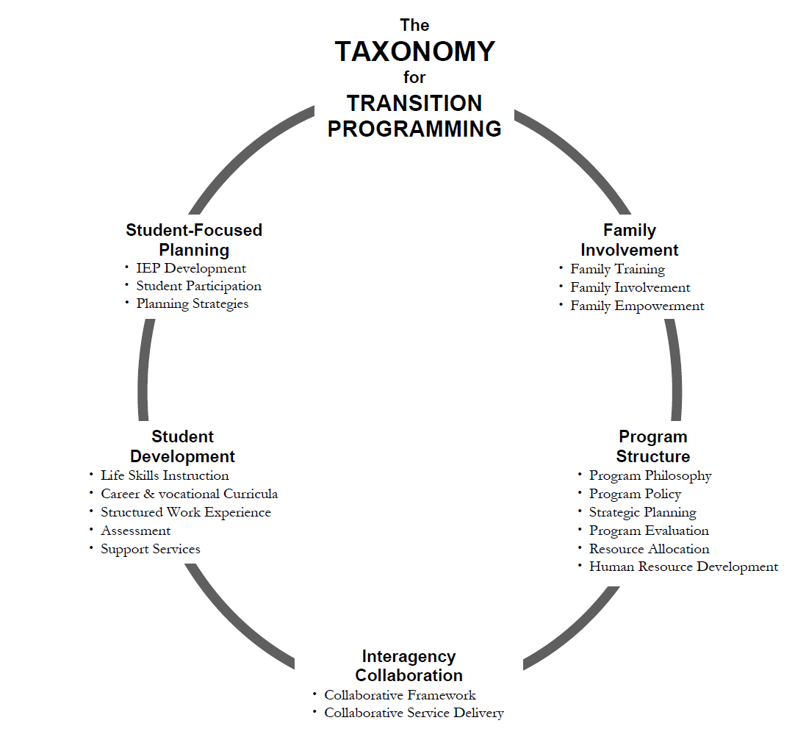
Kohler, P.D. (1996). Taxonomy for Transition Programming. Champaign: University of Illinois.

The following key elements are considered good practice for transition planning and are based on research by Paula D. Kohler, Ph.D.

- The transition planning process
The transition planning process is undertaken for every student with a disability to inform, plan and implement actions for a smooth transition out of school. This process will continue until a student exits school and enters into a post-school program of work, further education or a community participation program.

The key elements of the process comprise:
- planning commences when a student enters Middle School and continues throughout the students’ remaining time at school
- outcomes and goals are based on student and family choices, needs and preferences for the future, not on the services currently available. Service development needs to be an ongoing process
- coordination of and collaboration between all agencies involved
- appropriate documentation of the planning process is maintained and monitored, indicating actions and interagency linkages
- the handover meeting into post-school programs should be consolidated at the last meeting in the last year of school.

- Student focussed planning
Student focussed planning encompasses the right of each individual to plan for and be proactive in their own future goals and programs. The key principles of student focussed planning are:
- students are active participants in the planning process and supported in developing their own transition plans that reflect the students’ strengths, capabilities, interests and preferences
- students are given opportunities to learn about and experience a range of community options through programs such as work experience, school based enterprise programs and/or community access visits
- students are encouraged to advocate for their own post-school goals
- as all aspects of students’ life impact on one another, comprehensive and holistic planning is required
- only identified and relevant areas are addressed in regard to each student in line with his/her strengths and future goals.

- Interagency collaboration
Interagency collaboration is the relationship between individual students, the department and post-school program providers where they freely inform, discuss and assist in planning future options for all students. This collaboration includes and ensures the following:
- interaction between students, families and relevant agencies which is essential to establish or improve services and plan for student transitions
- the agencies involved share decisions, responsibility and trust through networking, coordination and cooperation
- communication ensures that information freely shared amongst key stakeholders (including families)
- accurate information about community services is made readily available to students and their families
- all stakeholders have clear understanding of roles and responsibilities in regards to information exchange, resources and essential service coordination.

- Family involvement
Family involvement recognises not only the individual but the role that families and care givers play in the transition process and future of that individual. Families and care givers are crucial to each student’s success and must have:
- regular involvement to enhance the student’s successful transition to adult life
- involvement in all decision making; meeting arrangements need to be flexible and accommodating to ensure this.
Consensus needs to be reached between all stakeholders regarding student outcomes. All ideas from family members are to be heard and respected.

- Program structures
Program structures are developed and incorporated into the planning and actions required for each individual to develop skills towards his/her post-school goal over the final years of schooling. Transition planning must include provision for:
- appropriate academic and vocational curriculum to prepare students for a range of experiences within their community
- functional content to reflect all domains of adult life
- teaching in natural environments, including real life scenarios within the classroom and school or in community-based settings.

- Post school services and community options
Various post-school services, community options and/or programs that have been identified as the most appropriate options for that individual may be available for a student upon leaving school. Future planning is essential to ensure:
- students, families and carers are empowered with the information necessary to make informed decisions
- school to post-school agency links are established
- services are available and accessible to all students completing school.
- services are person-centred and flexible so as to meet individuals’ needs
- processes are in place for agencies to determine the anticipated needs of transitioning students
- services and supports are available to facilitate natural support networks and community connections for transitioning students and their families.

4.5 Required professional reading and guiding documents
International and national bodies and governments alike recognise the importance of establishing and adopting strategies that guide the practices of disability support services. It is imperative that staff working in the Transition from School area complete the required professional reading to ensure that legislation and good practice is implemented in the Transition from School process.
TFS-Attachment B provides information regarding the documents considered to be crucial in guiding professionals in their work as well as informing individuals and their families about their rights and the responsibilities of others. TFS-Attachment B includes a list of professional readings and resources that provide useful tools that guide good practice.

5. COMPLAINTS PROCESS

The department may receive complaints from parents/caregivers about the services provided to their child. Complaints are to be managed in accordance with the Complaints Management in Schools Policy and Guidelines.
- ACKNOWLEDGEMENT
The department wishes to acknowledge the contribution of the following agencies in the development of these guidelines:
- Department of Health
- Territory Families
- National Disability Coordination Officer
- National Disability Insurance Scheme
- Disability Employment Services.

- ATTACHMENTS
Attachment A - Effective Transition Planning Timeline
Attachment B – Guiding Documents and Additional Resources

- LIST OF SUPPORTING DOCUMENTS
Explicit Planning Timetable for Post-School Programs
Individual Transition Plan and Guiding Questions (template)
Register of Attendees – Transition Planning Meeting
Planning for Personalised Learning and Support
Taxonomy for Transition Programming
Complaints Management in Schools Policy and Guidelines

Disability Standards for Education
Disability Discrimination Act 1992 (Cwlth)
Kohler, P.D. (1996). Taxonomy for Transition Programming. Champaign: University of Illinois.

