Northern Territory Board of Studies
  - Annual Report 2023

Document title | Northern Territory Board of Studies
Contact details | Education Department
Approved by | Marion Guppy, Chair Northern Territory Board of Studies
Date approved
Document review | Annually
TRM number | 50:D24:68596

June 2024

The Hon Mark Monaghan MLA
Minister for Education
Parliament House
DARWIN NT 0800

Dear Minister

I am pleased to present the Northern Territory Board of Studies Annual Report for the year ending 31 December 2023.
The report highlights the activities and achievements of the Northern Territory Board of Studies over the reporting year and has been prepared in accordance with Part 3 section 37 of the Education Act 2015.
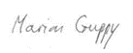

Marion Guppy
Chair

Contents
1. Report from the Chair 5
2. The Northern Territory Board of Studies 6
2.1. Establishment 6
2.2. Current iteration 6
2.3. Members 6
2.4. Meetings 7
2.4.1. Date and duration 7
2.4.2. Attendance 7
3. 2023 Achievements 8
3.1. Year 10 curriculum audit 8
3.2. Working groups and reviews 8
3.2.1. NTBOS policies and guidelines audit 8
3.2.2. Strategic plan alignment 8
3.2.3. Policy reviews 8
4. Awards 9
4.1. NTBOS awards ceremonies 9
4.1.1. 2023 top twenty NTCET recipients 10
4.1.2. Certificate of merit recipients 11
4.1.3. Industry-supported and additional awards recipients 12
4.2. Academic excellence awards 13
5. Overview of other Board activities 14
5.1.1. Northern Territory Certificate of Education and Training 14
5.1.2. National Assessment Plan Literacy and Numeracy 14
5.1.3. Australasian Curriculum, Assessment and Certification Authorities 15
5.1.4. Australian Curriculum, Assessment and Reporting Authority 15
5.1.5. South Australian Certificate of Education Board 15
5.1.6. Indigenous Languages and Cultures curriculum review 16
5.1.7. Transition Support Unit 16
5.1.8. NT School of Distance Education 16
6. Appendices 17
6.1. Overview of NAPLAN results 17
6.1.1. Student participation 17
6.1.2. Students Needing Additional Support 17
6.2. Overview of NTCET results 19
6.2.1. VET studies contributing to the NTCET 21

Report from the Chair

The Northern Territory Board of Studies (the board) provides advice on curriculum, assessment, reporting and certification to all schools in the Northern Territory (NT), as well as recognising the achievements of students in government and non-government schools across the NT.
The board plays a critical role in providing the Education Minster with advice on curriculum, assessment, reporting and certification. Nationally, and within the NT, there are major reforms underway, for which the advice of the board is essential, particularly given the cross-sectoral perspective the board provides.
In 2023, the board continued to forge strategic partnerships with several associations to enhance educational outcomes for Northern Territory students. The Australian Education Research Organisation (AERO) is one such organisation, delivering sound evidence to support improvement in student outcomes. Their work relating to curriculum assessment and reporting will continue to be shared with our schools, across all sectors.
The board analysed, discussed and considered reports and updates concerning: the South Australian Certificate of Education and Training (SACE), Australian Curriculum, Assessment and Reporting Authority (ACARA); the Australasian Curriculum Assessment and Certification Authorities (ACACA); the National Assessment Program – Literacy and Numeracy (NAPLAN) and the Northern Territory Certificate of Education and Training (NTCET).
There were new developments regarding the Early Years Learning Framework and the Indigenous Languages and Cultures Curriculum review. Addressing the emergence of new technologies and artificial intelligence (AI) is exciting, with further work required in this rapidly developing space. The board was very keen to learn more about interstate AI trials.
The board worked extensively in preparing for the Australian Curriculum version 9.0 implementation, liaising with all sectors.
Presentations for the NT Board of Studies Awards were held in Darwin and Alice Springs. These events are highlights for the board, where students are publicly recognised for academic and vocational excellence. We also like to acknowledge the educators, schools and families who significantly support these students.
I would like to thank the 2023 board members for the expertise and energy they brought to the work of the board throughout the year, and acknowledge the contributions made by departing members, Mr Ralph Wiese, Mr Charles Richardson and Ms Tabitha Fudge.
My sincere thanks go to the many people within the Department of Education who provide invaluable assistance to the Northern Territory Board of Studies.
Regards,

Marion Guppy
Chair

The Northern Territory Board of Studies (NTBOS)

Establishment
NTBOS was established in 1984 with its role being defined through legislation, however, the board’s operations and functions have changed considerably since then. Originally, the board was chaired by the Chief Executive of the Department of Education (DE), or by their nominee, and membership was comprised of representatives from various stakeholder groups.
NTBOS now consists of 11 members, made up of both representatives of stakeholder groups, and of nationally recognised experts in education. This model brings a balance of views to the board and maintains the cooperative arrangement between the government and non-government school sectors in the Northern Territory (NT). The board meets at least four times each year.
The board can set up committees that allow the board to inform itself on specific matters and seek the views of particular stakeholder groups.
The new structure of the board allows it to better fulfil the remit of providing high-quality and expert advice to the Minister for Education and the Chief Executive of DoE on matters of curriculum, assessment, reporting and certification.

Current iteration
The board is an independent authority consisting of 11 members:
- one DE officer nominated by the Chief Executive
- 4 stakeholder representatives – parent, teacher, employer and Indigenous
- 2 expert members drawn from the Catholic Education Office NT and the Association of Independent Schools of the NT
- 4 expert members nominated by the Minister for Education.
The focus of NTBOS includes:
- NT curriculum, assessment, reporting and certification
- early childhood
- middle years
- Indigenous education
- vocational education and training
- year 10, 11 and 12 outcomes
- student awards.

Members
A total of 11 people served on the Board throughout the course of 2023.
- Marion Guppy – chair - from 2 March 2023
- Ralph Wiese – expert member - from 2 March 2023, resigned 7 August 2023
- Charles Richardson – expert member
- Gavin Morris – expert member
- Saeed Amin – DE member
- Rachel Boyce – Association of Independent Schools of the NT member
- Jacqueline Langdon – Catholic Education Officer NT member
- Tabitha Fudge – parent representative
- Renez Lammon – Indigenous representative - from 2 March 2023
- Kellie Opitz – employer representative - from 2 March 2023
- Jacklyn Roberts – teacher representative - from 2 March 2023

Meetings

Date and duration
Table 1: 2023 meeting dates, duration and purpose are detailed in the table below
Meeting | Date | Duration | Purpose
1 | 31 March 2023 | Full-day meeting | Regularly scheduled meeting
2 | 26 May 2023 | Full-day meeting | Regularly scheduled meeting
3 | 11 August 2023 | Full-day meeting | Regularly scheduled meeting
4 | 27 October 2023 | Full-day meeting | Regularly scheduled meeting

Attendance
Table 2: Members attendance records
Members | 31/03/23 | 26/05/23 | 11/08/23 | 27/10/23
Marion Guppy | 🗸 | 🗸 | 🗸 | 🗸
Ralph Wiese | AP | AP | - | -
Saeed Amin | 🗸 | 🗸 | 🗸 | AP
Charles Richardson | 🗸 | 🗸 | 🗸 | 🗸
Gavin Morris | 🗸 | 🗸 | AP | AP
Rachel Boyce | AP | 🗸 | 🗸 | 🗸
Jacqueline Langdon | AP | 🗸 | 🗸 | 🗸
Tabitha Fudge | 🗸 | 🗸 | 🗸 | 🗸
Kellie Opitz | 🗸 | 🗸 | AP | 🗸
Renez Lammon | 🗸 | 🗸 | 🗸 | AP
Jacklyn Roberts | AP | AP | - | 🗸
AP = Absent with Apologies

2023 Achievements

Year 10 curriculum audit
The board requested an audit of schools within the NT still using the NTBOS Year 10 curriculum. Every school with Year 10 students was contacted and asked if they used the curriculum, and if so, why they were using it. Five schools were found to be using the Year 10 NTBOS curriculum in some way, however, in all instances it was blended with the Australian Curriculum or with the SACE curriculum.
The Year 10 NTBOS curriculum aligned with version 8.4 of the Australian Curriculum, but not with the newly endorsed, version 9. The board mandated that the Year 10 curriculum would be revoked from the start of 2024. Ms. Karen Weston, Chief Executive DoE and the Minister for Education, the Hon Mark Monaghan were supportive of this decision.

Working groups and reviews

NTBOS policies and guidelines audit
The board developed a working group to conduct an audit and review of its policies and guidelines published on the NTBOS webpage. The following policies were updated:
- Curriculum, assessment reporting and certification policy
- NTCET student awards policy.
The NTCET student awards policy was updated with a view to broaden the scope of additional awards and clarify eligibility criteria, with an emphasis on outstanding achievement.

Strategic plan alignment
A further working group reviewed the alignment of the board’s Strategic Plan 2023 – 2027 and the Minister for Education’s Commissioning Letter. The strategic plan is forward focussed and a tool for raising the status and visibility of the work of the board. The board created a workplan based on the Minister for Education’s Commissioning Letter; a working document to be updated with new milestones throughout the year.

Policy reviews
The board commenced a review of the NT senior secondary data release policy and the NTCET results release procedures.

Awards
Student achievement is recognised through an inclusive framework of awards and certification that aims to ensure every young person leaves school with appropriate documentation. Each year the NTBOS is privileged to be able to recognise students who attain excellent academic achievement.

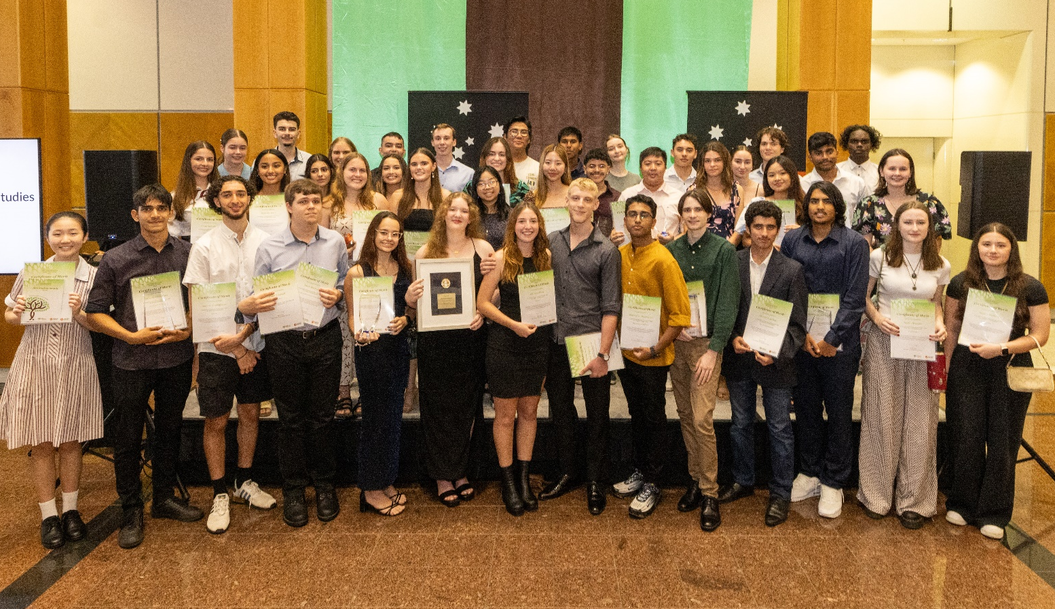
NTBOS awards ceremonies
Figure 1: NTBOS Award recipients at Parliament House, Friday 2 February 2024.
The board was delighted to hold presentation ceremonies for its awards. The ceremonies take place in the first two weeks of February each year, in both Darwin and Alice Springs. The awards ceremony for 2023 awards took place on Friday 2 February 2024, in Darwin, at Parliament House and
Thursday 8 February 2024, Alice Springs, at the Alice Springs Desert Park.
Awards are given to the top 20 NTCET completers, students who receive A+ Merit grades for Stage 2 board accredited subjects, and various industry-sponsored awards.
These events were attended by the Administrator of the NT, the Honourable Hugh Heggie PSM, the Minister for Education, the Hon. Mark Monaghan MLA, the Chief Executive of the Department of Education, Ms. Karen Weston, and many other distinguished guests, including board members.
These events are very special, and board members feel privileged to recognise and help celebrate the fantastic achievements of NT students.
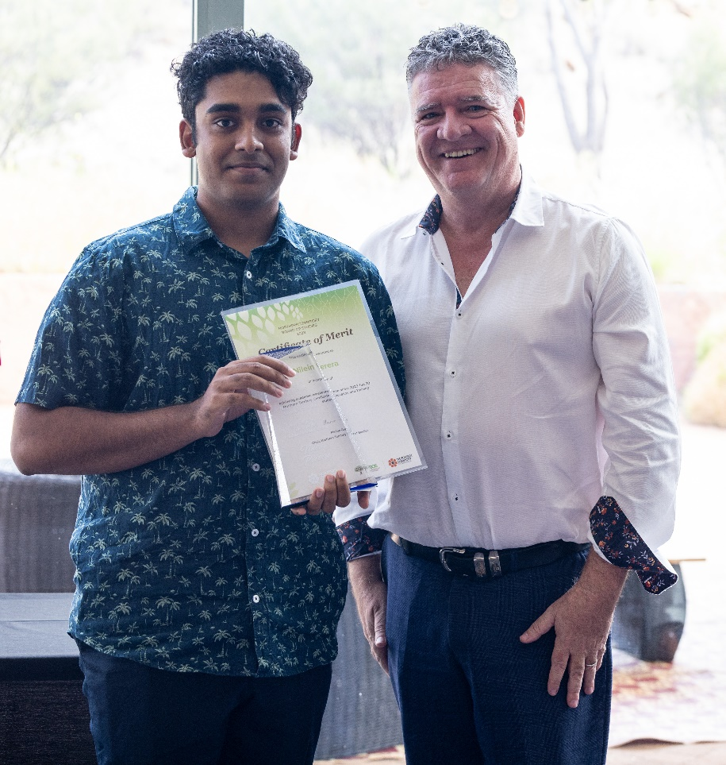

Figure 2: Nilein Perera receives his award from the Minister for Education, the Hon. Mark Monaghan MLA,
at the Alice Springs Desert Park, Thursday 8 February 2024.
NTBOS would like to congratulate the following award recipients:

2023 top twenty NTCET recipients
Recipient | School
Al-Hussain Al-Ibrahim | Darwin High School
Andrew Materazzo | Darwin High School
Senaru Herath | Darwin High School
Harold Niblock | Darwin High School
Oreoluwa Ogeleye | The Essington School
Vy Nguyen | Darwin high School
Oscar Twyford | Darwin high School
Grace Nice | Darwin High School
Sania Sabu | The Essington School
Stella Michael | Casuarina Senior College
Ayu Hamaguchi | The Essington School
Shannen Greenwood | Casuarina Senior College
Shivam Choudhary | The Essington School
Nilein Perera | St Philip’s College
Argiro Kokkinomagoulos | Darwin High School
Muhammad Adil Saeed | Darwin High School
Nathan Love | Casuarina Senior College
Sarah Nguyen | Casuarina Senior College
Emma Hornby | The Essington School
Anson Hao Yung Lee | The Essington School

Certificate of merit recipients
Recipient | School | Merit
Abbi Tastula | Darwin High School | General Mathematics
Al-Hussain Al-Ibrahim | Darwin High School | English Literary Studies, Chemistry, Health and Wellbeing and Specialist Mathematics
Andrew Materazzo | Darwin High School | Chemistry, Mathematical Methods and Physics
Anson Hao Yung Lee | The Essington School | Physics
Ayu Hamaguchi | The Essington School | Health and Wellbeing and Psychology
Carly Seaniger | Nhulunbuy High School | Research Project B
Charlee Phillips | Good Shepherd Lutheran College | Integrated Learning A
Chloe Kalikajaros | O’Loughlin Catholic College | Workplace Practices
Cian Huang | Darwin High School | English
Emma Hornby | The Essington School | Biology
Gabriella Francis | Darwin High School | Italian (beginners)
Gayatri Sureshbabu | Darwin High School | Indonesian (continuers)
George Michael | O’Loughlin Catholic College | Integrated Learning A
Georgia Park | The Essington School | Media Studies
Grace Nice | Darwin High School | English
Grace Rooney | MacKillop Catholic College | Psychology
Harold Niblock | Darwin High School | Chemistry, Mathematical Methods and Specialist Mathematics
Hayley Ryan | Darwin High School | Creative Arts
Ioannis Chatzipapas | Darwin High School | Biology
Ivy Fuss | Taminmin College | Research Project B
Jed Salmon | The Essington School | Media Studies
Jessica Hosking | Casuarina Senior College | Nutrition
Martina Oliver | Darwin High School | Biology
Matthew Winter | Nhulunbuy High School | English
Medha Tayal | The Essington School | Child Studies
Monishi Tripura | Darwin High School | Modern History
Muhammad Kazi | Darwin High School | Spanish (beginners)
Nathan Love | Casuarina Senior College | Digital Technologies
Nilein Perera | St Philip’s College | Physics
Noah Vladcoff | Good Shepherd Lutheran College | Music Performance – Ensemble
Oreoluwa Ogeleye | The Essington School | English Literary Studies and Nutrition
Oscar Twyford | Darwin High School | English Literary Studies, Industry and Entrepreneurial Solutions and Modern History
Phoebe Wiltshire | Darwin High School | Modern History
Pothik Mondol | Darwin High School | Research Project B
Rachelle Juan | The Essington School | Health and Wellbeing
Rebecca Ting Teo | Palmerston College | General Mathematics
Robert Cartmill | The Essington School | General Mathematics and Health and Wellbeing
Rupendren Manimaran | Darwin High School | Chemistry and Mathematical Methods
Samuel Ricketts | The Essington School | English Literary Studies
Sania Sabu | The Essington School | Child Studies and Health and Wellbeing
Sarah Nguyen | Casuarina Senior College | Biology
Senaru Herath | Darwin High School | Mathematical Methods, Physics and Specialist Mathematics
Shivam Choudhary | The Essington School | Health and Wellbeing
Taylah Stevens | Taminmin College | Psychology

Industry-supported and additional awards recipients
Recipient | School | Award
Emma Lodge | Taminmin College | Northern Territory Board of Studies 2023 Year 12 Vocational Education and Training Award
Alishia Buyong | Manunda Terrace Primary School | Administrator’s Medal for Northern Territory Primary Years Scholar
Hannah Baczynski | Sanderson Middle School | Administrator’s Medal for Northern Territory Middle Years Scholar
Nathan Love | Casuarina Senior College | Australian Computer Society (NT Branch) Technologies Award
Al-Hussain Al-Ibrahim | Darwin High School | Australian Meteorological and Oceanographic Society Physics Award
Al-Hussain Al-Ibrahim | Darwin High School | Australian Veterinary Association (NT division) Dennis Thomson Memorial Science Award
George Michael | O’Loughlin Catholic College | Department of Industry, Tourism and Trade Award for Business, Enterprise and Innovation
Grace Nice | Darwin High School | Department of Treasury and Finance Accounting Award
Abbi Tastula | Darwin High School | Department of Treasury and Finance Mathematics Award
Rebecca Ting Teo | Palmerston College | Department of Treasury and Finance Mathematics Award
Tanisha Davis | Alice Springs Language School | GTNT Group School-based Apprentice Award
Landon McElhone | Katherine High School | Karmi Sceney Urban Aboriginal Excellence and Leadership Award
Daicos Cooper | Gunbalanya School | Karmi Sceney Remote Aboriginal Excellence and Leadership Award
Naomi Jia | Darwin High School | Language Teachers’ Association of the Northern Territory Languages Award
Al-Hussain Al-Ibrahim | Darwin High School | Mathematics Teachers’ Association of the Northern Territory Mathematics Award
Senaru Herath | Darwin High School
Emma Hornby | The Essington School | Menzies School of Health Research Biology Award
Noah Vladcoff | Good Shepherd Lutheran College | Northern Territory Music School Music Award
Pheobe Wiltshire | Darwin High School | Rotary Club of Darwin Iain Smith Award for History
Matthew Winter | Nhulunbuy High School | Rotary Club of Darwin Ian MacGregor Award for Excellence in English
Grace Rooney | MacKillop Catholic College | Rotary Club of Darwin Hugh Bradley Award for Legal Studies
Samuel Ricketts | The Essington School | Rotary Club of Darwin Jim Gallacher Award for English Literary Studies
Al-Hussain Al-Ibrahim | Darwin High School | Royal Australian Chemical Institute Chemistry Award
Amy Ding | Haileybury Rendall School | Sally Bruyn Primary Science Award
Zachary Lutze-Gunner | Tennant Creek High School | Telstra Top Remote Aboriginal Male Student Award
Maxlyn Fry | Maningrida College | Telstra Top Remote Aboriginal Female Student Award
Vina Armand | Haileybury Rendall School | Victorian Certificate of Education Most Outstanding Northern Territory Student Award
Al-Hussain Al-Ibrahim | Darwin High School | Chief Minister’s Award Most Outstanding Stage 2 NTCET Student
Maddison Lea McCormick | Palmerston College | Chief Minister’s Award Most Outstanding Stage 2 NTCET Aboriginal Student
Rhenard Tan | NT School of Distance Education | Chief Minister’s Award Most Outstanding Stage 2 NTCET Distance Education Student

Academic excellence awards
NTBOS offers Academic Excellence Awards to government and non-government students in their final years of primary, middle and senior schooling. The top Aboriginal achiever in year 12, and the top personal learning achievers in year 12 are also awarded.
The winners are nominated by their school with presentations made at end-of year school functions. Each winner receives a $50 prize.

Overview of other Board activities
Each year the board considers matters important to education in the NT, and invites experts and spokespeople from education agencies, both government and non-government, to present information and reports to the board during meetings. These reports and presentations give members the opportunity to stay at the forefront of education practices, so that the board may better support the diversity of students in the NT. The 2023 addendum to the board’s Strategic Plan 2022 – 2027 stresses the importance of strategic partnerships between the board and educational organisations. The board sees partnerships with the following organisations as a priority:
- Charles Darwin University
- The Australian Institute for Teaching and School Leadership
- The Australian Education Research Organisation
- NT Teacher Registration Board.

Discussion on the following topics also took place throughout 2023:
- AI in schools
- Secondary education review
- Quality Standards Framework for Flexible Education Programs.

Northern Territory Certificate of Education and Training
The NTCET qualification is designed to recognise the knowledge and skills that have been acquired through formal education and training. It is the certificate students in the NT in years 10, 11, and 12 work towards during their final years of school. As providing high-quality advice on curriculum, assessment and reporting is one of the primary functions of the board, it takes a keen interest in the analysis of results, and in improving the administering of the NTCET.
The NTCET was discussed in every 2023 board meeting, with headline discussion topics as follows:
- 2022 NTCET data overview including completers, student pathways and student achievements
- projections for 2023 NTCET completions
- new and emerging subjects
- flexibility within the NTCET

National Assessment Plan Literacy and Numeracy (NAPLAN)
NAPLAN is one of the primary diagnostic tools for education agencies in measuring the literacy and numeracy of students. As providing high-quality advice on curriculum, assessment and reporting is one of the main functions of the board, members take a keen interest in the analysis of results and in improving the administering of NAPLAN.
In 2023 the board considered and discussed the following matters related to NAPLAN:
- term 1 testing and series break
- 4 new proficiency levels
- issues for remote schools
- the number of schools expecting to participate in NAPLAN in 2024
- a new release schedule.

Australasian Curriculum, Assessment and Certification Authorities (ACACA)
ACACA is the body for the chief executives of the statutory bodies in the Australian states and territories and in New Zealand responsible for curriculum, assessment and certification in education. ACACA routinely provides reports to the board, either in the form of a written report, or through updates provided by Tony Considine, Executive Director Department of Education and the 2023 Chair of ACACA.
In 2023 ACACA kept the board abreast of issues regarding secondary education such as:
- the SACE Board and Learner Profiles
- teacher shortages and teacher retention.

Australian Curriculum, Assessment and Reporting Authority (ACARA)
ACARA develops and refines the Australian Curriculum, national assessment including NAPLAN, and reports on key education indicators through the national report on schooling. ACARA is invited to provide a report at each board meeting, and the NT representative on the ACARA board, Ms. Jackie Roberts, nominated and appointed in 2022, is a permanent observer at board meetings.
In 2023 ACARA kept the board abreast of issues regarding curriculum and assessment such as:
- implementation of the Australian Curriculum Version 9.0 – English and Mathematics fully implemented in 2024 in all government schools and all other subjects to be implemented by the end of 2025
- implementation of the Australian Curriculum Version 9.0 in remote schools
- implementation of the Early Years Learning Framework
- Indigenous Language and Culture / Aboriginal and Torres Strait Islander languages
- NAPLAN.

South Australian Certificate of Education (SACE) Board
The SACE Board is responsible for the accreditation of subjects, and the recognition of learning and assessment as it pertains to the completion of the SACE. They also assess the achievements of students in the NT, which uses the SACE curriculum in the senior secondary years of education to deliver the NTCET. The SACE board provides regular reports to the board for their consideration. The NT has been invited to nominate a representative to sit on the Accreditation, Recognition and Certification (ARC) committee of SACE.
In 2023 SACE kept the board abreast of issues regarding their operations such as:
- new and emerging subjects and implementation in the NT
- SACE Capabilities and Learner Profile
- Exploring Identities and Futures (EIF) and Activating Identity and Futures (AIF)
- recognition of Aboriginal cultural knowledge
- recognition of learning.

Indigenous Languages and Cultures (ILC) curriculum review
The Keeping Indigenous Languages and Cultures Strong plan was launched in 2018. The plan provides a framework for the teaching and learning of Indigenous languages and cultures in NT schools through 4 main learner pathways across Transition to year 9:
- first Language
- bilingual
- maintenance
- language Revival
- renewal
- revitalisation
- revival
- second Language
- language and cultural awareness.
In 2023, the total number of students learning an Aboriginal language through the ILC curriculum was 4,016.
43 government schools across the five NT regions used the ILC curriculum with 30 languages reported on. In the Catholic school system, all remote schools offer an ILC program.
Strengthening the delivery of this program is key to achieving the goal of embedding the languages of First Nations people as languages to be taught within the Australian Curriculum. The board approved a scope for an external review of the ILC curriculum, with the focus of the review on identifying recommendations for how implementation of the ILC curriculum can be strengthened for all schools, across all regions.

Transition Support Unit (TSU)
The Director of the TSU, NT Department of Education, provided a presentation to the board on the work they do connecting students and families in remote and very remote locations to secondary education opportunities in the NT.

NT School of Distance Education (NTSDE)
NTSDE provided a presentation to the board regarding the HEAL project and the support they can provide to students in completing the NTCET. The HEAL project focuses on building the English, numeracy, literacy and ICT skills of students. It provides an opportunity to influence the quality of senior secondary education provision in remote schools.
NTSDE can help increase the level of expertise schools and teachers have access to. The new instruction model has been developed and a key part of this is moving all students to an online environment, assuring parity in the way NTSDE delivers education.

Appendices

Overview of NAPLAN results
NAPLAN is a set of tests in reading, writing, language conventions, spelling, grammar and punctuation, and numeracy. NAPLAN is a national standardised assessment and covers a broad spectrum of important functions, including:
- monitoring education achievement progress toward national goals
- assessing education system accountability and performance; including inter-jurisdictional and inter-sectoral comparisons and information on performance of students in equity groups
- tracking school improvement
- assessing individual student learning achievement and growth against standardised norms
- providing information to parents on school and student performance.

Student participation
Table 3: NT NAPLAN participation rates 2017 - 2023
Domain | Year Level | 2017 | 2018 | 2019 | 2021 | 2022 | 2023
Reading | Year 3 | 88% | 86% | 84% | 83% | 81% | 82%
 | Year 5 | 89% | 88% | 86% | 83% | 81% | 83%
 | Year 7 | 85% | 85% | 83% | 81% | 78% | 81%
 | Year 9 | 78% | 78% | 76% | 73% | 72% | 75%
Numeracy | Year 3 | 87% | 85% | 82% | 82% | 79% | 80%
 | Year 5 | 87% | 86% | 84% | 81% | 78% | 82%
 | Year 7 | 84% | 84% | 82% | 79% | 75% | 79%
 | Year 9 | 77% | 75% | 74% | 71% | 68% | 73%
Writing | Year 3 | 89% | 87% | 85% | 88% | 79% | 80%
 | Year 5 | 89% | 89% | 87% | 84% | 82% | 84%
 | Year 7 | 86% | 86% | 84% | 81% | 79% | 81%
 | Year 9 | 80% | 79% | 78% | 73% | 72% | 76%
Source: ACARA

Students Needing Additional Support
Table 4: Percentage of NT students whose results indicate they need additional support; 2023
Geolocation | Year Level | Reading | Numeracy | Writing
Outer Regional | Year 3 | 17% | 18% | 13%
 | Year 5 | 12% | 16% | 16%
 | Year 7 | 15% | 17% | 18%
 | Year 9 | 18% | 18% | 19%
 | All | 15% | 17% | 17%
Remote | Year 3 | 37% | 43% | 37%
 | Year 5 | 38% | 44% | 44%
 | Year 7 | 41% | 43% | 43%
 | Year 9 | 40% | 42% | 42%
 | All | 39% | 43% | 42%
Very Remote | Year 3 | 70% | 76% | 75%
 | Year 5 | 79% | 83% | 84%
 | Year 7 | 83% | 84% | 86%
 | Year 9 | 79% | 75% | 86%
 | All | 78% | 80% | 83%
All | Year 3 | 33% | 36% | 32%
 | Year 5 | 30% | 35% | 35%
 | Year 7 | 35% | 37% | 39%
 | Year 9 | 35% | 35% | 38%
 | All | 33% | 36% | 36%
Source: ACARA
Table 5: Percentage of students who achieved strong or exceeding proficiency levels; 2023
Indigenous Status | Year Level | Reading | Numeracy | Writing
Non-Aboriginal | Year 3 | 57% | 54% | 67%
 | Year 5 | 69% | 60% | 59%
 | Year 7 | 65% | 62% | 57%
 | Year 9 | 58% | 58% | 54%
 | All | 63% | 59% | 60%
Aboriginal | Year 3 | 12% | 9% | 15%
 | Year 5 | 13% | 9% | 12%
 | Year 7 | 11% | 8% | 9%
 | Year 9 | 11% | 9% | 9%
 | All | 12% | 9% | 11%
All | Year 3 | 39% | 36% | 46%
 | Year 5 | 47% | 40% | 40%
 | Year 7 | 42% | 39% | 36%
 | Year 9 | 37% | 36% | 34%
 | All | 41% | 38% | 39%
Source: ACARA
Notes and caveats about changes in NAPLAN 2023
Changes to the test in 2023 make results not comparable to 2022 and prior. Changes include:
- test timing change from May to March
- new scale developed
- proficiency levels replace previous NAPLAN band structure.
The participation measure remains consistent but may be influenced by the change in testing dates.
Students sitting the test, students present but not attempting the test and students who are exempt from testing are all included as participants.
The percentage of students in the 'needs additional support' or 'strong or exceeding' proficiency levels is derived by dividing the number of students in the respective proficiency level by the test population. While students exempt from testing are considered to need additional support, they are not included in the 'needs additional support' proportions.
Caution is required when interpreting differences in results between groups as differences may be driven by testing, participation rate and cohort variation.

Overview of NTCET results
In 2023 the board issued 1369 certificates to students who successfully completed their NTCET.
Figure 1: Percentage of year 12 students who achieved the NTCET - completion rate

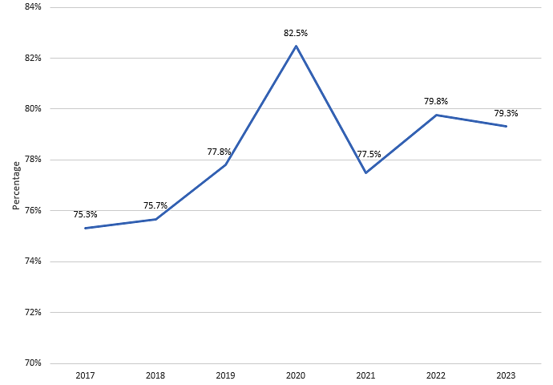

Figure 2: NTCET completion rate – male and female
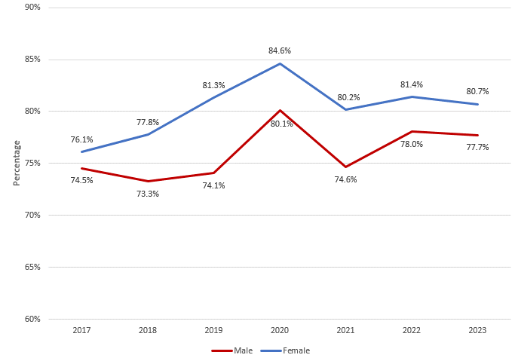

Figure 3: NTCET completion rate – Indigenous and non-Indigenous
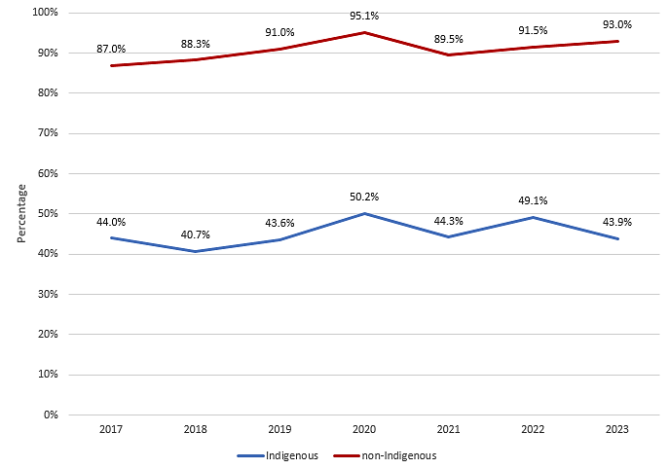

Vocational Education and Training (VET) studies contributing to the NTCET
VET studies continue to be a popular option for senior secondary students with almost half of NTCET completers studying VET in some capacity, and over a quarter needing VET credits to satisfy their NTCET requirements.
Figure 4: Percentage of NTCET completers who studied or needed VET as part of their NTCET
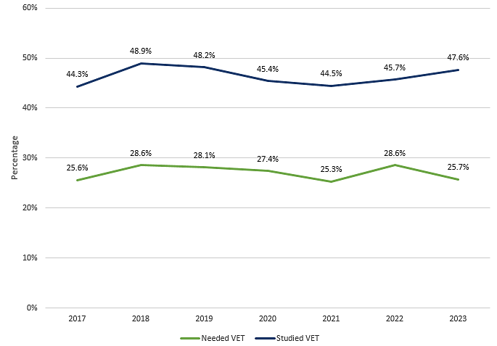

* Caveats:
- Data reported reflects the SACE Board post-clerical results, most recently released on 4th March 2023.
- Since 2022, there has been a change in the reported measure of NTCET completion rate so that it now takes as its denominator a distinct count of year 12 students as at Age Grade Census each year (August). This ensures that all students are only counted once, even if they have multiple enrolments during the year.
- To maintain comparability across years, the revised measure has been applied retrospectively such that currently reported figures may not correspond to previous publications.
- Students are counted as having studied VET if they passed/achieved the competency (result of ‘P’) or were granted recognition for prior learning (result of ‘R’).

