Northern Territory Board of Studies
Annual Report 2020



© Northern Territory Government 2020

For further information please contact
Executive Officer
Northern Territory Board of Studies
GPO Box 4821
DARWIN NT 0801

Telephone (08) 8944 9204
E-mail ntbos.det@education.nt.gov.au

Reproduction of this work, in whole or in part for educational purposes within an educational institution and on condition that it not be offered for sale, is permitted by the Department of Education.

Published by the Department of Education for the Northern Territory Board of Studies

Northern Territory Board of Studies

Annual Report/Northern Territory Board of Studies 2020 - Darwin:
Department of Education for the Northern Territory Board of Studies, 2020-v.:ill.; 25cn. Annual

ISSN 1033-0844

1. Northern Territory Board of Studies
2. Education-Northern Territory-Periodicals
3. Education and state-Northern Territory-Periodicals

379.9429 20


Level 11, Mitchell Centre
55-59 Mitchell Street
DARWIN NT 0800

Postal Address
GPO Box 4821
DARWIN NT 0801

T 08 8944 9204
E ntbos.det@education.nt.gov.au

Northern Territory Board of Studies

25 June 2021

The Hon Lauren Moss MLA
Minister for Education
Parliament House
DARWIN NT 0800

Dear Minister

I am pleased to present the Northern Territory Board of Studies Annual Report for the year ending 31 December 2020.

The report highlights the activities and achievements of the Northern Territory Board of Studies over the reporting year and has been prepared in accordance with Part 3 section 37 of the Education Act 2015.

Yours sincerely
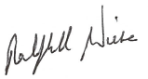

Ralph Wiese
Chair

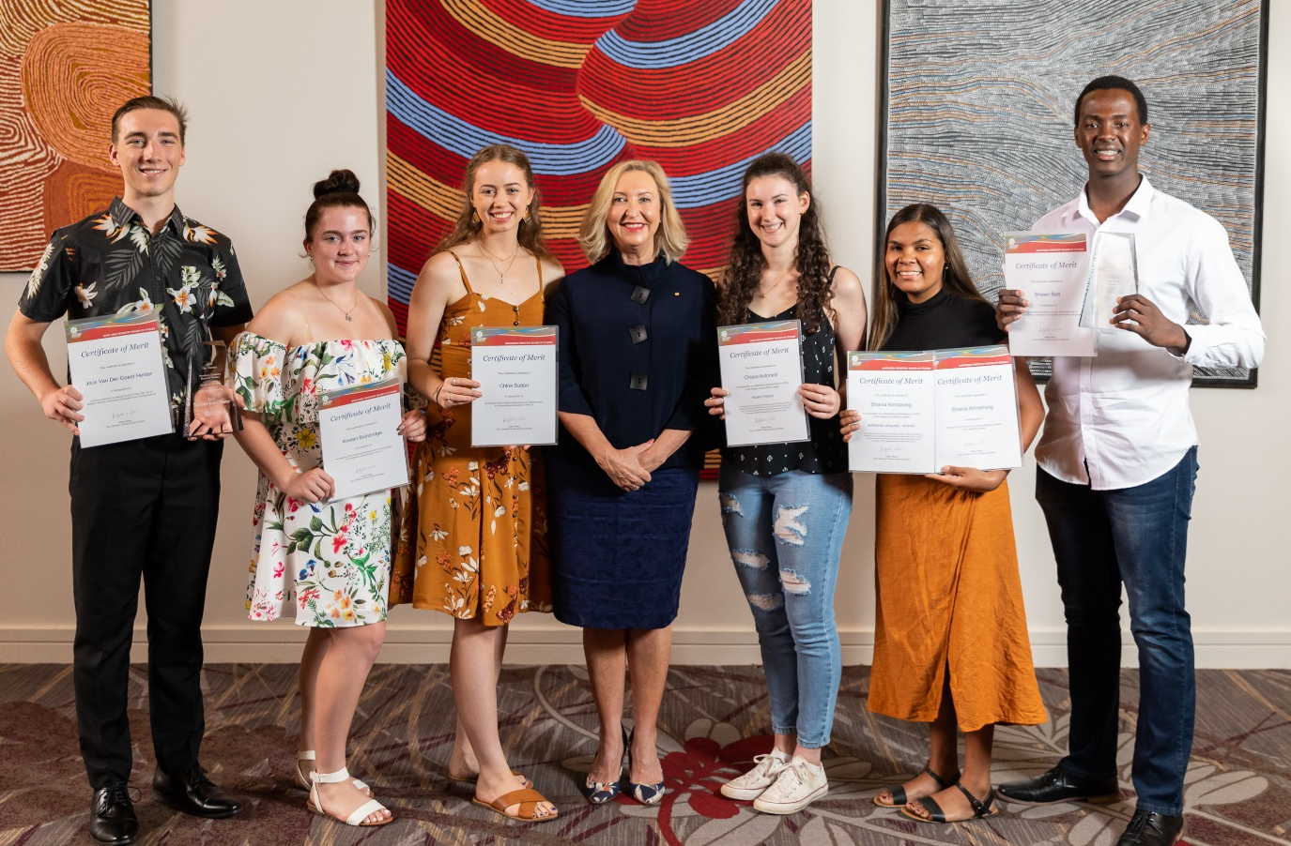
Alice Springs awardees with the
Administrator of the Northern Territory

Contents Page
Letter of Transmittal i
Report from the Chair 1
Functions of the Board 2
Overview 2
Board Membership as at 30 December 2020 4
Meeting Dates 2020 5
Member Attendance Register 2020 5
Matters and Reports Considered by the Board in 2020 6
National Assessment Program - Literacy and Numeracy 7
Northern Territory Certificate of Education and Training 8
Northern Territory Certificate of Education and Training Statistics 9
- Aboriginal and Torres Strait Islander Completion 10
- Northern Territory Certificate of Education and Training completers by gender 10
- Northern Territory Certificate of Education and Training completers by sector 13
- Top 20 Northern Territory Certificate of Education and Training Students and Merit Awardees 15
- Stage 1 Results 16
- Stage 2 Results 16
- Vocational education and training that contributes to the Northern Territory Certificate of Education and Training 17
Vocational Education and Training Delivered to Secondary School Students 18
- Overall Vocational Education and Training Data 2020 18
- Snapshot of Industry Training Programs 19
Appendices
- Northern Territory Board of Studies Student Awards 2020 20
- includes Academic Excellence Awards for Year 6, 9 and 12 students 30
- SACE Stage 1 Subjects for 2020 34
- SACE Stage 2 Subjects for 2020 36


Report from the Chair
This report covers the 2020 calendar year and is the fifth annual report of the Northern Territory Board of Studies (NTBOS) since changes were made to the Education Act in 2015.
NTBOS is an independent authority consisting of 11 members: one Department of Education officer nominated by the Chief Executive; four stakeholder representatives (parent, teacher, employer and Indigenous); two expert members drawn from the Catholic Education Office Northern Territory and the Association of Independent Schools of the Northern Territory; and four expert members nominated by the Minister for Education.
2020 was an extraordinary year and one we will remember. With the outbreak and spread of the COVID-19 pandemic affecting all Australians in some way, the board played an important role in assisting the Department of Education to deliver its response.
The board worked closely with the Department of Education, particularly the Quality Teaching and Learning division. This partnership of shared efforts covered a large number of national curriculum agenda issues including: Australian Curriculum Review; review of Australia’s national architecture for schooling; SACE modernisation; the National Assessment Program – Literacy and Numeracy; Northern Territory Certificate of Education and Training; and vocational education and training.
The board has continued to advance its work of contributing to the educational vision of the Territory and its desire to become the most improved education system in the country. The board provided input to the review of school term date structures for 2023 to 2027, reviewed NTBOS student awards and monitored the outcomes of the NT Indigenous Languages and Cultures Curriculum trial and the Employment Pathways Framework trial.
The Northern Territory Board of Studies Strategic Plan 2017-20 guides the board’s directions and goals.
A major event on the board’s agenda is the student award presentation ceremonies which are held annually in Alice Springs and Darwin. These events publicly recognise the academic and vocational excellence of school leavers and acknowledge the educators, schools and families who helped them excel.
On behalf of the board, I extend thanks to three departing members, Ms Leanne Nixon, Mr Mark Monaghan and Ms Annette Gillanders for their commitment and contributions to the work of the board during their tenures.
I also wish to thank those officers in the Department of Education who have supported the work of the board throughout 2020. And finally, I thank fellow board members for their enthusiastic commitment and the positive way in which they have taken up the challenges of working together to further improve education in the Territory.

RALPH WIESE
Chair

25 June 2021

Functions of the Board
The board has the following functions:
(a) to provide advice to the Minister for Education and the Chief Executive of the Department of Education on curriculum policy in relation to:
(i) establishing and maintaining curriculum frameworks that address the needs of all students in the Territory school education system; and
(ii) establishing and maintaining procedures for student assessment, reporting and certification; and
(iii) monitoring, evaluating and reporting on student performance; and
(iv) improving student outcomes;
(b) to provide advice to the Minister for Education and the Chief Executive on government policy affecting the board’s functions;
(c) to cooperate and consult with bodies prescribed by regulation that are engaged in education or related matters.
The board may determine the certificates to be issued to a person in respect of their educational achievements, and must issue a certificate to the person whose educational achievements, as assessed or recognised under this section, qualify the person for the certificate.
The board must prepare and maintain records of assessments and provide, on request by a student or former student, a copy of a record to the student or former student, or to such person as the student or former student specifies in that request.
The board is subject to the directions of the Minister for Education in performing its functions.

Overview

Boards of Studies
Boards of Studies exist under various names in all Australian states and territories. Although their functions vary, they share a number of common educational purposes including:
- to allow widespread community input
- to bring together all schools in establishing common directions
- to ensure fairness for all students
- to establish the curriculum for the stages of schooling
- to provide for assessment of student learning
- to control certification of student achievement.

The Board
The Northern Territory Board of Studies was established in 1984. In 2015 a review of the Education Act was undertaken with the new Education Act and Education Regulations commencing on 1 January 2016.
The changes in the legislation, which affected the Northern Territory Board of Studies, applied from 1 July 2016. The key difference resulting from the new legislation was that Northern Territory Board of Studies membership changed from a stakeholder representative model to a mixed model consisting of stakeholder and expert representatives.
The board promotes a common curriculum for the compulsory years of schooling which is designed to provide a challenging level of education for all learners, whatever their aspirations and abilities, and to ensure that all learners have the opportunity to learn and achieve in recognised areas.
In the pursuit of equity, the board fosters the fullest participation in education of groups and individuals for whom participation may involve special challenges. Student achievement is recognised through an inclusive framework of certification that aims to ensure every young person completes their schooling with appropriate educational achievements, qualifications and documentation.
The board consists of 11 members: one Department of Education officer nominated by the Chief Executive; four stakeholder representatives (parent, teacher, employer and Indigenous); two expert members drawn from the Catholic Education Office Northern Territory and the Association of Independent Schools of the Northern Territory; and four expert members nominated by the Minister for Education. All six expert members must have expertise in prescribed fields.

Board Membership as at 30 December 2020
view member profiles: https://education.nt.gov.au/committees,-regulators-and-advisory-groups


Mr Ralph Wiese
Chair and expert member

Appointed to 30/06/22
 | Mr Mark Monaghan  Employer representative  Appointed to 30/06/22  Resigned: 11/07/2020 |  | Ms Rachel Boyce  Expert member  Appointed to 30/06/22
 | Ms Mary Ellen Venes  Teacher representative  Appointed to 30/06/22 |  | Ms Annette Gillanders  Expert member  Appointed to 30/12/20
 | Mr Charles Richardson  Expert member  Appointed to 30/12/20 |  | Ms Jacqueline Langdon  Catholic Education Office  NT nominee  Appointed to 30/12/20
 | Mrs Tabitha Fudge  Parent representative  Appointed to 30/12/20 |  | Ms Cheryl Salter  Association of Independent Schools of the NT nominee  Appointed to 30/12/20
 | Ms Pauline Schober  Indigenous representative  Appointed to 30/06/22 |  | Ms Leanne Nixon  Department of Education nominee  Appointed to 30/12/20

Meeting Dates 2020
MEETING | DATE | VENUE | DURATION
1 | 20 March 2020 |  | Board meeting cancelled due to COVID-19
2 | 24 April 2020 | Darwin | 3 hours (COVID-19 Year 12 briefing)
3 | 29 May 2020 | Darwin | Full day board meeting
4 | 14 August 2020 | Darwin | Full day board meeting
5 | 13 November 2020 | Darwin | Full day board meeting

Member Attendance Register 2020
Board Members | 1 | 2 | 3 | 4 | 5
Board Members | 20/03/20  (cancelled) | 24/04/20 | 29/05/20 | 14/08/20 | 13/11/20
Ralph Wiese
Mary Ellen Venes |  | TC |  | AP | AP
Mark Monaghan |  |  |  | Resigned
Rachel Boyce
Jacqui Langdon |  |  |  | AP
Leanne Nixon |  |  |  |  | AP
Charles Richardson |  | TC | TC | TC
Cheryl Salter |  | TC | TC
Tabitha Fudge | Leave of Absence
Pauline Schober |  | TC | AP
Annette Gillanders |  |  | AP | AP | AP
A = Absent AP = Absent with apologies TC = Teleconference

Matters and Reports Considered by the Board in 2020
- Analysis of 2020 Northern Territory Certificate of Education and Training results
- Australasian Curriculum, Assessment and Certification Authorities
- Australian Curriculum, Assessment and Reporting Authority
- Australian Curriculum Review
- Curriculum, Pedagogy, Assessment and Reporting policy review
- COVID-19 pandemic
- Indigenous languages and cultures
- Indigenous education
- Literacy and numeracy
- NAPLAN Online
- National issues and initiatives
- Northern Territory Certificate of Education and Training
- NTBOS website
- Online Formative Assessment initiative
- Policies and guidelines
- Senior Secondary Pathways review
- South Australian Certificate of Education Board
- SACE modernisation
- Student awards and ceremonies
- Vocational education and training

National Assessment Program – Literacy and Numeracy

The cancellation of National Assessment Program – Literacy and Numeracy (NAPLAN) for May 2020 due to the COVID-19 pandemic meant there was no NAPLAN data for the NT Board of Studies 2020 Annual Report.

The COVID-19 pandemic disrupted lives across the globe and NAPLAN was cancelled to assist school leaders, teachers and support staff to focus on the wellbeing of students and continuity of education, as they responded to the COVID-19 pandemic.

Northern Territory Certificate of Education and Training
The Northern Territory Certificate of Education and Training (NTCET) commenced in 2011 as a senior secondary school qualification. The qualification is internationally recognised and prepares students for a range of post school pathways including further education and training and employment.
The NTCET generally takes a minimum of three years to complete. It usually commences in Year 10 with one subject, Professional Learning Plan (PLP), followed by Stage 1 subjects, usually in Year 11, followed by Stage 2 subjects, usually in Year 12. The NTCET requires students to complete a pattern of Stage 1 and Stage 2 subjects which includes some compulsory components. Recognition for vocational education and training (VET) may be included in the study pattern.
To qualify for the NTCET, students must record achievement in 200 credits and achieve satisfactory results in at least 140 credits. Students must also gain a C grade or higher for 20 credits of literacy, 10 credits of numeracy, 10 credits of the PLP and 60 credits at a C minus or better in Stage 2 subjects or their equivalent.

2020 Results Release
Students who completed requirements for the NTCET during 2020 received their results on 15 December 2020. The release date was coordinated with the South Australian Certificate of Education Board of South Australia (SACE Board of SA). All students in the Northern Territory and South Australia in urban, regional and remote areas were able to access their results electronically on the same day.
A results enquiry service was available to Year 12 students and their parents from 15 to 31 December 2020. This service, operating from the Teaching and Learning 10-12 team, Department of Education, aimed to assist students with interpreting results and support to students and parents about future pathways. Students are able to access the service via a free call number. The service received no calls in 2020. Results were released in 2020 while schools were still open and students were able to access support directly from their schools.

2020 Results Data – Northern Territory
Caveats
- This data is valid as of 30 March 2021.
- Use of this data is subject to the Protocols outlined in Memorandum of Administrative Arrangement (Data Exchange) between the SACE Board of SA and the Northern Territory Department of Education.
Notes:
- Students receive 10 credits for a one-semester subject.
- Students receive 20 credits for a full-year subject.
- At Stage 1, students can enrol in the same subject code more than once. These figures therefore reflect completed enrolment numbers rather than a student count.
- Non-graded results (for Modified subjects) are reported to students as ‘Completed’ or ‘Not Completed’ without an accompanying score or grade.
- Results for Stage 2 Community Studies subjects are reported as a grade between O (outstanding), A and E, or N (no result).

2020 Northern Territory Certificate of Education and Training Statistics
In 2020, the Northern Territory Board of Studies (NTBOS) issued 1622 NTCETs to students after results were finalised.
Figure 1 Number of NTCET completers compared to the number of Year 12 enrolments from 2011–20 from the age grade census*
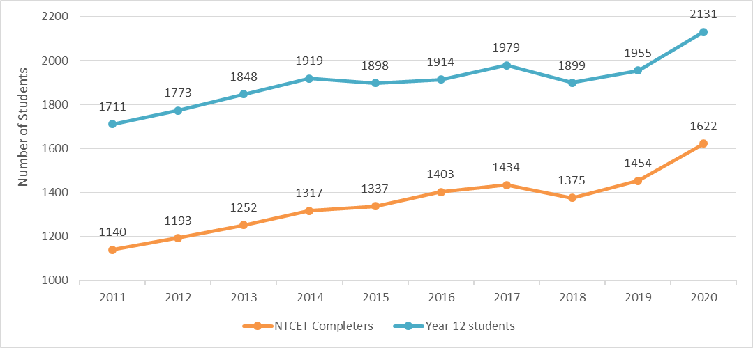
* Some data has been amended from previous years due to variances in data extraction dates.
The Age Grade Census is taken in August annually and counts enrolled students by assigned year levels. Not all students who are Year 12 are in the final year of their NTCET. There were 2131 Year 12 students in 2020.
Figure 2 Percentage of enrolled Year 12s who obtained their NTCET from 2011-20
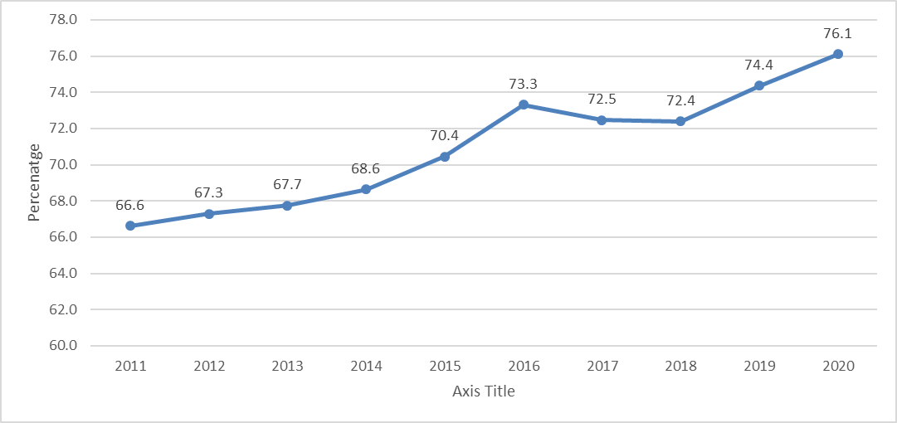
Figure 1 and Figure 2 analysis
In 2020, there were 168 more NTCET completers than in 2019. There was also an increase in the number of Year 12 students in the population.
The percentage of Year 12 students who obtained an NTCET in 2020 increased by 1.7 per cent from 2019.

Aboriginal and Torres Strait Islander Completion
Figure 3 NTCET completers by Aboriginal and Torres Strait Islander status
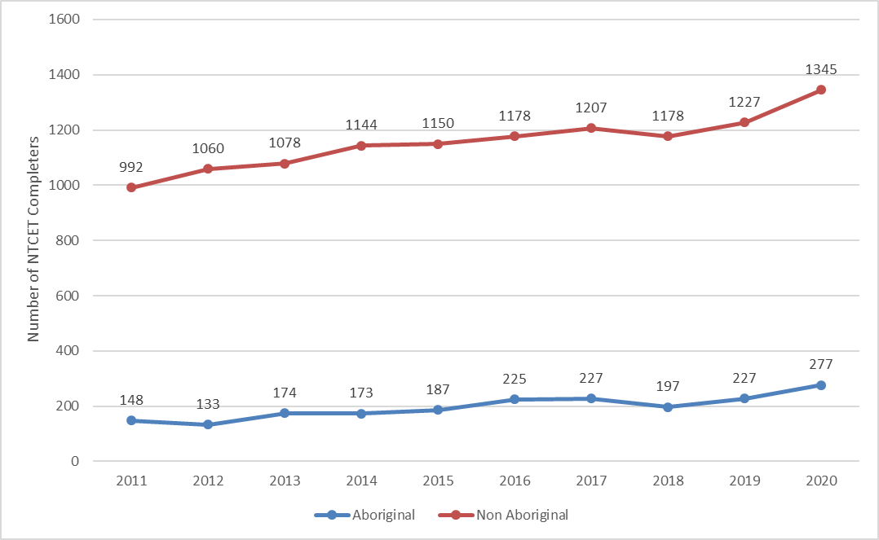
Figure 3 analysis
In 2020, 277 Aboriginal or Torres Strait Islander students completed their NTCET, an increase of 50 from the previous year. This represents 17 per cent of the NTCET completers and is a one per cent increase from the previous year.

NTCET Completion by Gender
Table 1 Year 12 students compared to NTCETs issued from 2011–20 by gender
Year | Females |  | Males
Year | Year 12  population | NTCET completions | Year 12  population | NTCET completions
2011 | 826 | 575 | 885 | 565
2012 | 901 | 640 | 872 | 553
2013 | 946 | 671 | 902 | 581
2014 | 1023 | 715 | 896 | 602
2015 | 982 | 695 | 916 | 642
2016 | 989 | 736 | 925 | 667
2017 | 998 | 730 | 981 | 704
2018 | 982 | 731 | 917 | 644
2019 | 1014 | 784 | 941 | 670
2020 | 1125 | 880 | 1006 | 742

Table 2 Year 12 students compared to NTCETs issued from 2011–20 by gender in percentage
Year | Percentage Female (%) |  | Percentage Male (%)
Year | Year 12 Population | NTCET completions | Year 12 Population | NTCET completions
2011 | 48 | 50 | 52 | 50
2012 | 51 | 54 | 49 | 46
2013 | 51 | 54 | 49 | 46
2014 | 53 | 54 | 47 | 46
2015 | 52 | 52 | 48 | 48
2016 | 52 | 52 | 48 | 48
2017 | 50 | 51 | 50 | 49
2018 | 52 | 53 | 48 | 47
2019 | 52 | 54 | 48 | 46
2020 | 53 | 54 | 47 | 46

Table 2 Analysis
The percentage of females has been higher in the population than males since 2012.
The percentage of females who have attained an NTCET has been higher than the percentage of males who have attained an NTCET since 2012.
The difference between the relative gender distribution of the population and the relative gender distribution of NTCET completers has narrowed by one per cent since 2019, with males improving in overall performance.

Figure 4 Aboriginal and Torres Strait Islander completers by gender
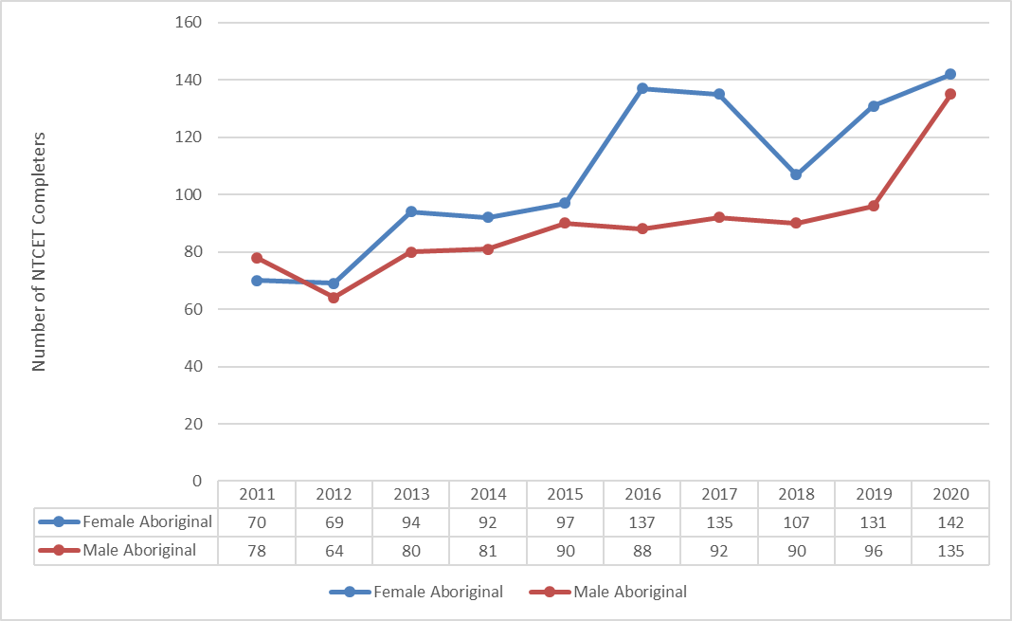
Figure 4: Analysis
In 2020, 39 more male Aboriginal and Torres Strait Islander students attained their NTCET than in 2019. This represented a six per cent increase in attainment in males.

NTCET Completion by Sector
Figure 5 NTCET completions by sector from 2011-20

Figure 5: Analysis
There was a relative five per cent increase in the number of completers in the government sector and a corresponding decrease in the percentage of completers in the non-government sector.

Figure 6 Aboriginal and Torres Strait Islander NTCET completers by sector
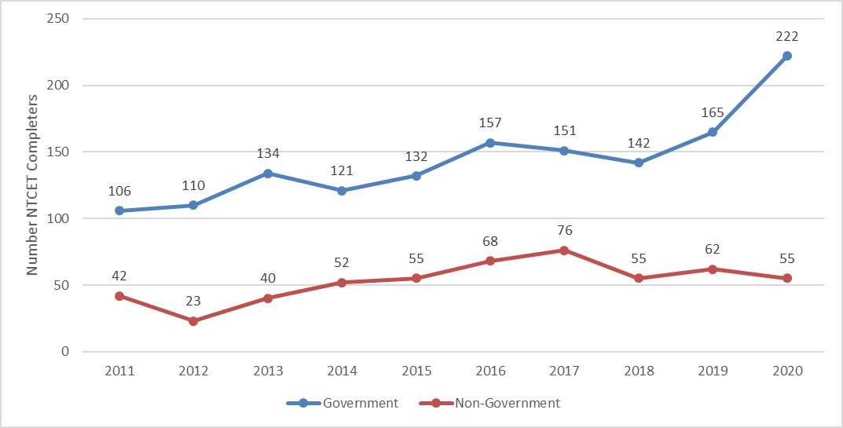
Figure 6: Analysis
There was a relative 7.4 per cent increase in the number of completers in the government sector from 2019 and a corresponding decrease in the percentage of completers in the non-government sector.

Figure 7 2011-20 PLP to NTCET completion rate
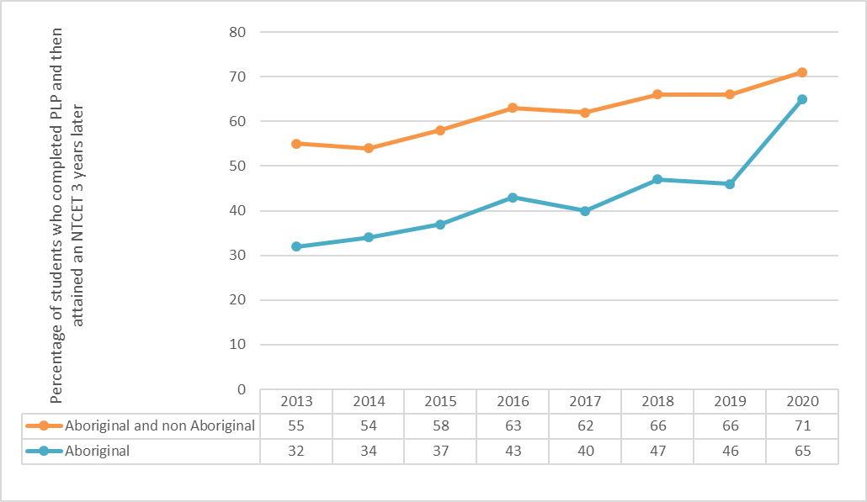
* PLP progress data for 2020 provided by the SACE Board of SA on 20 May 2021
Note: figures are subject to change as some students require more than two years to complete the NTCET
Figure 7 shows the PLP to NTCET completion rate. This is the percentage of students completing their NTCET compared to the number of students who completed their Stage 1 PLP in Year 10.
This data is at a system level and does not track individual students. It assumes the following.
- Students take three years to complete their NTCET.
- Students do not join or leave the cohort.

Figure 7 Analysis
The retention of all students between Year 10 to NTCET completion has increased in the past year. For the Aboriginal cohort, the rate has increased significantly since the previous year.

Top 20 NTCET Students and Merit Awardees
The top 20 NTCET students in the Northern Territory are recognised every year by the Northern Territory Board of Studies. These students gained university aggregates that ranged from 84.00 to 88.85 out of 90. Twenty-one students were in the top 20 in 2020 due to two students achieving the same university aggregate at the 20th position.
Of the top 20 students, 12 were male and nine were female.
Eleven of the top 20 students were from Darwin High School, four from The Essington School, two each from Casuarina Senior College and Our Lady of the Sacred Heart College (NT), one each from St Philip’s College and O’Loughlin Catholic College.
A+ Merit awards are presented to students for meritorious achievement in a SACE Board accredited subject. Students can gain an A+ Merit in a Stage 2 SACE Board accredited subject, if they meet the following two criteria:
- gain an overall subject grade of A+ for that subject
- be selected by a panel, appointed by the SACE Board of SA, as demonstrating exceptional achievement in the subject (typically, fewer than two per cent of the subject cohort would meet this criterion).
Forty-nine A+ Merits were awarded to 41 students in 28 subjects from 11 NT schools; eight government and four non-government, with five students achieving A+ Merits in more than one subject.

Stage 1 Results
The figure below provides the percentage of students in all Stage 1 learning areas that obtained a C grade or above.
Figure 8 Stage 1 results by learning area, 2020*
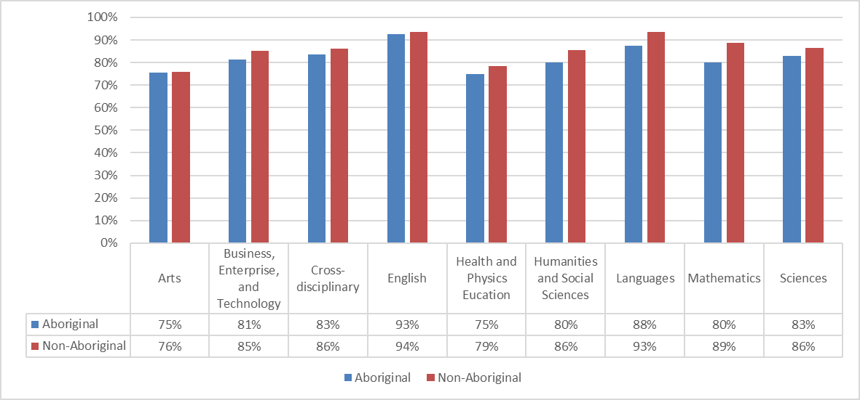
*Data extracted from BIC database on 22 May 2020

Stage 2 Results
The figure below provides the percentage of students in all Stage 2 learning areas who obtained a C⁻ grade or above.
Figure 9 Stage 2 results by learning area, 2020*

* Data extracted from BIC database on 20 May 2020

Vocational Education and Training that contributes to the NTCET
Table 3 NTCET students and their VET completions
VET Completions | 2020
Number of students who completed the NTCET with VET | 766
Number of students who completed the NTCET and would not have done so without VET | 445
*2020 NTCET completers VET data as extracted on 23 April 2021.
Source SACE Board of SA via Schools Online

In the Northern Territory Certificate of Education and Training, vocational education and training can be recognised at both Stage 1 and Stage 2. A completed Certificate III qualification and above can be used in the calculation of a student’s Australian Tertiary Admission Rank (ATAR).
Forty-seven per cent of students completed VET competencies and an NTCET (51 per cent in 2019). Twenty-seven per cent of students used VET to complete their NTCET (28 per cent in 2019).

Vocational Education and Training Delivered to Secondary School Students
The Department of Education’s Industry Training Programs business unit provides funding, industry connection and support for schools and students accessing VET across urban, regional and remote areas of the Northern Territory. This support includes the development and management of industry partnerships and pathways to assist the transition of students into the work place.

Overall Vocational Education and Training Data 2020
In 2020, there were 2151 students enrolled in a nationally accredited VET course, of these enrolments:
- 1087 students (51 per cent) completed a VET qualification
- 941 students (44 per cent) were female
- 729 students (34 per cent) were Aboriginal
- 180 students in NT schools (government and non-government) participated in school-based apprenticeships or traineeships, with 72 being Aboriginal.

In 2020, 1622 students completed their NTCET, of these:
- 47 per cent of students completed VET competencies and an NTCET
- 27 per cent of students used VET to complete their NTCET.

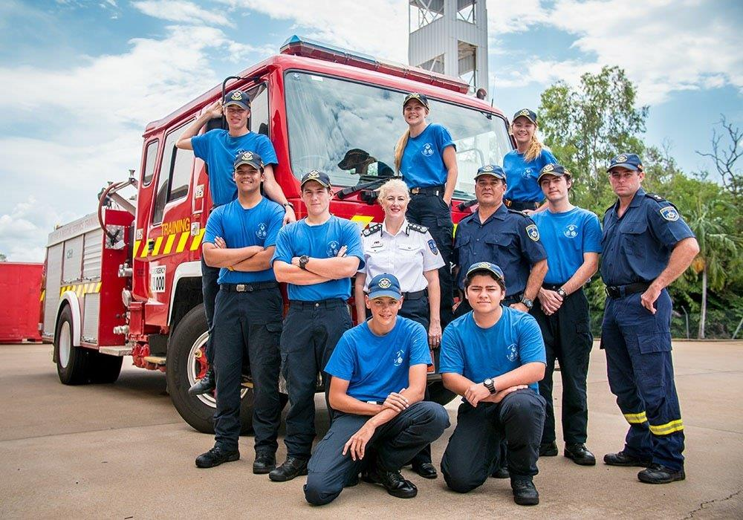
NT Police, Fire and Emergency Services Cadets

Snapshot of Industry Training Programs

Aircraft Technician Pathway Program
The two-year Aircraft Technician Program commenced in 2019 delivering Certificate II in Aircraft Line Maintenance in Alice Springs and Darwin, supported by ChartAir and CareFlight. In 2021 the structure of the program will change to allow Year 10 students to enrol. The new cohort will complete the qualification over 18 months.

Northern Territory Police, Fire and Emergency Services Cadet Program
Northern Territory Police, Fire and Emergency Services and the Department of Education partnered to offer students Certificate III in Business and Certificate II in Community Engagement over 18 months, growing a workforce in the public sector.
2021 will be the sixth year of the Darwin program, the fourth in Alice Springs and the commencement of a contextualised cadet program for Yirara College students where they will undertake a Certificate II in Community Engagement qualification to build the foundations of becoming an Aboriginal Community Police Officer.

The Maritime Program
The Maritime Program equips students from remote, regional and urban NT schools with the skills, knowledge and expertise required for employment within the maritime industry. This program offers a range of employment pathways and is heavily aligned with industry such as community ranger groups and other maritime related areas for instance, barge companies, water police, surf lifesaving and fisheries.

Swinburne University and Arnhem Land Progress Aboriginal Corporation
The partnership between the Arnhem Land Progress Association and Swinburne University delivers in three remote communities with clear industry links: Certificate II in Construction Pathways to students with employment prospects through local building organisations.

Learning on Country Program
Learning on Country is a culturally relevant school-based Indigenous ranger facilitated program aimed at linking Australian Curriculum subjects with field-based experiential learning and data collection. Through this program, Indigenous Land and Sea Rangers and Indigenous landowners collaborate with schools, to teach remote Indigenous school students language, literacy and numeracy, science and work skills, and impart local Indigenous knowledge both ‘on country’ and in classrooms. These programs may also be tied to a vet program that is nationally recognised.

Tiwi Plantation Partnership
The Tiwi Plantation Partnership is a new initiative commencing on the Tiwi Islands with a whole of community approach, establishing pathways to potential employment for students at Tiwi College and Xavier College. This program is heavily aligned with industry: Plantation Management Partners; Rangers; and registered training organisation - Train Safe NT.

  - Appendix 1

Northern Territory Board of Studies Student Awards 2020

Current and previous award winners can be viewed on the NTBOS webpage link: https://education.nt.gov.au/education-events-and-awards/ntbos-awards
Northern Territory Board of Studies (NTBOS) holds student award presentation ceremonies each year in Alice Springs and Darwin to publicly recognise the academic and vocational education and training achievements of the year’s outstanding senior secondary students. The events are held in the first two weeks of February and are hosted by the Minister for Education.
The 2020 awards formally recognised the top 20 achieving Northern Territory Certificate of Education and Training students, the students who received an A+ with merit for Stage 2 board-accredited subjects and industry-sponsored awards for particular subjects.
Listed below are the awards presented to 2020 graduates at ceremonies held in Alice Springs and Darwin in February 2021.
Award | Sponsor
Administrator’s Medal for Year 6 student | Administrator of the Northern Territory
Administrator’s Medal for Year 9 student | Administrator of the Northern Territory
Aboriginal Excellence and Leadership | Department of Education
Accounting | Department of Treasury and Finance
Biology | Menzies School of Health Research
Business, Enterprise and Innovation | Department of Industry, Tourism and Trade
Certificates of Merit (Stage 2) | Northern Territory Board of Studies
Chemistry | Royal Australian Chemical Institute
Community Employability Skills | The Arnhem Land Progress Aboriginal Corporation
English | Rotary Club of Darwin
English Literary Studies | Rotary Club of Darwin
History Studies | Rotary Club of Darwin
Legal Studies | Rotary Club of Darwin
Languages | Language Teachers’ Association of the Northern Territory
Leadership in Careers | Career Educators Association of the NT
Mathematics | Mathematics Teachers’ Association of the NT
Mathematics | Department of Treasury and Finance
Most Outstanding Victorian Certificate of Education Northern Territory student | NT Board of Studies
Most Outstanding Stage 2 NTCET | Chief Minister
Most Outstanding Stage 2 NTCET Aboriginal | Chief Minister
Most Outstanding Stage 2 NTCET Northern Territory School of Distance Education | Chief Minister
Music | Northern Territory Music School
Physics | Australian Meteorological and Oceanographic Society

School Based Apprentice or Trainee | GTNT Group
Science | Australian Veterinary Association (NT division)
Technologies | Australian Computer Society (NT branch)
Top remote male Aboriginal student | Telstra NT
Top remote female Aboriginal student | Telstra NT
Top Aboriginal Australian Tertiary Admission Rank student | Pro Vice-Chancellor Indigenous Leadership and Regional Outreach -Charles Darwin University
Top Ten Australian Tertiary Admission Rank students | Vice-Chancellor Charles Darwin University
Top 20 Northern Territory Certificate of Education and Training students | Northern Territory Board of Studies
Vocational Education and Training Year 11 | Minister for Education
Vocational Education and Training Year 12 | Minister for Education

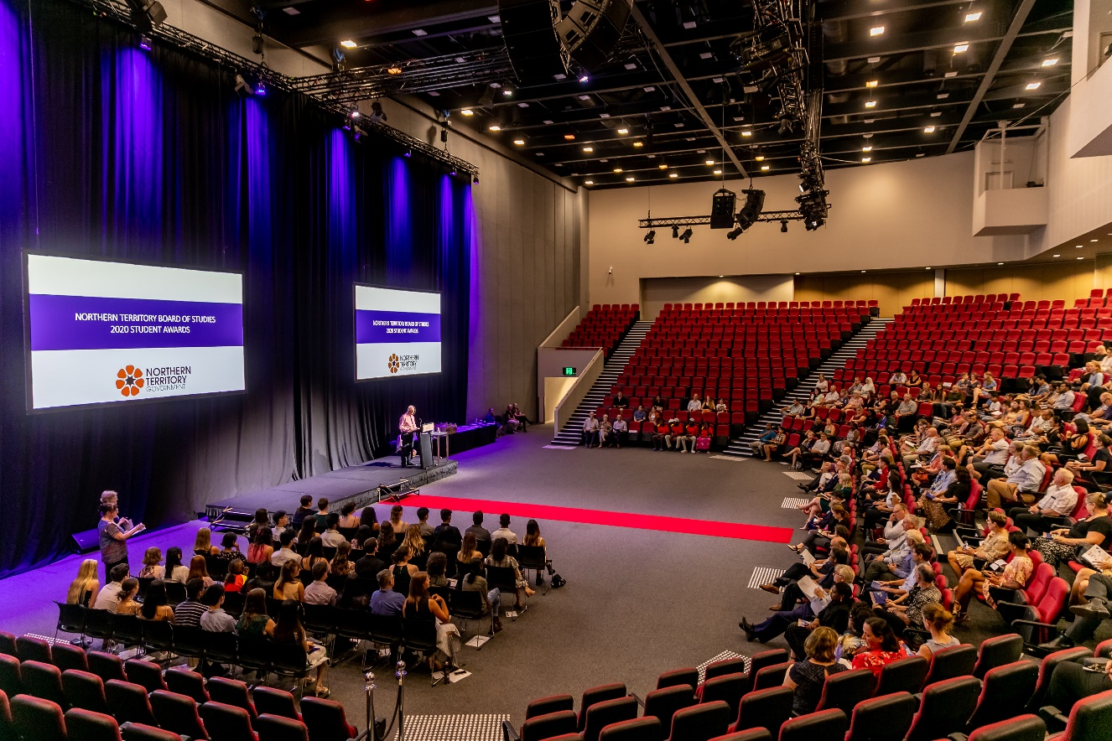

2020 Award Winners

Chief Minister’s Awards
Most Outstanding Stage 2  NTCET student | Laura Chapman | Darwin High School
Most Outstanding Stage 2  NTCET Aboriginal student | Georgia Kyranis | Darwin High School
Most Outstanding Stage 2  NTCET NT School of Distance Education student | Hayley Van Loenhout | NT School of Distance Education
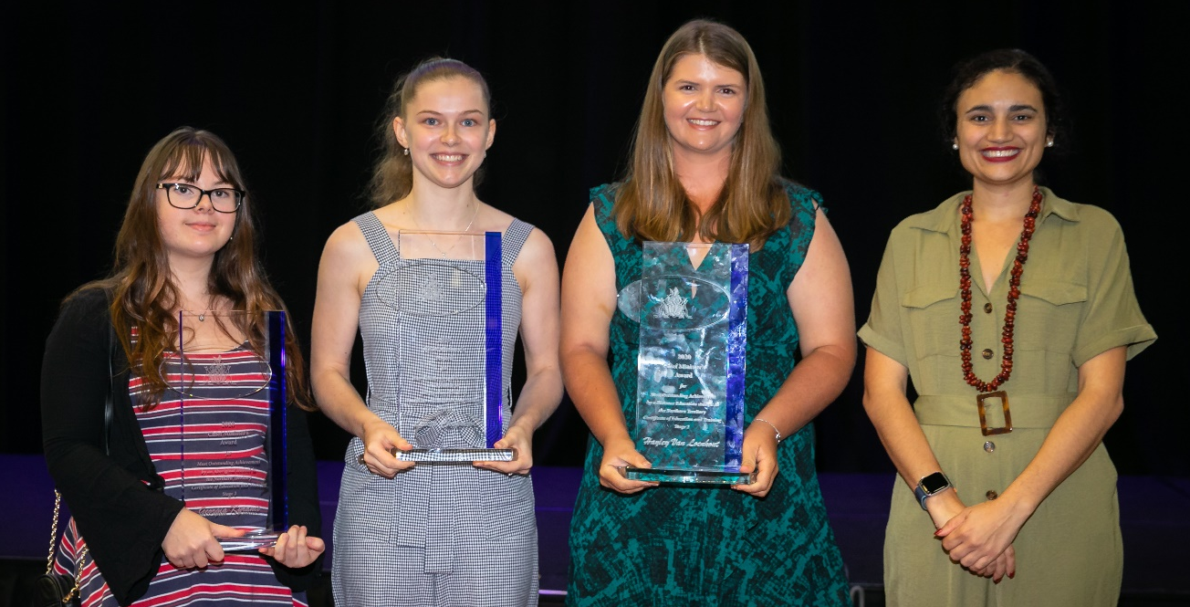
Georgia Kyranis, Laura Chapman, Hayley Van Leonhout
with the Hon Lauren Moss MLA, Minister for Education

Administrator’s Medals
Administrator’s Medal Year 6 | Hannah Baczynski |  | Manunda Terrace Primary School
Administrator’s Medal Year 9 | Aerich Tugano |  | Sanderson Middle School

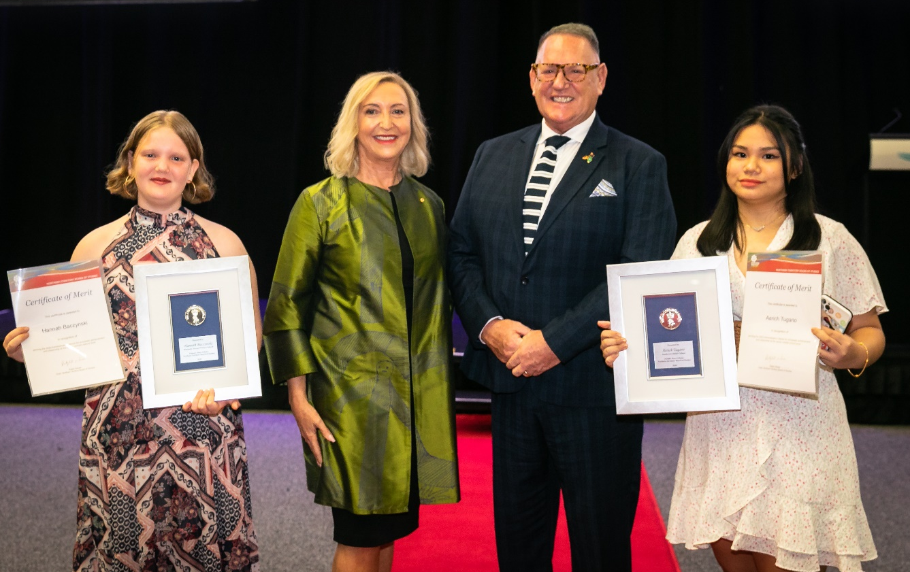
Hannah Baczynski and Aerich Tugano with
Her Honour the Honourable Vicki O’Halloran, Administrator of the NT
and Mr O’Halloran

Top 20 Ranked Year 12 Northern Territory Certificate of Education and Training Students
Student | School | University Aggregate | ATAR | Rank
Laura Chapman | Darwin High School | 88.85 | 99.85 | 1
Omar Mir | The Essington School | 88.15 | 99.60 | 2
Andrew Savvas | Darwin High School | 87.95 | 99.55 | 3
Benjamin Kievit | Darwin High School | 87.80 | 99.45 | 4
Hannah Kwon | Darwin High School | 87.75 | 99.40 | 5
Kieran Lelis | St Philip's College | 87.30 | 99.20 | 6
Mia Hardcastle | The Essington School | 87.30 | 99.20 | 6
Otto Blum | Darwin High School | 87.25 | 99.15 | 8
Nuhansi Wijesinghe | Darwin High School | 87.10 | 99.10 | 9
Ziyu Qin | Darwin High School | 86.70 | 98.90 | 10
Jarrod Li-Hunnam | Darwin High School | 86.55 | 98.85 | 11
Atish Ajaykumar | Darwin High School | 85.90 | 98.55 | 12
Basil Tom | The Essington School | 85.45 | 98.30 | 13
Tan Thanh Thai | Casuarina Senior College | 85.20 | 98.10 | 14
Tjina Stoll | Casuarina Senior College | 84.95 | 97.95 | 15
Hannah Evans | Darwin High School | 84.80 | 97.85 | 16
Jack Van Der Geest Hester | Our Lady Of The Sacred Heart Catholic College (NT) | 84.80 | 97.85 | 16
Shaun Thomas | Darwin High School | 84.55 | 97.70 | 18
Kayley Palmer | The Essington School | 84.25 | 97.55 | 19
Shawn Bett | Our Lady Of The Sacred Heart Catholic College (NT) | 84.00 | 97.40 | 20
Tara Innes | O'Loughlin Catholic College | 84.00 | 97.40 | 20

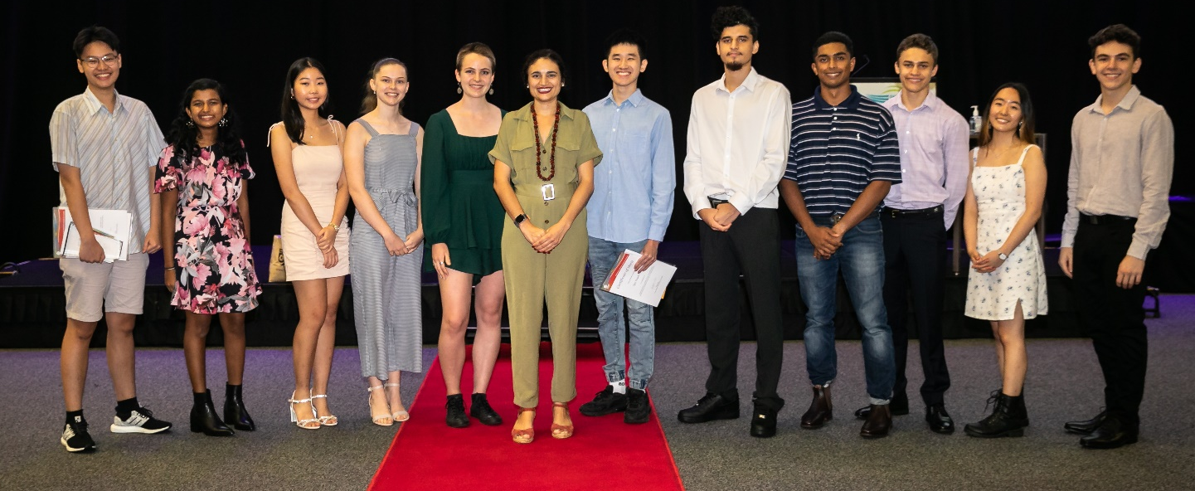
Top 20 awardees – Darwin
with the Hon Lauren Moss MLA, Minister for Education

Charles Darwin University Top Ten Australian Tertiary Admission Rank Awards
Student | School
Laura Chapman | Darwin High School
Tippipon Morgan | Haileybury Rendall School
Sally Spain | Haileybury Rendall School
Omar Mir | The Essington School
Andrew Savvas | Darwin High School
Benjamin Kievit | Darwin High School
Hannah Kwon | Darwin High School
Kieran Lelis | St Philip's College
Mia Hardcastle | The Essington School
Otto Blum | Darwin High School
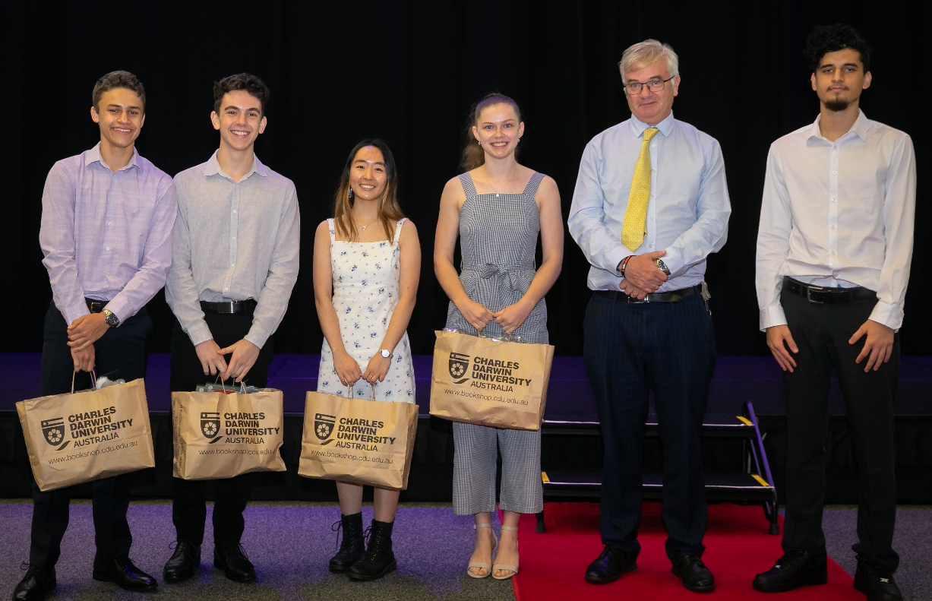
Top 10 ATAR awardees – Darwin with
Professor Mike Wilson, Interim Vice-Chancellor Charles Darwin University

Year 12 Certificates of Merit
Student | Subject | School
Jaimie Agapito | English Literary Studies | Casuarina Senior College
Tjina Stoll | English Literary Studies | Casuarina Senior College
Shania Armstrong | Additional Language - Arrernte | Centralian Senior College
Madeleine Barling | Women's Studies | Darwin High School
Nyah Brown | Digital Communication Solutions | Darwin High School
Laura Chapman | Biology, Chemistry, Physics and Mathematical Methods | Darwin High School
Zephyr Davis | Visual Arts - Art | Darwin High School
Laurence Delin | Foods and the Community | Darwin High School
Eihab Ibrahim | Scientific Studies | Darwin High School
Pamila Jayawardhana | Digital Communication Solutions | Darwin High School
Vaikaran Kirunthikaran | English as an Additional Language | Darwin High School
Aryan Kumar | Digital Communication Solutions | Darwin High School
Hannah Kwon | Mathematical Methods | Darwin High School
Georgia Kyranis | Business Innovation | Darwin High School
Jarrod Li-Hunnam | Mathematical Methods | Darwin High School
Brielle Longley | Modern History | Darwin High School
Francesca Pandini | Spanish (beginners) | Darwin High School
Sami Quader | Digital Communication Solutions | Darwin High School
Chi Khanh Tran | Chinese (beginners) | Darwin High School
Nuhansi Wijesinghe | Scientific Studies | Darwin High School
Csilla Nemeth | Hungarian (continuers) | Hungarian Community School, Adelaide Inc
Tahli Stimpson | English | Nhulunbuy High School
Lucy McCullough | English | Northern Territory School of Distance Education
Emily Kerwin | Health, Recreation, and the Community | O'Loughlin Catholic College
Chiara Antonelli | Modern History | Our Lady of the Sacred Heart Catholic College
Isabelle Craven | Creative Arts | Palmerston College
Shayne Lehmann | Interdisciplinary Learning and the Community | Palmerston College
Kieran Lelis | Specialist Mathematics | St Philip's College
Avni Agarwal | Child Studies | The Essington School
Frances Cruickshank | Psychology | The Essington School
Aila Heron | Child Studies | The Essington School
Marinelle Juan | Visual Arts - Art | The Essington School
Victoria Lyngaae | Psychology and Creative Arts | The Essington School
Omar Mir | Health and Psychology | The Essington School
Kayley Palmer | Psychology | The Essington School
Megan Rollings | English Literary Studies and Modern History | The Essington School
Daniel Sales | Physics | The Essington School
Emma Strohfeldt | English Literary Studies | The Essington School
Tessa Suppiah | Psychology | The Essington School
Jaydon Wilson | English | The Essington School
Kenisha Winunguj | Workplace Practices, Research Project A and First Language - Dhuwaya | Yirrkala School

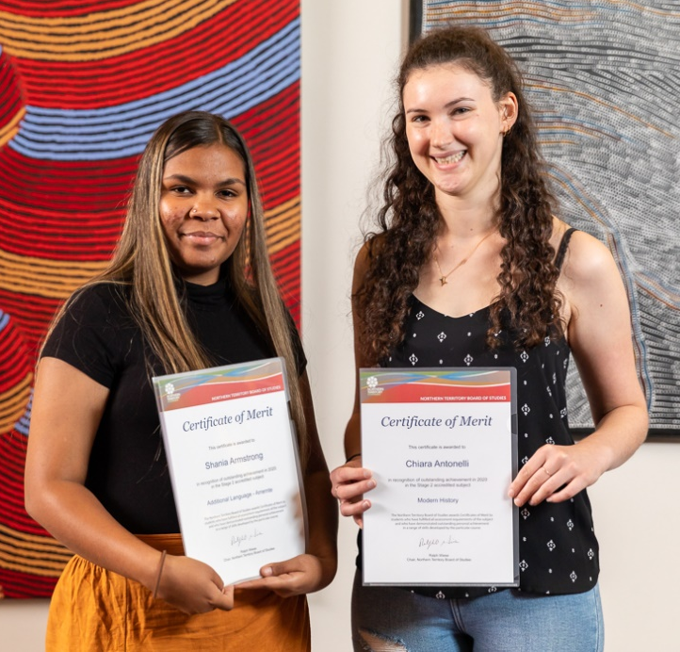
Shania Armstrong and Chiara Antonelli
Merit awardees – Alice Springs

Sponsored awards
Award | Student | School
Australian Computer Society Technologies award (joint winners) | Aryan Kumar  Sami Quader | Darwin High School  Darwin High School
Arnhem Land Progress Aboriginal Corporation Community Employability Skills award | Shianne Numamurdirdi | Numbulwar School
Australian Meteorological and Oceanographic Society Physics award | Daniel Sales | The Essington School
Australian Veterinary Association Dennis Thomson Memorial Science award | Laura chapman | Darwin High School
Career Educators Association of the Northern Territory Leadership in Careers award | Adeline Duncan | Jilkminggan School
Charles Darwin University Top Aboriginal ATAR award | Georgia Kyranis | Darwin High School
Department of Industry, Tourism and Trade award for Business, Enterprise and Innovation | Georgia Kyranis | Darwin High School
Department of Treasury and Finance Mathematics award (joint winners) | Madalena Matarazzo  Kassie Bush | St John’s College  Good Shepherd Lutheran College
Department of Treasury and Finance Accounting award | Benjamin Kievit | Darwin High School
GTNT Group Most Outstanding School-Based Apprentice award | Paw Wah | NT Christian College – Marrara Campus
Karmi Sceney Aboriginal Excellence and Leadership award | Shania Armstrong | Centralian Senior College and Alice Springs Languages Centre
Language Teachers’ Association of the Northern Territory Languages award | Francesca Pandini | Darwin High School
Mathematics Teachers’ Association of the NT Vic Czernezkyj Mathematics award | Hannah Kwon | Darwin High School
Menzies School of Health Research Biology award | Laura Chapman | Darwin High School
NT Music School Music award | Aisha Hayashi | Casuarina Senior College
Royal Australian Chemical Institute Chemistry award | Laura Chapman | Darwin High School
Rotary Club of Darwin Iain Smith award for History | Megan Rollings | The Essington School
Rotary Club of Darwin Jim Gallacher award for English Literary Studies | Jaimie Agapito | Casuarina Senior College
Rotary Club of Darwin Ian Macgregor award for excellence in English | Jaydon Wilson | The Essington School
Rotary Club of Darwin Hugh Bradley award for Legal Studies | Tara Innes | O’Loughlin Catholic College
Telstra Remote Male Aboriginal award | Leandro Feller | Nhulunbuy High School
Telstra Remote Female Aboriginal award | Kenisha Winunguj | Yirrkala School
Victorian Certificate of Education Most Outstanding Northern Territory student | Tippipon Morgan | Haileybury Rendall School
Vocational Education and Training Year 11 award | Kirsten Bainbridge | Our Lady of the Sacred Heart Catholic College
Vocational Education and Training Year 12 award | Chloe Sutton | Our Lady of the Sacred Heart Catholic College

  - Northern Territory Board of Studies 2020 Awards for Academic Excellence
Current and past award winners can be viewed on the webpage link https://education.nt.gov.au/education-events-and-awards/academic-excellence-awards
The Northern Territory Board of Studies offers Academic Excellence awards to students in their final years of primary, middle and senior schooling. The Academic Excellence award consists of a Certificate of Merit and a monetary prize of $50. Students who received the Academic Excellence award for the 2020 school year are listed below:

Year 6 Students
Student | School
John Kerr | Adelaide River Primary School
Emma Vowles | Alawa Primary School
Aroha Parkinson | Alyangula Area School
Goliath Holmes | Ampilatwatja School
Jarrah Llewelyn | Anula Primary School
Janjao Siah | Araluen Christian College
Vishali Bimbral | Bakewell Primary School
Katelyn Austin | Batchelor Area School
Maya Purdon | Bees Creek Primary School
Matthew Nguyen | Braitling Primary School
Akein Jayasekara | Casuarina Street Primary School
Shayla Mead | Driver Primary School
Davin Zarate | Durack School
Phuong Xuan Le | Gillen Primary School
Melissa Roberts | Girraween Primary School
Aaron Sarjan Varghese | Good Shepherd Lutheran College
Lawrie Bell | Gray Primary School
Aidan Mellors | Holy Family Catholic Primary School
Madison Woolley | Holy Spirit Catholic Primary School
Daniel Ea | Humpty Doo Primary School
Maya De Luca | Jingili Primary School
Gerasim Garkavyi | Katherine School of the Air
Malinda McGifford | Larapinta Primary School
Yejoon Choi | Larrakeyah Primary School
Dani Pittaway | Leanyer Primary School
Rhys Lubke | Manunda Terrace Primary School
Bella Gah | Moil Primary School
Zoe Francis | Nakara Primary School
Kate Mottram | Nhulunbuy Primary School
Georgie Luff | Nhulunbuy Christian College
Bailey Young | Nightcliff Primary School
Adrian Fernandes | Our Lady of the Sacred Heart Catholic College Alice Springs
Mackenzie Wilks | Palmerston Christian School
Lily Richards | Rosebery Primary School
Bahzi Nicholas | Ross Park Primary School
Beatrix Codog | Sacred Heart Catholic Primary School
Acacia Tipene | Sadadeen Primary School
Addison Green | Sattler Christian College
Jay Churly | St Francis of Assisi Catholic Primary School
Keeley Green | St Joseph's Catholic College - Katherine
Alna George | St Paul's Catholic Primary School
Judith Ugwu | Stuart Park Primary School
Moyed Aquib | Tennant Creek Primary School
Jayden Wong | The Essington School
Zafeera Jahana | Wagaman Primary School
Daniel Kyaw | Wulagi Primary School
Matilda McDonald | Wanguri Primary School
Jade Knight | Woodroffe Primary School

Year 9 Students
Student | School
Samuel Cheetham | Araluen Christian College
Richard Webb | Batchelor Area School
Ahnika Lennie | Centralian Middle School
Al-Hussain Al-Ibrahim | Darwin Middle School
Elizabeth Shibu | Dripstone Middle School
Grace Nice | Dripstone Middle School
Sopon Yong | Good Shepherd Lutheran College
Brooke Williams | Katherine School of the Air
Grace Rooney | MacKillop Catholic College
Arie Robson | MacKillop Catholic College
Hannah-Rose Simmonds | Nhulunbuy Christian College
Aisha Carpenter | Nhulunbuy High School
Julia Antonelli | Our Lady of the Sacred Heart Catholic College
Emma Stark | O'Loughlin Catholic College
James Nunn | Palmerston College
Caitlin Jong | Palmerston Christian School
Gail De Jesus | Sanderson Middle School
Khiandra Fabian | Sattler Christian College
Cameron Small | St Joseph's Catholic College Katherine
Keiko Zaicz (Combe) | St John's Catholic College
Iris Chenall | St Philip's College
Jenna Winteridge | Taminmin College
Zakelli Xie | The Essington School
Megan Pulumbarit | Tennant Creek High School

Year 12 Students
Student | School
Tan Thai | Casuarina Senior College
Alexander Cobern | Centralian Senior College
Laura Chapman | Darwin High School
Saskia Partridge | Good Shepherd Lutheran College
James Healy | MacKillop Catholic College
Tahli Stimpson | Nhulunbuy High School
Zoe van Bentum | NT Christian College
Tara Innes | O'Loughlin Catholic College
Jack van der Geest-Hester | Our Lady of the Sacred Heart Catholic College Alice Springs
Timothy Davis | Palmerston College
Margaret Garawirrtja | Shepherdson College
Madalena Matarazzo | St John's Catholic College
Eryn Whittaker | St Joseph's Catholic College
Banjo Waring | St Philip's College
Lachlan Dunemann | Tennant Creek High School
Ayla Christophers | Taminmin College
Omar Mir | The Essington School

Year 12 Aboriginal students
Student | School
Alyssa Swift | Casuarina Senior College
Billie Robb | Centralian Senior College
Georgia Kyranis | Darwin High School
Amelia Gordon | Good Shepherd Lutheran College
Leandro Feller | Nhulunbuy High School
Isaac Possingham | NT Christian College
Tyla Cubillo | O'Loughlin Catholic College
Chloe Sutton | Our Lady of the Sacred Heart Catholic College Alice Springs
Hailee Espie-Baker | Palmerston College
Peter Garawirrtja | Shepherdson College
Tahnee Brown | St Joseph's Catholic College
Tiahne Clarke | St John's Catholic College
Ira Gold | St Philip's College
Bradlee Dick | Tennant Creek High School
Ranjika Huppatz | Taminmin College
Madison Lodge | Taminmin College

Year 12 Personal Learning Achiever
Student | School
Mihali Reisis | Casuarina Senior College
Jim Sgarbossa | Centralian Senior College
Fotini Nicolakis | Darwin High School
Harrison Langdon | Good Shepherd Lutheran College
Leigh Bain | MacKillop Catholic College
Moana Hutton | Nhulunbuy High School
Raylene Rankin | NT Christian College
Raphael Racines | O'Loughlin Catholic College
Reilly Burell | Palmerston College
Brock Mountain | St Joseph's Catholic College
Deon Mathew | St Philip's College
Taylah Wadsley | Taminmin College
Kristy Howell | The Essington School

  - Appendix 2

SACE Subjects
All subjects contribute either 10 or 20 credits towards a student’s NTCET completion pattern.

Stage 1 Subjects available for 2020

ARTS
Creative Arts
Creative Arts: Local Program
Creative Arts: Modified
Dance
Drama

Music
Music Advanced
Music Experience

Visual Arts
Visual Arts — Art
Visual Arts — Design

BUSINESS, ENTERPRISE and TECHNOLOGY
Accounting
Business and Enterprise: Modified
Business Innovation
Digital Communication Solutions
Digital Technologies
Industry and Entrepreneurial Design Solutions
Information Processing and Publishing
Material Solutions
Robotic and Electronic Systems
Workplace Practices

CROSS-DISCIPLINARY
Community Studies
Cross-disciplinary Studies
Cross-disciplinary Studies: Local Program
Cross-disciplinary Studies: Modified
Integrated Learning
Personal Learning Plan
Personal Learning Plan: Modified
Research Practices

ENGLISH
English
English as an Additional Language
English: Modified
Essential English

HEALTH AND PHYSICAL EDUCATION
Child Studies
Food and Hospitality
Health
Health: Local Program
Health: Modified
Outdoor Education
Physical Education

HUMANITIES AND SOCIAL SCIENCES
Aboriginal Studies
Ancient Studies
Australian and International Politics
Economics
Geography
Legal Studies
Media Studies
Modern History
Philosophy
Religion Studies
Society and Culture
Society and Culture: Local Program
Society and Culture: Modified
Tourism
Women’s Studies

LANGUAGES
Australian Languages – Additional Language
Australian Languages – First Language
Australian Languages – Language Revival
Arabic (continuers)
Armenian (continuers)
Auslan (continuers)
Bosnian (continuers)
Chinese (background speakers)
Chinese (beginners)
Chinese (continuers)
Chin Hakha (continuers)
Croatian (continuers)
Dutch (continuers)
Filipino (continuers)
French (beginners)
French (continuers)
German (beginners)
German (continuers)
Hebrew (continuers)
Hindi (continuers)
Hungarian (continuers)
Indonesian (beginners)
Indonesian (continuers)
Italian (beginners)
Italian (continuers)
Japanese (background speakers)
Japanese (beginners)
Japanese (continuers)
Karen (continuers)
Khmer (continuers)
Korean (background speakers)
Korean (beginners)
Korean (continuers)
Language and Culture
Language and Culture: Local Program
Language and Culture: Modified
Latin (continuers)*
Macedonian (continuers)
Maltese (continuers)
Modern Greek (beginners)
Modern Greek (continuers)
Persian (continuers)
Polish (continuers)
Portuguese (continuers)
Punjabi (continuers)
Romanian (continuers)
Russian (continuers)
Serbian (continuers)
Sinhala (continuers)
Spanish (beginners)
Spanish (continuers)
Swedish (continuers)
Tamil (continuers)
Turkish (continuers)
Vietnamese (background speakers)
Vietnamese (continuers)
Yiddish (continuers)

MATHEMATICS
Mathematics
Essential Mathematics
General Mathematics
Mathematics: Modified

SCIENCES
Agriculture
Biology
Chemistry
Earth and Environmental Science
Nutrition
Physics
Psychology
Scientific Studies
Scientific Studies: Modified

SELF-DIRECTED COMMUNITY LEARNING PROGRAMS
Community Development
Independent Living
Performance
Recreation Skills and Management
Self-development
Sports Skills and Management
Volunteering
Works Skills and Career Development

  - Appendix 3

Stage 2 Subjects available for 2020

ARTS
Creative Arts
Creative Arts: Local Program
Creative Arts: Modified
Dance
Drama
Music Explorations
Music Performance – Ensemble
Music Performance – Solo
Music Studies
Visual Arts – Art
Visual Arts – Design

BUSINESS, ENTERPRISE and TECHNOLOGY
Accounting
Business Innovation
Business and Enterprise
Business and Enterprise: Modified
Digital Communication Solutions
Digital Technologies
Industry and entrepreneurial Design Solutions
Information Processing and Publishing
Material Solutions
Robotic and Electronic Systems
Workplace Practices A
Workplace Practices B
Workplace Practices

CROSS-DISCIPLINARY
Community Studies A
Arts and the Community
Communication and the Community
Foods and the Community
Health, Recreation and the Community
Science, Technology and the Community
Work and the Community

Community Studies B
Humanities and the Community
Interdisciplinary Learning and the Community
STEM and the Community
Cross-Disciplinary Studies
Cross-disciplinary Studies
Cross-disciplinary Studies: Local Program
Cross-disciplinary Studies: Modified
Integrated Learning A
Integrated Learning B
Research Project A
Research Project B
Research Project: Modified

ENGLISH
English
English as an Additional Language
English Literary Studies
English: Modified
Essential English

HEALTH and PHYSICAL EDUCATION
Child Studies
Food and Hospitality
Health
Health: Local Program
Health: Modified
Outdoor Education
Physical Education

HUMANITIES and SOCIAL SCIENCES
Aboriginal Studies
Australian and International Politics
Ancient Studies
Economics
Geography
Legal Studies
Media Studies
Modern History
Philosophy
Religion Studies

Society and Culture
Society and Culture
Society and Culture: Local Program
Society and Culture: Modified
Tourism
Women’s Studies

LANGUAGES
Australian Languages
Australian Languages – Additional Language
Australian Languages – First Language
Australian Languages – Language Revival
Languages and Culture
Languages and Culture: Local Program
Languages and Culture: Modified

Arabic (continuers)
Armenian (continuers)
Auslan (continuers)
Bosnian (continuers)
Chin Hakha (continuers)
Chinese (background speakers)
Chinese (beginners)
Chinese (continuers)
Croatian (continuers)
Dutch (continuers)
Filipino (continuers)
French (beginners)
French (continuers)
German (beginners)
German (continuers)
Hebrew (continuers)
Hindi (continuers)
Hungarian (continuers)
Indonesian (beginners)
Indonesian (continuers)
Italian (beginners)
Italian (continuers)
Japanese (background speakers)
Japanese (beginners)
Japanese (continuers)
Karen (continuers)
Khmer (continuers)
Korean (background speakers)
Korean (beginners)
Korean (continuers)
Latin (continuers)*
Macedonian (continuers)
Malay (background speakers)
Maltese (continuers)
Modern Greek (beginners)
Modern Greek (continuers)
Persian (continuers)
Polish (continuers)
Portuguese (continuers)
Punjabi (continuers)
Romanian (continuers)
Russian (continuers)
Serbian (continuers)
Sinhala (continuers)
Spanish (beginners)
Spanish (continuers)
Swedish (continuers)
Tamil (continuers)
Turkish (continuers)
Vietnamese (background speakers)
Vietnamese (continuers)
Yiddish (continuers)

MATHEMATICS
Essential Mathematics
General Mathematics
Mathematical Methods
Mathematics: Modified
Specialist Mathematics

SCIENCES
Agricultural Production
Agricultural Systems
Biology
Chemistry
Earth and Environmental Science
Nutrition
Physics
Psychology
Scientific Studies
Scientific Studies: Modified

NTBOS acknowledges and thanks Territory businesses, organisations, individuals and government agencies that provided sponsorship for the 2020 Northern Territory Board of Studies student awards.


















