  - Sally Bruyn Primary School Science Award
To be eligible for this award the student must be in Year 6 and demonstrate achievement and interest in science knowledge and understanding.

Criteria
School teachers are to provide a statement demonstrating the nominated student’s interest and effort in science.

Demonstration of interest and effort in science (maximum 500 words)
Consideration of the level of interest and effort the student displays for scientific solutions and understanding the roles community and collaboration play in moving solutions from prototype to practice. This is not limited to science learning at school and may include any other science-based opportunities.

Student response

Year 6 science investigation – Sustainability
Science learners will investigate the following question for their local area.
How can First Nations perspectives help us create a sustainable future for our world?
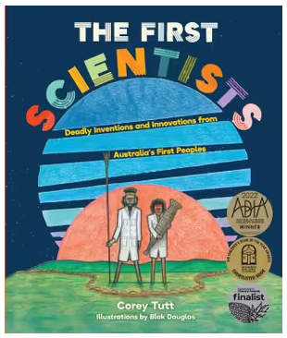
For 65,000 years First Nations communities lived sustainably in this country. They developed a deep relationship with the land, flora and fauna, and so survived global climate changes, for example, lakes that had been used for generations dried up and they were forced to move and adapt.
They have also survived the last 250 years with the influx of differing cultures, technologies, beliefs, values, and social structures that have transformed the continent and the planet. What can we learn from their connections to land, sea, sky and community to help us create a better future for all?
Resources for science learners:
- https://deadlystory.com/page/culture/Life_Lore/Food
- https://theconversation.com/stories-from-the-sky-astronomy-in-indigenous-knowledge-33140
- https://carbonmarketinstitute.org/projects/north-east-arnhem-land-fire-abatement-nealfa/

Submit: You can present your findings multimodally using a PowerPoint, video, poster, mixed-media or other method. All findings must be able to be submitted via email.

Panel criteria
Students have effectively demonstrated evidence of:
Scientific communication
- a clear explanation was presented
- effectively used scientific representations or diagrams.

Scientific concepts and related content
- appropriately used scientific terminology
- provided evidence of understanding to relevant scientific concepts, principles or theories (big ideas).

Nature and development of science
- Science involves testing predictions by gathering data and using evidence to develop explanations of events and phenomena and reflects historical and cultural contributions.

