This document should be read in conjunction with the:
- Students with Disability Policy
- Diagnostic Assessment Guidelines
- Enrolment in Special Schools and Special Centres Guidelines
- Transition from School for Students with Disability Guidelines
- Transport for Students with Disability Policy and Guidelines
- Detention and Suspension Guidelines
- Expulsion Guidelines

Introduction
All students with disability are entitled to an education on the same basis as their peers and should participate equally, through reasonable adjustments and support from their teachers, school staff and the wider community.
These guidelines provide a framework for the delivery of teaching and learning practices, and the provision of services and support, in a way that ensures that all students with disability can enjoy the benefits of education in a supportive environment that values diversity, inclusion and participation.
Schools are responsible for including students with disability through adjustments to enrolment, curriculum, assessment practices, teaching styles and the physical environment. A school may seek additional support by accessing the services outlined in department’s internal website iSupport to build capacity within the school and further support the teaching and learning needs of students.
The key messages underpinning these guidelines are:
- it is the responsibility of the Principal and school staff to accommodate students with disability as described in the Disability Standards for Education 2005 (the Disability Standards)
- it is recognised that students with disability have the right to have special adjustments and to have curriculum accommodations made so that they have equal opportunity in regard to education (this can be achieved through Planning for Personalised Learning and Support)
- the full range of school and systemic resources need to be used in a flexible manner in order to meet the changing needs of students with disability
- adjustments and curriculum accommodation are articulated by the teacher in the overall program, unit plans and assessments
- students are provided with the opportunity to have a voice where appropriate
- members of the school community have an obligation to address stereotypes and beliefs about students with disability.
In implementing the Disability Discrimination Act 1992 (Cwlth), the Disability Standards, Anti-Discrimination Act 1992 (NT), Education Act 2015 (NT) and Students with Disability Policy, schools are obliged to:
- Identify students with disability using the processes outlined in:
- Nationally Consistent Collection of Data on Students with Disability
- Student Wellbeing and Inclusion Processes in section 4.3 of this document.
- Provide inclusive curriculum that is evidenced by or in:
- school student file
- appropriate Planning for Personalised Learning and Support documentation and Education Adjustment Plans (EAPs) that are uploaded to Support Services Information Database (SSID) and/or Student Achievement Information System (SAIS)
- Australian Curriculum
- Resources that support inclusive practice available to education staff on iSupport, such as:
  - Inclusive Practice Teacher Guidelines
  - multiple intelligence matrix
  - adjustments and curriculum accommodation ideas.
Each school must ensure that it fulfils its obligation to students with disability to provide quality education suitable to the needs of those students. If a school is unable to meet this obligation, the principal should discuss this with the Director/Manager Quality School Systems and Support (QSSS) in order to find a solution.

Definitions
Adjusted age or corrected age refer to, in most cases, adjusting the age of pre-schoolers that have been born prematurely. It is important to correct the age of a child who was born prematurely in order to accurately assess their developmental abilities because the brain and the rest of the neurological system will not be as developed or as mature as a child of the same age that has been born at term.
Appropriate planning for personalised learning and support is imperative for students with disability. Students with disability must be provided with an appropriate adjustment plan which may include, but not be limited to, an Education Adjustment Plan (EAP) and/or a combination of the following: Student Support Plan (SSP), Individual Behaviour Plan (IBP), Individual Learning Profile (ILP), Health Care Plan (HCP), Risk Assessment, Individual Transition Plan (ITP) and /or Transition Plan (TP). The type of adjustment plan created will be directly linked to the area of disability that needs support or that enables the students to access their education on the same basis as their peers. Examples can be accessed via iSupport.
Disability, in relation to a person, means:
- total or partial loss of a person’s bodily or mental functions, or
- total or partial loss of a part of the body, or
- the presence in the body of organisms causing disease or illness, or
- the presence in the body of organisms capable of causing disease or illness, or
- the malfunction, malformation or disfigurement of a part of the person’s body, or
- a disorder or malfunction that results in the person learning differently from a person without the disorder or malfunction, or
- a disorder, illness or disease that affects a person’s thought processes, perception of reality, emotions or judgment, or that results in disturbed behaviour;
and includes disability that:
- presently exists, or
- previously existed but no longer exists, or
- may exist in the future, or
- is imputed to a person.,
Internal assessment provider is a NT Department of Education school-based corporate employee who has the qualifications required to administer standardised assessment which informs the decisions and instructions regarding support programs for students with disability.
Parent refers to:
- the child’s father, mother or any other person who has parental responsibility for the child and also for an Aboriginal or Torres Strait Islander child includes a person who is regarded as a parent under Aboriginal or Torres Strait Islander customary law or Aboriginal or Torres Strait Islander tradition;
- a guardian/caregiver and is a person who has parental responsibility for a child or daily care and control of a child, is the person with whom a child currently resides, or is a person caring for the child at any given time.

According to the Education Act 2015 (NT) s.7-8 a person has parental responsibility for a child if the person has daily care and control of the child (i.e. is entitled to exercise all the powers, rights and responsibilities in relation to the day-to-day care and control of the child) or is entitled to exercise all the powers, rights and responsibilities in relation to the long-term care and development of the child, or both.
School participation age refers to the age at which a student may participate in education at a school or special setting ‘on the same basis’ as their peers.
Students with disability refers to children, students or learners who require special assistance or adjustments and support because of cognitive, physical, social, emotional or sensory impairment that impacts their ability to participate in education on the same basis as their peers.
For the purposes of this policy, diagnosis of disability includes: intellectual/cognitive, sensory, physical, social/emotional, language/communication disability; a specific learning disability; or multiple disabilities and trauma. However, this does not preclude other disabilities or impairments identified in the Disability Discrimination Act and the Anti-Discrimination Act.
Students with additional or special needs refers to students affected by disability or medical or emotional condition or trauma, or neglect, may face additional challenges when attending school or in the community. When a child has additional needs, this may restrict them from being able to do some of the things that other children can do. In the Anti-Discrimination Act these students with additional needs are described as having ‘special needs’.

Twice exceptional (or 2e) refers to intellectually gifted children who have some form of disability. These children are considered to be exceptional ‘both because of their intellectual gifts and because of their special needs… [A 2e child] usually refers to a child who, alongside being considered intellectually above average, is formally diagnosed with one or more disabilities…’.

Roles and Responsibilities
Department of Education is responsible for:
- providing effective specialist education advice to schools, families and relevant stakeholders in regard to students with disability
- overseeing the recommendations regarding the enrolment of students with disability, and their access to special schools and special centres where the option is other than in a mainstream school setting, which should only be considered in accordance with the Students With Disability Policy (refer to section 4.2 Practice in this document)
- monitoring and responding to schools in regard to the support services, specialised facilities, equipment, resources and training required to meet individual student needs
- ensuring a high standard of information management in regard to students with disability
- ensuring the provision of coordinated services by developing and maintaining cooperative links with relevant government departments and community agencies.
Executive Director Education Policy and Programs is responsible for:
- ensuring that the policy is widely disseminated, understood and monitored throughout the department.

Senior Director School Improvement and Leadership (SIL) is responsible for:
- ensuring overall monitoring, implementation and application of this policy in schools through:
- performance review discussions
- recommending access to, or change from, educational options in accordance with the Enrolment of Students with Disability in Special Schools and Special Centres Policy, where the option is other than in a mainstream school setting; this may include a student moving from a special school/centre to a mainstream school setting
- ensuring the development of appropriate inclusive curriculum with supporting documents and annual operational plans that are inclusive of students with disability
- ensuring that Principals provide appropriate resources for the implementation of effective education programs for students with disability.

General Manger Student Wellbeing and Inclusion (SWI) is responsible for:
- facilitating and supporting the development, implementation and application of policy through advice and models of best practice in the field of special education
- arranging timely advice and training for principals and teachers with regard to changes in policy and legislation that affect the care or treatment of students with disability, and providing relevant information to schools to forward to families
- ensuring that the policy is widely disseminated and monitoring professional learning activity throughout the department.
Principal is responsible for:
- ensuring the policy is reflected in the school strategic improvement and annual operational plans.
- ensuring the policy and associated documentation are provided to school staff and parents in a format that is understood and meets their needs
- ensuring that school staff have access to relevant professional development opportunities, including the Students with Disability Policy
- delivering quality educational programs that respond to the needs and abilities of all students, including students with disability
- ensuring their school based team coordinates and supports a whole school approach to students with disability
- ensuring that Planning for Personalised Learning and Support occurs and that the school develops, implements, evaluates and reviews the Educational Adjustment Plan (EAP), Health Care Plan, Behaviour Support Plan, Transition Plan, Individual Transition Plan; Support Plan and/or Learner Profile for each student with disability. This process is to be outlined to parents/caregivers at the time of enrolment
- ensuring that stakeholders are invited, with reasonable notice, to meetings concerning the student’s profile, educational planning and other relevant education decisions, including educational placement options
- reporting outcomes in the school performance reports to the whole school community.
- actively initiating and maintaining consultation with, and reporting to, families, guardians and caregivers in regard to the educational placement, planning and ongoing education programs for their children
- ensuring that the identification and provision of educational programs for students with disability is in accordance with the Students With Disabilities Policy
- consulting with the Director/Manager Quality School and Systems Support (QSSS) to ensure that appropriate resources are provided for the implementation of effective education programs for students with disability
- informing Student Wellbeing and Inclusion, and other relevant business units, of the specialised services, facilities, equipment, resources and training required to meet the individual needs of each student with disability
- ensure transition plans are written
- ensuring that appropriate records are kept and filed in hardcopy or electronic format, and disseminated as appropriate:
- for Nationally Consistent Collection of Data (NCCD) evidence
- in Student Achievement Information System (SAIS)
- students with disability diagnosis reports and information are stored in each student’s school file
- appropriate plans are stored in each student’s school file or electronic student profile.

Special education teachers or senior teachers supporting special education are responsible for:
- supporting classroom teachers to deliver quality educational programs that respond to the needs and abilities of all students, including students with disability
- supporting classroom teachers to Plan For Personalised Learning and Support and coordinate the EAP and the appropriate planning processes in the preschool, primary, middle and senior years context
- write transition plans from preschool to primary to middle school to senior school, and that transition to work plans are written in consultation with the student, parents/caregivers and advisor
- ensuring that a strategic approach is developed in regard to implementing the recommendations, on receipt of specialist reports.
Classroom teachers are responsible for:
- developing, implementing, evaluating and reviewing appropriately, at least every six months, the Plan for Personalised Learning and Support, the EAP and the appropriate plan for the student with disability (this may involve working collaboratively with the special education teacher, parents, student and/or other relevant person)
- collaborating with the special education teacher and senior teacher to update specialist report recommendations, when reviewing the personalised learning process for each semester
- ensuring that a personalised learning plan is established within the first ten weeks of the enrolment of a student with disability
- delivering quality educational programs and developing appropriate curriculum assessments that respond to the needs and abilities of all students, including students with disability
- participating in professional learning and appropriate professional development opportunities around the Students with Disability Policy and special education.
Support staff are responsible for:
- supporting classroom teachers to deliver quality educational programs that respond to the needs and abilities of all students, including students with disability
- supporting the school’s inclusivity process by familiarising themselves with the needs of students with disability.
Parents are responsible for:
- initiating and maintaining constructive communication and relationships with schools, and any other providers involved, to achieve the best educational, social and emotional outcomes for the student
- actively participating in the planning, implementation, and review of EAP and other appropriate plans designed to assist the student with disability to achieve optimum educational outcomes.

Education service providers: a practical overview of the Disability Standards
Table 1: Rights and Requirements under the Disability Standards for Education
Rights | Requirements

Enrolment
Right to seek admission and enrol on the same basis as prospective students without disability including the right to reasonable adjustments. | - Take reasonable steps to ensure that the enrolment process is accessible.  - Consider students with disability in the same way as students without disability when deciding whether to offer a place.  - Consult with the prospective student or their associates about the effect of the disability on their ability to seek enrolment, and any reasonable adjustments necessary.

Participation
Right to access courses and programs; use services and facilities; and have reasonable adjustments made to ensure students with disability are able to participate in education and training on the same basis as students without disability. | - Take reasonable steps to ensure participation.  - Consult with the student or their associates about the effect of the disability on their ability to participate.  - Make a reasonable adjustment if necessary.  - Repeat this process over time as necessary.

Curriculum development, delivery and accreditation
Right to participate in courses and relevant supplementary programs that are designed to develop their skills, knowledge and understanding, on the same basis as students without disability; and have reasonable adjustments made to ensure students with disability are able to participate in education and training on the same basis as students without disability. | - Enable students with disability to participate in learning experiences (including assessment and certification).  - Consult with the student or his/her associates.  - Take into consideration whether the disability affects the student’s ability to participate in the learning experiences.

Student wellbeing and inclusion
Right to access student wellbeing and inclusion services provided by education institutions on the same basis as students without disability. Students with disability have the right to the specialised services needed for them to participate in the educational activities in which they are enrolled. | - Ensure that students with disability are able to use general support services.  - Ensure that students have access to specialised support services.  - Facilitate the provision of specialised support services.

Harassment and victimisation
Right to receive education and training in an environment that is free from discrimination caused by harassment and victimisation on the basis of disability. | - Implement strategies to prevent harassment or victimisation.  - Take reasonable steps to ensure that staff and students are informed about their obligation not to harass or victimise students with disability.  - Take appropriate action if harassment or victimisation occurs.  - Ensure complaint mechanisms are available to students.

Inclusive curriculum provision
An inclusive curriculum is the provision of flexible, relevant and meaningful curriculum that addresses different learning abilities. All students have the right to access curriculum including the Australian Curriculum, Early Years Learning Framework (EYLF), NT Certificate of Education and Training. Schools should enable students with disability to access curriculum on the same basis as students without disability.
- The learning programs are to be flexible, relevant and recognise the individual needs, strengths and abilities of students including relevant environmental, chronological, emotional and social aspects and the age and interests of the student. This may necessitate the provision of additional support services.
- The learning programs enable students to demonstrate the knowledge, skills or competencies being assessed.
- Where students are unable to be assessed in the same way as their peers, there should be appropriate provisions made to enable their access to assessments.
- The learning programs are designed to enable students to participate in the wider community. Learning programs may be implemented in a variety of school and community settings.
- Schools may use the Response to Intervention (RTI) Whole School Inclusion Matrix to review and reflect upon their practice. The Whole School Inclusion Matrix is a tool designed to help Principals and staff strive for excellence by creating a fully inclusive, whole school, supportive environment for students with additional needs.
- The content and delivery of the learning program for each student should be negotiated with relevant school staff, parents/caregivers and, where possible, the student; as well as other appropriate personnel.
- In determining whether an adjustment is reasonable, an education provider should take into account information about:
  - the nature of the student’s disability
  - the student’s preferred adjustment
  - any adjustments that have been provided previously
  - any recommended or alternative adjustments.
This information might come from the student, an associate of the student, independent experts, or a combination of those people.

Student Wellbeing and Inclusion services

Procedures for schools to access student wellbeing and inclusion services
Figure 1 outlines the steps that need to be completed by schools in partnership with families and Student Wellbeing and Inclusion before procuring external practitioners for assessment and support purposes.
Note: for further information regarding the procurement of external practitioners please refer to the Diagnostic Assessment Guidelines.

Student Wellbeing and Inclusion service delivery model
Student Wellbeing and Inclusion staff provide support services in regard to disability, behaviour and mental health.
Figure 2 outlines the service delivery model which is consistent with the Response to Intervention (RTI) approach (National Centre on Response to Intervention, 2010).
This approach integrates assessment and learning processes into a multi-level system to maximise student achievement and minimise behavioural problems. The approach uses data to:
- support students to achieve learning outcomes
- monitor students’ progress
- provide evidence based supports
- adjust the intensity and nature of the supports
- identify and support students with disability.
The approach is consistent with a range of strategic initiatives and, importantly, has explicit links to the improvement agenda described in the Education NT School Review (2013).

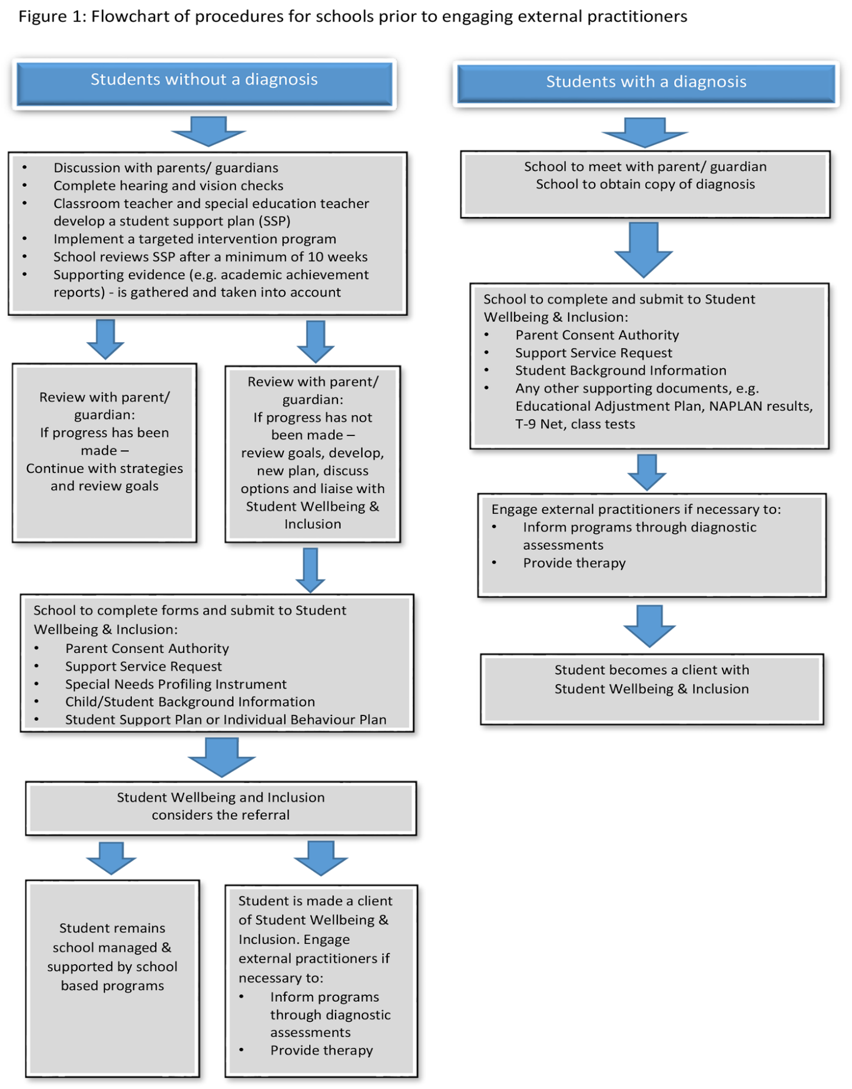

Figure 2: Student Wellbeing and Inclusion Service Delivery Model

Whole school approach to improving student achievement

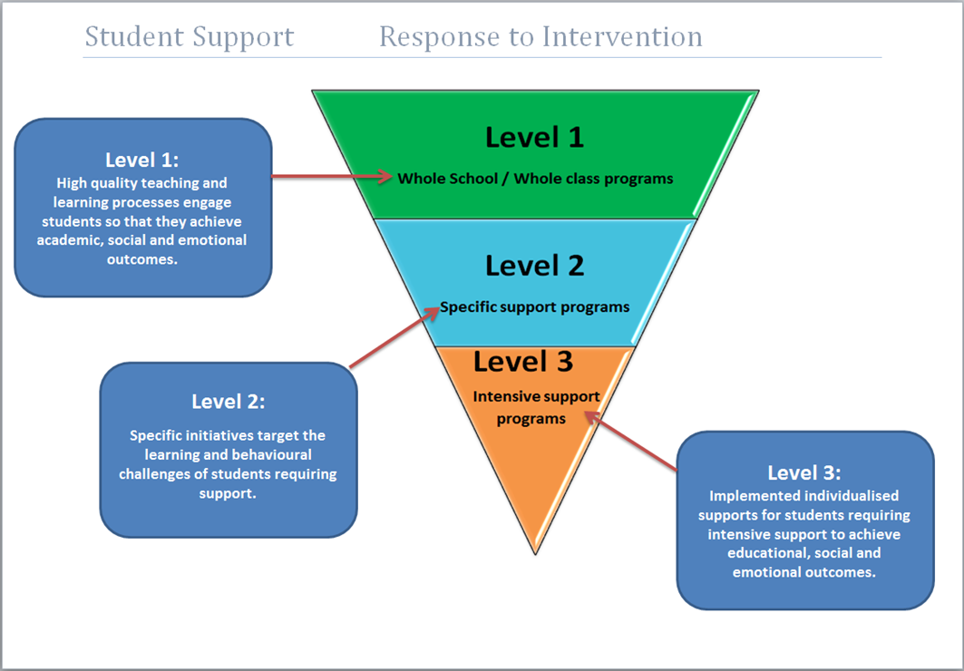

Age-related considerations
All education providers must refer to the principles governing ‘adjusted age’ and ‘school participation age’ for students with disability regarding participation, curriculum and assessment. For specific information regarding ‘school participation age’ please refer to the Council of Australian Governments (COAG) National Education Agreement 2009.
For further information:
- The University of Adelaide published a study regarding the effect of age-correction on intelligence quotient (IQ) scores among school-aged children born prematurely.
- Emory University’s School of Medicine provide guidelines in regard to the ‘adjusted age’ for pre-schoolers who have been born prematurely.

Additional semesters (subject to change as per the Education Bill, Section 83)
A student may be granted additional semesters at a NT Government school to complete a school year or program if this is deemed to be of educational benefit to the student.
Approval for additional semesters must be referred to the Chief Executive, Department of Education.
Where additional time is approved for a senior secondary level student to complete a school year or program, the school must develop and implement an Individual Transition Plan in consultation with the student and/or parents to support the student’s transition into identified post-school options. Please refer to the Enrolment Policy for more information on additional semesters.

Transition planning
Each student with disability needs support during the specific transitioning phases of the education process from preschool through to entering post-school options. Throughout that time, the school needs to support the student to access provision from within the department, other governmental departments, the student’s community and community programs, or non-governmental agencies.
A Transition Plan is expected when a student with disability moves from:
- preschool to primary school
- primary school to middle school
- middle school to senior school
- senior school to post-school options
- one school to another at any time.
For students with disability and their families, there are often additional challenges and uncertainty when reaching these transition stages. Schools must identify and address additional considerations during these periods.
The transition process is facilitated by ensuring that Transition Planning is embedded into the school program and guided by the student context, individual need and the type of transition, which may require several orientation visits. The transition process includes the timely provision of information and support to students and their families with the aim of maximising the students’ access to and participation in educational settings and post-school pathways.
The classroom teacher has an important role in the transition process. Where a student has more than one main classroom teacher (such as in Middle School), the school must designate a central contact person, such as a special education teacher or a senior staff teacher, to facilitate the transition process.
Students with disability have additional classroom needs and will require an Education Adjustment Plan (EAP) and appropriate transition plans. An EAP, Transition Plan (TP) and Individual Transition Plan (ITP) are the guiding documents referred to throughout the transition planning process.
The TP/ITP complements the EAP by providing further information about the transitioning student. The TP/ITP is completed by the classroom teacher, student (with assistance if appropriate), and the parents/caregivers of the student. The TP/ITP provides an overview of the student’s strengths, interests and specific needs which will assist in the student’s transition into a new environment and support his/her learning needs.
The EAP and TP/ITP guide the transition of the student planning to move from one school to another. The transition planning should commence in Term 3 or 4 of the student’s last year in preschool, primary, and middle school. The classroom teacher and/or SET will initiate the student’s transition planning by scheduling a meeting between him/herself, the student’s parents/caregivers and a Student Wellbeing and Inclusion advisor. For children not attending Preschool, the school in which that the child is intended to be enrolled should initiate this meeting. The student’s transition into the new school may require several orientation visits.
Transition between schools template is provided at iSupport.

Preschool and primary school
Appropriate special education advisors in the Student Wellbeing and Inclusion team support the client, family and preschool or primary school in the transitioning process through the implementation of an EAP and appropriate plan. The special education advisor supports the student, family and primary school in the process of transitioning the student into preschool or primary school through the development and implementation of a TP.

Middle and senior school
The minimum school-leaving age is consistent with the participation requirement agreed by Council of Australian Governments (COAG) on 2 July 2009. The agreed participation requirement includes the mandatory requirement for all young people to:
- participate in schooling (meaning in school or an approved equivalent) until they complete Year 10
- having completed Year 10, participate full-time (defined as at least 25 hours per week) in education, training or employment, or a combination of these activities, until age 17.
Through the implementation of a TP/ITP or appropriate plan, the special education advisor supports the client, family and school in the transitioning of the student into middle school or senior school. The special education advisor will invite the appropriate Transition from School staff, also in the Student Wellbeing and Inclusion team, to participate in planning senior school programs.

Transition from School
It is essential that students with disability who are leaving school are provided with appropriate support in that transition by the school staff, parents, Student Wellbeing and Inclusion, community and external agencies. The Transition from School staff may be included in the process of transition for students with disability who are leaving school.
Essential elements needed for the transitioning process for a student with disability leaving school are:
- extensive and regular consultation between the school or teacher, Transition From School advisor, parents/caregivers and student.
- development of a negotiated Individual Transition Plan (ITP) for Year 9 through to Year 12, and in some cases commencing prior to Year 9.
- consideration by principals of the nature and impact of the disability on a student’s ability to participate in education ‘on the same basis’ as his/her peers, and to be free from discrimination, by providing equitable educational opportunities for students with disability. This may require supporting/encouraging parents and students with disability to lodge an application for an additional school semester with the Department of Education, as the chronological age of a student with disability does not always reflect his/her intellectual, physical, emotional, social and/or academic ability age.
The Transition from School staff support the client, family and senior school during the student’s transitioning to post-school options, through the implementation of the ITP. Please refer to the Transition from School for Students with Disability Guidelines for more information.

Diagnostic assessment and reports
Prior to the school engaging Student Wellbeing and Inclusion or external practitioners to provide services, a Parent Consent Authority must be signed and submitted by the parent of the student. This consent authority is to be revisited when reviewing the personalised learning planning for each semester.
The parent must be contacted to gain consent prior to carrying out a diagnostic assessment and prior to carrying out each specific assessment. This is to ensure that the parent or guardian has an understanding of the assessment used, the process, potential risks and benefits, confidentiality limitations, and knowledge of who will receive or have access to the final report. Verbal consent via a telephone call is acceptable. Gaining the informed consent of the student also assists with building rapport and a trusting relationship.
Refer to the Diagnostic Assessment Guidelines for further information regarding procuring external practitioners’ services in regard to diagnostic assessments.
All staff members using diagnostic assessments should read the Special Education Assessment practices on iSupport prior to using those assessments for student profiling and planning programs. The provider needs to consult and negotiate with the department and parents/caregivers of the student in regard to assessment reports and other relevant documentation prior to submitting those reports and documentation.

Curriculum, assessment and reporting
Schools should ensure that students with disability have their achievements recognised by the educational system, in line with all other Northern Territory students. Students continuing their senior secondary studies can make application for Special Provisions in Curriculum and Assessment through their school which will follow guidelines and processes from the South Australian Certificate of Education (SACE) Board. Students with approved ‘Special Provisions in Curriculum and Assessment’ will be awarded the NTCET upon the completion of their NTCET requirements.

School curriculum reports
Parents of a student with special or additional learning needs who has an education adjustment plan (EAP) may elect not to receive an A–E report for their child via a written request to the school. School authorities must retain a copy of all such written requests on file.

Students with additional needs
A student who is twice exceptional (2e) needs inclusion by and support from their teachers and school. Identification of, and an individualised approach to, the educational needs of a ‘2e’ student creates a supportive learning environment where the curriculum is differentiated to support the student’s learning needs. However, the classroom teacher may request support from both a Gifted and Talented Teaching and Learning Officer, and an education advisor in order to plan and implement effective strategies. Collaboration between the classroom teacher, Gifted and Talented Teaching and Learning Officer, education advisor, parents and student is essential to providing appropriate support to the student.

Evidence and adjustments protocols

Nationally Consistent Collection of Data on School Students with Disability a (NCCD)
NCCD identifies several different adjustment categories for identifying the support and adjustments provided to students with disability in order for those students to participate in their education ‘on the same basis’ as their peers. The adjustment categories are: Support Provided within Quality Differentiated Teaching Practice, Supplementary Adjustments, Substantial Adjustments and Extensive Adjustments. These levels of adjustment highlight the need for evidence-based support and data-driven adjustments to be instituted by the school in order to meet the student’s needs and the Disability Standards for Education.

Adjustments
Adjustments may involve a combination of any of the following:
- addressing physical barriers, modifying programs or providing an alternative delivery, adapting curriculum delivery and/or adapting assessment strategies
- ongoing consultancy support or professional learning and training for staff
- providing specialised technology, computer software and/or equipment
- providing study notes or research materials in different formats
- providing services such as sign language interpreters, visiting school teams or specialist support staff
- providing additional personnel such as tutors or aides for personal care or mobility assistance
- providing an extension of time at school (i.e. granting additional semesters)
- providing a reader, extra time, scribe, separate venue, transcripts and/or oral exams and tests, for internal and external assessments
- negotiating special provisions for students who may write external exams, or a negotiated, modified program.
The Adjustments for Students with Disability document provides details of specific accommodations that can be made to help schools build understanding, capture evidence and make appropriate adjustments in regard to students with learning difficulty or disability.

National Assessment Program
‘All students in Australia in Years 3, 5, 7 and 9 are assessed in literacy and numeracy using the same year level tests. The national tests, which replaced a raft of tests administered by Australian states and territories, improved the comparability of students’ results across states and territories.’ ‘NAPLAN tests the sorts of skills that are essential for every child to progress through school and life, such as reading, writing, spelling and numeracy. The assessments are undertaken nationwide, every year, in the second full week in May.’
NAPLAN is comprised of tests in four areas (or ‘domains’):
- reading
- writing
- language conventions (spelling, grammar and punctuation)
- numeracy.
NAPLAN tests skills in literacy and numeracy that have been developed over time through the school curriculum. NAPLAN’s aim is for these tests to maximise participation and NAPLAN tests have special provisions for students with disability. Parents/caregivers may request an exemption so their child does not participate. Information and the procedure regarding special provisions for students with disability are available on the website: NAP: National Assessment Program.

External exam adjustments and special provisions
External exam adjustments and special provisions for a student with disability should be considered as early as Year 10. All subject teachers must participate in the development of an appropriate adjustment plan for the student.
The special provisions which enable a student to participate ‘on the same basis’ as students without disability must be trialled over a six to ten week period. Modifications should be made to the accommodations to ensure that they are effective and support the student’s learning and wellbeing. All teachers must agree on the special provisions being used for the exams, and that the student is being provided with equitable, consistent support as identified in the Disability Standards for Education.
Students across the Northern Territory have the freedom to participate in many different types of education systems; namely, Australian Curriculum and Reporting Assessment, South Australian Certificate of Education, or Special Provisions, and/or International Baccalaureate Program. Each system has specific procedures and protocols for external examination adjustments or special provisions. For more guidance about any of these systems, please contact the providers of those systems.

Transport
The Transport for Students with Special Needs Policy outlines the criteria used to establish the eligibility of students with disability and the right of those students to access transport through Department of Education, which collaborates with Department of Infrastructure, Planning and Logistics in regard to granting appropriate access for those students.

Safe school environment
Every Australian child, including every student with disability, has the right to education. Students with disability have the right to fully access an inclusive education, without restrictions, through the Australian Curriculum and/or Early Years Learning Framework.
NOTE: In the context of this section ‘exclusion’ is defined as not including a student with disability in a specific activity, program or excursion on the same basis as their peers, as distinct from ‘Exclusion’ as defined under the Education Act.

Suspension
Suspension processes for all students are outlined in the Suspension Guidelines. Given the complexities associated with having a disability, however, suspension of students with disability must only be considered in extreme situations.
Suspension should only be considered if the school has an active, school-wide positive behaviour policy and the child has an individual behaviour plan, positive behaviour plan or educational adjustment plan in place.
Before suspending a child from school, a principal must be satisfied that, as a consequence of the student’s behaviour, their presence at school is likely to constitute a risk of physical or psychological harm to other persons at the school.
Suspensions must be applied fairly and consistently and reflect the context, nature and seriousness of a child’s conduct. A child should not be suspended for minor breaches of discipline or infringement of school rules.
When considering suspension of a child with disability, the principal should use the Suspension Decision-Making Checklist for Principals to ensure the child is not discriminated against, harassed or victimised in line with the Disability Discrimination Act 1992 (C’wlth) and the Disability Standards for Education.

Matters of consideration regarding the suspension of students with disability include:
- during the suspension, a relevant professional should have regular consultation with the student to enable positive support and re-engagement with the school, peers and teachers
- re-entry meetings should be held outside school grounds the day before the student recommences school. The meetings must be conducted in a constructive, restorative manner and involve a
- significant person in the student’s life. Be mindful that not all students with disability can engage in this process and may need more practical support.
In order for the suspension process to move from a punitive approach which leads to feelings of rejection, victimisation or discrimination for students with disability to a meaningful, positive learning experience the school should consider and draw upon the following whole school strategies:
- alternatives to suspension chart (see below)
- Visible Learning strategies
- a school-wide approach to positive behaviour management
- a social and emotional learning program
- relationship building
- consultant support
- psychological support.
Alternatives to suspension | Effective Classroom Management Practices  Classroom management strategies are universal practices that are powerful in increasing student achievement (Kratochwill, 2014; Hattie, 2012). These practices help to build a sense of community and foster relationships between teachers and students and among students. Effective classroom management strategies help to prevent student misbehaviour and missed instructional time.
Foster Positive Relationships in the Classroom Community (Hattie, 2012) | - Positive, empathetic teacher-student relationships are powerful moderators of classroom management.  - Welcome students to class by name and encourage classmates to greet each other.  - Call or send positive notes home to acknowledge positive behaviour.  - Learn about students’ strengths and needs, interests, families and accomplishments outside school.  - Build positive relationships among students by providing opportunities for group work.  - Create the sense that the teacher and all students are working together to learn and grow.
Establish an Inclusive Classroom Environment (APA, 2008) | - Use and reinforce language that is respectful, gender neutral, and free of bias.  - Learn about and honour cultures represented in your classroom.  - Select curricular materials that reflect the cultures and life experiences of the students.  - Have high expectations and provide high levels of support for all students.  - Ensure instruction is matched to students’ skill levels.  - Encourage and expect participation from all students.  - Provide additional support to the students who need it.
Make Data-Based Decisions to Support Positive Behaviour | - Collect and maintain data on student behaviour.  - Examine student behaviour data by:  - Time of day  - Time of year  - Location  - Type of task  - Day of the week  - The students who are involved.  - Use data to identify positive classroom management strategies that effectively support classroom engagement, and strategies to address potential problems.  - Monitor data to evaluate the effectiveness of the classroom management strategies.
Teach, Review and Reinforce Clear Expectations (Newcomber, 2009) | - State classroom behaviour expectations positively (e.g. ‘raise your hand’).  - Establish and maintain consistent behaviour expectations and procedures.  - Teach behaviour expectations in the context and location that they occur.  - Remind students of expectations prior to the routine or context.  - Monitor student behaviour and provide frequent and specific feedback.  - Praise or reinforce students for following expectations.  - Provide at least four positive comments for every directive or corrective comment.  - Review procedures/expectations periodically and preventatively.
Optimise the Physical Space of the Classroom (Newcomber, 2009) | - Arrange furniture to allow easy traffic flow and make high traffic areas easily accessible.  - Ensure that students are supervised in all areas.  - Ensure that seating arrangements and lighting are conducive to work.
Create Routines for Common Activities/Tasks (Newcomber, 2009) | - Working in groups versus independently.  - Communicating with students and families.  - Turning in homework, grading, and returning homework to students.  - Getting permission to use the restroom, go to the nurse, etc.  - Getting and returning classroom materials.
Provide Engaging Instruction (Kratochwill, 2014; Newcomber, 2009) | - Establish clear learning goals and encourage higher-order thinking skills.  - Vary the method (lecture, audio, and video) and response format (group versus individual).  - Vary response type (oral, written, active).  - Move around the room, scan the room and interact with students.  - Positively and warmly acknowledge effort and participation.  - Use media and technology.

Alternatives to suspension | Effective Classroom Management Practices  Classroom management strategies are universal practices that are powerful in increasing student achievement (Kratochwill, 2014; Hattie, 2012). These practices help to build a sense of community and foster relationships between teachers and students and among students. Effective classroom management strategies help to prevent student misbehaviour and missed instructional time.
Responding to Potential Problems (Newcomber, 2009) | - Identify the issue and act quickly and calmly, and maintain emotional objectivity.  - Make simple, positively stated requests to help develop students’ self-control and self-regulation skills.  - Acknowledge students who are engaging in appropriate behaviour.  - Identify the function of the behaviour and any related skill deficits.  - Develop a plan that addresses the function and skill deficits of the student.  - Teach, model and reinforce skills or replacement behaviours.  - Recognise the student’s positive attempts at changing behaviour.  - Objectively follow school procedures for major behaviour problems.  - Preserve students’ dignity.
References | Anderson, C. M., & Borgmeier, C., (2010). Tier II interventions within the framework of school-wide positive behaviour support: Essential features for design, implementation, and maintenance. Behav Anal Pract. 3(1): 33-45. http://www.ncbi.nlm.nih.gov/pmc/articles/PMC3004682/  Hattie, J. (2012). Visible Learning for Teachers: Maximizing impact on learning. New York, New York: Routledge.  Kratochwill, T. (2014). Classroom Management Teachers Modules. American Psychological. Association  https://www.apa.org/education/k12/classroom-mgmt.aspx?item=1#  Newcomber, L. (2009). Universal positive behavior support for the classroom. OSEP Technical Assistance Center on Positive Behavioral Interventions & Supports Newsletter Volume 4, Issue 4  http://www.pbis.org/pbis_newsletter/volume_4/issue4.aspx. https://www.pbis.org/common/cms/files/Newsletter/Volume4%20Issue4.pdf  For more information, see the Alternatives-to-Suspension Fact Sheets on the Minnesota Department of Education website:  https://education.mn.gov/MDE/dse/sped/alt/index.htm  or contact Cindy Shevlin-Woodcock at (651) 582-8656 or cindy.shevlin-woodcock@state.mn.us

Whether the suspension is in-school or out-of-school, the process applied to a student with disability must be fair and equitable, and not necessarily the same process that would be applied to their peers. The student must also be provided with support by the teachers and principal.
Meaningful consultation with the student, parents/caregivers, and teachers must take place before the student is suspended. Please refer to the Teacher Registration Board’s Protective Practices for further information that informs protective practice for teachers.
If suspension occurs, principals can access support in relation to students with disability through contacting their allocated SWI/NCCD advisor as part of post suspension return to school planning.

Cultural competence
All staff and external practitioners operate with the student’s best interests in mind by thoughtful consideration of the student’s cultural context, and ensuring that the relevant staff members or external practitioners undertake Cultural Competence training. Refer to the Diagnostic Assessment Guidelines supporting documents: General Principles of Practice and Cultural Competence.

Records Management
Student diagnostic assessment reports, data and evidence are to be filed electronically on TRM by the department’s Student Wellbeing and Inclusion Advisor or the staff member responsible for delivering services to the client. If there are copyright restrictions preventing copying or scanning the report it will be placed on a hard copy file that is linked to the client’s electronic TRM file.
Each departmental school psychology report should be filed electronically in the individual student’s TRM file. Psychology reports with sensitive information are placed within the electronic psychology sub-file, by the School Psychologist who has completed the report. Any external psychologists’ reports should also be filed electronically in the student’s TRM file by the School Psychologist working with the student or by the Senior School Psychologist. All hard copy test booklets should be placed in a folder on the psychology hard file, in a secure, locked filing system within the Regional Office.
Each School Counsellor’s client record case notes should be filed electronically in the individual student’s TRM file, within the counsellor’s designated electronic sub-files, by the School Counsellor who has completed the notes. If required, a hard copy TRM file can also be used to store therapeutic work, on a case by case basis; this hard copy file must then be linked to the relevant electronic file on TRM.

Complaints process
The consequences of education providers not meeting their obligations to promote the inclusion of students with disability may include schools being required to engage with specific professional learning to build staff capability. The department may receive complaints from parents/caregivers about the services provided to their child, in which case the department complaints process will be implemented (Complaints Management in Schools Policy and Guidelines).
Where the department does not adequately address complaints internally, parents/caregivers may process the complaint through the Northern Territory Anti-Discrimination Commission or the Australian Human Rights Commission.

Related legislation, policies and resources
Legislation | Disability Discrimination Act 1992 – promotes the elimination of discrimination against persons on the grounds of disability, ensure people with disability have the same rights to equity before the law and promote recognition and acceptance that people with disability have the same fundamental rights as the rest of the community.
 | Disability Standards for Education 2005 – makes explicit the obligations of education and training service providers under the Disability Discrimination Act 1992 and the rights of people with disabilities in relation to education and training.
 | Education Act 2015 (NT) - promotes the high-quality contemporary education to develop students’ potential and maximise their educational achievement.
 | Education and Care Services (National Uniform Legislation) Act 2011 (NT) - sets a national standard for children’s education and care across Australia.
 | Anti-Discrimination Act 1992 (NT) – promotes equality of opportunity by protecting persons from unfair discrimination in certain areas of activity including education.
Policies and guidelines | Students with Disability Policy and Guidelines
 | Diagnostic Assessment Guidelines
 | Enrolment in Special Schools and Special Centres Guidelines
 | Transition from School for Students with Disability Guidelines
 | Transport for Students with Disability Policy and Guidelines
 | Detention and Suspension Guidelines
 | Expulsion Guidelines
Resources | Framework for Inclusion 2019-2029
 | Allied Health Practitioner Agreement of Service
 | External Practitioner Checklist for Principals
 | General Principles of Practice and Cultural Competence
 | Recommended Structure of a Report by an External Practitioner

Disability Standards for Education 2005 https://education.gov.au/disability-standards-education
Disability Discrimination Act 1992 (Cwlth) https://www.legislation.gov.au/Series/C2004A04426
“Twice exceptional”. https://nagc.org/resources-publications/resources-parents/twice-exceptional-students.
Disability Standards for Education: Fact Sheet 2.Disability Standards for Education. http://www.education.gov.au/disability-standards-education.
NTCET, NT Department of Education, https://nt.gov.au/learning/primary-and-secondary-students/about-nt-certificate-of-education-and-training.
Response To Intervention Service Delivery Model. Student Support iSupport. NT DoE. http://ed.ntschools.net/studserv/studentsupport/Pages/welcome.aspx.
Response to Intervention. Center on Response to Intervention. http://www.rti4success.org/.
The Effect of Age-correction on IQ Scores Among School-aged Children Born Preterm. Australian Journal of Educational & Developmental Psychology. Vol 13, 2013, Pp. 1-15. ROBERTS ET AL. http://files.eric.ed.gov/fulltext/EJ1016101.pdf.
Emory University School of Medicine Department of Paediatrics. Emory University. FAQ Adjusted Age.
Northern Territory Education Act. Northern Territory Consolidated Acts. https://legislation.nt.gov.au/en/Legislation/EDUCATION-ACT-2015.
Twice Exceptional kids: both gifted and challenged, https://childmind.org/article/twice-exceptional-kids-both-gifted-and-challenged/.
Why NAP? NAPLAN: National Assessment Program. http://www.nap.edu.au/about/why-nap.html.
NAPLAN. NAPLAN. http://www.nap.edu.au/naplan/naplan.html.
Inclusive education provides all children with the possibility to learn together without discrimination. It should take into account the diversity of disabled children. United Nations Educational, Scientific and Cultural Organisation (UNESCO).
Alternatives-to-Suspension Fact Sheet: Effective Classroom Management Practices. Behaviour Assessment and Intervention http://education.state.mn.us/MDE/EdExc/SpecEdClass/BehavAssessInterv/004658.
Alternatives-to-Suspension Fact Sheet: Effective Classroom Management Practices. Behaviour Assessment and Intervention http://education.state.mn.us/MDE/EdExc/SpecEdClass/BehavAssessInterv/004658.

