Northern Territory Board of Studies

Annual Report 2024

|  |  |
| --- | --- |
| **Document title** | Northern Territory Board of Studies |
| **Contact details** | Education Department |
| **Approved by** | Marion Guppy, Chair Northern Territory Board of Studies |
| **Date approved** |  |
| **Document review** | Annually |
| **TRM number** | 50-D25-39682 |

1 April 2025

The Hon Jo Hersey MLA  
Minister for Education and Training  
Parliament House  
DARWIN NT 0800

Dear Minister

I am pleased to present the Northern Territory Board of Studies Annual Report for the year ending 31 December 2024.

The report highlights the activities and achievements of the Northern Territory Board of Studies over the reporting year and has been prepared in accordance with Part 3 section 37 of the *Education Act 2015*.

Yours sincerely



Marion Guppy  
Chair

Contents

1. Report from the Chair 5

2. The Northern Territory Board of Studies (NTBOS) 6

2.1. Members 6

2.2. Meetings 7

2.2.1. Date and duration 7

2.2.2. Attendance 7

3. 2024 Achievements 8

3.1. Monitoring Implementation of V9 of the Australian Curriculum 8

3.2. Curriculum, Assessment, Reporting and Certification Policy 8

3.3. Student Awards 8

4. Awards 9

4.1. NTBOS awards ceremonies 9

4.2. Academic excellence awards 10

5. Overview of board activities 11

5.1. Artificial Intelligence in Schools 11

5.2. Northern Territory Certificate of Education and Training 11

5.3. South Australian Certificate of Education (SACE) Board 11

5.4. National Assessment Plan Literacy and Numeracy (NAPLAN) 12

5.5. Australasian Curriculum, Assessment and Certification Authorities (ACACA) 12

5.6. Australian Curriculum, Assessment and Reporting Authority (ACARA) 12

5.7. Indigenous Languages and Cultures (ILC) Curriculum review 12

6. Attachment A 14

6.1. 2024 top twenty NTCET recipients 14

6.2. Certificate of merit recipients 14

6.3. Industry-supported and additional awards recipients 15

7. Attachment B 17

7.1. Overview of NTCET results 17

7.1.1. Vocational Education and Training (VET) studies contributing to the NTCET 19

8. Attachment C 20

8.1. Overview of NAPLAN results 20

8.1.1. Student participation 20

8.1.2. Students needing additional support 20

8.1.3. Students achieving strong or exceeding proficiency levels 21

# Report from the Chair

The Northern Territory Board of Studies (the board) provides advice on curriculum, assessment, reporting and certification to all schools in the Northern Territory (NT), as well as annually recognising the achievements of students in government and non-government schools across the NT.

The board plays a critical role in providing the Minister for Education and Training and all schools in the NT with advice on curriculum, assessment, reporting and certification. Nationally, and within the NT, there are major education reforms underway, for which the advice of the board is essential, particularly given the cross-sectoral perspective the board provides.

The board continues to forge strategic partnerships with several associations to enhance educational outcomes for Northern Territory students. Establishing a partnership with The Australian Education Research Organisation (AERO) is of utmost importance as its evidence-based work supports improved curriculum, assessment and reporting outcomes. This is a major priority of the board.

During 2024 the board analysed, discussed and considered reports and updates concerning: the South Australian Certificate of Education and Training (SACE), Australian Curriculum, Assessment and Reporting Authority (ACARA); the Australasian Curriculum Assessment and Certification Authorities (ACACA); the National Assessment Program – Literacy and Numeracy (NAPLAN) and the Northern Territory Certificate of Education and Training (NTCET).

The Indigenous Languages and Cultures Curriculum (ILC) review continues to be a focus of the board. The ILC has been taught in schools since 2017 and the board notes that cultural knowledge is at the heart of teaching and learning ILC in the NT. Additionally, the application of artificial intelligence (AI) in schools to support both teaching and learning is another very exciting development. Subject experts provided significant updates and presentations to the board throughout the year which were well received.

The implementation of the Australian Curriculum version 9.0 continues to be monitored by the board, with vital input from all sectors.

The NT Board of Studies student awards ceremonies were held in Darwin and Alice Springs early in the school year, with students publicly recognised for their academic, leadership and vocational excellence. These ceremonies are an annual highlight, and the board welcomes the opportunity to acknowledge the educators, schools and families who significantly support these students.

I would like to thank the 2024 board members for the expertise and energy they brought to the work of the board throughout the year.

My sincere thanks go to the many people within the Department of Education and Training who provide invaluable assistance to the Northern Territory Board of Studies.

Regards

**Marion Guppy**  
Chair

# The Northern Territory Board of Studies (NTBOS)

The Northern Territory Board of Studies (NTBOS) was established in 1984 with its role being defined through legislation, however, the board’s operations and functions have changed considerably since then. Originally, the board was chaired by the Chief Executive of the Department of Education, or by their nominee, and membership was comprised of representatives from various stakeholder groups.

NTBOS now consists of 11 members, made up of both representatives of stakeholder groups, and of nationally recognised experts in education. This model brings a balance of views to the board and maintains the cooperative arrangement between the government and non-government school sectors in the Northern Territory (NT). Positions on the board include:

* 1 Department of Education and Training officer nominated by the Chief Executive
* 4 stakeholder representatives – parent, teacher, employer and Indigenous
* 2 expert members drawn from the Catholic Education Office NT (CENT) and the Association of Independent Schools of the NT (AISNT)
* 4 expert members nominated by the Minister for Education and Training.

The board can set up committees that allow the board to inform itself on specific matters and seek the views of stakeholder groups.

The current structure of the board allows it to fulfil the remit of providing high-quality and expert advice to the Minister for Education and Training and the Chief Executive of the Department of Education and Training on matters of curriculum, assessment, reporting and certification.

## Members

The below list are members who served on the board throughout the course of 2024:

* **Marion Guppy** – chair
* **Saeed Amin** – DET representative (resigned 1 November 2024)
* **Rachel Boyce** – Association of Independent Schools NT representative
* **Annalea McCurry** – Catholic Education NT representative
* **Nicole Thompson** – parent representative
* **Renez Lammon** – Indigenous and Torres Strait Islander representative
* **Kellie Opitz** – employer representative
* **Felicity McLure** – expert member
* **Gavin Morris** – expert member (resigned 9 July 2024)
* **Nick Lovering** – expert member (resigned 12 July 2024)
* **Jackie Roberts –** teacher representative (resigned 18 July 2024)
* **Kerry Hudson** – invited as a department observer

## Meetings

The board meets at least four times each year, at least once each term. The Minister for Education and Training may at any time direct the chairperson to call a meeting of the board.

### Date and duration

Table 1: 2024 meeting dates, duration and purpose are detailed in the table below

|  |  |  |  |
| --- | --- | --- | --- |
| Meeting | Date | Duration | Purpose |
| 1 | 22 March 2024 | Full-day meeting | Regularly scheduled meeting |
| 2 | 24 May 2024 | Full-day meeting | Regularly scheduled meeting |
| 3 | 15 August 2024 | Full-day meeting | Regularly scheduled meeting |
| 4 | 25 October 2024 | Full-day meeting | Regularly scheduled meeting |

### Attendance

Table 2: Members attendance records

|  |  |  |  |  |
| --- | --- | --- | --- | --- |
| Members | 22/03/24 | 24/05/24 | 15/08/24 | 25/10/24 |
| Marion Guppy | 🗸 | 🗸 | 🗸 | 🗸 |
| Saeed Amin | 🗸 | 🗸 | 🗸 | 🗸 |
| Felicity McLure | 🗸 | 🗸 | 🗸 | 🗸 |
| Rachel Boyce | 🗸 | 🗸 | AP | 🗸 |
| Nicole Thompson | 🗸 | 🗸 | 🗸 | - |
| Annalea McCurry | 🗸 | 🗸 | 🗸 | 🗸 |
| Kellie Opitz | AP | 🗸 | - | 🗸 |
| Renez Lammon | 🗸 | 🗸 | 🗸 | 🗸 |
| Jackie Roberts | 🗸 | AP | - | - |
| Gavin Morris | 🗸 | 🗸 | - | - |
| Nick Lovering | 🗸 | 🗸 | - | - |

AP = Absent with Apologies

# 2024 Achievements

## Monitoring Implementation of V9 of the Australian Curriculum

The board established a curriculum working group consisting of members from all sectors to monitor the implementation of the Australian Curriculum Version 9 (Ac v9). The working group reviewed requested information from all sectors on progress on the implementation and identified options for sectors to work together and support each other through the implementation.

The board noted the tremendous uptake of the AC v9 in schools and the preparatory work undertaken by sectors to effectively commence delivery of the AC v9. This included the development of checklists, whole school curriculum maps, scope and sequencing. Schools were well supported and scaffolded to implement the new curriculum. All sectors reported strong take up of AC v9 Mathematics and English in their schools.

The board considered development of clear guidance for reporting against the AC v9 to reflect the new achievement standards.

## Curriculum, Assessment, Reporting and Certification Policy

The board’s Curriculum, Assessment, Reporting and Certification Policy (CARC) outlines the legislative requirements that early childhood education and care programs and schools must meet in planning and implementing their curriculum, assessment, reporting and certification practices.

The NTBOS policy applies to all NT government and non-government schools and approved services in the NT. The board recognised opportunities for this policy to be more explicit, with reference to clear standards on good quality assessment and reporting in respect of A-E grades and how this can inform system level education improvement activities.

The board identified a need for greater consistency in the moderation of A-E grades. The recommendation for a more explicit CARC will highlight best practice guidance on curriculum implementation, reporting to parents, and assessment and moderation.

## Student Awards

The board hosts an annual awards ceremony to recognise outstanding achievement by students in the NTCET. A working group was established to review the NTBOS sponsored awards.

The board examined data on student enrolments, academic rigour of the subject and subject results. This examination led to the creation of four new awards. The identified subjects consisted of high enrolments and significant A and A+ achievement.

The board is extremely grateful to the new sponsors who leapt at the opportunity to participate. Sponsors attend the ceremonies and personally present the awards at the respective ceremony. The new awards recognise academic excellence in the following Stage 2 subjects: 1. Psychology, 2. Performing Arts, 3. Health and Wellbeing, 4. Humanities.

# Awards

Each year the NTBOS is privileged to be able to recognise students who attain excellent academic achievement through their multiple awards.

## NTBOS awards ceremonies

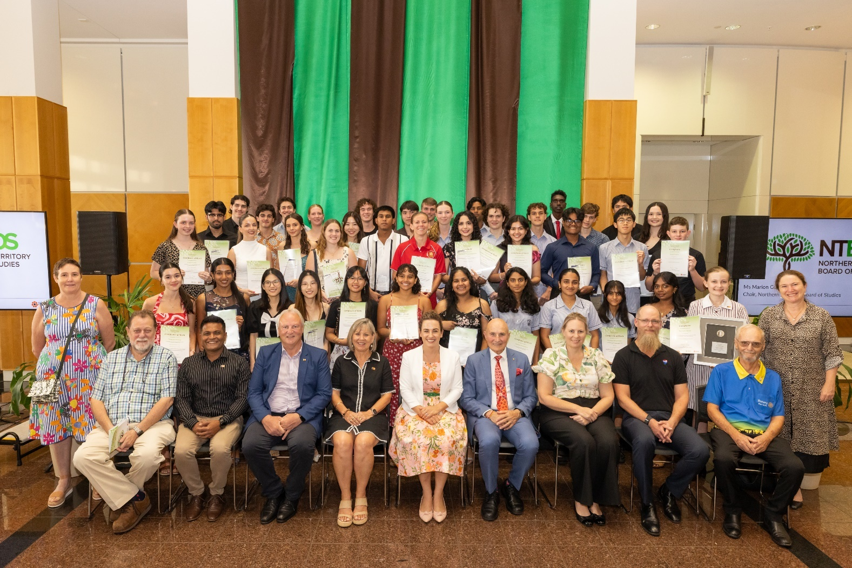

Figure 1: NTBOS award recipients at Parliament House on Friday 31 January 2025.

The board was delighted to hold presentation ceremonies for its NTCET awards. The Darwin awards ceremony for 2024 took place on Friday 31 January 2025 at Parliament House. The Alice Springs awards ceremony took place on Thursday 6 February 2025 at the Alice Springs Desert Park.

Awards are given to the top 20 NTCET completers, students who receive A+ Merit grades for Stage 2 subjects, and various industry-sponsored awards.

These events were attended by the Administrator of the NT, the Honourable Hugh Heggie PSM, the Chief Minister, the Minister for Education and Training, the Hon. Jo Hersey MLA, the Chief Executive of the Department of Education and Training, Ms. Susan Bowden, and many other distinguished guests, including board members.

These events are very special, and board members feel privileged to recognise and help celebrate the fantastic achievements of NT students.

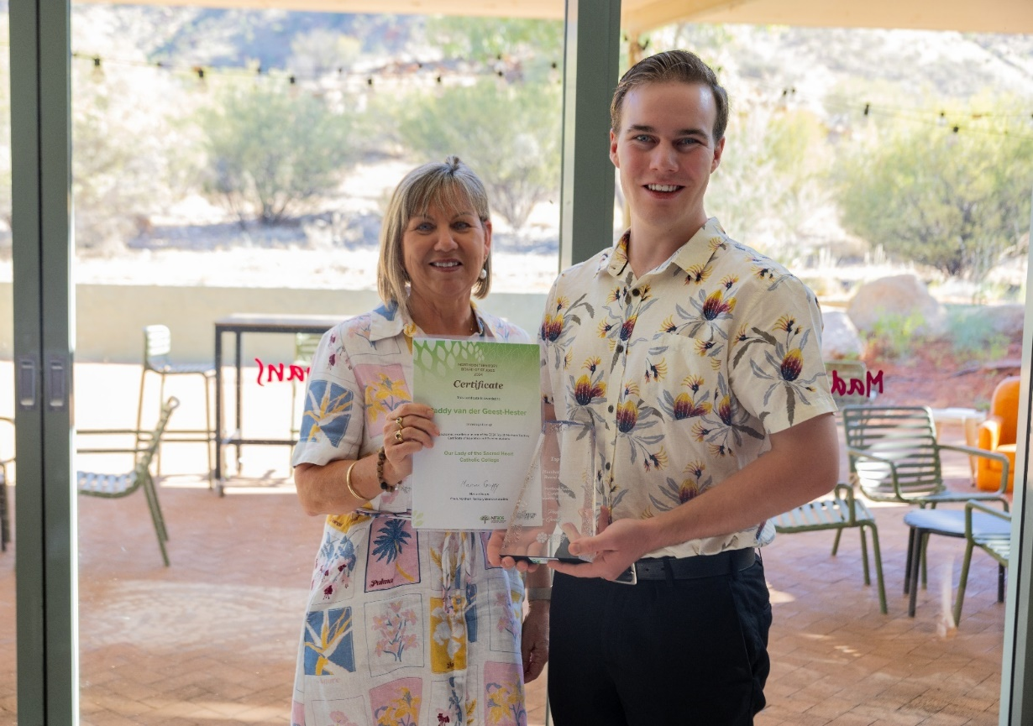

Figure 2: Paddy van der Geest-Hester receives his award from the Minister for Education and Training,   
the Hon. Jo Hersey MLA, at the Alice Springs Desert Park on Thursday 6 February 2025.

## Academic excellence awards

NTBOS offers Academic Excellence Awards to government and non-government students in their final years of primary, middle and senior schooling. The top Aboriginal achiever in year 12, and the top personal learning achievers in year 12 are also awarded.

The winners are nominated by their school with presentations made at end-of year school functions. Each winner receives a certificate and $50.00 prize money.

Figure 3: NTBOS award recipients at the Alice Springs Desert Park on Thursday 6 February 2025.

# Overview of board activities

## Artificial Intelligence in Schools

A national taskforce was established to develop the Australian Framework for Generative Artificial Intelligence in Schools (the framework). The framework was approved in October 2023 by education ministers. In 2024, working groups were established under the taskforce to deliver advice in the areas of ‘AI in practice’ and ‘AI compliance and standards’. The work of the national taskforce and key partnerships with Microsoft will provide Northern Territory schools with advice, resources and training on the safe and ethical use of AI technology.

In awareness of these developments, the board facilitated some outstanding presentations on generative AI in schools in 2024 and will seek advice on ‘lessons learnt’ in the future. This includes liaising with the Department of Education and Training and the work being undertaken to operationalise the framework.

Charles Darwin University (CDU) presented to the board on the impressive work they have undertaken. CDU has an AI action plan which required the development of new assessments for all subjects to address the use of AI. A guide was also developed to ensure ethical and responsible use of AI in CDU’s academic environments, promoting learning while maintaining academic integrity.

## Northern Territory Certificate of Education and Training

The NTCET qualification is designed to recognise the knowledge and skills that have been acquired through formal education and training. The NTCET is awarded to students who have completed the required number of credits gained throughout years 10, 11, and 12. Providing high-quality advice on curriculum, assessment and reporting is one of the primary functions of the board, and so it takes a keen interest in the analysis of results, and in improving the administering of the NTCET. NTCET completion data for 2024 is provided at Attachment B.

The NTCET was discussed at 2024 board meetings, with headline discussion topics as follows:

* 2023 NTCET data overview including completers, student pathways and student achievements
* projections for 2024 NTCET completions via the ‘student tracking system’
* establishment of a data sharing agreement between the three sectors.

## South Australian Certificate of Education (SACE) Board

The SACE Board are responsible for delivering all aspects of the NTCET, including development of curriculum and accreditation of subjects, setting assessments, managing moderation and assessing student achievement. The SACE board provides regular reports to the board for their consideration.

In 2024 SACE kept the board abreast of issues regarding their operations such as:

* Passport to thrive – a qualification for a changing world
* New and emerging subjects
* SACE capabilities and learner profile
* Recognition of Aboriginal cultural knowledge.

## National Assessment Plan Literacy and Numeracy (NAPLAN)

NAPLAN is one of the primary diagnostic tools for education agencies in measuring the literacy and numeracy of students. Providing high-quality advice on curriculum, assessment and reporting is of great interest to the board, as is the analysis of results to better understand student achievement in the NT. A summary of the 2024 NAPLAN results is provided at Attachment C.

## Australasian Curriculum, Assessment and Certification Authorities (ACACA)

ACACA is the body for the chief executives of the statutory bodies in the Australian states and territories and in New Zealand responsible for curriculum, assessment and certification in education. ACACA routinely provides reports to the board, either in the form of a written report or through updates provided by Teaching and Learning Services with the department.

## Australian Curriculum, Assessment and Reporting Authority (ACARA)

ACARA develops and refines the Australian Curriculum, national assessment including NAPLAN, and reports on key education indicators through the national report on schooling. A report on ACARA priorities is provided to the board through the NT ACARA representative.

## Indigenous Languages and Cultures (ILC) Curriculum review

The Keeping Indigenous Languages and Cultures Strong plan was developed in response to the commitment by the NT Government to implement the Australian Curriculum, specifically the Framework for Teaching Aboriginal and Torres Strait Islander Languages.

Target 16 of Closing the Gap identifies that by 2031, there is a sustained increase in the number and strength of Aboriginal and Torres Strait Islander languages being spoken. A key measure is the number of Aboriginal languages being taught in early learning, primary and secondary schools.

The plan provides a framework for the teaching and learning of Indigenous languages and cultures in NT schools through four main learner pathways across Transition to Year 9:

1. First Language
2. Language Revival
3. Second Language
4. Language and Cultural Awareness.

Strengthening the delivery of this program is key to achieving the goal of embedding the languages of First Nations people as languages to be taught within the Australian Curriculum.

In 2024, the board agreed to a review of the ILC. The review was commissioned in recognition that while the ILC is implemented well in many schools, there has not been fulsome implementation of the ILC across all schools and regions in the Northern Territory. The review focuses on identifying recommendations for how implementation of the ILC curriculum can be strengthened for all schools, across all regions.

The objective of the review is to strengthen implementation of the ILC Curriculum by:

* Improving the ease of use of the curriculum
* Increasing the number of schools using the curriculum
* Ensuring the different learner pathways are effective and being used appropriately.

The model of the ILC Curriculum centres on Cultural Knowledge and Content. This is the starting point for collaborative planning with Elders and speakers of the languages. It defines topics that students may learn through, rather than learn about.

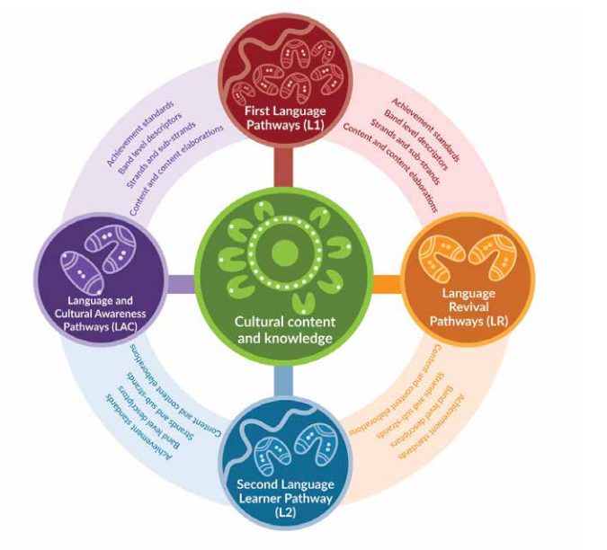

Figure 4: A model for the NT Curriculum for Indigenous Languages and Cultures.

# Attachment A

## 2024 top twenty NTCET recipients

NTBOS would like to congratulate the following award recipients:

|  |  |
| --- | --- |
| Recipient | School |
| Samuel Ricketts | The Essington School |
| Rupendren Manimaran | Darwin High School |
| Hunter Roomes | The Essington School |
| Muhammad Qasim | Darwin High School |
| Zirui Zheng | Darwin High School |
| Naomi Jia | Darwin high School |
| Pothik Mondol | Darwin high School |
| Paraskevi Diamandopoulos | Darwin High School |
| Jasper Mules | The Essington School |
| Darshi Pandithage | Casuarina Senior College |
| Gabriella Francis | Darwin High School |
| Mohammad Hasan | Darwin High School |
| Joe Abraham | The Essington School |
| Shanum Khan | The Essington School |
| Nathaniel Freeland | Darwin High School |
| Phoebe Wiltshire | Darwin High School |
| Taufiq Lubis | Darwin High School |
| Joel Durrheim | Darwin High School |
| Talia Freijah | Darwin High School |

## Certificate of merit recipients

|  |  |  |
| --- | --- | --- |
| Recipient | School | Merit |
| Alvin Lam | The Essington School | Mathematical Methods |
| Anna Abraham | The Essington School | Biology and Chemistry |
| Ashleigh Emmett | Good Shepherd Lutheran College | Integrated Learning A |
| Cassia Latz | Darwin High School | Psychology |
| Chloe Kalikajaros | Darwin High School | Creative Arts |
| Emma Ryan | St John’s Catholic College | Indonesian (continuers) |
| Eshani Senarath | Darwin High School | Digital Communication Solutions |
| Greta Strohmayr | Darwin High School | Spanish (beginners) |
| Haylia Lewis | Darwin High School | Italian (beginners) |
| Hunter Roomes | The Essington School | Mathematical Methods |
| Jack Walmsley | O’Loughlin Catholic College | Mathematical Methods |
| Jaedon Hocking | The Essington School | Health and Wellbeing |
| Jasper Mules | The Essington School | Activating Identities and Futures |
| Joel Durrheim | Darwin High School | Biology |
| Kayla Watkins | Darwin High School | Communication and the Community |
| Konstantinos Chatzipapas | Darwin High School | Industry and Entrepreneurial Solutions |
| Larisha Pandey | Darwin High School | Digital Communication Solutions |
| Liam Huang | Darwin High School | Chinese (beginners) |
| Lily Topham | Darwin High School | Creative Arts |
| Linh Nguyen | Darwin High School | Digital Communication Solutions |
| Methuli Kulasekara | The Essington School | Biology, Chemistry, English and Psychology |
| Mithuru Perera | The Essington School | Psychology |
| Muhammad Qasim | Darwin High School | Biology, Chemistry and Specialist Mathematics |
| Myles Smith | Darwin High School | Scientific Studies |
| Naomi Jia | Darwin High School | Chemistry |
| Paraskevi Diamondopoulos | Darwin High School | Psychology |
| Pedro Sanches Luiz | Darwin High School | General Mathematics |
| Rupendren Manimaran | Darwin High School | Biology |
| Ruvinya Abeyaratne | The Essington School | Biology |
| Samson Bament | O’Loughlin Catholic College | Mathematical Methods |
| Samuel Ricketts | The Essington School | Physics and Philosophy |
| Tamsin Groves | The Essington School | Outdoor Education |
| Tasha Ullas | Darwin High School | Indonesian (beginners) |
| Zirui Zheng | Darwin High School | Accounting, English as an Additional Language, Mathematical Methods and Specialist Mathematics |
| Zixin Zheng | Darwin High School | Specialist Mathematics |

## Industry-supported and additional awards recipients

| Recipient | School | Award |
| --- | --- | --- |
| Scarlett Parkin | Haileybury Rendall School | Administrator’s Medal for Northern Territory Primary Years Scholar |
| Jemma Stark | Sanderson Middle School | Administrator’s Medal for Northern Territory Middle Years Scholar |
| Konstantinos Chatzipapas | Darwin High School | Australian Computer Society (NT branch) Technologies Award |
| Samuel Ricketts | The Essington School | Australian Meteorological and Oceanographic Society Physics Award |
| Muhammad Qasim | Darwin High School | Australian Veterinary Association (NT division) Dennis Thomson Memorial Science Award |
| William Cotter | Darwin High School | Catholic Education NT Performing Arts Award |
| Jaedon Hocking | The Essington School | Catholic Education NT Health and Wellbeing Award |
| Nadishka Fernando | Darwin High School | Department of Trade, Business and Asian Relations Innovation Award |
| Zirui Zheng | Darwin High School | Department of Treasury and Finance Accounting Award |
| Pedro Sanches Luiz | Darwin High School | Department of Treasury and Finance Mathematics Award |
| Kallum Powell | Alice Springs Language Centre | GTNT Group School-based Apprentice Award |
| Jamahl Cameron-Thorpe | Katherine High School | Karmi Sceney Remote Aboriginal Excellence and Leadership Award |
| Shanille Braybon | Centralian Senior College | Language Teachers’ Association of the Northern Territory Languages Award |
| Zirui Zheng | Darwin High School | Mathematics Teachers’ Association of the Northern Territory Mathematics Award |
| Muhammad Qasim | Darwin High School | Menzies School of Health Research Biology Award |
| Olivia Wall | Casuarina Senior College | Rotary Club of Darwin Iain Smith Award for History |
| Methuli Kulasekara | The Essington School | Rotary Club of Darwin Ian MacGregor Award for Excellence in English |
| Samuel Ricketts | The Essington School | Rotary Club of Darwin Hugh Bradley Award for Humanities |
| Grace Bramley | St Philip’s College | Rotary Club of Darwin Jim Gallacher Award for English Literary Studies |
| Naomi Jia | Darwin High School | Royal Australian Chemical Institute Chemistry Award |
| Muhammad Qasim | Darwin High School |
| Methuli Kulasekara | The Essington School |
| Anna Abraham | The Essington School |
| Rudi Fraser | Anula Primary School | Sally Bruyn Primary Science Award |
| Mithuru Perera | The Essington School | Science Teachers’ Association of the Northern Territory Psychology Award |
| Cassia Latz | Darwin High School |
| Leon Wanybarrnga-Ngadhutjpi | Ramingining School | Telstra Top Remote Aboriginal Male Student Award |
| Samuel Ricketts | The Essington School | Chief Minister’s Award Most Outstanding Stage 2 NTCET Student |
| Ramona Dooley | St Philip’s College | Chief Minister’s Award Most Outstanding Stage 2 NTCET Aboriginal Student |
| Bana Ajjur | NT School of Distance Education | Chief Minister’s Award Most Outstanding Stage 2 NTCET Distance Education Student |

# Attachment B

## Overview of NTCET results

In 2024, the board issued 1,468 certificates to students who successfully completed the Northern Territory Certificate of Education and Training (NTCET).

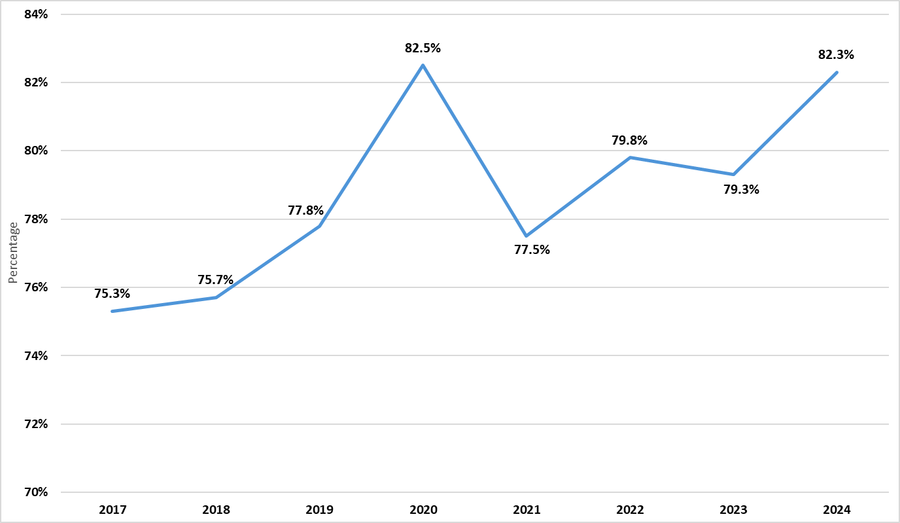  
Figure 1: Percentage of year 12 students who achieved the NTCET - completion rate

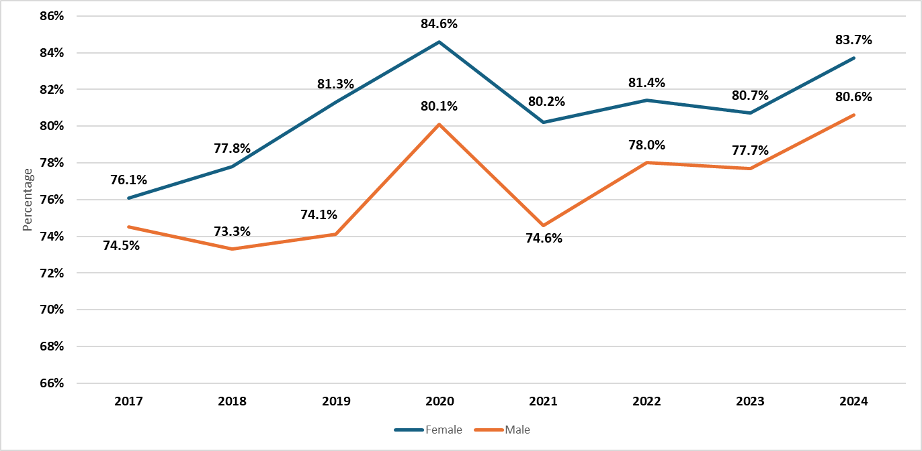Figure 2: NTCET completion rate – male and female

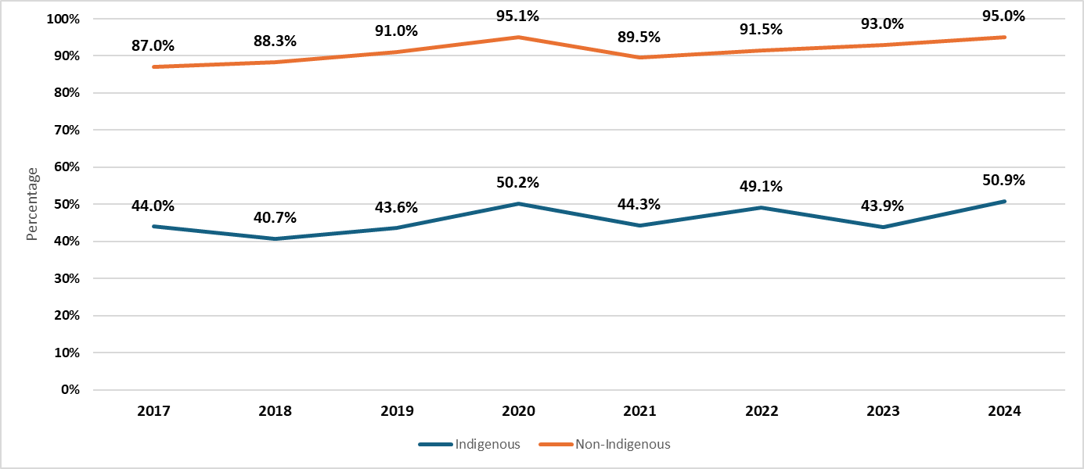Figure 3: NTCET completion rate – Indigenous and non-Indigenous

### Vocational Education and Training (VET) studies contributing to the NTCET

VET studies continue to be a popular option for senior secondary students with almost half of NTCET completers studying VET in some capacity, and over a quarter needing VET credits to satisfy their NTCET requirements.

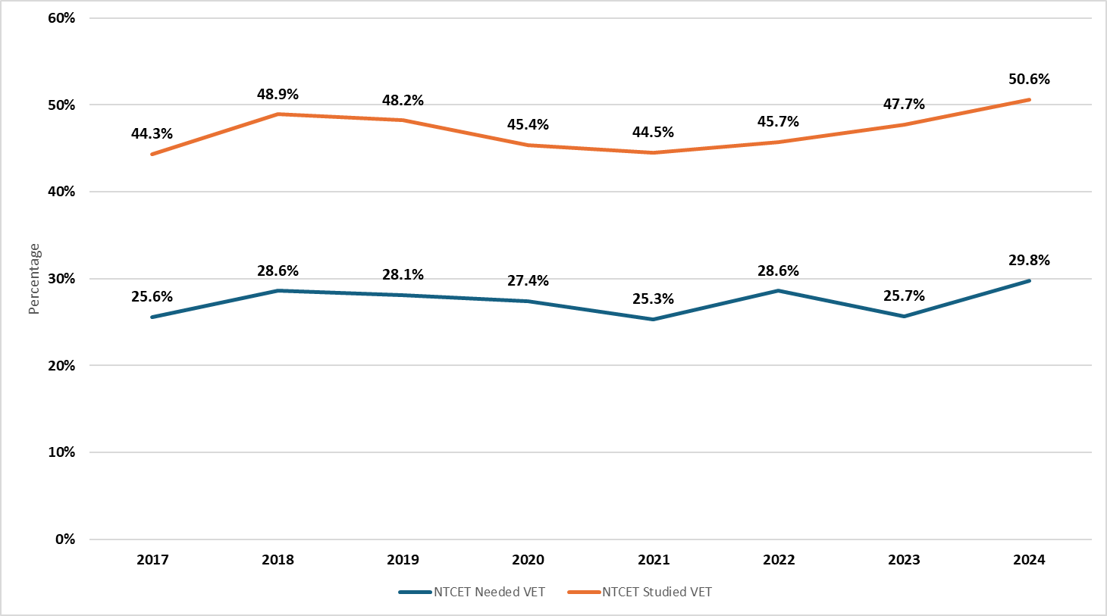Figure 4: Percentage of NTCET completers who studied or needed VET as part of their NTCET

**Caveats:**

1. Data reported reflects the South Australian Certificate of Education (SACE) Board post-clerical results, most recently released on 3 March 2025.
2. The data is current as of the date of provision.
3. The students’ Aboriginal and Torres Strait Islander (ATSI) status is based on data provided by SACE, which may differ from the records in the Student Administration and Management System (SAMS).
4. Since 2022, there has been a change in the reported measure of NTCET completion rate. It now uses a distinct count of year 12 students as at Age Grade Census each year (August) as the denominator. This ensures that all students are only counted once, even if they have multiple enrolments throughout the year.
5. To maintain comparability across years, the revised measure has been applied retrospectively. As a result, the currently reported figures may not align with those in previous publications.
6. Students are counted as having studied VET if they passed/achieved the competency (result of ‘P’) or were granted recognition for prior learning (result of ‘R’).

# Attachment C

## Overview of NAPLAN results

NAPLAN is a set of tests in reading, writing, language conventions, spelling, grammar and punctuation, and numeracy. NAPLAN is a national standardised assessment and covers a broad spectrum of important functions, including:

* monitoring education achievement progress toward national goals
* assessing education system accountability and performance; including inter-jurisdictional and inter-sectoral comparisons and information on performance of students in equity groups
* tracking school improvement
* assessing individual student learning achievement and growth against standardised norms
* providing information to parents on school and student performance.

### Student participation

Table 3: NT NAPLAN participation rates 2017 - 2024

|  |  |  |  |  |  |  |  |  |
| --- | --- | --- | --- | --- | --- | --- | --- | --- |
| Domain | Year Level | 2017 | 2018 | 2019 | 2021 | 2022 | 2023 | 2024 |
| Reading | Year 3 | 88% | 86% | 84% | 83% | 81% | 82% | 83% |
|  | Year 5 | 89% | 88% | 86% | 83% | 81% | 83% | 86% |
|  | Year 7 | 85% | 85% | 83% | 81% | 78% | 81% | 80% |
|  | Year 9 | 78% | 78% | 76% | 73% | 72% | 75% | 71% |
| Numeracy | Year 3 | 87% | 85% | 82% | 82% | 79% | 80% | 81% |
|  | Year 5 | 87% | 86% | 84% | 81% | 78% | 82% | 84% |
|  | Year 7 | 84% | 84% | 82% | 79% | 75% | 79% | 78% |
|  | Year 9 | 77% | 75% | 74% | 71% | 68% | 73% | 69% |
| Writing | Year 3 | 89% | 87% | 85% | 88% | 79% | 80% | 82% |
|  | Year 5 | 89% | 89% | 87% | 84% | 82% | 84% | 86% |
|  | Year 7 | 86% | 86% | 84% | 81% | 79% | 81% | 81% |
|  | Year 9 | 80% | 79% | 78% | 73% | 72% | 76% | 73% |

Source: ACARA

### Students needing additional support

Table 4: Percentage of NT students whose results indicate they need additional support; 2024

|  |  |  |  |  |  |  |  |
| --- | --- | --- | --- | --- | --- | --- | --- |
| Geolocation | Year Level | Reading | | Numeracy | | Writing | |
| Proportion | Change | Proportion | Change | Proportion | Change |
| Outer Regional | Year 3 | 18% | 1 pp | 15% | -3 pp | 10% | -3 pp |
|  | Year 5 | 16% | 4 pp | 14% | -1 pp | 13% | -2 pp |
|  | Year 7 | 15% | 0 pp | 15% | -2 pp | 15% | -4 pp |
|  | Year 9 | 17% | 0 pp | 18% | -1 pp | 18% | -1 pp |
|  | All | 16% | 1 pp | 15% | -2 pp | 14% | -3 pp |
| Remote | Year 3 | 41% | 4 pp | 40% | -3 pp | 35% | -2 pp |
|  | Year 5 | 36% | -2 pp | 39% | -5 pp | 38% | -6 pp |
|  | Year 7 | 45% | 4 pp | 48% | 6 pp | 46% | 3 pp |
|  | Year 9 | 45% | 6 pp | 45% | 2 pp | 46% | 4 pp |
|  | All | 42% | 3 pp | 43% | 0 pp | 41% | -1 pp |
| Very Remote | Year 3 | 77% | 6 pp | 82% | 6 pp | 77% | 1 pp |
|  | Year 5 | 80% | 1 pp | 79% | -4 pp | 81% | -3 pp |
|  | Year 7 | 78% | -5 pp | 78% | -7 pp | 82% | -4 pp |
|  | Year 9 | 82% | 3 pp | 82% | 7 pp | 86% | -1 pp |
|  | All | 79% | 1 pp | 80% | 1 pp | 81% | -1 pp |
| All | Year 3 | 35% | 2 pp | 34% | -2 pp | 30% | -2 pp |
|  | Year 5 | 33% | 3 pp | 33% | -2 pp | 32% | -3 pp |
|  | Year 7 | 35% | -1 pp | 35% | -2 pp | 35% | -3 pp |
|  | Year 9 | 37% | 2 pp | 37% | 2 pp | 38% | 1 pp |
|  | All | 35% | 2 pp | 35% | -1 pp | 34% | -2 pp |

Source: ACARA  
Note: Change = the change in proportion from 2023 to 2024 in percentage points and a **decreasing proportion is desired**.

### Students achieving strong or exceeding proficiency levels

Table 5: Percentage of NT students who achieved strong or exceeding proficiency levels; 2024

|  |  |  |  |  |  |  |  |
| --- | --- | --- | --- | --- | --- | --- | --- |
| Indigenous Status | Year Level | Reading | | Numeracy | | Writing | |
| Proportion | Change | Proportion | Change | Proportion | Change |
| Non-Aboriginal | Year 3 | 58% | 1 pp | 56% | 2 pp | 70% | 3 pp |
|  | Year 5 | 65% | -4 pp | 59% | -1 pp | 62% | 2 pp |
|  | Year 7 | 66% | 1 pp | 63% | 1 pp | 62% | 6 pp |
|  | Year 9 | 58% | 0 pp | 57% | -1 pp | 56% | 2 pp |
|  | All | 62% | -1 pp | 59% | 0 pp | 63% | 3 pp |
| Aboriginal | Year 3 | 12% | 0 pp | 9% | 0 pp | 15% | 0 pp |
|  | Year 5 | 13% | 0 pp | 10% | 2 pp | 14% | 2 pp |
|  | Year 7 | 12% | 1 pp | 9% | 1 pp | 11% | 2 pp |
|  | Year 9 | 10% | -2 pp | 8% | -1 pp | 9% | 0 pp |
|  | All | 12% | 0 pp | 9% | 0 pp | 12% | 1 pp |
| All | Year 3 | 40% | 1 pp | 37% | 1 pp | 48% | 2 pp |
|  | Year 5 | 44% | -2 pp | 40% | 0 pp | 42% | 2 pp |
|  | Year 7 | 43% | 1 pp | 40% | 1 pp | 41% | 5 pp |
|  | Year 9 | 37% | 0 pp | 35% | -1 pp | 35% | 2 pp |
|  | All | 41% | 0 pp | 38% | 0 pp | 42% | 3 pp |

Source: ACARA  
Note: Change = the change in proportion from 2023 to 2024 in percentage points and an **increasing proportion is desired**.

**Notes and caveats about changes in NAPLAN 2023**

Changes to the test in 2023 make results not comparable to 2022 and prior. Changes include:

* test timing change from May to March
* new scale developed
* proficiency levels replace previous NAPLAN band structure.

The participation measure remains consistent but may be influenced by the change in testing dates.

Students sitting the test, students present but not attempting the test and students who are exempt from testing are all included as participants.

The percentage of students in the 'needs additional support' or 'strong or exceeding' proficiency levels is derived by dividing the number of students in the respective proficiency level by the test population. While students exempt from testing are considered to need additional support, they are not included in the 'needs additional support' proportions.

Caution is required when interpreting differences in results between groups as differences may be driven by testing, participation rate and cohort variation.