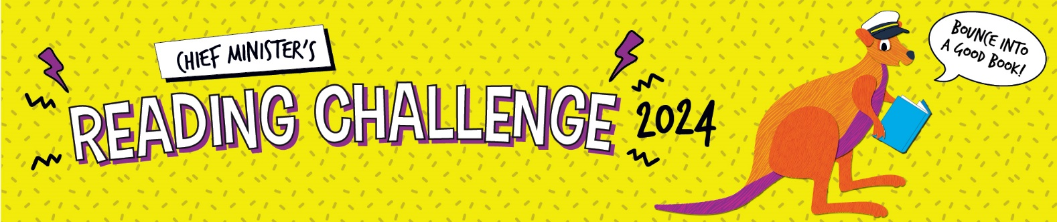

Student reading record

Student name: Year level:

Ask a teacher, parent, carer or librarian to write their initials in the right-hand column when you complete a book. They should check that the title and author are correct.

Book number | Book title | Author | Adult initials
1
2
3
4
5
6
7
8
9
10
11
12

Congratulations! You have met the Challenge!
Schools to upload student data on SAIS for students participating as a part of school. For individual students (participating interpedently of a school) and home school students: please ask your parent or carer to confirm that you have read these books. Parent/carer to upload reading record to a personalized secure OneDrive folder through the link that cmrc.doe@education.nt.gov.au will email them. Please upload this form by Friday 23 August 2024.

Parent/carer: ________________________________________ ______________________________________________
Printed name Signature

If you’d like to, you can continue reading and recording more books on this page.
Book number | Book title | Author | Adult initials
13
14
15
16
17
18
19
20
21
22
23
24

Visit the Chief Minister’s Reading Challenge website for more suggested books on the booklist:
https://education.nt.gov.au/education-events-and-awards/chief-ministers-reading-challenge

