  - Easy read information sheet

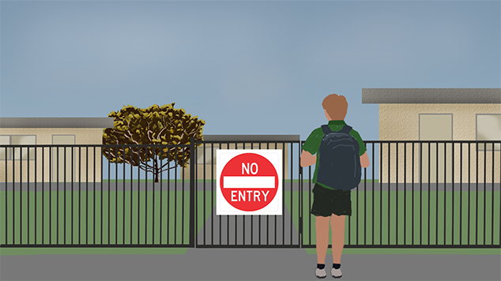

What is suspension?
Suspension means children are not allowed to go to school.
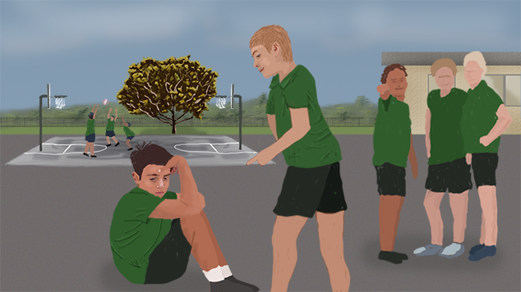 | Why are children suspended?  Children get suspended if they say or do something that hurts someone or makes them feel bad or scared.
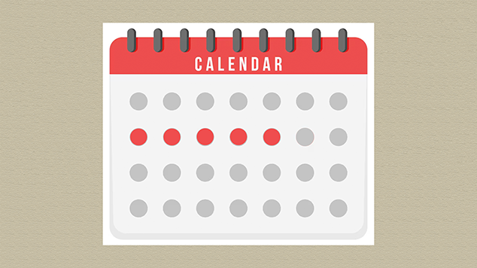 | How long does suspension last?  - Suspension can be for a short time or a long time.  - It depends on how long it takes to make it safe for children to be at school together.  - The longest time children can be suspended is 20 school days, that is 4 weeks.
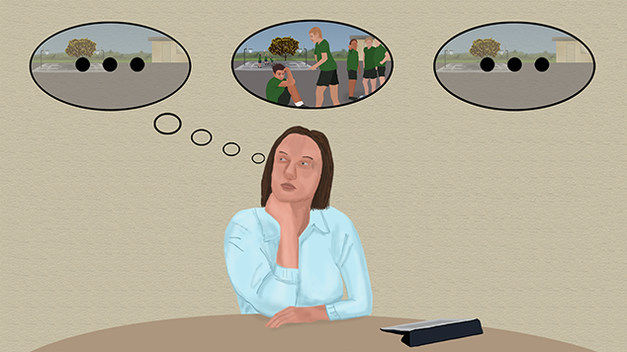 | Before children are suspended  The principal will think about  - what happened  - why it happened  - ways to help your child stay at school.
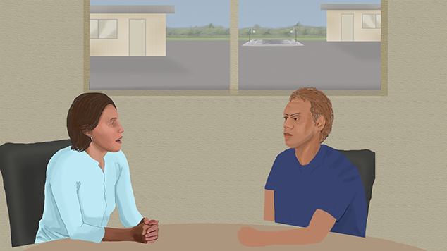 | Principals will talk to you about what happened and ask if you want to have a say. You can talk about  - why your child behaved that way  - how long the suspension will last  - who will look after your child when they are not at school.
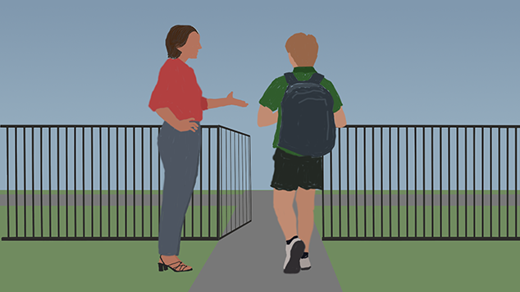 | Your child will be suspended if the principal decides it’s the only way to make sure other people at school are safe.
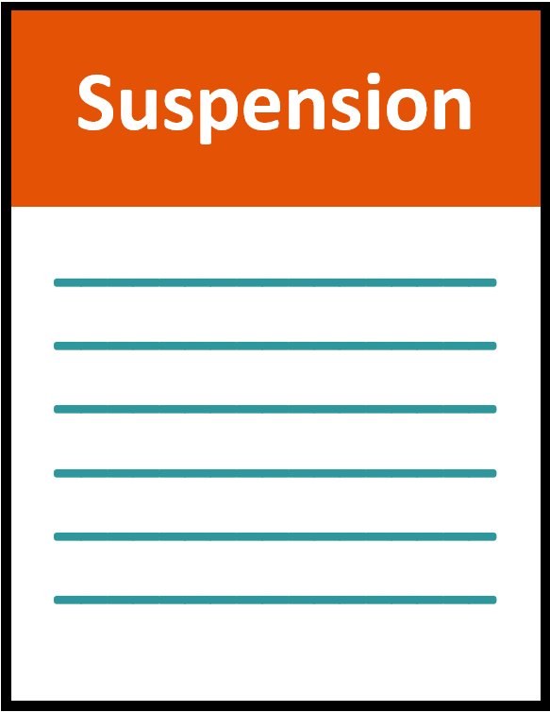 | If the principal decides to suspend your child, they will give you and your child:  - a notice of suspension  - a letter
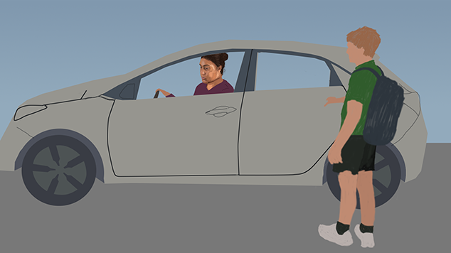 | The principal will also talk to you about how your child will get home safe.

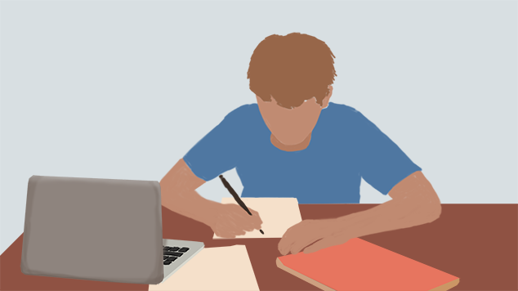 | School work at home  Children will get schoolwork to do when they are on suspension.

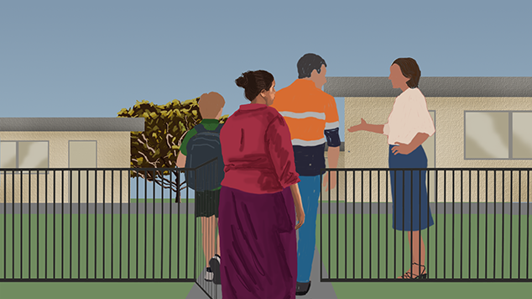  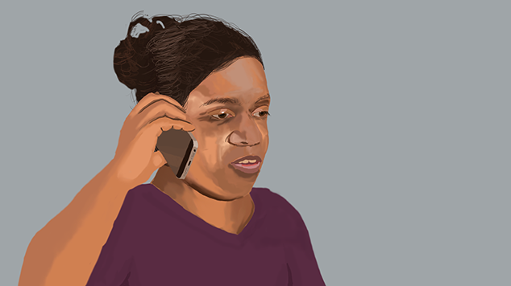 | What happens at the end of suspension?  The school will ask you and your child to a meeting to welcome them back to school.  Do you want to know more?  If you have any questions during the suspension or think the suspension is unfair you can talk it through with the principal.

If you are not happy after that, you can call the regional office and talk to them about how to work it out.
Regional office | Phone number
Darwin | 8999 5612
Top End | 8944 9200
Central | 8951 1616
East Arnhem | 8987 0888
Big Rivers | 8972 5389
Barkly | 8963 2010

More information
If you want to talk to someone about your child’s behaviour you can call:
Parentline
Phone 1300 30 1300 6am to midnight, every day
Website www.parentline.com.au
Children can talk to:
Kids helpline
Phone 1800 551 800 24 hours a day, every day
Website www.kidshelpline.com.au
or
headspace
Phone 1800 650 890 3pm to 10pm, every day
Website www.headspace.org.au

