www.education.nt.edu.au
May 2019

DEPARTMENT OF EDUCATION

LOCAL INDUCTION FOR TEACHERS IN REMOTE SCHOOLS: GUIDELINES

Contents
Introduction 3
Purpose 4
Why is local induction important? 4
Who is local induction for? 5
What are the foundations of a quality local induction program? 5
What is included in a quality local induction program? 6
Timeframe 7
Roles and responsibilities 7

Introduction
The Northern Territory Department of Education (the department) is committed to building a culture of professional growth in all schools across the Northern Territory. Schools that actively support teachers in developing skills, knowledge, professional practice and professional identity contribute to:
- teacher commitment and retention rates
- developing quality teaching
- improved student outcomes.

Each remote school and community is unique. Teachers new to these contexts face many challenges, both professional and personal. It is a shared responsibility of the department, principals, school leaders, teachers and assistant teachers to ensure new teachers are well supported.
Teachers will commence in remote schools at varying stages of their careers with a range of knowledge and experiences. Induction is a highly valuable process that provides a foundation for career-long professional growth.
Quality local induction builds whole school professional learning cultures and enables teachers to transition to remote teaching contexts. It supports teachers to meet professional growth and career needs while supporting teacher wellbeing.
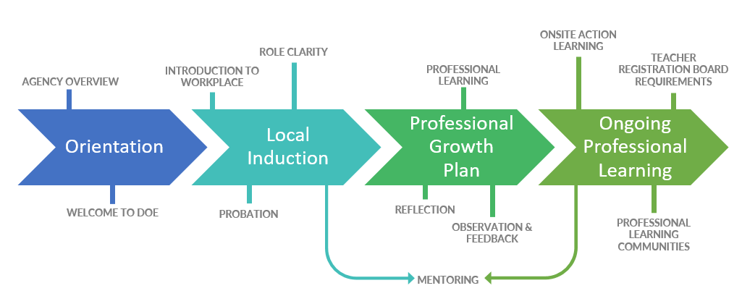

Purpose
The Local Induction for Teachers in Remote Schools: Guidelines (the Guidelines) assists schools to develop flexible local induction processes and practices. The goal is to reflect the diversity of remote teaching contexts and communities, and support individual teacher needs.
The overall aim of the Guidelines is to ensure that consistent, comprehensive and sustainable local induction processes are in place for remote teaching staff.
The Guidelines support teachers to meet professional development requirements of the Teacher Registration Board of the Northern Territory and are informed by the following resources:
- Australian Professional Standards for Teachers
- Capability Framework: Teaching Aboriginal and Torres Strait Island EAL/D learners
- Professional Growth for Teachers
- Teacher Probation Policy
- Aboriginal cultural competency standards
- Educator wellbeing.

The Guidelines are accompanied by an adaptable Local Induction Planner (the Planner) that includes a pre-commencement checklist, suggested local induction and professional learning activities, and an example induction feedback template. The Planner assists principals and school leaders to plan and implement tailored local induction processes and practices.
Feedback on these resources or queries regarding induction can be directed to the HR Workforce Capability team via email at educapability.doe@nt.gov.au.

Why is local induction important?
Local induction is defined as a formal program developed to suit the local school and community context, and the career stage of individual teachers. It is a critical phase of a professional learning continuum based on clearly defined professional growth and mentoring processes.
Local induction benefits teachers at all career stages and familiarises them with the school and local community. Effective local induction socialises teachers to their role and benefits the school by:
- improving staff morale and commitment to the school and community
- familiarising teachers with the languages of the community and developing their cultural competence
- supporting the wellbeing of teachers through developing collegial relationships, providing support structures and identifying resilience strategies
- engaging teachers, leading to longer tenure and reduced recruitment and training costs
- developing quality teachers who have a positive impact on student outcomes.

Who is local induction for?
Local induction is for all teachers who are new to a particular remote school. The content and duration will be determined by career stage and individual need. It is the responsibility of principals to individualise the induction program. Example of how this can be done, or assistance in tailoring induction materials can be sought from the HR Workforce Capability team via email at educapability.doe@nt.gov.au.

What are the foundations of a quality local induction program?
A local induction program is a series of regular and planned activities that begin prior to the teacher’s commencement within a school and community. It continues as an ongoing, formalised, school-based process tailored to the career stage of individual teachers and supported by mentors. Induction and mentoring activities are included in daily routines within the school.
Quality teacher induction may continue for up to two years. It includes a focus on wellbeing and targets personal and professional aspects of a teacher’s role.
Induction is supported by an assigned mentor and allows for structured classroom observations between mentor and mentee. It is inclusive of teachers and teaching teams beyond the primary mentor/mentee relationship and includes opportunities to engage with professionals external to the school.
Reduced teaching loads and time release for the mentor and mentee are negotiated at the school level depending on available resources. Research indicates that reduced teaching loads for graduate teachers yield positive outcomes by allowing more time dedicated to planning, reflection and mentoring activities.

What is included in a quality local induction program?
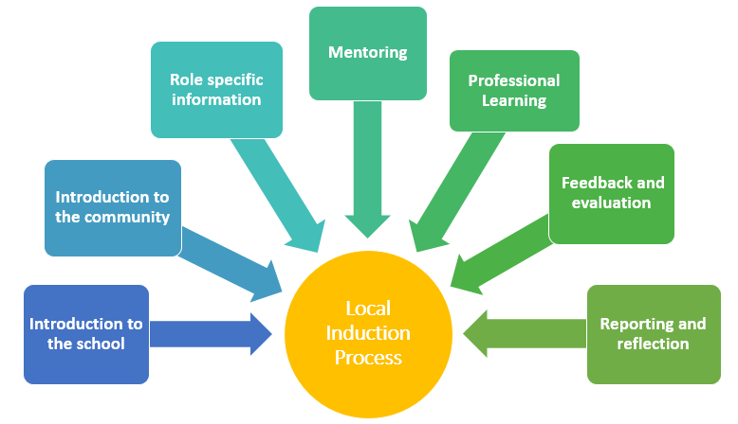
- Introduction to the school community to welcome new teachers and assist them to connect with peers and colleagues employed within the school. This includes sharing information about school strategic plans and goals, organisational structure, policies, processes and the history of the school. All teachers need to be informed about work health and safety processes and emergency procedures.
- Introduction to the community context to raise awareness of local languages and cultural practices fostering the development of cultural competency. Key community members are introduced where appropriate. New teachers will benefit by being familiar with the community layout, local services, amenities and teacher accommodation.
- Role specific information enabling teachers to consider their existing skills, knowledge and experience. New teachers are provided with relevant information regarding English as an Additional Language or Dialect (EAL/D) learners and school approaches to literacy and numeracy. New teachers are introduced to school practices and expectations about the department’s Working in Teams approach and team teaching with assistant teachers.
- Establishment of a mentoring relationship to formalise and build the mentoring process and provide a supported transition into the school and community.
- Professional learning identified through professional growth conversations. Professional learning opportunities consider the 70:20:10 learning model approach. 70% of learning occurs through daily on-the-job tasks, challenges and practice; 20% of learning occurs with and through other people, such as coaching and mentoring; 10% of learning occurs through structured training courses and programs.
- Feedback and evaluation offers teachers multiple opportunities to provide feedback on the quality and delivery of induction and mentoring.
- Reporting and reflecting on professional learning undertaken throughout induction using the department’s Professional Learning System, the Teacher Registration Board’s Commentary of professional development activities template or a teacher generated template.

Timeframe
The length of induction varies for individual teachers depending on their career stage, previous remote teaching experience, role complexity and level of responsibility. It is recommended that:
- graduates are provided a mentor for two years.
- probationers (other than graduate) are provided a mentor for the duration of the probation process.
- probationers with five years or more teaching service are provided a mentor for a minimum of one semester.
- teachers on internal transfers are provided a mentor for a shorter period that aligns with professional growth plans and considers previous teaching experience.

Roles and responsibilities

The department
The department provides central resource information to support local induction processes in schools, such as mentoring resources, local induction guidelines and planning templates.
All new recruits, existing staff and school leadership have access to the department’s online Remote Teacher Induction resources through the department’s website.
Each semester the department runs a mandatory central orientation program for new recruits.
Four wheel drive training is provided for new remote teachers in preparation for any work-related, off-road travel.

Principals
Principals provide teachers with local information prior to arrival at the community and facilitate participation at community focused events for new staff and their families on arrival.
Development, implementation and evaluation of local induction practices and processes are the responsibility of the principal as documented in the School Strategic Improvement Plan and Annual School Improvement Plan.
Principals are responsible for commencing and monitoring the probation process for new teachers. They build and maintain a culture within the school that supports induction, professional growth, mentoring and the wellbeing of new teachers.

Supervisors (principals, assistant principals and/or senior teachers)
Supervisors are responsible for implementing, monitoring and evaluating local induction practices within the school as set out in the school’s local induction planner. They identify experienced team members to mentor new teachers and confirm that mentors and mentees have completed the department’s online mentor or mentee training. Supervisors are responsible for facilitating a replacement mentor if the mentoring relationship ends prior to the contracted period.
It is the responsibility of supervisors to ensure that content outlined in the school’s local induction planner is addressed and that a mentee’s professional growth plan aligns with the activities of induction. Supervisors provide information and support to mentors and new teachers regarding the teacher probation process and relevant mentoring activities to meet Teacher Registration Board requirements for full registration. They are responsible for ensuring the overall process is on track and support the new teacher in gathering and documenting evidence of practice throughout the process.
Supervisors oversee mentoring practices and schedule regular meetings (e.g. monthly) with mentors and mentees to ensure induction and mentoring processes are effective and tailored to the needs, goals and aspirations of the new teacher.
Supervisors address performance concerns with new teachers and ensure that this responsibility does not fall to the mentor.

Mentors
For the purpose of the local induction process, a mentor is defined as a person with requisite skills and knowledge to provide guidance on the basis of past experiences and applied learning. In remote schools, mentors demonstrate high levels of cultural competency and are experienced at team teaching with assistant teachers.
Mentors offer support in the form of pragmatic, relevant, realistic and objective assistance. Both mentor and mentee share a common purpose of development and learning. The aim of mentoring is to build the professional identity, knowledge and professional practices of the new teacher to enable them to develop against the Australian Professional Standards for Teachers (APST). Mentors undertake a range of mentoring activities, including goal setting, modelling teaching practices, classroom observations and evidence based feedback. Mentors work collaboratively with supervisors to support teachers in gathering and documenting evidence of practice required to progress from provisional to full registration against Teacher Registration Board registration requirements. Mentors act without judgement and refrain from performing the duties of the supervisor.

Newly arrived teachers
Newly arrived teachers are required to actively and openly engage in the induction process and work closely with mentors and supervisors to establish and meet goals. They work respectfully and professionally with experienced remote educators to engage in professional development opportunities identified in the school’s local induction process. New teachers partner with school leadership and mentors to meet Northern Territory Teacher Registration Board requirements and processes. They demonstrate a willingness to work reciprocally with colleagues and the community to develop cultural competency throughout local induction.

Assistant teachers
Assistant teachers play a vital role in local induction and can support mentors throughout the mentoring relationship. They may assist teachers to develop the skills and knowledge required for team teaching in remote schools. Assistant teachers can provide valuable knowledge around the core elements of the department’s Working in Teams approach, which includes:
- learning together
- planning together
- teaching and assessing together.

Assistant teachers support classroom teachers to know the students they teach, cultivate teaching strategies and develop cultural competency when working in remote schools and communities.

