This document should be read in conjunction with the following documents:
- Education Engagement Strategy 2022 – 2031
- Enrolment policy
- Enrolment guidelines
- Enrolment enforcement guidelines
- INTRODUCTION
These guidelines outline how authorised persons under the Education Act 2015 (the Act), will work in partnership with schools and families to enforce the compulsory enrolment requirements under section 39 of the Act using engagement as a key and central strategy when undertaking all enrolment support activities.

Enrolment in early childhood programs such as Families as First Teachers, preschool and Transition is non-compulsory and therefore not within the scope of these guidelines. However, the Department and responsible business unit, Student Engagement, will actively promote and work in partnership with families and schools to assist with their enrolment in the Families as First Teachers to implement the engagement strategy.
- DEFINITIONS
Approved education and training is prescribed under the Act as:
- Year 11 or 12 of secondary education in the Territory or the equivalent in a State or another Territory
- an education program or course of study or instruction provided by Charles Darwin University or the Batchelor Institute of Indigenous Tertiary Education
- a higher education course accredited under the Higher Education Act
- an accredited course or approved apprenticeship under the Northern Territory Employment and Training Act
- other education or training approved by the Chief Executive
- other education or training at an institution in a State or another Territory that, if provided in the Territory, would comply with the NT requirements.

Authorised persons are persons who have been appointed by the Chief Executive Officer of the Northern Territory Department of Education under the Act. In addition, some authorised persons exercise delegated legislative powers and functions by the Chief Executive.

Child living independently is a child who is of or above the age of 14 years and not living with a parent. A child who is living with a parent is also considered to be independent if the parent is unable to control the child’s behaviour in relation to enrolment, attendance, and participation.

Child of compulsory school age is a child who has turned six years of age on or before the 30 June of the school year and has not completed Year 10, or turned 17 years of age, whichever comes first.

Compulsory participation phase applies to a student who has completed Year 10 and has not yet turned 17, where the student either continues with school or has been approved to participate in an eligible option on a full-time basis until they turn 17.

Direction to enrol is a notice issued by an authorised person which compels a parent or student living independently to enrol in school.

Eligible option is participation on a full time basis in one of the following:
- approved education or training
- if 15 years or over, paid employment (minimum average of 25 hours per week) or
- a combination of approved education/training and paid employment.

Flexible education arrangement is an arrangement that allows a student’s educational program to be delivered through the school and/or alternative approved providers.

Parent signifies a child’s father, mother or any other person who has parental responsibility for the child, including a person who is regarded as a parent of a child under Aboriginal customary law or Aboriginal tradition. However, a parent standing in the place of a parent of a child on a temporary basis is not a parent of the child.

Parental responsibility of a person signifies that the person:
- has daily care and control of the child or
- is entitled to exercise all the powers and rights in relation to, and has full responsibility for all aspects of, the long-term care and development of the child or
- has daily care and control of the child, and the entitlement and responsibilities mentioned at (b) and includes a person who has been given the above responsibilities under the law of another jurisdiction.

Student Engagement and Attendance Team (SEAT) is the electronic database that Student Engagement utilises to record case management activities, interactions, and other pertinent information regarding parents and students. SEAT also has the capacity to generate a variety of reports to assist the user for data and statistical purposes.

Student Engagement, Senior Managers and Regional Managers are authorised persons based in regional centres who monitor the implementation of the Education Act 2015, including the use of authorised legislative powers and other attendance and engagement initiatives. They also manage Student Engagement Officers in both regional and remote areas.

Student Engagement Officers (SEOs) and School Based Engagement Officers (hereafter included in the definition of the Student Engagement Officers) are authorised persons that work under the Act to reduce non-attendance by administering legislative powers. Such powers include, but are not limited to, the following:
- issuing notices
- coordinating compulsory conferences
- referring student files for prosecution.
- ROLES AND RESPONSIBILITIES

Principals will:
- ensure the school has procedures in place for notifying Student Engagement Senior or Regional Manager s where there are reasonable grounds to believe that a child of compulsory school age is not enrolled in school
- manage student (re)entry into school to ensure appropriate support, which may include the provision of re-engagement strategies or flexible education arrangements to facilitate student attendance
- ensure students wishing to participate in an out of school eligible option are supported in transitioning into the new arrangements and a Notification of Arrangements form is completed and provided to the Eligible Options Coordinator.

Student Engagement unit will:
- develop NT-wide policy, guidelines and regulatory practices relating to implementation of the Act to ensure consistent practice
- provide timely advice to schools and regional staff on department policy, legislation and any other issues that affects the enrolment of students in NT government schools
- ensure core training is provided to authorised persons as and when required
- develop and supply documents (notices and directions) and identity cards for use by authorised persons
- collate and report NT enrolment and attendance data.

Student Engagement Senior Managers and Regional Managers will:
- ensure authorised persons within the region implement the Act accurately through effective recruitment, training and performance management
- set up local processes to ensure implementation of the Act within the region
- manage and respond to the regional Student Engagement phones, including taking action on complaints received and ensure appropriate resolutions
- review records in the School Enrolment and Attendance Team (SEAT) database and ensure SEOs accurately record data.

Student Engagement Officers (SEO) will:
- support schools to implement engagement strategies to ensure children seeking to enrol in a NT government school is engaged
- enforce enrolment of compulsory school aged and compulsory participation phase children pursuant to the enforcement powers provided under section 176 of the Act
- inform and liaise with a school on a Direction to Enrol to help ensure school readiness for a child who has been disengaged
- maintain accurate records of their actions via the School Enrolment and Attendance Team (SEAT) database.

Eligible Options Coordinator will:
- support schools, employers, registered training organisations etc. in developing suitable eligible options for students outside of school
- record and maintain a register of details and arrangements of students participating in out of school eligible options
- monitor student arrangements and participation in out of school eligible options and refer files to the relevant Student Engagement Senior or Regional Manager for intervention where necessary
- provide advice to parents, students, school, department staff and external stakeholders (government and non-government) about department policy and guidelines and legislative requirements.

Manager Prosecutions will:
- review and assess contested infringement notices and cases referred to Student Engagement
- work with department staff to collect information and evidence and direct further investigation when required
- provide case documentation and refer matters to the Chief Executive or Minister for consent to prosecute
- work with NT government agencies to process cases through court.
- COMPULSORY ENROLMENT AND OUT OF SCHOOL ELIGIBLE OPTIONS
Children who turn six years of age on or before 30 June of the school year are of compulsory school age and must be enrolled in a school or a Distance Education Centre, unless they are:
- complying with special arrangements or are exempt from enrolling by the Chief Executive
- participating in an approved home education program (refer to the Home Education policy).

Under the Act, a parent of a child of compulsory school age has a legal obligation to ensure the child is enrolled in and attends school each school day, or each part of a school day, where instruction is provided.

Once a student has completed Year 10 the child must participate in an eligible option until they reach 17 years of age. An eligible option is approved education or training or, provided the student is 15 years or over, paid employment or a combination of the two. This is referred to as compulsory participation phase.

A parent has a legal obligation to ensure the child is participating in an eligible option. Students living independently have the same legal obligations as a parent in respect to enrolment, attendance and participation.

4.1 Out of School Eligible Options (Notification of Arrangements)
Where a student has completed Year 10 and is between 15 and 17 years of age, the student may choose to participate full time in one of the following eligible options:
- paid employment (minimum average of 25 hours per week); or
- a combination of approved education/training and paid employment.

Schools are responsible for working with students who wish to participate in one of the above eligible options and facilitate the student’s transition into the new arrangements. The Eligible Options Coordinator will provide advice to schools, as required, to ensure that eligible option arrangements comply with compulsory participation requirements.

Where a student is participating in an out of school eligible option, the principal must ensure that a Notification of Arrangements form is completed and forwarded to the Eligible Options Coordinator. This will include options where a student is participating in:
- full time employment; or
- approved education or training where the provider is not a school (e.g. an apprenticeship other than a school based apprenticeship or full time study through a university or registered training organisation).

The Eligible Options Coordinator will maintain a register of students participating in out of school eligible options. Once the student has commenced participation in the out of school eligible option the student may be placed on the school’s former roll.

The Eligible Options Coordinator will monitor the arrangements and participation of registered students and where non-compliance or disengagement is identified, refer the student to the relevant Student Engagement Senior or Regional Manager for intervention. Table 1 provides a flowchart of these arrangements.

Table 1. Flowchart of out of school eligible options registration and enforcement
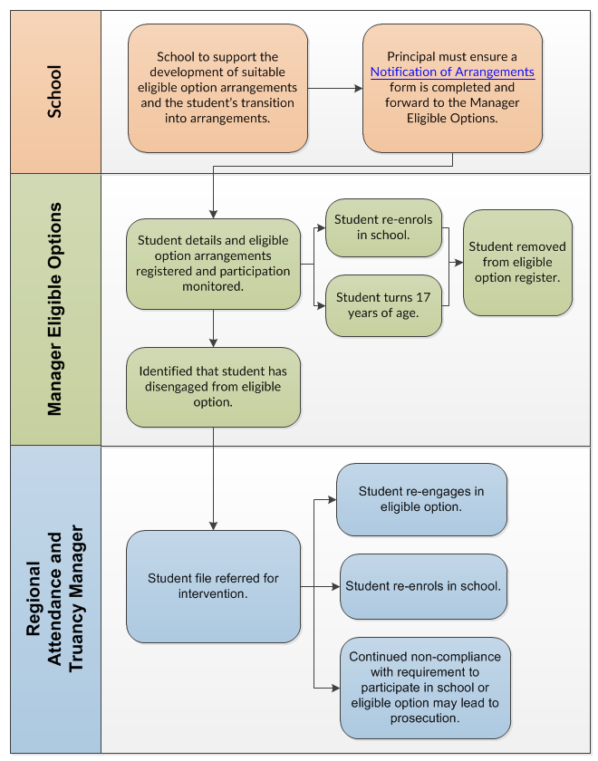

Once a student is registered for an out of school eligible option, it becomes the responsibility of the parent, or student living independently, to complete and submit a new Notification of Arrangements form if or when arrangements change.

Notification of arrangements must continue until the student is 17 years of age.
- ENFORCEMENT MEASURES
Under the Act, as authorised persons, SEOs may apply enforcement measures for non-compliance with the compulsory enrolment requirements.

It should be noted that for students in the compulsory participation phase, enforcement measures can only be applied when it has been identified that a child has not participated in an eligible option for an aggregate or continuous period of three months within a twelve-month period.

5.1 Authorised persons may request information
SEOs conduct public patrols and approach compulsory school aged children during school hours to enquire why they are not in school or participating in an eligible option. During patrols SEOs, as authorised persons, may take the details of compulsory school age children that they approach in order to check their reason for not being in school or participating in an eligible option.

Authorised persons may also call at an address between the hours of 8am and 7pm and request information, from any person 14 years of age or over, regarding the enrolment or eligible option arrangements of any school aged children who usually reside at that address.

5.2 Direction to Enrol
Under section 176 of the Act, SEOs, as authorised persons, can issue a Direction to Enrol to a parent requiring them to enrol their child in a school within 10 school days after the Direction to Enrol is given. Where a student is living independently, the direction to enrol will be issued to the student. When issuing a Direction to Enrol the SEO must:
- clearly explain what the notice means and what the consequences are should they not comply
- provide advice on the process for enrolment and the next steps they should take
- seek information to determine if there are any barriers to enrolment and attendance
- liaise with the school where enrolment is intended.

The Direction to Enrol will state the date by which the child must be enrolled in school. On this date, the SEO should contact the proposed school(s) to determine whether or not the child has enrolled.

If the child has not enrolled, the SEO should then conduct a home visit to determine why. In special circumstances, the SEO may extend the Direction for a further 10 days. However, if the child has not enrolled without a reasonable excuse, the SEO can proceed with issuing an infringement notice.

  - Infringement Notice
An Infringement Notice is a financial penalty for not complying with the Act. It is to provide an incentive to comply with enrolment requirements before possible court action is taken.

Continued non-compliance with the Act may result in prosecution, however this will be a last resort and only used after engagement strategies have been undertaken by the SEO.

  - Prosecution
If the child is not enrolled in a school or engaged in an out of school eligible option despite SEO intervention, prosecution may be considered through the following steps:
- SEOs will refer cases for prosecution to their Student Engagement Senior or Regional Manager
- Student Engagement Senior or Regional Manager will review a case and seek advice from the Manager Prosecutions within Student Engagement
- if a case referred for prosecution is accepted by the Prosecutions Manager, case documentation is forwarded to the Chief Executive or the Minister for their consent
- if approval is obtained, the Prosecutions Manager will work with the Student Engagement Senior or Regional Manager and SEOs in coordinating the prosecution case.

If there is a reasonable prospect of conviction, the parents will be charged and summonsed to appear before the Court of Summary Jurisdiction.

