
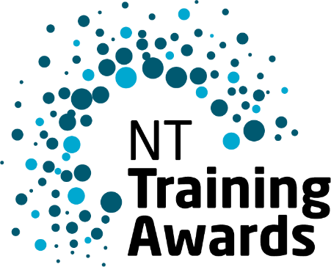

Aboriginal and Torres Strait Islander
Student of the Year
Vanessa Williams
2024 Winner NTTA Aboriginal
and Torres Strait Islander Student of the Year
The Aboriginal and Torres Strait Islander Student of the Year Award recognises
the achievement of an Aboriginal or Torres Strait Islander student who displays a strong understanding and knowledge of the vocational education and training (VET) system and demonstrates the relevance of lifelong learning for themselves and their community.

Eligibility
- Be an Australian citizen or a permanent resident of Australia.
- Identify as being of Aboriginal or Torres Strait Islander descent.
- Meet the criteria of one of the following:
  - Austin Asche Apprentice of the Year Award, or
  - Australian School-based Apprentice or Trainee of the Year Award, or
  - Trainee of the Year Award, or
  - Vocational Student of the Year Award.
- Have completed or be due to complete your VET training in a course within the NT that leads to a nationally recognised outcome or qualification in the period 1 July 2024 to 30 June 2025.
- Meet NT Training Award and Australian Training Awards conditions of entry.
- Ensure availability for compulsory attendance event dates.

Nominating Online
All nominations must be completed through the NT Training Awards portal.
As well as addressing the selection criteria, you must be able to provide the following:
- Confirmation of Aboriginality or Torres Strait Islander descent
- Your course details.
- Employer and or Host employer details (if applicable).
- Registered Training Organisation details.
- Evidence of completion date or early completion date (i.e. certificate of proficiency, signed request for competency-based completion with RTO evidence attached).
- Letters of support and endorsement (suggest from RTO, employer, teacher/trainer etc) – OR - confirmation from your school principal or teacher stating that you are currently enrolled in school at the time of entry submission.
- Additional letters of support – and copies of any certificates, awards or prizes you have received.
You are able to submit up to five (5) supporting documents with your application.

Nominations close
Nominations close at midnight Wednesday 7 May 2025.
For a guide to preparing your application, visit TrainingAwards.nt.gov.au.

Application
In your application, you must clearly address the award criteria. This application will carry through to the Australian Training Awards judging panel if you are successful at the NT awards.
Section A: Overview
This information will not be considered or used for judging purposes, but it may be used as your summary throughout the Awards process.
Provide a short overview covering a description of the qualification you are enrolled in, your registered training organisation and employer and host employer (if applicable) as well as your reason for choosing the industry and training path.
(300 Limit words)

Section B: Selection Criteria
This information will be considered and used for judging purposes.
Criterion 1: Career and Study Achievements (limit: 400 words)
Consider things such as:
- Why did you choose your course?
- How has it changed or impacted on you?
- What have you gained from it?
- Have you had to address any challenges that have impacted on your training?
Criterion 2: Team and communication skills (limit: 400 words)
Consider any skills you have developed through your training, such as:
- What have you been able to tell others, students, mates etc. about your training?
- What do you like about working in a team setting?
- What traits do you think are important to positively influence others?
Criterion 3: Ability to be an Ambassador (representative) for training in Australia (limit: 400 words)
Tell us about:
- Provide examples where you have taken a leadership role inside or outside of training/work.
- What other activities have you been involved in where you have been a representative?
- How would you describe the quality of your training?
Criterion 4: Community Engagement (limit: 400 words)
You may wish to include information about:
- How are you connected with your community/extended family?
- How has the training impacted on your community?
- What qualities do you have or activities you have been involved in that you feel would be useful in your role as Aboriginal Torres Strait Islander of the Year?
- Your achievements in areas other than study and work.

