Sun safety in schools – policy

Contents
1. Introduction 4
2. Business need 4
2.1. School settings 4
2.2. Regulated preschools 4
3. Scope 4
4. School based procedures 4
5. Sun safety and the curriculum 5
6. Sunscreen 5
6.1. Sunscreen allergies 5
7. Heat stress 5
8. Ultraviolet rating 6
9. Roles and responsibilities 6
9.1. School Operations 6
9.2. Principals 6
9.3. Teachers 6
10. Definitions 7
11. Related legislation policy, documents and resources 7
11.1. Legislation 7
11.2. Policy 8
11.3. Documents 8
11.4. Resources 8
Appendix 1 – Australia UV comparison 9

This document should be read in conjunction with the School uniforms and dress codes policy.

Introduction
All Northern Territory Government schools including preschools and Families as First Teachers (FaFT) programs must develop and implement school based procedures in line with this policy to prevent students being harmed through excessive exposure to extreme heat and ultraviolet (UV) radiation.

Business need

School settings
Children are particularly susceptible to heat and ultraviolet (UV) radiation related side effects including sunstroke, heatstroke, dehydration, sunburn, skin damage, and eye damage. To minimise the risk of students suffering from any of the above side effects, a whole school approach to the adoption of sun smart behaviours needs to be demonstrated through procedures developed by individual schools.

Regulated preschools
Most Northern Territory Government preschools operate within scope of the National Quality Framework (NQF) and are assessed and rated by the Regulatory Authority, Quality Education and Care NT. The Education and Care Services National Regulations (National Regulations) form part of the NQF and outline specific requirements and quality standards with which regulated preschools must comply. This includes having sun protection policies and procedures and providing shaded areas in outdoor spaces to protect children from overexposure to extreme heat and UV radiation. Failure to meet these regulatory requirements may result in a compliance direction being issued to the Department of Education (the department). Preschools that are outside of the scope of the NQF must also comply with this policy.

Scope
This policy applies to all Northern Territory Government schools, including preschools and FaFT programs.

School based procedures
It is recognised that sun safety procedures will differ for each school and for the different stages of schooling, however at a minimum, school sun safety procedures must include:
- a dress code that aligns with the Department of Education’s (department) school uniforms and dress codes policy
- prevention of over exposure to the sun
- access to adequate shaded areas
- access to drinking water
- access to sunscreen
- reference to sunscreen application and use.

Responsible staff must ensure students comply with sun safety procedures when students are:
- on school grounds
- participating in school coordinated excursions and events outside the school premises
- participating in services, events or activities operated by the school or the school representative body including out of school hours care or after school sports programs.
To assist schools in developing their individual sun safety procedures, the department has provided a school procedure checklist. Sun safety procedures must be readily available to staff, parents and students.

Sun safety and the curriculum
From transition to year 10, health and physical education forms part of Australian Curriculum delivery. Health and physical education should include student awareness and understanding of the importance of sun smart behaviours, and the implementation of such behaviours while participating in outdoor physical education activities.
Teachers should role model sun smart behaviour to actively encourage students to adopt similar behaviours.

Sunscreen
The provision of sunscreen must be reflected in the school’s sun safety procedures.
Schools may choose to provide sunscreen or develop procedures stating that it is a parental responsibility for sunscreen to be available for student use. Sunscreen should be used during outdoor activities where students are exposed to UV radiation and heat. This includes activities such as recess, lunchtime, outdoor physical education, sports, swimming carnivals and excursions.
Sunscreen for use at school should be SPF30 or higher broad spectrum and water resistant. Where sunscreen is available for sale at the uniform shop or front office, parents may use the Back to School Payment Scheme entitlement.

Sunscreen allergies
Some students may present allergies to sunscreen which should be recorded on their student’s health issues record. As part of a school’s sun safety procedure, the school may seek parental consent regarding the provision and application of sunscreen to ensure that the school is aware of any potential risks posed to individual students. A parent consent template is available on the department’s website.
In the case of an allergic reaction and depending on the information recorded on the student’s health issues record, first aid may be administered by someone who holds a qualified first aid certificate and the student’s parents will be contacted as soon as possible. Refer to the Administration of medications to students with notified medical conditions policy and procedures.

Heat stress
To avoid overexposure to extreme heat, schools should:
- become familiar with Sports Medicine - Australia Beat the Heat playing and exercising safely in hot weather fact sheet and the UV exposure and heat illness guide
- schedule outdoor activities outside the 11 am to 3 pm heat risk period, especially between the months of September and March. Where this is unavoidable, shaded areas should be used
- monitor health and physical education timetable allocation and length of outdoor classes during times of extreme heat, especially between September and March
- provide access to indoor, covered or shaded areas for assemblies, swimming carnivals or sports days, lunchtime and during recess activities
- monitor students and stop a student’s participation if they become distressed from the heat during outdoor physical activities
- engage in heat stress education programs, mentorship and professional development for staff and students on the facilitation of outdoor physical activities in extreme heat
- ensure adequate drinking tap or fountain facilities are available for students.

Ultraviolet rating
When exposed in excessive amounts, UV radiation can cause sunburn, skin damage, eye damage and skin cancer. The World Health Organization's Global Solar UV index 2002 measures levels of UV radiation on a scale from 0 (low) to 11+ (extreme) level.
Schools should monitor their local UV rating by using the Bureau of Meteorology UV index forecast or through local weather forecasts. The Cancer Council recommends that schools engage with sun smart behaviours when the UV index reaches 3 or above.
The UV index in each area of the Northern Territory changes throughout the year, as seen in appendix 1– Australia UV comparison. However, during school hours the UV index across the Northern Territory generally sits at 3 or above. As the UV rating increases, so should precautionary measures in schools.

Roles and responsibilities

School Operations
Directors School Operations are responsible for:
- ensuring schools comply with this policy.

Principals
Principals are responsible for:
- ensuring sun smart procedures are developed and implemented in line with this policy
- ensuring sun smart procedures in line with this policy are reflected uniforms or dress codes policies, as per the departments school uniforms and dress codes policy
- ensuring teachers and educators demonstrate sun smart behaviour as part of a whole school approach
- making procedures available to parents, students and other staff.

Teachers
Teachers are responsible for:
- teaching students about sun smart behaviour through health and physical education lessons and role modelling
- assisting and encouraging students to apply sunscreen when required.

Definitions
Term | Definition
Families as First Teachers programs | The term FaFT programs is inclusive of FaFT/Stay Play Learn.
Infrared radiation - heat | Effects from the heat of the sun can include dehydration, sunstroke and heatstroke.
Parent | Parent means a child’s father, mother or any other person who has parental responsibility for that child, including a person who is regarded as a parent of the child under Aboriginal or Torres Strait Islander customary law or tradition. The definition of a parent does not include a person standing in place of the parent on a temporary basis.
School representative body | An incorporated body under the Education Act 2015 and includes independent public school boards, school councils and joint school representative bodies.
Sun smart role modelling | The demonstration of sun smart behaviour to students, such as wearing hats while in the sun, applying sunscreen, wearing protective clothing and using shaded areas.
School staff | For the purpose of this policy, refers to all adults who have a duty of care to children and young people at the site, school council employees, out of school hours care staff and other adults in the vicinity of children in the department’s care.
Sun smart behaviour | The understanding and practice of procedures which help to reduce the harmful risks associated with too much UV including sunburn and skin cancer. Sun smart behaviours include using:  - a sun protective hat, a wide brimmed hat that shades the head, face, neck and ears  - sun protective uniform or clothing, cool, loose fitting clothing that covers as much skin as practical and has a densely woven fabric  - sunscreen, SPF30 or higher broad spectrum, water-resistant sunscreen  - sunglasses, wrap around style labelled AS1067  - shade, built, natural or portable that creates densely shaded areas.
UV radiation | Radiation that is produced by the sun and some artificial sources.

Related legislation policy, documents and resources

Legislation
- Education Act 2015 - https://legislation.nt.gov.au/Legislation/EDUCATION-ACT-2015
- Education and Care Services National Regulations 2011 (NSW) - https://legislation.nsw.gov.au/view/html/inforce/current/sl-2011-0653
  - Regulation 168 Education and care services must have policies and procedures
  - Regulation 170 Policies and procedures must be followed
  - Regulation 171 Policies and procedures must be kept available
  - Regulation 114 Outdoorspace-shade
- Education and Care Services (National Uniform Legislation) Act 2011 - https://legislation.nt.gov.au/Legislation/EDUCATION-AND-CARE-SERVICES-NATIONAL-UNIFORM-LEGISLATION-ACT-2011

Policy
- Administration of medications to students with notified medical conditions policy and procedures - https://education.nt.gov.au/policies/health-safety/medications
- Excursions policy and guidelines - https://education.nt.gov.au/policies/school-operations
- Preschool specific policy - https://education.nt.gov.au/policies/early-childhood-education-and-care/preschool-specific-policy
- School uniforms and dress codes policy - https://education.nt.gov.au/policies/school-operations

Documents
- Parent consent template - https://education.nt.gov.au/policies/health-safety/sun-safety
- School procedure checklist - https://education.nt.gov.au/policies/health-safety/sun-safety

Resources
- Back to School Payment Scheme - https://nt.gov.au/learning/student-financial-help-and-scholarships/back-to-school-payment-scheme
- Bureau of Meteorology UV Index Forecast - http://www.bom.gov.au/uv/index.shtml
- Cancer Council – SunSmart in school and early childhood - https://www.cancer.org.au/cancer-information/causes-and-prevention/sun-safety/be-sunsmart/sunsmart-in-schools
- Department of Health Therapeutic Goods Administration – Sunscreens information for consumers - https://www.tga.gov.au/news/news/about-sunscreens
- Sports Medicine Australia - Beat the Heat playing and exercising safely in hot weather fact sheet - https://sma.org.au/resources-advice/policies-and-guidelines/hot-weather/
- Sports Medicine Australia - UV exposure and heat illness guide - https://sma.org.au/resources-advice/policies-and-guidelines/hot-weather/
- SunSmart – Resources - https://www.sunsmart.com.au/resources
- World Health Organization's Global Solar UV Index 2002 - https://www.who.int/publications/i/item/9241590076

Appendix 1 – Australia UV comparison
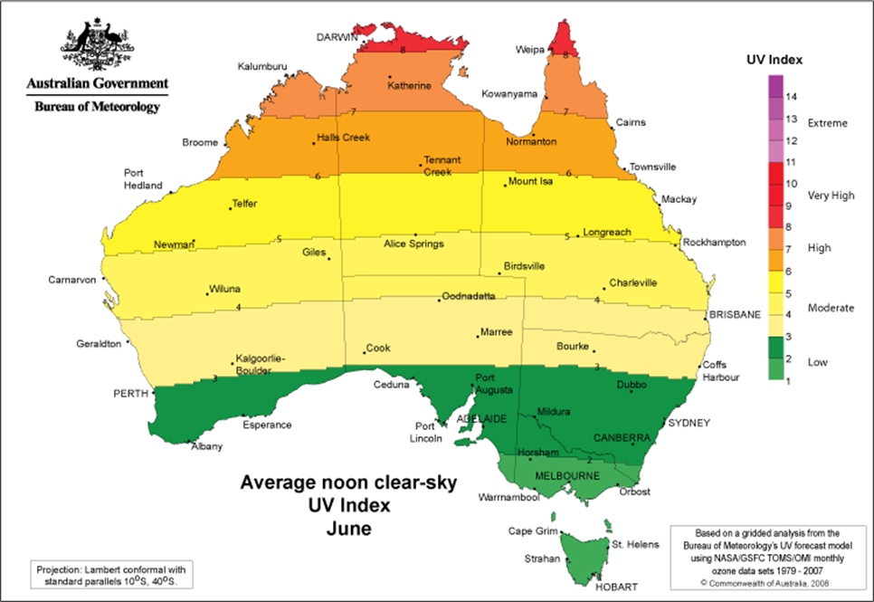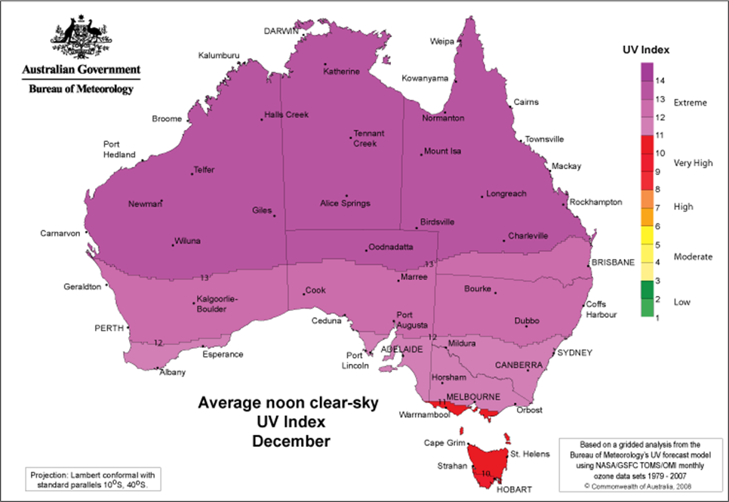

Acronyms | Full form
NT | Northern Territory
SPF | Sun protection factor
UV | Ultraviolet

Document title | Sun safety in schools – policy
Contact details | Inclusion and Engagement Services, Inclusion, Wellbeing Programs and Services swipolicy.doe@education.nt.gov.au
Approved by | Executive Director Inclusion and Engagement Services
Date approved | 30 August 2023
TRM number | 50:D22:107828

Version | Date | Author | Changes made
1 | April 2016 | Student Wellbeing and Inclusion | First release
2 | August 2023 | Inclusion, Wellbeing Programs and Services | Administration amendments to align roles and responsibilities to the structural alignment in effect from 1 July 2022, including NTG template and minor formatting

https://www.legislation.nsw.gov.au/#/view/regulation/2011/653

