ANZAC Spirit Study Tour
By Stephanie Scott

Step 1
Question: What does the enduring relationship between Australians and the people of Villers-Bretonneux teach us about the ANZAC Spirit?
“Private Edwin Need tore off his white armbands in the clear moonlight”, intent on protecting himself from being a target from the Germans. He didn’t want to be visible in any way, particularly as the light from the flames from the village of Villers Bretonneux was “lighting up the whole countryside”. It was a dangerous situation and the Australian troops knew that “there was nothing to do but go straight forward and die hard [14]”.
Private Need was part of the 15th Brigade of the Fifth Australian Division who had been assigned to protect Villers Bretonneux, a village located east of Amiens in France. It had been situated at the rear of the action with French troops coming and going and the inhabitants staying in the village. “It was not until the German offensive in Picardy that Villers-Bretonneux became a central location for the fighting”. The Germans attacked the town on the 5th of April hoping to use it as a stepping stone to taking Amiens which was in a strategic position for the Germans. The village found itself at the center of violent battles which caused a tremendous amount of destruction.
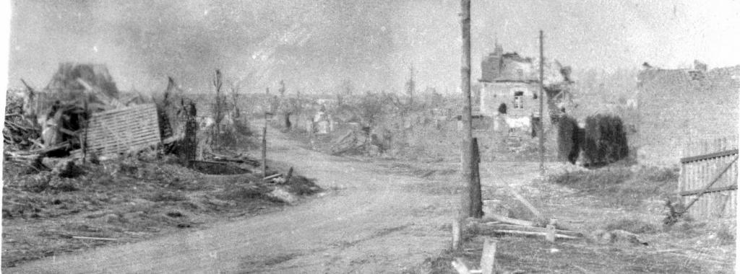 [13]
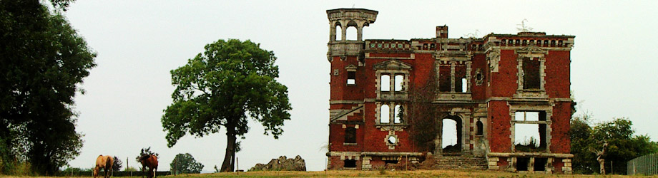 [12]
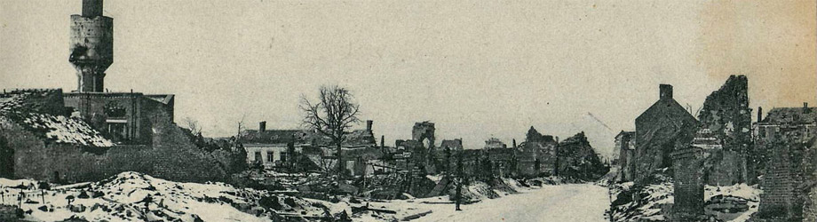
The Australians were asked to defend the village and it was not unnoticed that the day that the offensive occurred was the eve of ANZAC day. It must have been symbolic to the Australian soldiers that on this day they were going to sacrifice themselves to protect others just as the men at Gallipoli did three years before. The people of Villers-Bretonneux also must have felt threatened, afraid and vulnerable, knowing that they were the next objective of the German forces in their relentless momentum towards the sea. The Australians put all their force and ANZAC spirit into the battle forcing “many of the Kaiser’s top-line troops to flee and surrender” [11].
On this day “British general Henry Rawlinson wrote in his diary: “The Australian counter-attack … succeeded beyond my expectations. We have, by dusk, recaptured the whole of Villers-Bretonneux ... The 15th and 13th Australian brigades did brilliantly, especially the former, attacking round the north of the village. … The counter-attack was exceedingly well carried out by the Australians.” [11]
The ANZAC spirit was shown in the “endurance, courage, ingenuity, good humour, larrikinism, and mateship” [10] of the troops who fought this battle. The odds of winning the battle were very poor and the Australians required a lot of courage to continue in their path. “Australian official war correspondent Charles Bean, who was nearby when the attack happened, wrote in his diary: "I don't believe they have a chance… I went to bed thoroughly depressed ... feeling certain that this hurried attack would fail hopelessly.”[9]
Historian Ross McMullin, who wrote a biography on General Elliot, says he wanted to attack right away after the Germans captured the town [3]. This shows the bravery and courage of the Australian leadership when initiating the conflict. The Australian soldiers showed the ANZAC spirit of courage, lack of fear and were relentless in the battle. The people of Villers-Bretonneux responded with thankfulness. The mayor wrote “Soldiers of Australia, whose brothers lie here in French soil, be assured that your memory will always be kept alive, and that the burial places of your dead will always be respected and cared for…”[17]
Looking down the years to 2017, this act of courage and bravery by the Australian troops has been remembered in both Australia and in France. In Villers-Bretonneux there are numerous military cemeteries, memorials and events which remind the villagers of the debt they owe to the Australian troops. In the local school there is a large sign which says “Do not forget Australia” to teach the children of the events in World War 1 which affected their ancestors. This year almost 3000 people remembered the act of courage at a dawn service at the Australian National Memorial near Villers-Bretonneux.
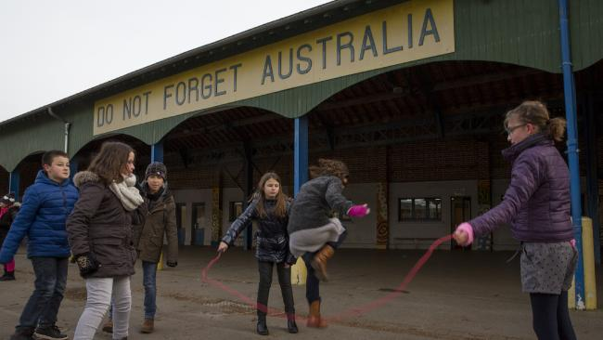[8]
In return, Australia has maintained strong links with the community, donating money to build a school building and sending delegations to keep the friendship alive between the village and Australia. One member of a delegation, in the ANZAC spirit of larrikinism, left a footy at the grave of one of the soldiers because her great grandfather had died there and she knew he liked football. [16] When strolling down the centre of town an Australian flag flies in remembrance of the ANZAC spirit displayed by the Australian soldiers.
When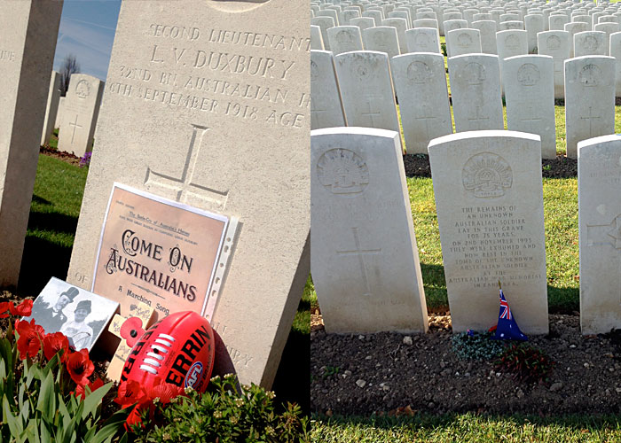 [16]
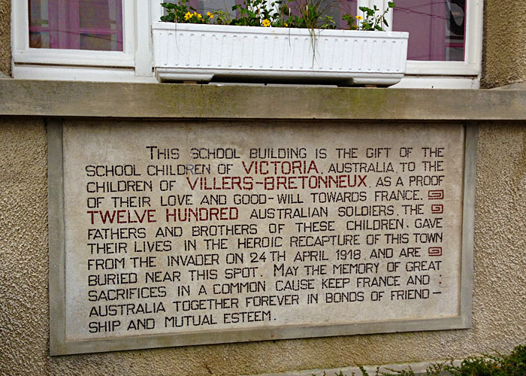 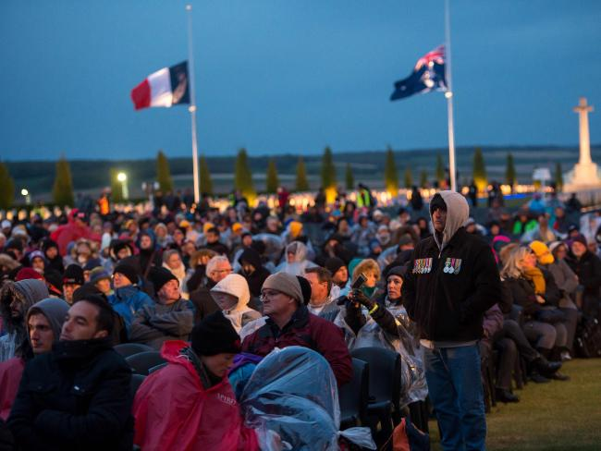[7]
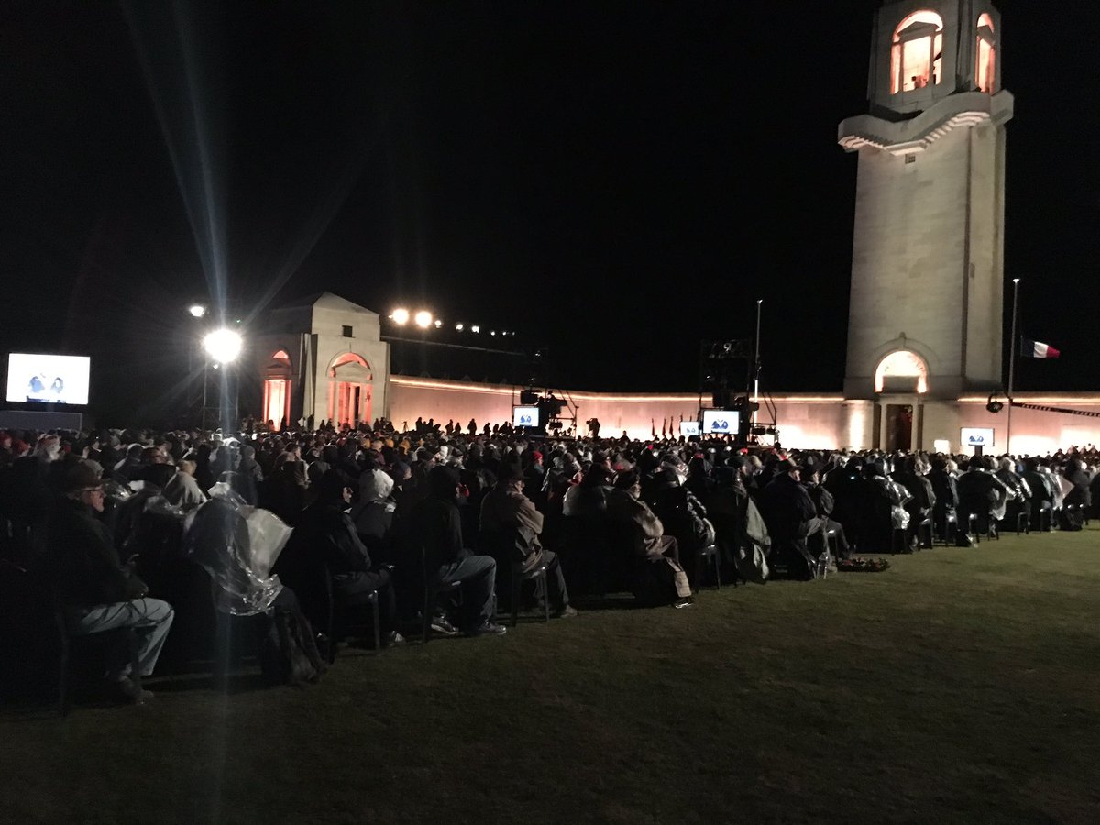[6]
Edwin Need survived that night of fighting for the Australian Army. He went on to live a full life in Australia and told his story in a diary which is now kept in the Australian War Memorial, as a record of the ANZAC spirit he possessed. Unfortunately others did not make it. Another Edwin (Barnes) died that night at Villers-Bretonneux sacrificing his life for his mates, his country and for the people of Villers-Bretonneux. His body is buried in Panel 118 at the Villers-Bretonneux Memorial where visitors can lay a poppy commemorating the wonderful ANZAC spirit he had when he died. [15] For those who lived or died fighting the battle of Villers-Bretonneux, we are taught that these men and their values of endurance, courage, ingenuity, good humour, larrikinism, and mateship are timeless and significant. The ANZAC spirit lives on in the wonderful friendship and mutual assistance given by the Australian and French people to each other when remembering the Australian soldiers’ deeds.
Lest We Forget

Word count: 909

References
- http://thegreatworldwar.weebly.com/how-it-all-began.html
- http://aenet.esuhsd.org/citizenship_lessons/connie/wwI_q.html
- http://www.abc.net.au/news/2014-06-06/battle-of-villers-bretonneux/5497598
- http://www.smh.com.au/entertainment/books/it-was-like-hell-let-loose-tales-from-the-wwi-front-line-in-peter-fitzsimons-new-book-victory-at-villersbretonneux-20161026-gsbdmn.html
- http://www.picardie1418.com/fr/transversales/villers-bretonneux-dans-la-grande-guerre.php
- http://www.news.com.au/national/anzac-day-2017-dawn-services-and-marches-in-australia-and-overseas/news-story/4b09dbf1315e0b9fd7f08e1ee6ef68c7
- http://www.abc.net.au/btn/story/extracontent/2013/anzacstory/photos/victoriaschoolsign1.jpg
- http://cdn.newsapi.com.au/image/v1/821e5b2d8b990670b5281534239c1685?width=650
- http://www.abc.net.au/news/2014-06-06/battle-of-villers-bretonneux/5497598
- https://en.wikipedia.org/wiki/Anzac_spirit
- http://www.theaustralian.com.au/arts/review/victory-at-villersbretonneux-latest-in-peter-fitzsimonss-trilogy/news-story/e3085588b8c05f9497d1fad7d2ceb5d0
- http://www.picardie1418.com/fr/transversales/villers-bretonneux-dans-la-grande-guerre.php
- http://www.somme14-18.com/event/villers-bretonneux-grande-guerre-reconstruction
- http://www.smh.com.au/entertainment/books/it-was-like-hell-let-loose-tales-from-the-wwi-front-line-in-peter-fitzsimons-new-book-victory-at-villersbretonneux-20161026-gsbdmn.html
- https://www.awm.gov.au/collection/R1634565/
- http://www.abc.net.au/btn/story/s3784919.htm
- https://twoinfrance.com.au/places/villers-bretonneux-and-australia/#7/48.772/2.637

