Emergency management plans for schools - procedure

Contents
1. Introduction 3
2. Procedures 3
2.1. Developing an Emergency management plan 3
2.2. Information required in an Emergency management plan 4
2.3. Emergency management plan template for schools 5
2.4. Principal’s checklist 5
3. Legal obligations 5
3.1. Legal obligations 5
3.2. Access to school premises – right of entry 5
4. Communications 6
4.1. Reporting 6
4.2. Media 6
4.3. Students and the media 6
4.4. Parents 6
5. Roles and responsibilities 7
5.1. Directors School Operations 7
5.2. Principals 7
5.3. Principals operating a preschool regulated under the National quality framework 8
5.4. Principals of schools designated as a public emergency shelter 8
5.5. School staff 8
6. Definitions 8
7. Related legislation, policy and references 10
7.1. Legislation 10
7.2. Policy 10
7.3. References 10
Appendix A: Summary of emergency management plans information 11
Appendix B: Principal’s checklist – Emergency management plan 12

Read this document with the Emergency management school preparedness policy.

Introduction
These procedures are designed to assist all Northern Territory (NT) Government schools to develop an Emergency management plan. Emergency management plans are required for all schools and can reduce the likelihood of emergencies and critical incidents from occurring, and minimise the impact of these situations on the wellbeing of students, staff and the operation of the school.
In order to properly prepare for emergency events, it is essential for schools to have an understanding of the potential hazards that their school community faces and ensure they have:
- prevention and risk mitigation programs for emergencies and critical incidents
- response and recovery plans to deal with ongoing identified potential risk
- clear responsibilities for controlling and coordinating emergency management at their school and allocating support roles
- cooperation between emergency services and other services that may be critical during an emergency event or critical incident
- efficient and coordinated approaches to the use of resources
- arrangements in place to help the school community to recover from the emergency.
In the event of an emergency schools must:
- call 000 immediately to report any incident threatening life or property. Emergency services on this number are:
- police for crime or injury that may not be accidental or that may constitute assault
- ambulance for injury and medical assistance
- fire brigade for fires and incidents involving hazardous and dangerous materials. Report all fires where the alarm has been activated, regardless of state or size, even if extinguished, as this may pick up important issues regarding current practices relating to fire, potential hazards, and community or public safety issues
- notify the relevant Director Regional Services, School Operations as soon as possible
- notify Quality Education and Care Northern Territory (QECNT) within 24 hours if the incident has occurred at the preschool or involves a child enrolled at a preschool.
There may be other situations which disrupt the provision of essential services and in these instances the Contingency plans developed by schools should be activated to minimise disruption to school operations and avoid needing to send students away from school. Contingency plans must be identified and documented within an Emergency management plan.
Temporary school closures are a last resort and will only be endorsed in accordance with the Temporary school closures guidelines.

Procedures

Developing an Emergency management plan
Emergency management plans are essential in preventing and managing critical incidents and emergencies when they occur and must be based on an assessment of risks present for the school.
Emergency management plans must be tailored to prevent, prepare, respond and recover to these risks, should they occur. The flowchart below refers.
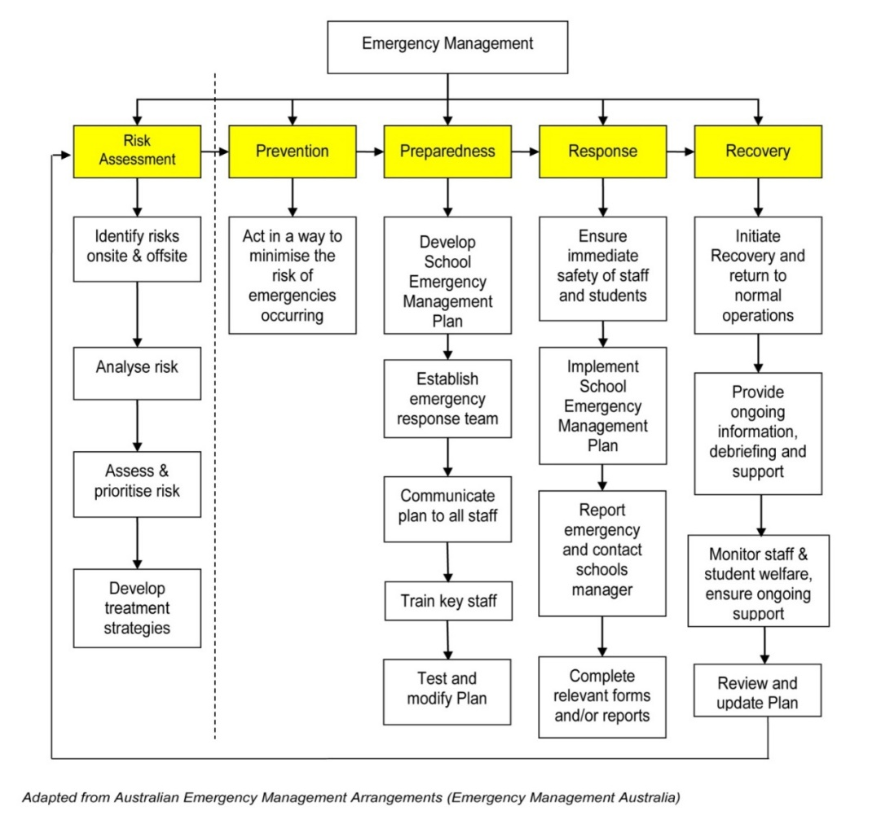

Information required in an Emergency management plan
Information contained in Emergency management plans must be based on the individual needs of the school, students and staff. Refer to the Summary of emergency management plans information within this procedure. Emergency management plans must be:
- based on the individual needs of their school
- reviewed regularly to ensure the content contained is up-to-date and accurate
- accompanied by training and communication to staff and students to ensure a thorough understanding of the actions that they will be required to take in an emergency situation
- visually displayed in a location that is accessible during an emergency
- encompass strategies to ensure that students and staff with disabilities or requiring assistance during an emergency are clearly identified
- specific about the allocation of responsibilities during an emergency to people with relevant skills and training.

Emergency management plan template for schools
The Emergency management plan template for schools can be used as a useful resource for principals when undertaking planning. This template provides guiding notes for the preparation of an emergency management plan and acts as a guide to assist schools to record relevant information for use in an emergency situation.

Principal’s checklist
Principals must complete the Principal’s checklist and attach this to their Emergency management plan. The Principal’s checklist assists schools to ensure their obligations have been met.
Plans will not be endorsed by the Director School Operations unless the Principal’s checklist is included.

Legal obligations

Legal obligations
Emergency preparedness for the department occurs at a number of levels:
- emergency management framework is planning at the department level
- emergency management plans is planning at the school level
- specialist plans may include health and safety procedures or a flood plan.
Emergency management plans are not intended to conflict with the legal obligations of schools and other workplaces such as those imposed under the Work Health and Safety (National Uniform Legislation) Act 2011 or standard duty of care responsibilities for school staff. Implementation of operational plans does not absolve schools, workplaces or individuals from complying with existing legal obligations.

Access to school premises – right of entry
Emergency situations may increase the presence of those not required or wanted on school grounds. This could include onlookers, media or other community members who do not have a reasonable purpose for being on school grounds. No one has automatic right of access to school property. Permission from the principal must be obtained before access is granted.
If required, principals can contact NT Police to assist with prohibiting or restricting access to school premises.

Communications

Reporting
All emergencies must be reported as soon as possible to the relevant emergency service. Schools must contact the appropriate Director School Operations to:
- discuss actions to be taken in response to the incident
- determine the types and levels of support required
- consider potential legal and media issues and determine whether a newsflash or other follow-up is required
- ensure that when an incident occurs, an electronic Work Health and Safety (WHS) incident report form is completed within 24 hours, including injuries, hazards and near misses involving staff.

Media
The department’s Communications unit has overall responsibility for all media liaison, including contact with journalists, and any contact with media outlets must be managed in accordance with the department’s Media liaison policy. Principals and department staff must ensure that they comply with these requirements.

Students and the media
Critical incidents and emergencies are stressful situations and it is appropriate for the principal to protect the students from unwarranted interviews with the media. Students are not permitted to give interviews at the school or on behalf of the school or department and should be strongly discouraged from making private arrangements to be interviewed.

Parents
Communication to parents through letters or newsletters will provide information on the disruption to the normal school program. Principals should engage the assistance of the department’s Communications unit when preparing correspondence to the school community following a critical incident or emergency.
In the event of a student death, a letter to parents or carers of the students class or year level should be sent home by the principal as soon as possible, preferably on the day of or the day following, advising them of the incident. Parents need to be aware of behavioural changes they may notice and be encouraged to provide support and to seek help. It is important for schools to have established relationships with local service providers who offer support for students in these circumstances. The departments Student Inclusion, Wellbeing Programs and Services branch can provide assistance in these circumstances. Local service providers can be engaged by the school or relevant details provided to parents to allow them to access support if necessary.
Adolescents often look to their peers for support and families need to be informed that this is normal. Counselling support will usually be provided depending upon the incident. School staff, in consultation with the department and local service providers would arrange for appropriate support for both students and staff. The Student Inclusion, Wellbeing Programs and Services branch can assist in arranging assistance for students through relevant service providers, such as Headspace.

Roles and responsibilities

Directors School Operations
Directors School Operations will:
- ensure that principals have adhered to the requirements of this policy
- approve all emergency management plans for schools within their region
- maintain a current copy of the emergency management plans for schools in their region in case of an emergency event or critical incident
- assist schools affected by emergencies and critical incidents with advice and support
- ensure all plans are uploaded to the departments Territory Records Management (TRM) prior to the commencement of term 1.

Principals
All principals will:
- develop and implement their school’s Emergency management plan, including contingency plans to manage disruptions to normal schooling
- ensure that the development of the Emergency management plan is based on:
- consideration of the management of foreseeable risk
- current work health and safety guidelines
- the current Territory emergency plan
- ensure that consultation has occurred with local Police, Fire and Emergency Services in the development and risk management phases
- submit their school’s Emergency management plan to the Director School Operations for endorsement
- ensure that staff, particularly new and temporary staff, students and the school community know what the plan contains and its location, and are trained appropriately in preparation for an emergency
- develop training schedules in their schools through provision of on-site training and regular rehearsals of procedures
- develop Personal Emergency Evacuation Plans (PEEP) for all relevant staff and students
- make decisions regarding the welfare of the school and relating to the management of an emergency or critical incident, which may include the closure of school facilities. School closures must be in accordance with the Temporary school closure guidelines
- provide leadership for the response and recovery that is relevant to the emergency or critical incident
- ensure ongoing student and staff wellbeing during and following an emergency or critical incident occurring.

Principals operating a preschool regulated under the National quality framework
Principals operating a preschool regulated under the National quality framework will:
- notify QECNT:
- within 24 hours of a critical incident occurring or the time that the principal becomes aware of the incident
- following an incident occurring that requires a preschool to close or reduce the number of children attending
- within 7 days of an event, or the department being made aware of an event that poses a risk to the health, safety or wellbeing of a child attending the preschool.

Principals of schools designated as a public emergency shelter
Principals of schools designated as a public emergency shelter will:
- ensure appropriate plans are in place to manage the shelter in the event of an emergency as detailed in the Emergency management public emergency shelter responsibilities policy.

School staff
All school staff will:
- ensure that their own personal safety and the safety of others is paramount and not place themselves in a situation likely to cause injury or harm
- ensure that they are familiar with their school’s Emergency management plan, including their responsibilities during an emergency or critical incident.

Definitions
Term | Definition
Contingency planning | Procedures that minimise disruption to normal school operations when supply of services such as air conditioning, power or water is interrupted and the possible downtime cannot be forecast with accuracy.
Critical incident | Any event which causes disruption to the school, creates significant danger, risk or likelihood of traumatic effects and creates a situation where staff, students and parents experience trauma, feel unsafe, vulnerable or under stress. Critical incidents may:  - be extremely dangerous or distressing  - be sudden and unexpected  - be disruptive to one’s sense of control, security and safety of the situation around them  - include high levels of risk  - include elements of physical or emotional loss or risk of loss.
Emergency | Encompasses a range of events which could otherwise be described as incidents, accidents, catastrophes, disasters or crises. An emergency embraces the range of terms frequently used to describe an event, actual or imminent, which endangers or threatens to endanger life, property or the environment and which requires a significant and coordinated response. In the context of schools in the NT, an emergency includes, but is not restricted to:  - bomb threat  - collapse or major damage to building or equipment  - disappearance or removal of student or staff  - fatality, serious injury, serious assault or sexual assault of student or staff  - fire in school building or grounds, arson or bushfire  - flood or wind storm or other natural event, for example, cyclone  - fumes, spill, leak or contamination by hazardous material  - outbreak of disease or pandemic  - siege, hostage or firearms  - civil or political events, for example, acts of terrorism, large scale riots  - air-conditioning or air quality failure.
Emergency preparedness | Planning and preparation of processes to be undertaken to prevent or manage an emergency or critical incident. The core aspects of emergency preparedness and continuity management recognised by Emergency Management Australia and the NT Government are:  - Prevention: measures to identify risks and eliminate or reduce the incidence or severity of emergencies.  - Preparedness: measures to ensure that communities are capable of coping with the effects of emergencies.  - Response: measures taken during and immediately after emergencies to ensure the effects are minimised and appropriate responses are initiated.  - Recovery: measures that support resumption of business as usual as soon as possible after an incident has occurred. This includes a review of the effectiveness of the responses to adjust processes as necessary to improve emergency management.
Emergency management plans | Detail assigned responsibilities and procedures required in the event of an emergency or critical incident.
Directors Regional Services, School Operations | When referred to in this procedure, are those who provide operational advice and services to schools.
National quality framework | The regulatory system agreed to by all Australian governments, through the Council of Australian Governments, to raise quality and drive continuous improvement in early childhood education and care services, including preschools.
Newsflashes | Succinct briefings that provide critical information to the department’s Chief Executive and the Minister’s office. The department’s Communication unit and Deputy Chief Executives are also notified of information through this process.
Parent | A child’s father, mother or any other person who has parental responsibility for a child under Aboriginal or Torres Strait Islander customary law or tradition. The definition of a parent does not include a person standing in place of the parent on a temporary basis.
QECNT | Refers to the NT regulatory authority responsible for administering the Education and Care Services (National Uniform Legislation) Act 2011 and Regulations.
School | Includes preschool and the land area up to the school boundaries.
School staff | Includes any person responsible for the operations or education services at a school. This can include contractors, visitors or volunteers.

Related legislation, policy and references
Additional resources can be found on the department’s Emergency management site, staff access only.

Legislation
Work Health and Safety (National Uniform Legislation) Act 2011 - https://legislation.nt.gov.au/Legislation/WORK-HEALTH-AND-SAFETY-NATIONAL-UNIFORM-LEGISLATION-ACT-2011
Education and Care Services (National Uniform Legislation) Regulations 2011 - https://legacy.legislation.nsw.gov.au/#/view/regulation/2011/653

Policy
Emergency management school preparedness policy - https://education.nt.gov.au/policies/school-operations#emergency_management
Media liaison policy - http://ed.ntschools.net/documentcentre/Pages/home.aspx?category=Corporate%20communications&subcategory=Media
Temporary school closures guidelines - https://education.nt.gov.au/policies/school-operations#emergency_management

References
Image within procedure: Adapted from the Emergency Management Hub, © Commonwealth of Australia 2012 - https://data.gov.au/data/user/emknowledge

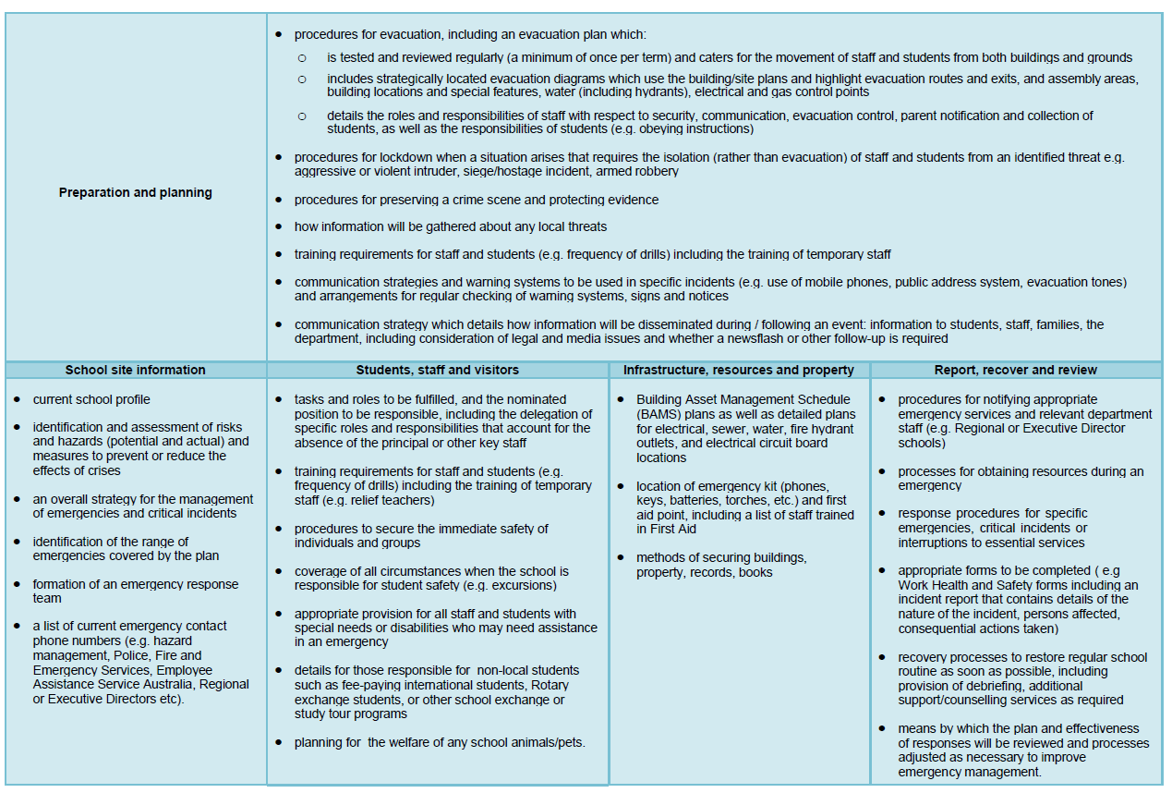
Appendix A: Summary of emergency management plans information

Appendix B: Principal’s checklist – Emergency management plan
School |  | Date
Action |  | Yes/No | Comments
Have emergency contact numbers been confirmed with relevant emergency services |  | Y/N
Has a risk assessment been conducted to identify potential emergencies that are relevant for the school and preschool |  | Y/N
Are the emergency contact numbers prominently displayed in this plan and in readily accessible areas of the school |  | Y/N
Does the plan clearly specify procedures for reporting emergencies to the emergency services, to the department and in relation to preschools Quality Education and Care NT |  | Y/N
Are potential risks within and up to a kilometre from the school identified |  | Y/N
Does the plan include procedures for issues specific to your school or community |  | Y/N
Are alternative evacuation assembly areas listed including one at least a kilometre from the school |  | Y/N
Does the plan identify how food, shelter, toilets will be provided during an extended evacuation |  | Y/N
Is a site plan included which displays emergency exits, access roads, water, gas and electricity supply points |  | Y/N
Does the site plan show the location of fire extinguishers, hose reels, hydrants, alarms and evacuation exits |  | Y/N
Does the plan include procedures for lockdown of the school when a situation requires isolation rather than evacuation |  | Y/N
Are the roles and responsibilities of key personnel clearly defined - principal as emergency coordinator, school leadership team, classroom teachers, preschool teacher-in-charge, office and support staff, and students |  | Y/N
Are staff responsibilities to account for and supervise students during and following the emergency clearly described |  | Y/N
Does the plan identify strategies to ensure students, staff and visitors with disabilities, or requiring assistance during an emergency, are clearly identified including the preparation of Personal emergency evacuation plans were necessary |  | Y/N
Does the plan describe how individuals will receive counselling or other specialist support |  | Y/N
Does the plan include additional procedures with regard to fee paying international students or those participating in exchange or study tour programs |  | Y/N
Does the plan describe minor works or repairs required for fire prevention purposes and propose a timetable for their completion |  | Y/N
Does the plan describe how staff will be trained, when procedures will be rehearsed and how principals will record participation in training |  | Y/N
Has the plan been developed in consultation with local NT Police, Fire and Emergency Services |  | Y/N
Are arrangements for reviewing the plan described |  | Y/N
Has the plan been endorsed by the Director School Operations |  | Y/N
Further information
Once completed, please send form to schoolops@education.nt.gov.au

Acronyms | Full form
NT | Northern Territory
QECNT | Quality Education and Care Northern Territory
PEEP | Personal Emergency Evacuation Plans
WHS | Work Health and Safety

Document title | Emergency management plans for schools - procedure
Contact details | Agency Services, Emergency Management and Security odce.agencyservices@education.nt.gov.au
Approved by | Deputy Chief Executive, Agency Services
Date approved | 21 February 2023
TRM number | 50:D22:108618

Version | Date | Author | Changes made
1 | November 2015 | School Support Services | EDOC2018/93765
2 | February 2023 | Emergency Management and Security | Administrative amendments made to align roles and responsibilities to the structural alignment in effect from 1 July 2022 including NTG template and minor formatting.

