A first aid guide for education and children’s services

Seizure–major generalised
(including use of intranasal midazolam)

NOTE time of seizure onset

CALL AMBULANCE IF:
 Injury suspected  Breathing difficulty
 Required by person’s health support plan

PROTECT from injury
DO NOT restrict movement
LEAVE IN WHEELCHAIR/SEAT/PRAM if this is the site of seizure onset
REMOVE objects which may cause harm
DO NOT attempt to put anything into the mouth during seizure

MONITOR airway–support jaw if needed

GENTLY roll onto side (RECOVERY POSITION) as soon as able
LEAVE IN WHEELCHAIR as long as a clear airway can be maintained

CONVULSIVE ACTIVITY
lasts for more than 3 minutes (child)/
5 minutes (adult)
CONVULSIVE ACTIVITY
stops within 3 minutes (child)/
5 minutes (adult)

CALL AMBULANCE GIVE MIDAZOLAM AS
PRESCRIBED into the nose
RETURN to recovery position

OBSERVE: Airway Breathing Signs of life

SEIZURE ACTIVITY RESUMES

RESUME ACTIVITY AFTER FULL RECOVERY (within an hour)*

RECORD *If still recovering after one hour seizure activity in INFORM EMERGENCY CONTACTS individual seizure log to arrange recuperation at home

See over for details on administering intranasal midazolam (INM)

TO CALL AMBULANCE: Dial out, then 000 or mobile 112
Say what state you are calling from, the person’s condition and location
INFORM EMERGENCY CONTACTS in accordance with DECS guidelines

Department of Education and Children’s Services SA with expert advice from Australian Red Cross SA Division and St John Ambulance Australia SA Inc, 2007 and The Epilepsy Centre SA

Pre- requ is ite s fo r sa fe f i rs t aid a d min i s t ration o f in tranasa l mid a zo la m (INM)

 The person administering intranasal midazolam requires knowledge of basic first aid and seizure
management, and to be authorised to administer by their employer/agency/service.
 The person for whom INM is ordered must have had a previous dose of midazolam without adverse
effect.
 Only a plastic ampoule containing 5mg in 1ml can be used.
 If midazolam is given in school, preschool or child/care, an ambulance must be called.
 Refer to the person’s seizure care plan and seizure first aid plan.

Giving in tra n asa l mid a zo la m ( I NM )

1. Note time of onset of seizure
2. Check administration details on signed specialist authority
3. Check that the medication authority matches label on box
1
4. Check expiry date on ampoule
5. Check ampoule is 5mg in 1ml

6. Decide which side of person to work from (person’s head to your left if you are right handed)
7. Turn person on back with head slightly extended, or position in
2 wheelchair so head is back and airway open
8. Twist top off ampoule, and invert

9. Squeeze ampoule to drop out 1-3 drops into each nostril until ampoule empty. If movement marked, go more slowly 1 drop at a time to get into nose. Don’t rush; the first few drops should help
3 slow seizure so other drops are easier to get in
10. As soon as practicable, turn person onto side in recovery position or support head in wheelchair, maintain clear airway

11. Note time seizure stops
12. Stay with the person; follow the standard first aid practice until ambulance arrives (follow person’s health care plan re calling
4 ambulance)
13. Keep empty ampoule to give to ambulance officers
14. Nothing by mouth until the person starts conscious movements, (gag reflex is reduced)
15. Document.

TO CALL AMBULANCE: Dial out, then 000 or mobile 112
Say what state you are calling from, the person’s condition and location
INFORM EMERGENCY CONTACTS in accordance with DECS guidelines

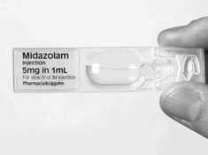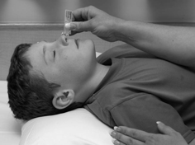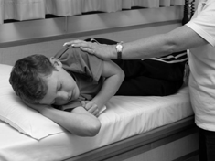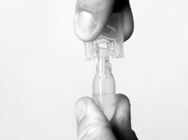

Department of Education and Children’s Services SA with expert advice from Australian Red Cross SA Division and St John Ambulance Australia SA Inc, 2007 and The Epilepsy Centre SA

