1. **POLICY**

The department recognises the importance of parent and community member involvement in school decision making through the establishment and effective operation of school representative bodies. The [*Education Act*](https://legislation.nt.gov.au/en/Legislation/EDUCATION-ACT)(the Act*)* and [Education Regulations](https://legislation.nt.gov.au/Legislation/EDUCATION-REGULATIONS) (the Regulations) provide the legal basis for school representative bodiesto be established in Northern Territory (NT) Government schools.

There are three types of school representative bodies in the NT:

|  |  |
| --- | --- |
| **School council** | a body of school and community members representing a Government school |
| **Independent public school board** | a body of school and community members representing a Government school that is an independent public school |
| **Joint school representative body** | a body of school and community members representing two or more Government schools. |

School representative bodies enable parents, teachers, the principal, invited members and students (in secondary schools) to work collaboratively to achieve the best educational outcomes for students in their communities. As community input is important for every school, if a school representative body does not exist, principals must take reasonable steps each year to establish one.

In circumstances where it is not possible for a school representative body to be established, a school management council manages the financial responsibilities of the school. In this situation, principals may also establish a parent consultative group to ensure that parents have an opportunity to provide input on decisions that impact their child’s education.

All school representative bodies, school management councils and parent consultative groups need to comply with the Act and Regulations. This policy and associated guidelines will assist school representative bodies, management councils and groups adhere to their obligations.

* 1. **SCHOOL REPRESENTATIVE BODIES**

A school representative body is an incorporated body under the Act and, therefore, is its own legal entity. This means its functions, responsibilities and obligations are governed by the Act and Regulations.   
  
**Constitution**

All school representative bodies must have a constitution that governs the way in which they operate. Each school representative body must use the department’s model constitution. The rules in the model constitution are explained in the [School Representative Body Constitution guidelines.](https://education.nt.gov.au/education/policies/school-representative-bodies)

**Functions**

The Act gives a school representative body its powers and functions, listed at Appendix A.

|  |
| --- |
| **School council** |
| A school council is the most common type of representative body established in NT Government schools. A school council will work with school staff to establish the school’s vision, determine priorities and ensure the school is responsive to the needs of its community. The council has financial, strategic and advisory functions and works in partnership with the school principal. |
| **Independent public school board** |
| Independent public school boards are recognised by the Act as being accountable to their local communities for the achievement of educational outcomes for children and young persons in those communities. Boards have the same authority and functions as school councils, with some increased flexibility.  A board has a greater focus on strategic improvement, monitoring and accountability than a council. There is a greater level of transparency required in the board’s actions and decisions. |
| **Joint school representative body** |
| A joint school representative body provides shared advisory and strategic functions over the schools, although it does not have the financial functions that a council or board have. If a school forms part of a joint body, the individual school must have a school management council to perform the financial functions. |

* 1. **OTHER AVAILABLE STRUCTURES**

|  |
| --- |
| **School management council** |
| A school management council is not a school representative body. It is established where a school representative body does not exist and is created to carry out the financial responsibilities for the school. A school management council will usually consist of one member, generally the school principal. The Minister can appoint other persons where necessary. |

|  |
| --- |
| **Parent consultative groups** |
| A parent consultative group is not a school representative body. Principals can establish a parent consultative group when a school management council exists, or when it is in the best interests of the school community.  A parent consultative group gives parents the opportunity to provide input on decisions that impact their child’s education in circumstances where it is not viable to establish a school representative body. The group can consist of parents and community members served by the school.  A parent consultative group is unincorporated and acts as an advisory group to the principal, rather than as a decision making group. Being unincorporated means it does not have financial powers and responsibilities, which are instead carried out by the school management council. |

1. **BUSINESS NEED**

The department recognises the importance of productive partnerships between schools and community and is committed to ensuring parents and their local communities are represented in the governance of their schools. Departmental guidance will assist schools manage the governance requirements of a school representative body, school management council and parent consultative group.

1. **SCOPE**

The policy and associated guidelines apply to all NT Government schools. They set out the available legal frameworks for school governance and community involvement in school decision making.

1. **DEFINITIONS**

**Invited member** means a person who is invited to be a member of the school representative body who meets the requirements of Regulation 22(7) and who has accepted the invitation.

**Parent** is a child’s father, mother or any other person who has parental responsibility for the child, including a person who is regarded as a parent of the child under Aboriginal and Torres Strait Islander customary law or tradition.

**School community** means the teaching staff, parents, students and other persons who have a direct involvement or interest in the school.

**Parental responsibility** of a person signifies that the person:

1. has daily care and control of the child, or
2. is entitled to exercise all the powers and rights in relation to, and has full responsibility for all aspects of, the long-term care and development of the child, or
3. has daily care and control of the child, and the entitlement and responsibilities mentioned at (b)

and includes a person who has been given the above responsibilities under another state or territory law.

**School community** means the teaching staff, parents, students and other persons who have a direct involvement or interest in the school.

**School staff** means the teachers and department staff employed at the school.

1. **RELATED POLICY, LEGISLATION AND DOCUMENTS**

Legislation and regulations

* [Education Act](https://legislation.nt.gov.au/Legislation/EDUCATION-ACT) and [Education Regulations](https://legislation.nt.gov.au/Legislation/EDUCATION-REGULATIONS)

Department policy and guidelines

* [School Representative Body Constitution guidelines and model constitution](https://education.nt.gov.au/education/policies/school-representative-bodies)
* [Establish and abolish a school representative body procedures](https://education.nt.gov.au/education/policies/school-representative-bodies)
* [School Council guidelines](https://education.nt.gov.au/education/policies/school-representative-bodies)
* [School Management Council guidelines](https://education.nt.gov.au/education/policies/school-representative-bodies)
* [Parent Consultative Group guidelines](https://education.nt.gov.au/education/policies/school-representative-bodies)

1. **EVALUATION**

Regional Directors and principals are responsible for the ongoing monitoring of performance and compliance of school representative bodies in line with this policy and department guidelines, the Act and the Regulations. The policy and guidelines are to be reviewed in accordance with departmental requirements.

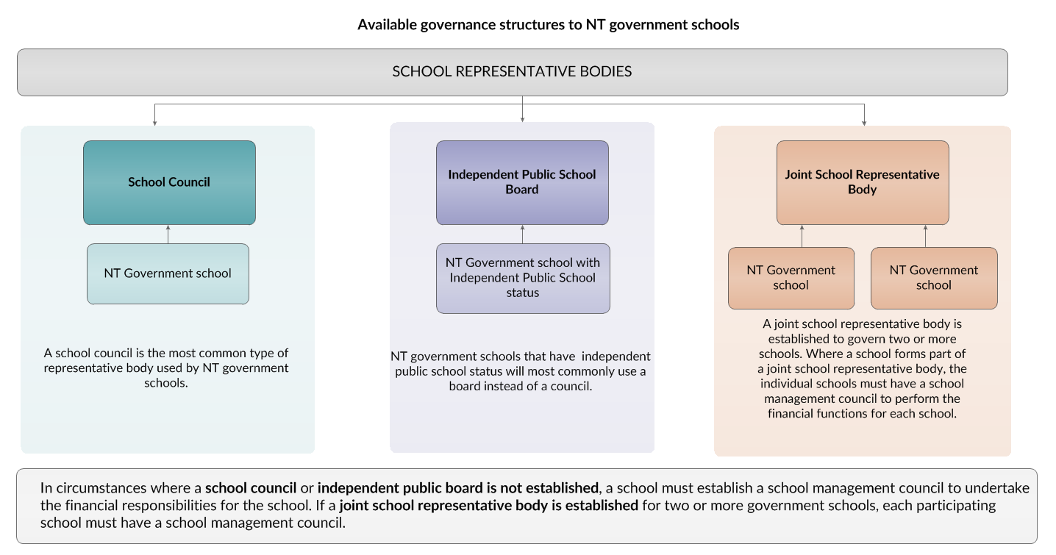

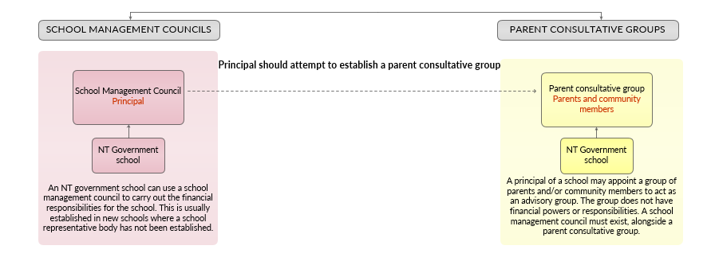

|  |  |
| --- | --- |
| **Function** | **School representative body** |
| ***Advisory***   1. Examine how the educational policies of the Territory are to be implemented at the school and advise the principal accordingly 2. Inquire into, and identify, the particular educational needs of the community served by the school, and advise the CEO with respect to those needs 3. Consider and advise the principal and CEO with respect to community education initiatives, and in particular, on means for improving links between the school, parent organisations and the community in general 4. Assess, from time to time, the following needs and make recommendations to the CEO with respect to satisfying them: 5. the needs of the school for buildings, facilities and equipment 6. the needs of students, teachers and other staff. | **School counci**l |
| **Independent public school board** |
| **Joint school representative body** |
| ***Budget allocation and expenditure***   1. Within the scope allowed by the functions conferred on the body, determine the purposes for which money allocated by the Agency to the school is to be expended and expend money paid by the Agency to the school; | **School council** |
| **Independent public school board** |
| ***Regulate buildings and grounds***   1. Determine whether, and regulate how, the buildings or grounds of the school may be used for the conduct of activities for the benefit of the community served by the school at any time when they are not required for school purposes; | **School council** |
| **Independent public school board** |
| **Joint school representative body** |
| ***Control buildings and grounds***   1. Exercise general control over the buildings and grounds of the school, including (with the consent of the CEO) controlling, on any terms and conditions approved in writing by the CEO, the conduct of work carried out in or on them; 2. Control the manner in which services of a kind prescribed by regulation are provided for the school; | **School council** |
| **Independent public school board** |
| ***Staffing***   1. Advise the CEO about the job description for the position of principal; 2. Advise the principal about the job descriptions for teaching and ancillary staff; | **School council** |
| **Independent public school board** |
| **Joint school representative body** |
| ***Employ staff***   1. In accordance with the *Fair Work Act* 2009 (Cth) and any relevant award, employ persons on any terms and conditions that are approved in writing by the CEO; | **School council** |
| **Independent public school board** |
| ***Raising funds***   1. Carry out any activities, if approved by the CEO, for raising money to be expended on, or in relation to, the school and expend that money accordingly. | **School council** |
| **Independent public school board** |
| **Joint school representative body** |
| ***Charge optional extra items***   1. Determine fees that may be charged for the provision to a student of any approved materials, services or facilities not covered by section 75(2) that a parent of the student chooses to have provided to the student; | **School council** |
| **Independent public school board** |
| ***Voluntary contributions***   1. Seek voluntary contributions from parents of students enrolled in the school for a purpose prescribed by regulation; | **School council** |
| **Independent public school board** |
| ***Any other functions***   1. Perform any other functions as directed by the CEO. | **School council** |
| **Independent public school board** |
| **Joint school representative body** |