This document should be read in conjunction with:
- Chaplaincy Services in Schools Policy
- National School Chaplaincy Program Handbook (Northern Territory).

- INTRODUCTION
This document outline the requirements for schools to follow in order to implement effective chaplaincy services and, where relevant, ensure compliance with the National School Chaplaincy Program (NSCP).

The guidelines detail how chaplaincy services will be delivered. It covers:
- operational framework
- community consultation
- effective implementation
- optional participation
- service parameters
- school management
- complaints/concerns management
- duty of care.
- DEFINITIONS
Conflict of interest - situation where a person's own interests, or a duty towards someone else, may affect the way they carry out a duty towards others, such that an independent observer might reasonably question whether the professional actions or decisions of that person are influenced by their own interests.

Contact - any form of physical contact, oral communication (whether face-to-face or by other means) or any form of written communication.

Employing agency - is the organisation with whom the school chaplain’s contract of employment is made. For example: religious representative bodies (e.g. Northern Territory Council of Churches), non-government service providers (e.g. Salvation Army, Scripture Union NT), other religious organisations (e.g. mosques, temples). This should not be the school representative body and must be a legal entity capable of entering into a Deed of Agreement with the school.
General school activities - support duties that could normally be expected of support personnel in schools (such as attendance at assemblies and school events, safety interventions, support to school management and staff).

Parent(s) - inclusive of those with parental responsibility and caregivers.

Proselytise - to solicit a decision to change belief system.

Opt-in - requirement to obtain parental permission for the student to access one-on-one and specialised programs or support services offered by the school chaplain.

School chaplain - a chaplain is an individual who:
- is recognised by the school community and the appropriate governing authority for the school as having the skills and experience to deliver chaplaincy services to the school community
- is recognised through recognised through formal ordination, commissioning, recognised religious qualifications or endorsement by a recognised or accepted religious institution
- meets the school requirements and minimum qualifications required by the department’s Chaplaincy Services in Schools Policy.

School chaplaincy service - a service which aims to assist schools through the provision of pastoral care, general spiritual advice and comfort to students, staff and members of the school community.
- ROLES AND RESPONSIBILITIES
General Manager Student Wellbeing and Inclusion (SWI) is responsible for:
- ensuring the policy is widely disseminated, understood and monitored throughout the department
- lead the development of policy, guidelines and other documentation relating to school based chaplaincy services in collaboration with the regions
- coordinating investigation of complaints with the regions
- overseeing the implementation of the Australian Government funded National School Chaplaincy Program.

Director / Manager Quality School Systems and Support (QSSS) is responsible for:
- ensuring principals adhere to the requirements of the Chaplaincy Services in Schools Policy and Guidelines in schools where chaplaincy services are being provided.

School Principal is responsible for:
- In association with the school representative body, consulting widely and providing information to parents and the Director / Manager QSSS about the proposed chaplaincy services prior to implementation
- ensuring the school representative body’s support for the service is formally recorded in meeting minutes and the school representative body is kept abreast of developments that may impact on its support for the chaplaincy services
- maintaining communication with parents in relation to the chaplaincy services
- ensure that the services provided by the chaplain are consistent with their qualifications, external funding agreement requirements and the department’s General Principles for Selecting Suitable Resources in Schools
- ensuring the chaplaincy services are integrated as part of the school’s wellbeing service
- maintaining records of the chaplian provided by the Employing Agency as required by the Deed of Agreement and conducting referee checks prior to the commencement of employment .
- ensuring the chaplain is aware of the school’s record-keeping requirements in relation to the provision of services and that there are procedures in place to ensure that the chaplain can only access relevant personal information relating to students who have parental permission to participate in chaplain services
- If the school is participating in the NSCP, ensuring compliance with all program requirements, including compliance with the following NSCP requirements:
  - participation by schools and students is voluntary
  - chaplains may be from any faith
  - chaplains must:
    - not proselytise
    - respect, accept and be sensitive to other people’s views, values and beliefs;
    - comply with State and Territory laws and policies in relation to child protection matters; and
    - meet the NSCP’s minimum qualification requirements
    - undertake professional learning in responding to and preventing bullying and cyberbullying provided by the Office of the eSafety Commissioner.
  - acquitting the funding grant as noted in the funding agreement (non-government) or funding schedule (NT Government)
- in consultation with the school representative body chairperson and the Employing Agency (as appropriate), managing issues within the school community that may arise as a result of provision of the chaplaincy services (complaints must be dealt with in line with the Complaints Management in Schools Policy)
- ensuring that the chaplain is made aware of, and adheres to requirements of this policy as well as other relevant departmental policies and legislation while operating within the school (where the principal has a real or perceived conflict of interest in relation to the enforcement of these requirements, matters should be referred to the relevant Director / Manager QSSS)
- ensuring the chaplain’s operations within the school adhere to the guidelines set out in any external funding arrangement

School representative body is responsible for:
- determining the need for, and scope of the school’s chaplaincy services in in consultation with the school principal
- assisting the school principal in the selection of the chaplain in line with the requirements of this policy and for supporting the principal in the management of the chaplaincy services
- where appropriate, determining if a sub-committee needs to be formed to plan, implement or manage the chaplaincy services (should such a sub-committee exist, the school representative body, in consultation with the principal is responsible for determining the membership and terms of reference of this group).

Employing agency is responsible for:
- adhering to the requirements as outlined in the NSCP Deed of Agreement
- overseeing the professional development of the chaplain and ensuring that the chaplain has appropriate qualifications and clearances to operate within a school environment.

Chaplain is responsible for:
- ensuring adherence to the requirements of the Code of Conduct for School Chaplains in Northern Territory schools and the Deed of Agreement
- ensuring that specialised chaplaincy services or programs are not delivered to students who have not opted in to the program
- maintaining adequate records as required by the school, particularly in relation to one-on-one sessions with students (these records must be made available to parents if required)
- ensuring they only access relevant personal information relating to students who have parental permission to participate in the chaplaincy services
- undertaking professional learning in responding to and preventing bullying and cyberbullying provided by the Office of the eSafety Commissioner if the school participates in the NSCP.

- Operational framework for chaplaincy services

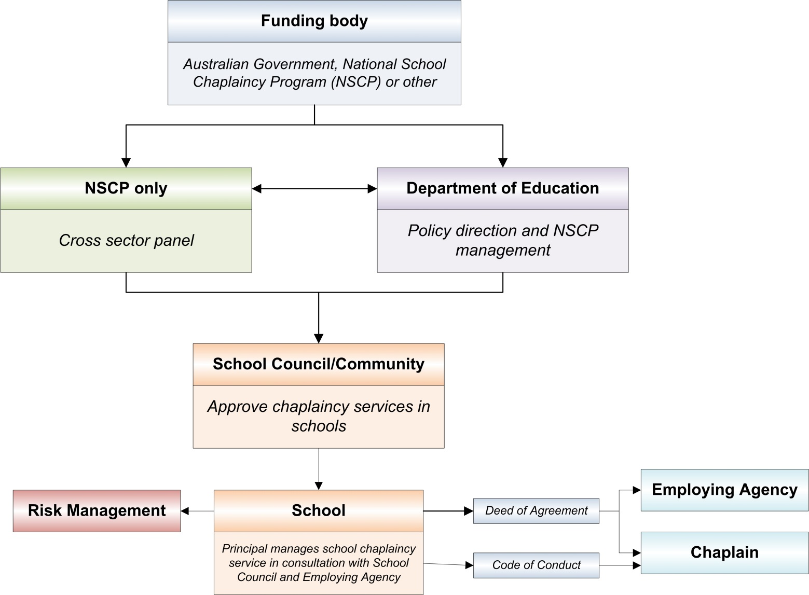

  - Community consultation
The establishment of chaplaincy services in any school should not proceed unless it is clear that there is support within the school community about the nature and aims of a school chaplaincy service and an appropriate provider.

Consider:
- What are the goals and roles for school chaplaincy services held by the school community?
- How do these support the range of cultural and religious backgrounds represented in the school?
- What level of support is there from the school community and other community groups?
- Is the proposed school chaplaincy service consistent with departmental policy?
- Is the school chaplaincy service fully funded and deliverable over a period of time, through the support of the local religious community?
- What services will be offered under the opt-in arrangement? Will one-on-one services be included in the scope of services offered?

The relevant school Director / Manager QSSS must also be informed of a school’s intention to engage a chaplaincy service.
  - Target groups
Wide consultation should occur prior to commencing a school chaplaincy service. Negotiations may include the following people and groups:
- school representative body
- parents/caregivers
- teachers and other school staff
- students
- chaplains
- Director QSSS
- Employing Agency – for example: religious representative bodies (such as Northern Territory Council of Churches etc), non-government service providers (such as Salvation Army, Scripture Union NT etc), other religious organisations (mosques, temples etc)

  - Implementing a school chaplaincy service
Once school community consultation has occurred, and an Employing Agency has been identified, the following must occur:
- prior to providing chaplaincy services at the school, the Employing Agency and the chaplain must enter into a Deed of Agreement (Attachment refers) with the Northern Territory Government to give effect to, but not limited to, the matters in the following:
  - The Employing Agency will enter into an indemnity directed to the Northern Territory Government and the school representative body indemnifying it against any claims/proceedings as per the terms of the Deed.
  - The Employing Agency will provide the principal and the department with copies of current, appropriate insurances in place to cover the prospect of such claims/proceedings, as well as copies of the chaplain’s police clearances and other relevant documentation.
  - The chaplain will sign the Code of Conduct for School Chaplains (Attachment refers) in Northern Territory Schools (Code of Conduct) prior to commencing duties and will agree to adhere to the requirements of the Chaplaincy Services in Schools Policy.

  - Optional participation
Student participation in a school chaplaincy service is optional, and parents must be informed in writing about:
- the availability and nature of chaplaincy services and activities, including the clear distinction between the activities of the chaplain generally as part of the school’s wellbeing service and those which will be provided specifically as opt-in chaplaincy services
- the processes for accessing the opt-in service, and the requirements for written permission using the standard consent form template (Attachment refers)
- the opportunity to review permission annually and when there is a change to the chaplain or their program of services.

As part of the communication about school activities, schools may determine it is appropriate to advise parents where chaplains may be involved in general school activities.

A User Defined Information (UDI) field should be created in the Student Administration and Management System (SAMS) against which the status of parental consent can be recorded. Up-to-date class and whole school reports, adjusted according to new enrolments, must be made available to the chaplain.

Completed standard consent forms (Attachment refers) should be retained on student files according to requirements in the General Disposal Schedule for School Records and Storage Procedural Guidelines.

  - Parameters of school chaplaincy service
Generally chaplains will provide support in relation to spiritual or pastoral care services. Broadly, this may include:
- general spiritual advice
- supporting students to explore their spirituality
- providing guidance on spirituality, values and ethical matters
- facilitating access to support agencies in the community, both church-based and secular.
- pastoral care
- participation in general school activities as a member of the wellbeing service
- providing guidance to students on issues concerning human relationships
- providing support in cases of bereavement, family breakdown or other crisis/loss situations.

Chaplains must not provide professional services for which they are not qualified or beyond the scope of agreed services. They must adhere to the requirements of the Code of Conduct, have a working knowledge of child development and demonstrate a willingness to work in cooperation with all staff.

Chaplains engaged as part of the National School Chaplaincy Program must meet the program’s minimum qualifications.

School chaplaincy services do not extend to teaching or counselling roles. Where a chaplain has qualifications in these areas, they are not permitted to provide teaching or counselling roles in their capacity as chaplain.

The primary role of the chaplain is with students. However, school staff may initiate access to collegial support from the chaplain on a voluntary basis. Both chaplains and school staff should ensure that chaplaincy services are not accessed for matters that are more appropriately dealt with through the Employee Assistance Service (EAS) particularly matters relating to work. EAS can assist staff with matters related to aspects of both their personal and professional lives.

Should a school wish to engage a chaplain to provide professional services in another capacity within the school, these services must be independent of their chaplaincy role and cannot be provided simultaneously.

  - Management within the school
Chaplains are performance managed by their Employing Agency however they are subject to the direction and management of the principal in relation to the chaplaincy provided to school students.

The chaplain, as a member of the school staff, should benefit from and be subject to the overall management structures and procedures of the school. The chaplain should be part of the school wellbeing team. However, chaplains must be excluded from those parts of wellbeing team meetings where discussion involves students who do not have parental consent to participate in the chaplaincy program.

The following aspects of the school chaplain’s duties are managed from within the school:
- the allocation of working space and support facilities
- procedures for access to the school chaplain by students, parents and other relevant persons
- procedures for checking the qualifications of chaplains prior to the delivery of programs
- record keeping
- access and contributions by the chaplain to other school records relating to opt-in students
- procedures for referrals to other people and agencies both in and outside the school
- the clarifying of the principles, ethics and practical implications of confidentiality in accordance with the Information Privacy Principles of the Information Act 2017 (NT)
- access to appropriate school organised professional learning.

A process for managing issues that may arise as a result of the chaplaincy service must be developed. Schools must prepare a risk management plan (see template at Attachment) relevant to their school context which considers potential risks and appropriate actions/responses.

The plan should consider risks relating to:
- the chaplaincy program at the school,
- the specific services offered by the chaplain, and
- other matters that may be considered controversial or contentious by members of the school community.

  - Complaints/concerns regarding school chaplaincy services
Parents and students have a right to raise complaints/concerns about the chaplaincy service at their school. Staff must not unduly influence parents or students in relation to complaints or concerns about the chaplaincy service. Complaints relating to the chaplain and/or chaplaincy program at the school should be dealt with by the principal in consultation with the school representative body and the Employing Agency, in line with the requirements of the department’s Complaints Policy and the Deed of Agreement. Where the principal has a real or perceived conflict of interest in relation to the chaplaincy program, complaints may be referred to the Director/Manager QSSS in that case.

  - Duty of care
Under no circumstances can the school’s duty of care for students be delegated to the chaplain. It is important that the chaplain and school staff understand that responsibility for student health, safety and welfare rests with the supervising or controlling teacher. Further information regarding duty of care can be obtained from the department’s Duty of Care Information Sheet.

  - Deed of Agreement
A Deed of Agreement that has been approved by the department must be signed by the Employing Agency, the department’s relevant Director/Manager QSSS, the school representative body chairperson and the chaplain.

Student Wellbeing and Inclusion distribute a Deed of Agreement to schools that are participating in the Australian Government funded National School Chaplaincy Program. Schools should contact the department’s Legal Services if they intend to use a deed for other purposes.

  - Attachments – refer Chaplaincy services in schools
- Permission for student to participate in Chaplaincy Program form template
- School chaplaincy program risk management plan template
- Chaplaincy Services in Schools Deed of Agreement template
- Code of Conduct for School Chaplains template.

