QUALITY EDUCATION AND CARE NT

REGULATION AND
COMPLIANCE FRAMEWORK

Version 2 2019
TRM Ref: 50:D19:17908

Contents
INTRODUCTION 1
QECNT APPROACH TO REGULATION 1
Authorised officer powers 1
Regulatory framework 2
Risk-based regulation 3
Responsive regulation 4
QECNT APPROACH TO COMPLIANCE 5
Inform and educate 5
Support to comply 6
Assess and rate 6
Monitoring compliance 6
Notifications 6
Targeted monitoring campaigns 6
Data analysis 6
Assessment and rating 7
Investigations 7
Enforce the Law 7
Administrative letters 7
Compliance directions 7
Compliance notices 7
Infringement notices 8
Emergency action notices 8
Prohibition notices 8
Variations, suspensions and cancellations of approvals 8
Enforceable undertakings 8
Prosecutions 9
ACKNOWLEDGEMENT 9

INTRODUCTION
Quality Education and Care NT (QECNT) is located within the Department of Education and is responsible for regulating approved early childhood education and care services and providers in the Northern Territory (NT). Regulated service types include:
- long day care
- preschool
- outside hours school care (before school, after school and vacation care)
- family day care.

Most early childhood education and care services operate under the National Quality Framework (NQF). The NQF has legislative components that provide a nationally consistent approach to regulation of education and care services. In the NT these are enacted as the;
- Education and Care Services (National Uniform Legislation) Act (National Law)
- Education and Care Services National Regulations (National Regulations).

QECNT also investigates education and care services that operate without service approval.

QECNT promotes high quality early childhood education and care and undertakes regulatory action in line with the following principles:
- outcomes focussed | - proportionate & fair
- risk based | - timely
- transparent | - ethical & accountable
- consistent | - collaborative.

QECNT APPROACH TO REGULATION
QECNT is a risk based, responsive regulatory authority. This allows QECNT to ensure that resources are directed to areas of highest risk, based on quality intelligence about an education and care services operation.

Authorised officer powers
The National Law provides for the authorisation of individuals to exercise a variety of powers related to assessment and compliance. Authorised officers have power to:
- enter the premises of approved education and care services,
- identify and question persons,
- obtain information, documents and other evidence, and
- issue compliance notices and directions.

The legislation also allows QECNT to enter into enforceable undertakings with persons who have contravened a provision of the law.

Regulatory framework
QECNT operates within a comprehensive regulatory framework which consists of an integrated series of components that incorporate legislation, policy, education, approval, assessment and rating, monitoring, audit, investigation, and compliance and enforcement actions.

Figure 1. Diagrammatic representation of the components of the framework.
Repeat / identification of non-compliance

Risk-based regulation
QECNT applies a responsive and risk-based approach to its regulatory compliance functions, where risk is measured in terms of the likelihood of non‐compliance occurring and the real or potential consequences posed to children as a result of that non‐compliance.

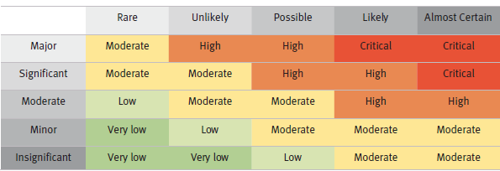
Figure 2. QECNT Risk-based Model
Likelihood
Consequence
Children, and particularly very young children, are vulnerable members of the community therefore QECNT will always place the best interests of the child at the centre of every regulatory decision. Their rights and best interests are paramount.

Only very low level residual risk to the safety of children attending education and care services can be tolerated within the risk‐based model. QECNT will consider the compliance history of the service and/or service provider when assessing non‐compliance and the likely risks to children.

The National Regulations define certain events as ‘serious incidents’. Under the National Law serious incidents must be reported to QECNT. QECNT treats these notifications seriously and ensures that timely and appropriate action is taken in regard to all serious incidents. Serious incidents include:
- the death of a child
- an incident involving serious injury, trauma to, or illness of a child requiring urgent medical attention or for which the child attended or ought to have attended, a hospital
- an incident requiring the attendance of emergency services at the service premises
- any circumstances where a child appears to be missing from the service or is locked in or out of a service.

Responsive regulation
Understanding what has led to non‐compliant behaviour helps when deciding the appropriate regulatory tool to use to address the non‐compliance. QECNT aims to utilise regulatory tools which result in compliance but impose the least amount of regulatory burden.

QECNT escalates its regulatory response according to the:
- level of risk to children
- seriousness of the non-compliance
- willingness of the service or service provider to comply
- compliance history of the service and/or service provider.

Figure 3. QECNT Responsive Regulation Model
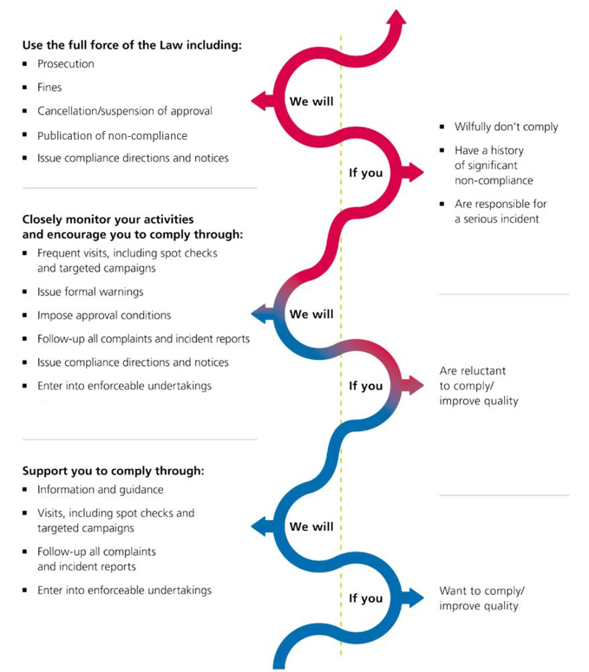

QECNT APPROACH TO COMPLIANCE
QECNT’s approach to compliance is aimed at supporting the sector to provide sustainable high quality education and care services in the NT. Strategies are aimed at assisting providers and education and care services to meet legislative objectives and obligations and to promote continuous quality improvement.

Figure 4. Compliance Strategies
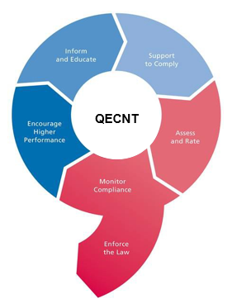

Inform and educate
QECNT and the Australian Children’s Education and Care Quality Authority (ACECQA) provide information to the sector on legislative obligations and requirements to encourage voluntary compliance and improved quality. Setting clear expectations raises awareness about the benefits of complying with the law and the potential consequences of failing to do so. It also helps to remove misconceptions that might foster non‐compliance.

QECNT also works with regulators in other jurisdictions to ensure communications relating to the NQF are coordinated and consistent across Australia.

Support to comply
QECNT will provide practical and constructive advice on how to comply with the law and regulations, interpret quality standards and, where necessary, how to remedy non-compliance to any person who has a duty or obligation under the National Law and National Regulations.

Where an inspection or audit identifies non‐compliance and action is required to remedy the issue, authorised officers will work with the service provider and staff to determine appropriate actions to address the problem and achieve desired outcomes.

Assess and rate
Assessment and rating against the National Quality Standard (NQS) is embedded in the National Law. Quality ratings enable education and care services and the community to make relative judgements about the quality of a service against the NQS.

Assessment and rating, along with Quality Improvement Plans, is a cornerstone of the system of continuous quality improvement. QECNT is committed to implementing an effective and efficient assessment and rating process that supports the integrity of the NQF, and encourages continuous improvements to service quality over time.

Monitoring compliance
QECNT undertakes monitoring activities to ensure the safety, health and wellbeing of children attending education and care services in line with the requirements of the National Law and the National Regulations. Monitoring compliance also allows QECNT to promote continuous improvement in the provision of quality education and care. Various means are used to monitor compliance, these include:

Notifications
QECNT receives complaints from the public and notifications from service providers. Notifications include any serious incidents occurring at a service and any complaints made about the safety, health and wellbeing of a child while attending a service. These reports play an important role in assisting QECNT to identify potential incidents of non‐compliance. All complaints and notifications are reviewed and, where necessary, investigated.

Targeted monitoring campaigns
QECNT undertakes targeted campaigns that focus on common non-compliance trends. During a targeted campaign, QECNT will undertake announced or unannounced visits over a set period of time to check on compliance with the relevant requirements.

Data analysis
QECNT can draw on data from the National Quality Agenda IT System to undertake desktop analysis of emerging trends or patterns in compliance issues. This assists QECNT to plan monitoring and compliance activities and implement strategies to assist where the sector may be experiencing difficulties and to address emerging problems before they escalate.

Assessment and rating
Areas of potential non-compliance may be identified during an assessment and rating process. Authorised officers conducting assessments can provide advice to service providers on matters that need to be addressed in order to ensure compliance with regulatory requirements.

Investigations
QECNT investigates serious incidents and breaches of the National Law and/or National Regulations. Investigations are a formal process where authorised officers gather evidence in order to substantiate whether breaches have occurred and if so the severity of the breaches.

Evidence may be gathered in the form of recordings and photographs, samples and physical evidence, documents, witness statements and records of interviews. Investigations are conducted in accordance with the investigative powers under the National Law.

Enforce the Law
When non‐compliance is identified, QECNT will evaluate its significance to determine the most appropriate response.

‘Significance’ is determined by establishing the level of risk to children as a result of the non‐compliance as well as other factors, such as the offender’s attitude to compliance, the compliance history of the provider and/or service, whether the breach is intentional, and what, if any, benefits have been derived by the offender from the non‐compliance.

Any action taken by QECNT will aim to ensure that the regulatory action is proportionate to the offence and acts as a deterrent to re‐offending. QECNT uses a variety of approaches and tools to address instances of non‐compliance. These include:

Administrative letters
Administrative letters are a caution issued where breaches, typically of a minor nature, are identified and require rectification or explanation. An administrative letter advises the provider and or service which may include; an educator, person placed in day-to-day charge, nominated supervisor or person with management and control of the identified breach and may require that the breach be remedied within a specified timeframe.

Non-compliance with an administrative letter, or continued non-compliance that has resulted in administrative letter may result in further action being taken.

Compliance directions
Compliance directions are used where a specific requirement of the National Regulations is not being complied with. A compliance direction requires a service provider to rectify an identified breach within a specified timeframe and sets out the steps that need to be taken to address the breach. Penalties can be incurred if a service provider does not comply with a compliance direction.

Compliance notices
Compliance notices can be used wherever the National Law or National Regulations are not being complied with. A compliance notice requires a service provider to rectify any identified breaches within a specified timeframe and sets out the steps that need to be taken to address the breach. Penalties can be incurred if a service provider does not comply with a compliance notice.

Infringement notices
A penalty infringement notice is a monetary penalty issued for non‐compliance with a limited number of specific requirements. Penalty infringement notices have an immediate punitive effect and serve as a deterrent against future non‐compliance.

Emergency action notices
Emergency action notices are used when QECNT is satisfied that a service is operating in a manner that poses an immediate risk to the safety, health or wellbeing of children attending a service. An emergency action notice requires a service provider to immediately isolate and rectify the problem that is posing the risk to children.

Prohibition notices
QECNT can issue a prohibition notice to a person, who is in any way involved in the provision of an approved service, preventing them from remaining on the premises of the service or providing education and care to children.

QECNT can also direct that any person who is deemed ‘inappropriate’ be excluded from an education and care service while children are in attendance. An inappropriate person is anyone who may pose a risk to the safety, health or wellbeing of children attending the service or whose behaviour or state of mind is such that it would be inappropriate for that person to be on the premises while children are present.
QECNT can also direct a provider of a family day care service to suspend an educator where QECNT is satisfied that the conduct of that educator, or the inadequacy of the service provided by that educator, may cause a risk to the safety, health or wellbeing of children attending the service, or where the actions of the educator are causing the provider and/or the service to be in breach of the legislation.

Variations, suspensions and cancellations of approvals
QECNT has the option of placing conditions on service approvals. Conditions can cover a broad range of matters relating to both service premises and/or staff.

QECNT can also suspend or cancel approvals in certain circumstances. The grounds for suspending or cancelling approvals are set out in the National Law and include failure to comply with conditions on a service approval, failure to comply with the National Law, and situations where QECNT believes that it is not in the best interests of children attending the service for that service to continue.

In most cases a service provider will have the opportunity to provide evidence as to why the suspension or cancellation should not proceed. This opportunity is not required in cases where QECNT is satisfied that there is an immediate risk to the safety, health or wellbeing of children attending the service.

Enforceable undertakings
An enforceable undertaking may be accepted by QECNT as an alternative to prosecution where there has been a serious breach of the National Law. QECNT is able to accept a written undertaking by a service provider to take action to deal with an alleged breach or breaches. These undertakings are enforceable through the Court.

A key objective of an enforceable undertaking is to ensure systemic change in the management or operation of an education and care service so as to prevent future breaches. When considering whether to enter into an enforceable undertaking QECNT will choose the approach that is most likely to produce the best results in terms of ongoing compliance, remedial action to address the alleged non‐compliance, and obtaining improvements in service quality over time.

Prosecutions
The basic pre‐requisite for any prosecution is that the evidence available establishes a prima facie case (ie. a legally sufficient level of evidence). QECNT will also take into account whether it is in the public interest to prosecute a case.

QECNT will consider prosecution for serious breaches of the National Law, National Regulations or repeat offenders. QECNT will only proceed with prosecution if it is deemed the most appropriate course of action in the circumstances. Prosecution sends a message to the sector and the wider community that failure to comply with legislative requirements will be enforced through the courts.

ACKNOWLEDGEMENT
QECNT gratefully acknowledges the New South Wales Department of Education for permitting QENCT to utilise the Early Childhood Education Directorate Compliance Policy to develop this framework.

