Chief Minister’s Anzac Spirit Study Tour:

The Relationship between Australians and the people of

Villers-Bretonneux

Word Count: 989
Ellen Archibald
Good Shepherd Lutheran College
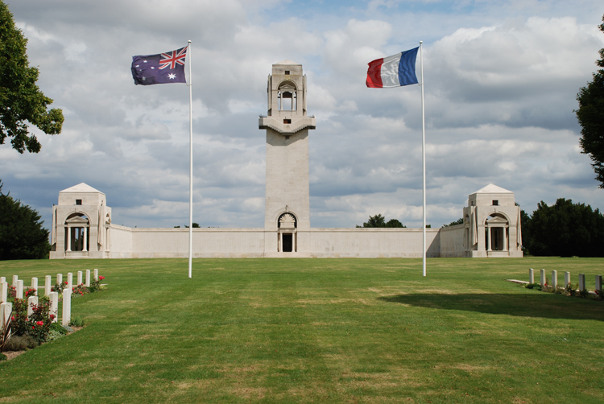
The French and Australian flags fly over the Australian War Memorial at Villers-Bretonneux.

“What does the enduring relationship between Australians and the people of Villers-Bretonneux teach us about the Anzac Spirit?”
After the assassination of Archduke Franz Ferdinand of Austria on the 28 June 1914, conflict spread through Europe in what became known as World War.^{[1]} Thousands of Australians signed up to go to the other side of the world to fight for their King and their mother country. In 1915, as Australian and New Zealand soldiers fought alongside each other in Gallipoli, the Anzac Spirit was born.^{[2]} Later in the war, as Australian soldiers fought on the Western Front, they defended a small French village called Villers-Bretonneux, which resulted in thousands of deaths. This forged a bond between Australia and these villagers that would last over 100 years.
The Battle of Villers-Bretonneux occurred when German forces tried to reach the city of Amiens by going through the small French village called Villers-Bretonneux.^{[3]} On the 4th of April 1918 Germany attempted to capture the village but the Australian 36th Battalion quickly moved forward at the right moment, and with the help of British and other Australian forces pushed the Germans back almost two kilometres securing the front line.^{[4]} Germany attacked again twenty days later on the 24th of April, and with the aid of thirteen A7V tanks, they were able to capture the town of Villers-Bretonneux. This was the first tank versus tank battle in history.^{[5]} That night the British launched a counter attack at 10pm, conducted by General Harold Edward “Pompey” Elliott, leading the 13th and 15th Australian Brigades.^{[4][6]} These brigades were able to attack from the north and south and encircle Villers-Bretonneux, driving out the Germans and reclaiming the town. By the morning of the 26th of April, the British and Australians had “restored the front line to its former position”.^{[7]} Throughout the recapture of the town, 1200 Australians lives were lost. They will always be remembered for their sacrifice and demonstration of the Anzac Spirit.
The Anzac Spirit is very difficult to define. The word ‘ANZAC’ is an acronym standing for Australian and New Zealand Army Corps.^{[8]} The Anzac Spirit is made up of numerous qualities including mateship, endurance, courage, ingenuity, good humour, sacrifice, initiative, discipline, tenacity, and often a disrespect for authority.^{[9][10]} The Anzac Spirit can also be defined as helping a friend out regardless of the consequences, and them doing the same for you.^{[11]} This is seen in the relationship between the people of Villers-Bretonneux and Australia.
The bond between Australians and the people of Villers-Bretonneux is very strong. It has lasted 100 years and still endures. After the battle of Villers-Bretonneux, Australians helped to rebuild the small French village.^{[4]} The people of this village were thankful for everything that the Australian diggers had done so they named two streets and a restaurant in honour of them. These were called Rue de Melbourne, Rue de Victoria and Restaurant Kangarou.^{[12]} The local school L'école Victoria has the words “Do Not Forget Australia” painted in the schoolyard and “N'oublions Jamais l'Australie” in each classroom, meaning “Never Forget Australia”.^{[4]} In the 1920s school children from the state of Victoria donated a penny each, raising money for the Villers-Bretonneux school to be rebuilt. It was completed in 1927.^{[13]} Eighty two years later in 2009, the community of Villers-Bretonneux repaid the debt when three Australian schools burnt down in the Black Saturday bush fires. They raised $20,000 to help rebuild one of the destroyed schools, keeping their promise to “Never Forget Australia”.^{[14]} This is a great example of the enduring Anzac Spirit where friends helped each other in times of need, extending over many generations. Each year Villers-Bretonneux remembers the Australian lives lost during the recapture of their village by holding a small ceremony on their hilltop memorial.^{[15]}
Through my experiences, I have seen that the Anzac Spirit still lives on today. Every year on Anzac Day, my father and I attend the Dawn Service at the Adelaide River War Cemetery. It is always encouraging to see the large number of people that get up so early to go to this service and remember those who lost their lives defending our country and our freedom. My great great grandfather, Augustus William Sinclair, died fighting on Turkish soil at Anzac Cove. He is buried at Gallipoli and he and his fellow diggers will always be remembered for their service. These diggers showed the Anzac Spirit through their courage, tenacity and sacrifice. My father said “A. W. Sinclair exhibited the Anzac Spirit in a different way to many of his mates. He was a 32-year-old farm labourer from Western Australia who was married, and was a father to a young daughter. Although greatly needed at home, he felt compelled to go and fight for King and country alongside his mates who had volunteered earlier. He had been at Anzac Cove less than 48 hours before being killed during the Battle of Lone Pine. He paid the ultimate sacrifice for his duty to his country and mates”.^{[16]} For over 100 years the Anzac Spirit has lived on in Australia and overseas, and has played a major part in my family's lives in remembering those who died for us.
The enduring relationship between Australians and the people of Villers-Bretonneux is a perfect example of the Anzac Spirit. It teaches us that the Anzac Spirit lives on and its influence is felt worldwide. The Anzac Spirit is shown through the relationship between Australians and the French villagers, and Australian soldiers during times of warfare. It has also shown that the Anzac Spirit means that you will do what needs to be done no matter what, and that you are willing to make the ultimate sacrifice when it needs be. Lastly, it demonstrates to us that the Anzac Spirit was forged in time of war and has withstood the test of time, just like the relationship itself. Australia and Villers-Bretonneux have shown the Anzac Spirit by helping each other in times of conflict and hardship and will continue to do so for many years to come.

References:
- HISTORY.com. (n.d.). Archduke Franz Ferdinand assassinated - Jun 28, 1914. [online] Available at: http://www.history.com/this-day-in-history/archduke-franz-ferdinand-assassinated [Accessed 9 Aug. 2017].
- Awm.gov.au. (2017). Dawn of the Legend: The Anzac spirit. [online] Available at: https://www.awm.gov.au/visit/exhibitions/dawn/spirit [Accessed 28 Jul. 2017].
- Awm.gov.au. (n.d.). 1918 - Dernancourt and Villers-Bretonneux: Halting the Germans. [online] Available at: https://www.awm.gov.au/visit/exhibitions/1918/battles/dernancourt [Accessed 3 Aug. 2017].
- Awmlondon.gov.au. (2017). Villers Bretonneux: The End of the German Advance. [online] Available at: http://www.awmlondon.gov.au/battles/villers-bretonneux [Accessed 28 Jul. 2017].
- Rickard, J. (n.d.). Second Battle of Villers-Bretonneux, 24-27 April 1918. [online] Historyofwar.org. Available at: http://www.historyofwar.org/articles/battles_villers_bretonneuxII.html [Accessed 7 Aug. 2017].
- McMullin, R. (2008). Why a French town never forgets us. [online] Theage.com.au. Available at: http://www.theage.com.au/news/national/why-a-french-town-never-forgets-us/2008/04/24/1208743142170.html [Accessed 28 Jul. 2017].
- Anzacportal.dva.gov.au. (n.d.). What happened here?. [online] Available at: http://anzacportal.dva.gov.au/node/1235/ [Accessed 31 Jul. 2017].
- Army.gov.au. (2016). Anzac Day. [online] Available at: https://www.army.gov.au/our-history/traditions/anzac-day [Accessed 9 Aug. 2017].
- Awm.gov.au. (n.d.). Anzac spirit. [online] Available at: https://www.awm.gov.au/articles/encyclopedia/anzac/spirit [Accessed 3 Aug. 2017].
- Afssse.asn.au(n.d.). Are the qualities that make up Anzac Spirit still alive in society today?. [online] Available at: http://www.afssse.asn.au/simpson/prize2005/essays/ru_sa_mahesh.pdf [Accessed 5 Aug. 2017].
- Kokodaspirit.com.au. (2014). I am the ANZAC SPIRIT. [online] Available at: http://www.kokodaspirit.com.au/the-anzac-spirit/ [Accessed 28 Jul. 2017].
- Two In France. (2013). Villers-Bretonneux and Australia. [online] Available at: https://twoinfrance.com.au/places/villers-bretonneux-and-australia/#11/49.6712/2.2635 [Accessed 24 Jul. 2017].
- Kearney, E. (2013). Battle for Villers-Bretonneux. [online] education.qld.gov.au. Available at: http://education.qld.gov.au/students/grants/scholarships/anzac/docs/villers-bretonneux.pdf [Accessed 6 Aug. 2017].
- Miranda, C. (2016). The school kids that ‘don’t forget Australia’ in Villers-Bretonneux. [online] news.com.au. Available at: http://www.news.com.au/national/the-school-kids-that-dont-forget-australia-in-villersbretonneux/news-story/fd4e566140410dd27d65ad207c208a80 [Accessed 28 Jul. 2017].
- ABC News. (2014). Looking back on the battle of Villers-Bretonneux. [online] Available at: http://www.abc.net.au/news/2014-06-06/battle-of-villers-bretonneux/5497598 [Accessed 24 Jul. 2017].
- Personal communication. Jared Archibald - Curator of Territory History at the Museum and Art Gallery of the Northern Territory (3 August 2017)

