Families as First Teachers – policy
  - Teaching and Learning Services
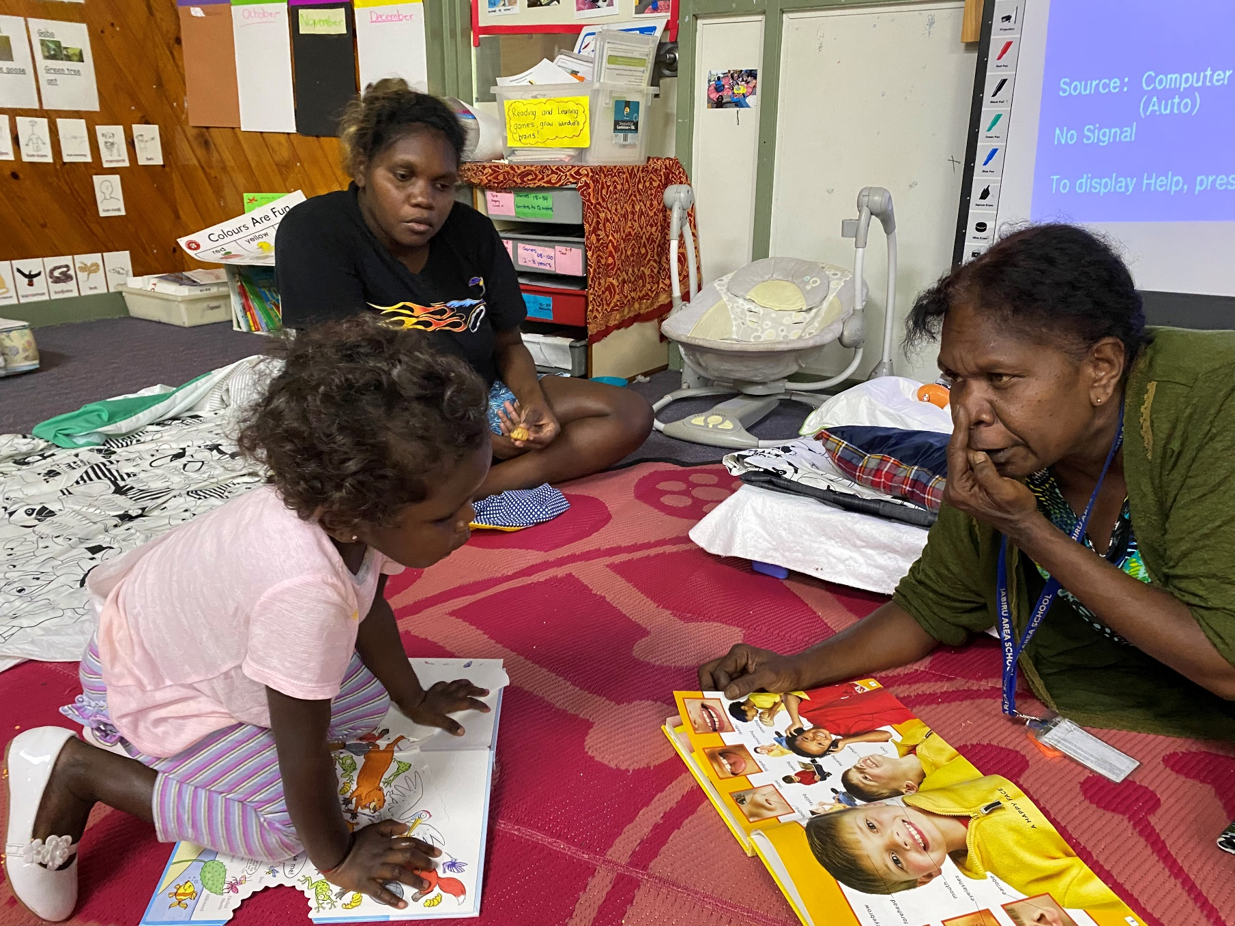

Contents
1. Context 3
2. Policy 3
3. Business need 4
4. Scope 5
5. Roles and responsibilities 5
6. Definitions 5
7. Related policy and legislation 5
7.1. Policy 5
7.2. Legislation 5

This policy is part of the Families as First Teachers (FaFT) information available on the Department of Education School polices webpage in the Families as First Teachers section. Read this document with the FaFT guidelines and the FaFT Book. The FaFT Book is a resource that provides information about FaFT and the theory that underpins the program.

Context
FaFT is an established and culturally competent foundational learning program that operates throughout the Northern Territory (NT). It aligns with the principles, practices and outcomes of Belonging, Being and Becoming: The Early Years Learning Framework for Australia (EYLF) and is inclusive of all children, including those with special needs, in line with the Disability Standards for Education 2005. FaFT is supported by the Education NT Strategy 2021 – 2025 strategic actions, by building the foundations for learning and placing the child and student at the centre of the NT education system.
The FaFT program delivers quality early learning and family support programs to young children and their families. The program acknowledges the important role families play as their children’s first teachers. It develops place-based programs to engage families and communities, and build parents’ capacity to give their children the best start in life. This policy provides consistency and clarity about the delivery of FaFT programs.

Policy
The NT Government has partnered with the Australian Government to provide FaFT in identified remote and very remote locations under the NT Remote Aboriginal Investment Strategy and in selected urban locations. The department has responsibility for delivery and oversight of the FaFT program in NT Government education sites as well as funding arrangements with some non-government FaFT service providers. Delivery, reporting and accountability processes for the program are mandatory and evidence-based. They must be complied with in a timely manner.
A FaFT program is a standalone program designed specifically for children from birth to age four and their parents. The exception is where specific sites are selected to provide a Stay Play Learn (SPL) program. A FaFT program is delivered separately to a preschool program to ensure the outcomes for each program are able to be met.
The school principal or external provider is responsible for the day-to-day management of the FaFT program. This includes ensuring all FaFT educators undertake the department’s Mandatory reporting of harm and exploitation of children training. Information about mandatory reporting training requirements can be found on the department’s School policies webpage, in the Mandatory reporting of harm and exploitation of children section.
The school principal is responsible for ensuring FaFT educators record the daily attendance and participation of children and families in the Early Childhood Programs Attendance System (ECPAS).
The FaFT program is co-delivered by a family educator who is a qualified early childhood teacher – registered with the Teacher Registration Board of the NT (TRB) – and a family liaison officer who is a local Aboriginal community member.
The FaFT SPL program is delivered by a family educator who is a qualified early childhood teacher and registered with the TRB.
All FaFT educators including family educators, family liaison officers and playgroup leaders must hold a current Working with Children Clearance Notice, known as an Ochre card. Information about the Working with Children Clearance Notice can be found on the department’s School policies webpage, in the Working with Children Clearance Notice section.
All FaFT educators are certified Abecedarian Approach Australia (3a) practitioners and maintain their certification annually.
FaFT programs are funded for, and must provide, quality early learning and family support programs that are responsive to the needs of the community.
The FaFT program operates and is accessible each school day from Monday to Friday during school terms, while being responsive to community needs. The program must provide a minimum of 20 hours per week of family and child engagement or 15 hours per week in a FaFT SPL program. Family and child engagement includes daily face-to-face group sessions inclusive of outreach programs. Additional program requirements include parent capacity building, engagement with community and stakeholders and Ages and Stages Questionnaires – Talking about Raising Aboriginal Kids developmental screening.
FaFT educators must implement the 3 core elements of:
- quality child centred early learning
- parent capacity building
- community engagement – working with community.
FaFT educators embed the 3a strategies in all program models. The program is delivered in alignment with the principles and practices of the EYLF and conforms with the department’s Curriculum, assessment, reporting and certification policy: early childhood to Year 12.
All children attending a FaFT program must attend with their parent and be enrolled in the Student Administration and Management System at the school in which the program operates. The department’s Enrolment form and the Supplementary preschool enrolment form are available on the department’s Enrol your child at school webpage.
It is mandatory that child and parent participation data is entered into ECPAS every day.

Business need
The department recognises the importance of early childhood development to maximise children’s educational outcomes and wellbeing and the crucial role families play in this, as their children’s first teachers.
This policy and the supporting guidelines and procedures will:
- enable consistent establishment and quality implementation of the FaFT program in all settings including NT Government schools and other settings regardless of the program model
- provide school principals and external providers with clear statements about their roles and responsibilities in relation to the delivery of FaFT
- provide clarity of business processes and accountability requirements for FaFT programs.

Scope
This policy applies to all NT Government schools and external providers that deliver a FaFT program.
This policy applies to all family educators, family liaison officers and playgroup leaders who may be employed at individual sites, and support staff involved in the establishment, implementation and ongoing provision of FaFT programs in the NT.

Roles and responsibilities
A comprehensive list of roles and responsibilities is outlined in the Families as First Teachers guidelines and attendance reporting procedures.

Definitions
A comprehensive list of definitions can be found in the Families as First Teachers guidelines.

Related policy and legislation

Policy
Belonging, Being and Becoming: The Early Years Learning Framework for Australia
Curriculum, assessment, reporting and certification policy: early childhood to Year 12
Early childhood transitioning policy
Enrolment policy and guidelines
Mandatory reporting of harm and exploitation of children guidelines
Working with children clearance notice (Ochre cards) policy

Legislation
Disability Standards for Education 2005
Care and Protection of Children Act 2007

Acronyms | Full form
3a | Abecedarian Approach Australia
ECPAS | Early Childhood Program Attendance System
EYLF | Early Years Learning Framework
FaFT | Families as First Teachers
NT | Northern Territory
SAMS | Student Administration and Management System
SPL | Stay Play Learn program
TRB | Teacher Registration Board of the Northern Territory
TRM | Territory Records Manager

Document title | Families as First Teachers – policy
Contact details | Teaching and Learning Services, Early Years and Primary, Families as First Teachers, faft.doe@education.nt.gov.au
Approved by | Executive Director Teaching and Learning Services
Effective date | 27 October 2022
TRM number | 50:D22:87174

Version | Date | Author | Changes made
1 | 12 August 2021 | Families as First Teachers | New policy
2 | 20 July 2023 | Quality Standards and Regulation – Operational Policy | Administrative amendments to align roles and responsibilities to the structural alignment in effect from 1 July 2022, including NTG template and minor formatting

https://education.nt.gov.au/policies/early-childhood-education-and-care
https://www.acecqa.gov.au/nqf/national-law-regulations/approved-learning-frameworks
https://www.education.gov.au/disability-standards-education-2005
https://education.nt.gov.au/statistics-research-and-strategies/strategic-plan
https://education.nt.gov.au/policies/health-safety#mandatory_reporting
https://education.nt.gov.au/policies/conduct/working-with-children-clearance-notices-ochre-cards
https://education.nt.gov.au/policies/curriculum
https://nt.gov.au/learning/primary-and-secondary-students/enrol-your-child-at-school
https://education.nt.gov.au/support-for-teachers/transitioning-package
https://legislation.nt.gov.au/Legislation/CARE-AND-PROTECTION-OF-CHILDREN-ACT-2007

