
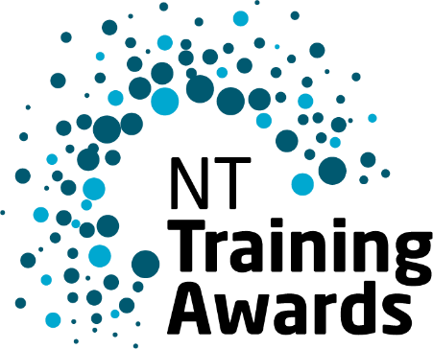
Storm Cloud
2024 Winner NTTA Trainee of the Year

Trainee of the Year
The Trainee of the Year Award is presented to an individual who is
undertaking a traineeship and has been outstanding in all aspects of their training.

Eligibility
- Be an Australian citizen or a permanent resident of Australia.
- Have a Contract of Training registered with the Northern Territory State Training Authority.
- Have completed or be due to complete your training in the period 1 July 2024 to 30 June 2025 in a training course that leads to a nationally recognised outcome or qualification relevant to the award you are applying for.
- Meet NT Training Award and Australian Training Awards conditions of entry.
- Ensure availability for compulsory attendance event dates.

Nominating Online
All nominations must be completed through the NT Training Awards portal.
As well as addressing the selection criteria, you must be able to provide the following:
- Your course details
- Employer and or Host employer details (if applicable).
- Registered Training Organisation details.
- Evidence of completion date or early completion date (i.e. certificate of proficiency, signed request for competency-based completion with RTO evidence attached).
- Letters of support and endorsement (suggest from RTO, employer, teacher/trainer etc).
- Additional letters of support – and copies of any certificates, awards or prizes you have received.
You are able to submit up to five (5) supporting documents with your application.

Nominations close
Nominations close at midnight Wednesday 7 May 2025.
For a guide to preparing your application, visit TrainingAwards.nt.gov.au.

Application
In your application, you must clearly address the award criteria. This application will carry through to the Australian Training Awards judging panel if you are successful at the NT awards.
Section A: Overview
This information will not be considered or used for judging purposes, but it may be used as your summary throughout the Awards process.
Provide a short overview covering a description of the qualification you are enrolled in, your registered training organisation and employer and host employer (if applicable) as well as your reason for choosing the industry and training path.
(300 Limit words)

Section B: Selection Criteria
This information will be considered and used for judging purposes.
Criterion 1: Career and Study Achievements (limit: 400 words)
Consider things such as:
- Why did you choose your course?
- How has it changed or impacted on you?
- What have you gained from it?
- What have you been able to bring to your workplace?
Criterion 2: Team and communication skills (limit: 400 words)
Consider any skills you have developed through your training, such as:
- What have you been able to tell others, work mates, employers etc. about your training?
- What do you like about working in a team setting?
- What traits do you think are important to positively influence others?
Criterion 3: Ability to be an Ambassador (representative) for training in Australia (limit: 400 words)
Tell us about:
- Provide examples where you have taken a leadership role inside or outside of work.
- What other activities have you been involved in where you have been a representative?
- How would you describe the quality of your training?
Criterion 4: Other qualities and pursuits (limit: 400 words)
You may wish to include information about:
- Have you had to address any challenges that have impacted your training?
- When have you been required to use initiative either in your training, your personal life or your workplace?
- What other qualities or activities do you feel would be useful in your role as Trainee of the Year?
- What other community or industry involvement have you had?

