This document should be read in conjunction with:
- Enrolment Policy and Guidelines
- Students with Disability Policy and Guidelines
- Diagnosis Assessment Guidelines.

Introduction
The Department of Education (the department) operates a number of Special Schools and Special Centres to cater for students with intellectual disability and/or additional complex needs. A list of current Special Schools and Special Centres is provided at Appendix A.
These guidelines provide clear and consistent eligibility criteria and verification processes for the enrolment of students in Special Schools and Special Centres through the provision of:
- Special School and Special Centre placements
- Special School and Special Centre functional placements.
The eligibility criteria and verification processes ensure that the wellbeing and educational needs of each student are carefully considered and assessed prior to the student’s placement or functional placement in a Special School or Special Centre.
Parents have the right to appeal a decision where a student has been deemed ineligible for a placement or functional placement in a Special School or Special Centre.

Definitions
Appeal is a review process that can be undertaken in the event that a student has not met the eligibility criteria, and is unsuccessful in obtaining verification for a Special School or Special Centre placement or functional placement.
Capacity/expertise for the purpose of this document refers to a Special School or Special Centre’s ability to provide specialised support and educational programs to meet the student’s specific needs.
Complex needs for the purpose of this document refers to a student with or without an identified disability who may require intensive support and a highly individualised program to access, and participate in, the curriculum. The student may meet the eligibility criteria for a functional placement in a Special School or Special Centre.
Daily care and control of a child (in regards to the definition of parent) refers to a person who is entitled to exercise all the powers and rights, and has all the responsibilities, in relation to the day-to-day care and control of the child.
Disability, in relation to a person, means:
- total or partial loss of a person’s bodily or mental functions, or
- total or partial loss of a part of the body, or
- the presence in the body of organisms causing disease or illness, or
- the presence in the body of organisms capable of causing disease or illness, or
- the malfunction, malformation or disfigurement of a part of the person’s body, or
- a disorder or malfunction that results in the person learning differently from a person without the disorder or malfunction, or
- a disorder, illness or disease that affects a person’s thought processes, perception of reality, emotions or judgment, or that results in disturbed behaviour;
and includes disability that:
- presently exists, or
- previously existed but no longer exists, or
- may exist in the future, or
- is imputed to a person.,
Functional placement in a Special School or Special Centre is where a student with complex needs with an identified disability, and without an intellectual disability, meets the eligibility criteria of these guidelines.
Parent signifies the child’s father, mother or any other person who has parental responsibility for the child, including a person who is regarded as a parent of the child under Aboriginal customary law or Aboriginal tradition.
Parent refers to:
- the child’s father, mother or any other person who has parental responsibility for the child and also for an Aboriginal or Torres Strait Islander child includes a person who is regarded as a parent under Aboriginal or Torres Strait Islander customary law or Aboriginal or Torres Strait Islander tradition;
- a guardian/caregiver and is a person who has parental responsibility for a child or daily care and control of a child, is the person with whom a child currently resides, or is a person caring for the child at any given time.

According to the Education Act 2015 (NT) s.7-8 a person has parental responsibility for a child if the person has daily care and control of the child (i.e. is entitled to exercise all the powers, rights and responsibilities in relation to the day-to-day care and control of the child) or is entitled to exercise all the powers, rights and responsibilities in relation to the long-term care and development of the child, or both.
Special Centre refers to a special education setting attached to a mainstream school for students with an intellectual disability as approved by the Chief Executive.
Special School refers to a special education setting for students with an intellectual disability as approved by the Chief Executive.
Special School or Special Centre placement is where a student has been identified as eligible and is enrolled in a Special School or Special Centre in line with these guidelines.
Transition planning is the process of developing short and long-term goals and strategies to prepare students to transition through their schooling and into their chosen post-school pathway.
Verification is the process undertaken by Student Wellbeing and Inclusion in consultation with school psychologists to ensure that each student enrolled in a Special School or Special Centre has met the eligibility criteria required for the enrolment.

Roles and responsibilities
General Manager Student Wellbeing and Inclusion is responsible for:
- monitoring the implementation and application of the Enrolment in Special Schools and Special Centres Guidelines
- convening and making determinations in case conferences to determine the outcome of an appeal
- providing timely advice to department stakeholders on changes in policy and legislation that affects the enrolment of students with disabilities in Special Schools and Special Centres
- engaging in case conferences to assist in determining the outcome of an appeal
- verifying the student’s educational needs upon recommendations from the Senior School Psychologist and sign verification notices to support decisions.

Principal is responsible for:
- ensuring compliance with the Enrolment in Special Schools and Special Centres Guidelines
- explaining the enrolment process to parents and ensure they are kept informed
- collecting relevant documentation and providing information to Student Wellbeing and Inclusion team to enable verification of eligibility
- enrolling students that meet the eligibility criteria and have an approved verification notice in accordance with the Enrolment Policy and Guidelines
- engaging in case conferences to assist in determining the outcome of an appeal
- ensuring student diagnostic assessments are current at transitioning points
- maintaining a schedule of review for all students.

Senior Manager Inclusive Practice is responsible for:
- liaising with school psychologists and ensuring specialist assessments are carried out in a timely manner
- participating in the case consultation process for determining an appeal
- supporting schools to ensure student diagnostic assessments are current at key transition points
- conducting reviews in consultation with principals and school psychologists
- ensuring relevant documentation is recorded in TRM and student details are entered into the Support Services Information Database (SSID).

Senior School Psychologist is responsible for:
- overseeing the assessment and verification process.
School Psychologist is responsible for:
- completing assessments in accordance with the Australian Psychology Society Guidelines
- liaising with parents, school staff, and the senior school psychologist as required about the results of assessments
- providing advice on the eligibility for enrolment
- ensuring student support processes are carried out in a timely manner
- consulting with senior school psychologist on complex issues
- assisting schools with scheduled reviews.

Eligibility
Criteria for assessing a student’s eligibility for enrolment in a Special School or Special Centre is aligned with the Diagnostic and Statistical Manual of Mental Disorders 5th Edition (2013) (DSM-V).

Placement Criteria
A student may be enrolled in a Special School or Special Centre if each of the following entry criteria are met:
Year of entry | Entry criteria
Early years (P-3) | - Global Developmental Delay confirmed through comprehensive assessment by a paediatrician, and/or psychologist:  - deficits in intellectual functions (at or below 2nd percentile) confirmed by both clinical assessment and individualised, standardised intelligence testing, or  - other evidence of failure to meet developmental milestones in several areas of intellectual functioning when individual’s disabilities prevent standardised assessment, or  - deficits in adaptive functioning that result in failure to meet developmental milestones, below 2nd percentile across majority of functioning, and  - adaptive functioning deficits indicate significant impairment in several domains - communication, social participation, early learning and development.  - Requiring extensive adjustments that are highly individualised, comprehensive and ongoing to allow access to, and participation in the curriculum.  By age 8, sufficient valid and reliable assessment evidence must be compiled to confirm diagnosis, identify education needs and program development options.

Year of entry | Entry criteria
Primary, middle and senior years | - Intellectual Disability confirmed through comprehensive assessment by a psychologist that includes:  - deficits in intellectual functions, confirmed by both clinical assessment and individualised, standardised intelligence testing (IQ at or below 2nd percentile)  - deficits in general adaptive functioning (standard score at or below 2nd percentile) that result in failure to meet developmental and socio-cultural standards for personal independence and social responsibility. Those deficits limit functioning in a wide range of activities of daily life.  - Extensive adjustments that are highly individualised, comprehensive and ongoing to allow access to and participation in the curriculum are required.

Functional Placement Criteria
A student may be enrolled in a Special School or Special Centre if each of the following entry criteria is met:
Year of entry | Entry criteria
Preschool to year 12 | - Evidence of complex needs accompanying a diagnosed disability:  - deficits in general adaptive functioning (standard score at or below 2nd percentile) that result in failure to meet developmental and socio-cultural standards for personal independence and social responsibility. Those deficits limit functioning in a wide range of activities of daily life.  - Extensive adjustments that are highly individualised, comprehensive and ongoing to allow access to and participation in the curriculum are required.  - Long documented history of adjustments and support with analysis of progress, and  - History of advice and support from multidisciplinary professionals over an extended period of time (i.e. counsellor, therapists, psychologist, psychiatrist, Student Support Advisors).

Process for Student Enrolment
All enrolments must be processed in accordance with the Enrolment Policy and its associated enrolment guidelines and procedures. For enrolments in a Special School or Special Centre the following steps must also be followed:
- A parent or school initiates a request for enrolment of a student in a Special School or Special Centre. This may be for:
- a student who has not previously been enrolled in a Northern Territory Government school
- a student who is currently enrolled in a mainstream Northern Territory Government school
- a student who is already verified as eligible to enrol in a Special School or Special Centre.

- A meeting between the parents and the principal is required to review the student’s diagnostic reports and any other relevant documentation.
- where it is believed that a Special School or Special Centre is an appropriate educational setting for the student, copies of all documentation are provided to the Special School or Special Centre principal
- where the student is transferring between a Special School or Special Centre, it is not necessary to request verification at the enrolling school if a current verification notice is in place.
- The Special School or Special Centre principal:
- may, where a student clearly meets the eligibility criteria outlined in section 4.1, deem the student as eligible and enrol the student in the school (Note: Where the principal makes a decision to enrol a student prior to verification, it must be acknowledged by all parties that the enrolment is temporary until such time as a verification notice is received by the school and/or parents)
- may choose not to make a determination and forward all documentation to Student Wellbeing and Inclusion for verification
- ensures a Parent Permission – request for verification to enrol form will be completed by the parents and the Special School or Special Centre principal and submitted to Student Wellbeing and Inclusion with documentation for verification.
- The Senior School Psychologist will verify the student’s eligibility with the school psychologist against the criteria outlined in section 4.1.
- Where a student is verified for a placement or functional placement, the Senior School Psychologist will prepare the relevant Successful Verification Notice for approval by the General Manager Student Wellbeing and Inclusion.
- Where a student is found ineligible for a placement or functional placement, the Senior School Psychologist will prepare an Unsuccessful Verification Notice to be signed by the General Manager Student Wellbeing and Inclusion. The notice will include reasons for the decision and recommendations for alternative enrolment and support options.
- Where the principal has enrolled the student in a Special School or Special Centre prior to verification and the student is then found ineligible for a placement or functional placement, the Senior School Psychologist will prepare a temporary placement notice for approval by the General Manager Student Wellbeing and Inclusion. A Temporary Placement Notice will allow the student to remain enrolled in the Special School or Special Centre for up to one semester to allow adequate time for transitioning into a mainstream school setting. The student must be enrolled within a mainstream school or classroom setting by the date specified on the notice.
In some cases, particularly where a functional placement is being verified, a student may need to be placed in their local school until the verification process is complete.

- The General Manager Student Wellbeing and Inclusion will approve and sign off on the relevant notice based on the Senior School Psychologist’s recommendation.
Recommendation | Documentation
Placement approved | Successful Verification Notice – Special School or Centre Placement
Functional placement approved | Successful Verification Notice – Special School or Centre Functional Placement
Placement not approved | Unsuccessful Verification Notice  (must include reasons for decision and recommendations for alternative enrolment and support options)
Temporary placement | Temporary Placement Notice  (must specify date by which the student must be transferred to a mainstream school or classroom)

Copies of the relevant signed notice will be forwarded to the relevant stakeholders as appropriate, e.g. principal, parents, and education advisors.
- Enrolment is to take place in accordance with the documentation issued by General Manager Student Wellbeing and Inclusion.
- The Senior Manager Inclusive Practice to ensure that all records are placed in TRM and the student details are entered into SSID.
Where a student has been deemed ineligible for a placement, the student may receive support from a Special Education Teacher, Special Education Assistant and/or specialised programs.
A workflow diagram for the Enrolment Process for Special Schools and Special Centres is provided in Appendix B.

Diagnostic assessments review
Student diagnostic assessments should be reviewed and updated at key transition points:
- primary to middle school
- middle school to senior secondary.
The school psychologist will ensure that psychological assessments are current.
Principals and Student Wellbeing and Inclusion staff will support assessments at key transition points.

Functional placement review
Functional placements in Special Schools and Special Centres are required to be reviewed by the date specified in the Successful Verification Notice. The review is to determine if the functional placement is to continue or if the student will begin the transition into a mainstream classroom setting. The school will need to provide a Summary Report Functional Placement Review that incorporates the following information:
- reasons and evidence for functional placement
- any updated diagnosis assessments and additional reports
- adaptive assessment behavior
- synopsis of student history/background information
- information pertaining to adjustments in current Educational Adjustment Plan that allow access to and participation in the curriculum
- history and analysis of previous adjustments
- history of advice and support from multidisciplinary professionals
- information pertaining to student’s ability to socialise
- evidence of meeting to obtain informed consent with parent.
The principal is responsible for maintaining a schedule of reviews and initiating the review process for each student.
Each review is undertaken in consultation with the parents, principal, relevant Student Wellbeing and Inclusion advisor, School Psychologist and Senior School Psychologist. Recommendations will be outlined in a new verification notice prepared by the Senior School Psychologist and forwarded to the General Manager Student Wellbeing and Inclusion for approval and approval. Where a review determines that a student should be transitioned into a mainstream classroom setting, a Temporary Placement Notice will be issued to provide adequate time for the transition to occur.
Where a student in a functional placement is transferring from primary to middle school or middle to senior school, the verification notice should be checked to confirm the review date.

Right of appeal
A parent has the right to appeal a decision not to approve a student for a placement or functional placement in a Special School or Special Centre.
The parent should submit their appeal in writing to the General Manager Student Wellbeing and Inclusion within 10 working days of receiving the ineligibility notice. The appeal should outline the parent’s concerns regarding the department’s decision not to verify the child’s eligibility for enrolment in a Special School or Special Centre.
The General Manager Student Wellbeing and Inclusion will convene a case conference with the appropriate stakeholders. Depending on the complexity of the case, the case conference may involve the following stakeholders:
- Relevant Senior Director School Improvement and Leadership
- Relevant Director / Manager Quality School Systems and Support
- General Manager Student Wellbeing and Inclusion
- Senior Manager Inclusive Practice
- Senior School Psychologist
- School Psychologist
- School Principal.
Attendees of the case conference will review the student’s diagnostic reports and other supporting documentation. Based on the outcomes of the case conference, the General Manager Student Wellbeing and Inclusion will make a determination and advise the student’s parents in writing of the final decision.

Appendices
- Appendix A ─ Approved Special Schools and Special Centres
- Appendix B ─ Enrolment Process for Special Schools and Special Centres

Related legislation, policies and resources
Legislation | Disability Discrimination Act 1992 – promotes the elimination of discrimination against persons on the grounds of disability, ensure people with disability have the same rights to equity before the law and promote recognition and acceptance that people with disability have the same fundamental rights as the rest of the community.
 | Disability Standards for Education 2005 – makes explicit the obligations of education and training service providers under the Disability Discrimination Act 1992 and the rights of people with disabilities in relation to education and training.
 | Education Act 2015 (NT) - promotes the high-quality contemporary education to develop students’ potential and maximise their educational achievement.
 | Education and Care Services (National Uniform Legislation) Act 2011 (NT) - sets a national standard for children’s education and care across Australia.
Policies and guidelines | Enrolment Policy and Guidelines
 | Students with Disability Policy and Guidelines
 | Diagnosis Assessment Guidelines
Forms | Request for Verification to Enrol
 | Summary Report Functional Placement Review
 | Obtain Informed Consent Functional Placement

Appendix A

APPROVED SPECIAL SCHOOLS AND SPECIAL CENTRES
These Special Schools and Special Centres are approved by the Department of Education as settings for students with high support needs arising from an intellectual disability.

Special Schools
- Nemarluk School Darwin (P-6)
- Henbury School Darwin (7-12)
- Forrest Parade School Palmerston (P-6)
- Kintore School Katherine (P-12)
- Acacia Hill School Alice Springs (P-12)

Special Centres
Special Centres are located at the following schools:
- Humpty Doo Primary School (P-6)
- Nhulunbuy Primary School (P-6)
- Woodroffe Primary School (P-6)
- Centralian Middle School (7-9)
- Katherine High School (7-12)
- Nhulunbuy High School (7-12)
- Palmerston Senior College (7-12)
- Taminmin College (10-12)
- Centralian Senior College (10-12)
- Tennant Creek Primary School (P – 6)

Appendix B

ENROLMENT PROCESS FOR SPECIAL SCHOOLS AND SPECIAL CENTRES
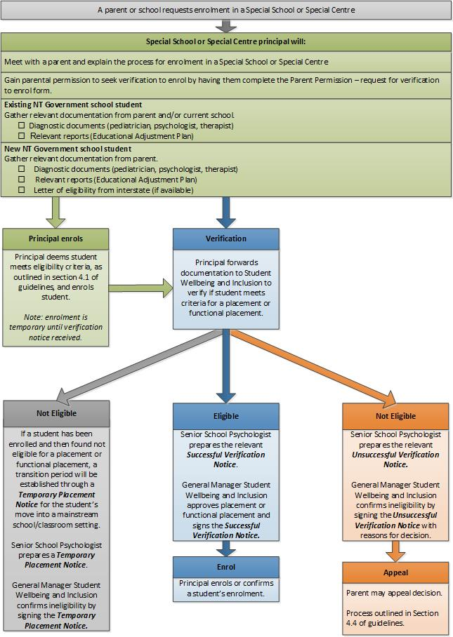

Disability Standards for Education 2005 https://education.gov.au/disability-standards-education
Disability Discrimination Act 1992 (Cwlth) https://www.legislation.gov.au/Series/C2004A04426

