Complaints management for schools - guidelines

Contents
1. Introduction 3
2. Definitions 3
3. Roles and responsibilities 4
3.1. Complainants 4
3.2. Staff receiving the complaint 4
3.3. Staff responding to the complaint 5
3.4. Principals 5
3.5. Workplace managers 6
3.6. School Operations 6
3.7. Senior Director and Directors School Operations 6
3.8. Early Years and Education Services 6
3.9. Education Regulation 6
3.10. Student Wellbeing and Inclusion Programs and Services 7
3.11. Human Resources 7
3.12. Freedom of Information and Privacy Officer 7
3.13. Chief Executive or delegate 7
4. Guidelines and procedures 7
4.1. Lodgment and escalation of a complaint 7
4.1.1. Local level 7
4.1.2. Regional level 8
4.1.3. Chief Executive level 8
4.2. De-escalation of a complaint 9
4.3. Communication and timeframes 9
4.4. Management of complaints 9
4.5. Rejection of a complaint 10
4.6. Withdrawal of a complaint 10
4.7. Remedial action 10
4.8. Appointment of an investigator 10
4.8.1. Report by investigator 11
4.8.1.1. Service, policy or administrative action 11
4.8.1.2. Breaches of discipline 11
4.9. Records of complaints 11
5. Lodgement and escalation of internal complaints – flowchart 12
6. Complaints lodged with the Chief Executive, Minister or Chief Minister - flowchart 13
Appendix A – Factors to consider when developing a plan for involving children and young people in a complaints process 14

Read this document with the Complaints management in schools policy.

Introduction
Students, parents and members of the community affected by a decision or services provided by Northern Territory (NT) Government schools are entitled to seek a resolution of their complaints or concern. These guidelines aim to provide a clear process for the management of complaints relating to NT Government schools, which is child focused.

Definitions
Term | Definition
Approved early childhood education and care services | Refers to long day care services, family day care services, outside school hours care services, preschool programs and early childhood programs.
Complainant | A student, parent, community member, business or any other person affected by the actions of the department and may include a departmental employee in their private capacity who has a complaint.
Complaint | The expression of dissatisfaction with any aspect of the service provided, or not provided or regulated by the department. It may include the behaviour or decisions of staff, or practices, policies or procedures. A complaint must contain sufficient detail to enable it to be recorded and addressed.
De-escalation | For the purpose of this policy, refers to the process of referring a complaint closer to the point of responsibility so that the likelihood of resolution is increased. In the majority of instances this will see the complaint referred to the relevant area of responsibility. This will occur when a complaint is lodged directly with the Chief Executive, Minister or Chief Minister, without first being addressed at the local level.
Local level | Refers to a school, preschool or departmental corporate workplace.
Parent | Refers to a child’s father, mother or any other person who has parental responsibility for the child, including a person who is regarded as a parent of the child under Aboriginal or Torres Strait Islander customary law or tradition.
Procedural fairness | Requires a fair and equitable procedure to be used when making a decision. This includes the right for all parties to be fully informed of allegations and to have the opportunity to respond prior to a decision being made.
Regional level | Refers to the section within the department responsible for the management of a school or corporate workplace.
Respondent | Refers to a person requested to respond to complaints made about them.
School representative bodies | Enable parents, teachers, the school principal, invited members and students in secondary schools to work collaboratively to achieve the best educational outcomes for students in their communities. There are three types of school representative bodies:  - School council – a body of members for a government school  - Independent public school board – a body of members for a government school that is an independent public school and  - Joint school representative body – a body of members which represent two or more government schools.
Workplace manager | Refers to the immediate supervisor of a workplace.

Roles and responsibilities

Complainants
Complainants should:
- raise their concerns at the local level in the first instance
- be as clear as they can about the concerns they have, and the result they are seeking
- use every effort to raise their concerns in a courteous and respectful manner
- wherever possible, provide contact details to the staff member receiving the complaint so that the result can reported back to the complainant.

Staff receiving the complaint
Staff receiving the complaint will:
- receive the complaint in a courteous and respectful manner
- if the complaint relates to one of the below, refer the complainant to the relevant pathway or body that can address their concerns:
  - privacy breaches are to be referred to the department via the email address detfoi.det@nt.gov.au
  - approved early childhood education and care services are to be managed in line with the information on the concerns or complaints about your childcare service website
  - vocational education and training (VET) quality and regulation complaints are to be referred to the Australian Skills Quality Authority
  - higher education complaints are to be referred to the Tertiary Education Quality Standards Agency (TEQSA)
  - non-government schools complaints are to be referred to the relevant non-government provider
  - complaints from departmental employees in relation to issues affecting them in the course of their employment
    - department staff acting in an official capacity may raise their concerns with the person, workplace manager or seek advice from their Human Resources Consultant on how best to manage concerns or actions of another employee.
    - employees also have recourse under the grievance provisions of the Public Sector Employment and Management Act 1993, Section 59
- ascertain whether the complainant has discussed their concerns at the local level and, where possible, refer complainants back to the local level if it is established that this has not yet occurred, and that there are no circumstances preventing the complainant from doing this
- advise complainants of the complaints handling process, and information about accessing the complaints policy and guidelines website1
- listen to the complainant’s concerns and record the details required to ensure that the complaint is able to be referred to the appropriate section of the school or department for action
- inform the complainant that a record of their initial contact has been made. It is important that staff acknowledge the complaint and confirm the accuracy of the complaint details taken verbally by reading back the written notes to the complainant
- refer the complaint to the appropriate area for action as soon as practicable after being received
- participate in the formal complaints process as required - see below for further information.

Staff responding to the complaint
Staff responding to the complaint will:
- endeavour to resolve the complaint at the local level
- ensure that when a complaint is made by a student or child, a child focused approach is taken. Staff should refer to Appendix A – Factors to consider when developing a plan for involving children and young people in a complaints process
- refer to the Sexual behaviour in children guidelines for guidance, where a complaint alleges a child has exhibited sexual behaviour harmful to another child or to themselves
- record and refer unresolved complaints for ongoing management in accordance with the policy and guidelines
- seek advice from the principal or workplace manager or the legal unit if there is any issue of concern or uncertainty, or the complaint has legal implications.

Principals
Principals will:
- ensure the development and implementation of a school complaints procedure that:
  - encourages complaint resolution at the local level
  - includes regular and appropriate communication with relevant stakeholders
  - articulates record keeping protocols in keeping with departmental standards
- ensure that information about the process for making a complaint is available to parents, students and members of the local community.

Workplace managers
Workplace managers will:
- establish record keeping protocols in keeping with departmental standards that ensure monitoring and recording of complaints that enable improvements to be identified and implemented
- resolve complaints at the local level where possible
- record and refer unresolved complaints for ongoing management in accordance with the policy and guidelines.

School Operations
School Operations (SO) will:
- make provision for, and manage, departmental complaint lines for their respective regions
- establish record keeping protocols in keeping with departmental standards that ensure recording and monitoring of complaints to enable improvements to be identified and implemented
- record and refer unresolved complaints for ongoing management in accordance with the policy and guidelines.

Senior Director and Directors School Operations
Senior Director and Directors SO will:
- ensure that schools apply consistency and fairness in managing complaints
- ensure that principals apply appropriate complaint management processes that align with correct procedures, and adhere to the requirements of this policy and the relevant guidelines when managing complaints
- review complaints, including those that have been previously resolved, in light of new information if required.

Early Years and Education Services
Early Years and Education Services will:
- ensure that preschools have written policies, guidelines and procedures that meet the Education and Care Services National Law (NT) and Regulations.

Education Regulation
Education Regulation will:
- handle complaints relating to Industry Engagement and Employment Pathways activities in schools
- handle complaints in relation to compliance with the Education Act for the non-government school sector
- handle complaints in relation to international education services
- handle complaints relating to the administration of home education applications.

Student Wellbeing and Inclusion Programs and Services
Student Wellbeing and Inclusion Programs and Services will:
- handle complaints relating to decisions and services relating to students with disabilities.

Human Resources
Human Resources will:
- handle complaints that have been referred to the department through the Ombudsman
- manage complaints between staff.

Freedom of Information and Privacy Officer
Freedom of Information and Privacy Officer will:
- handle complaints relating to breaches of privacy received by departmental staff in accordance with the Privacy Complaints Policy.

Chief Executive or delegate
Chief Executive or delegate will:
- ensure monitoring mechanisms are in place to evaluate the management of complaints with the aim of reducing the occurrence of systemic and recurring issues
- investigate complaints in relation to independent public schools that have not been resolved at the local level
- determine when a formal investigation needs to be pursued and resolved.

Guidelines and procedures
Complaints may be raised in person, by telephone or in writing.

Lodgment and escalation of a complaint
Section 5 contains includes a flowchart for the lodgment and escalation of complaints.
Whenever possible, complaints will in the first instance be referred for resolution at the local level.

Local level
All complainants should raise their concerns with the staff member or workplace supervisor that the complaint refers to in the first instance. In schools, this is the classroom teacher, senior staff member or ultimately the school principal.
Complaints about school representative body employees or decisions should be made to the school representative body via the chairperson or principal. School representative bodies are incorporated entities and separate legal entities to the department. As such, the extent to which complaints can be handled at the regional level is dependent on the context of the matter raised.
Complainants should be clear about the concerns they have and the outcome they are seeking.
Any staff member that receives a complaint should address the matter personally or refer it to the most appropriate officer for resolution such as the teacher or principal. If the matter cannot be resolved immediately, the complainant should have their complaint acknowledged and be advised of the timeframe in which they can expect a response.
If a complaint is complex and more time is required, the principal must ensure that:
- key timeframes for the complaint process are established and communicated clearly to the complainant
- adequate communication with the complainant on the status of their complaint is maintained throughout the complaint process.
When satisfactory resolution cannot be reached at the local level or a conflict of interest is perceived, the complaint may be referred to the regional level.

Regional level
Once the complainant has attempted to seek resolution at the local level and a satisfactory resolution cannot be reached, the complainant can then contact the relevant department complaints line, by email to schoolops.det@nt.gov.au or alternatively the principal may refer the matter directly to the most appropriate regional office or section of the department for action.
The appropriate regional office must ensure that:
- acknowledgement of the receipt of the complaint is provided to the complainant within five working days
- key timeframes for the complaint process are established and communicated clearly to the complainant
- adequate communication with the complainant on the status of their complaint is maintained throughout the complaint process.
If satisfactory resolution cannot be reached at the regional level through an investigation conducted by the Regional Director or Executive Director, the matter may be escalated to the Chief Executive.

Chief Executive level
Correspondence to the Chief Executive can be undertaken by mail or email:
Chief Executive
Department of Education
GPO Box 4821
Darwin NT 0801
infocentre.det@nt.gov.au
As with the local and regional levels of complaint management, the Chief Executive must ensure that communication is maintained with the complainant including: acknowledgement of receipt of the complaint within five working days; and communication regarding the timeframes for the complaint process.
The Chief Executive will decide if any further action will be taken in response to the complaint.
In the event that a complaint is being referred to the department through the Ombudsman, it will be directed to the General Manager, Human Resources for resolution.

De-escalation of a complaint
Where a complainant escalates a matter to the Chief Executive, Minister or Chief Minister without first lodging their complaint at the local level, the matter should be de-escalated by referring it to the appropriate level of responsibility in line with departmental and ministerial protocols.
In the event that a complainant directs their complaint to more than one level of responsibility, then the complaint is to be de-escalated to the relevant level of responsibility with one action officer identified to handle the resolution.
Appendix B provides a flowchart for the de-escalation of complaints.

Communication and timeframes
Acknowledgement of receipt of a complaint must be provided to the complainant within five working days of the complaint being lodged. Where a complaint cannot be resolved immediately, the workplace manager of the relevant business area is responsible for ensuring that:
- key timeframes for the complaint process are established and communicated clearly to the complainant
- adequate communication with the complainant on the status of their complaint is maintained throughout the complaint process.
The timeframe for resolving a complaint will depend upon the nature and complexity of the matter and whether the matter is being escalated to the regional level or Chief Executive. All departmental staff involved in the processing of a complaint must act to manage and resolve the complaint as a matter of priority to prevent unnecessary escalation.

Management of complaints
Complaints may be lodged with the department through the relevant school or regional office in accordance with the Complaints Management policy and these guidelines. If a verbal complaint is complex, the complainant may be asked to put the complaint in writing or sign a summary taken by the staff member receiving the complaint.
Complainants and respondents can have a support person or interpreter present during any discussion.
When complaints are made about the conduct of any employee, procedural fairness requires that the person that is the subject of the complaint know the details of the case against them and that they be given the opportunity to respond prior to any decision being made in relation to the complaint. Usually the name of the complainant will also be provided to the employee, unless a complainant’s identity needs to be withheld for safety or investigative reasons.
Where a complaint refers to a suspected criminal matter it should be referred to the Northern Territory Police or the Child Protection Hotline.

Rejection of a complaint
In some circumstances it may be appropriate for a complaint to be rejected. For example if the complaint is without substance, without merit, contains personal abuse or inflammatory statements, or material that is clearly intended to intimidate. The complainant will be advised why the matter will not be addressed and a record of this should be kept in case there is a pattern of similar complaints that require action at a later date.

Withdrawal of a complaint
A person who has made a complaint may withdraw the complaint at any time. A complaint can be withdrawn verbally and a notation made to that effect by the relevant staff member. However, it is preferable to obtain a written withdrawal from the complainant.
The relevant staff member must then provide notice of the withdrawal to any parties affected by the complaint. Complaints may be pursued after a withdrawal if the department deems it necessary.

Remedial action
The department is committed to improving government education services. Remedial action at all levels may include, but is not limited to:
- an apology
- an explanation
- change in decision
- mediation
- review of policy
- staff training service improvement
- system change
- action in accordance with the disciplinary provisions of the Public Sector Employment and Management Act.

Appointment of an investigator
Where a complaint is referred for formal investigation, the Chief Executive or delegate will assign an investigator who has the appropriate experience, skills and attributes to enable them to effectively perform their investigative function. The investigator will be impartial and independent.
The investigator will determine the procedures for investigation, subject to any direction or terms of reference provided by the Chief Executive or delegate, and in accordance with procedural fairness.

Report by investigator
The investigator must report their finding of factual matters to the Chief Executive or delegate within the timeframes specified by the Chief Executive. The report must include details of the investigative process and factual findings.
4.8.2 Outcome of investigation

Service, policy or administrative action
Once the factual findings of an investigation are provided to the Chief Executive, the Chief Executive will determine whether remedial action is required, and will delegate this to the most appropriate business area for action. The complainant will be advised of the outcome.

Breaches of discipline
If a complaint has led to formal disciplinary action the complainant may be informed of this step. However, as disciplinary proceedings against an employee are strictly confidential between the employer and the employee, complainants will not be informed of the nature of any disciplinary action taken against the employee.

Records of complaints
Schools and regions must adopt a standard form to record the details of complaints, particularly where they are received over the phone or verbally. Attachment A provides a Complaint Form that may be adopted for this purpose.
Appropriate documentation of the complaint, any response to the complaint, and any action taken as a result of the complaint, must be created and managed in accordance with relevant departmental recordkeeping requirements. Relevant documentation includes, but is not limited to:
- records of the substance of the complaint, for example, written complaint from the complainant, a written summary agreed to by the complainant such as the Complaint Form at Attachment A
- copies of correspondence with the complainant regarding the complaint, including emails and notes of telephone communications
- records of internal correspondence or meetings regarding the complaint, including legal or operational advice obtained in relation to the matter
- records of any action taken, or agreed to be taken, as a result of the complaint, including expected timeframes
- records of any decision to not take further action in relation to a complaint, including reasoning as to why this decision has been made and whether the complainant is satisfied with this decision.
The school is responsible for maintaining appropriate records relating to complaints lodged at the local level. The relevant regional office is responsible for maintaining appropriate records relating to complaints lodged at the regional level.
Upon escalation of a complaint, the records maintained at the local and regional level will be forwarded to the new complaint resolution level. These records are required to ensure that the person taking over the investigation of the complaint is fully informed of the matter, history and handling.

Lodgement and escalation of internal complaints – flowchart
- At each level outlined below, the recipient of a complaint must acknowledge receipt of the complaint within five working days. Where a complaint cannot be resolved immediately, regular communication with the complainant must be maintained until the complaint is resolved.
- Records of complaints must be maintained throughout the complaint lodgement and escalation process as outlined in section 4.1 of these guidelines.
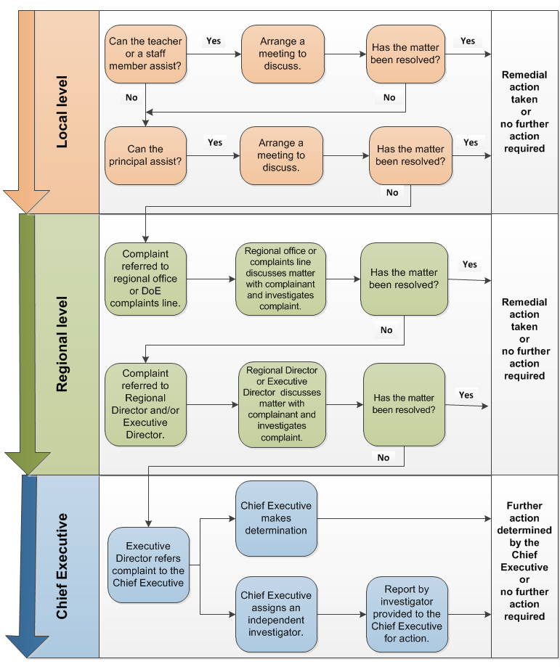
Note: If a complaint is made in relation to an approved education or care service then Quality Education and Care NT must also be notified of the matter.
Phone: 8999 3561 or email qualityecnt.det@nt.gov.au.

Complaints lodged with the Chief Executive, Minister or Chief Minister - flowchart
The following process is to be followed when a complaint is lodged directly to the Chief Executive, Minister, or Chief Minister without first being lodged at the local level.
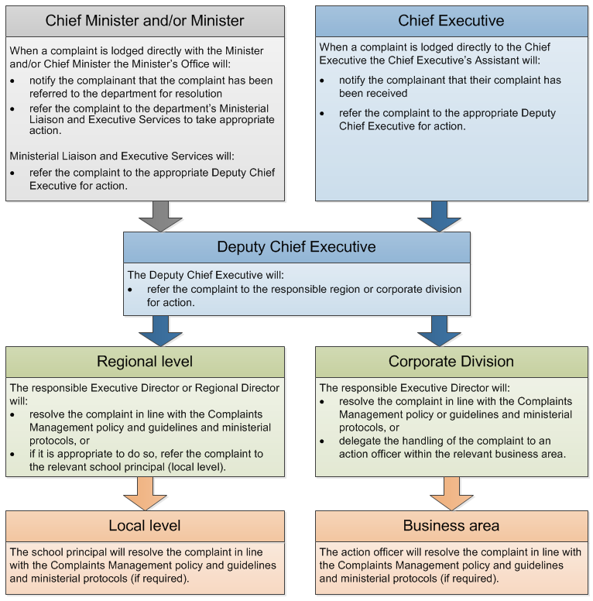
Note: In the event that a complainant directs their complaint to more than one level of responsibility then this complaint is to be de-escalated to the relevant level of responsibility with one action officer identified to handle the resolution.
Records of complaints must be maintained throughout the de-escalation process as outlined in section 4.2 of these guidelines.

Appendix A – Factors to consider when developing a plan for involving children and young people in a complaints process
- Try to find out as much as you can about the child’s or young person’s specific needs and background before you first meet with them
- If you are aware that the child or young person has a disability or any communication support or other specific needs, ensure that these are catered for
- Be mindful of any issues that relate to the child’s or young person’s cultural background or issues relating to their sexual orientation, intersex status or gender
- Allow adequate time for all discussions
- Make sure the venue is appropriate
- Explain how they can participate, what is likely to be involved and what might be required of them
- Ask them about how they would like to be kept informed and check in regularly in case things change
- Ask them who they would like to support them throughout the complaints process and if they have any specific needs to help them feel safe and comfortable
- Think about the likely questions they will have about the complaints process and have your answers ready
- Explain the type of information you may need from them clearly and simply and why it’s important. Be clear if the discussion will be confidential or if certain information will need to be shared.
- Be clear, honest and realistic about the boundaries of a discussion and what can change. It is critical that you are genuine in your approach to children and young people and follow through on what you say you will do. Credibility needs to be earned and can be easily lost
- Listen to what you are being told. Children and young people may have a very different view to you or what you expect, so acknowledge, value and take what they say seriously
- Ensure you have procedures in place to provide support to any child to prevent or reduce any anxiety or distress
- Provide feedback to children and young people about how their views have informed decisions along the way
- At the end of the process, seek their views about their experience of the complaints process. Let them know what changes have been made as a result.

Acronyms | Full form
NQF | National Quality Framework
NTG | Northern Territory Government
SO | School Operations
TEQSA | Tertiary Education Quality Standards Agency
TRM | Territory Records Manager
VET | Vocational Education and Training

Document title | Complaints management for schools - guidelines
Contact details | Quality Standards and Regulations, Resolution Unit, resolution.doe@education.nt.gov.au
Approved by | Executive Director Quality Standards and Regulations
Date approved | 3 July 2023
TRM number | 50:D23:55499

Version | Date | Author | Changes made
3.1 | 30 June 2020 | Operational Policy Coordination Unit | Minor amendment for NTG template, branding and publishing standards
3.1 | July 2020 | Resolution Unit | Inclusion of preschools within the scope of the guidelines
3.2 | July 2023 | Resolution Unit | Minor changes to language to align with post-alignment department structure and inclusion of child focused complaints handling principles for compliance with NQF

https://nt.gov.au/learning/early-childhood/concerns-or-complaints-about-your-child-care-service
http://www.asqa.gov.au/
http://www.teqsa.gov.au/
https://legislation.nt.gov.au/en/Legislation/PUBLIC-SECTOR-EMPLOYMENT-AND-MANAGEMENT-ACT-1993#page=50&zoom=auto,88,595
https://nt.gov.au/learning/primary-and-secondary-students/complain-about-your-school
https://nt.gov.au/community/child-protection-and-care
https://ocpe.nt.gov.au/employment-law/public-sector-employment-and-management-act-and-regulations
© Commonwealth of Australia, Department of the Prime Minister and Cabinet, Complaint Handling guide: Upholding the rights of children and young people

