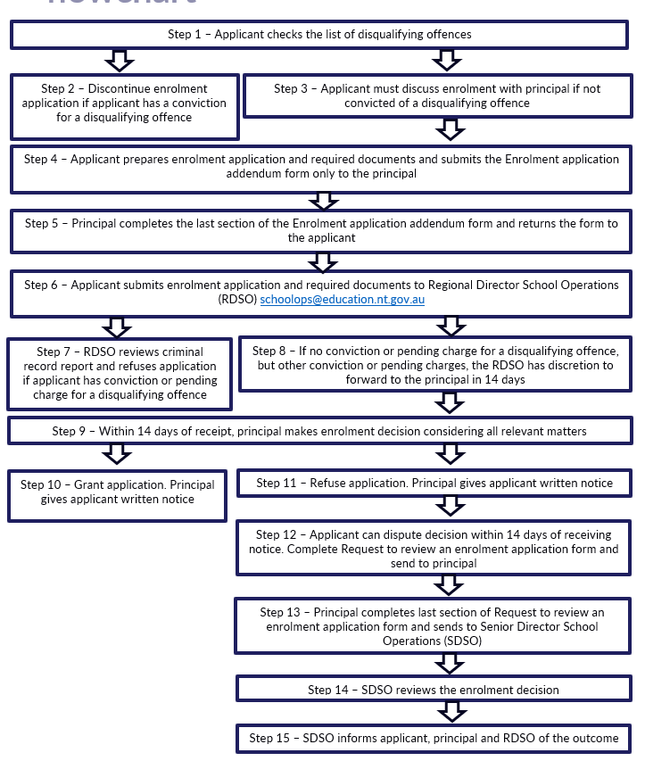

Summary
A prospective mature age student (applicant) follows the procedures outlined in the Mature age student enrolment procedures. The above flowchart summarises the key steps to be undertaken by relevant stakeholders.

Steps

Steps 1 to 6 lists the applicant enrolment process
Step 1: The applicant checks Disqualifying offences for mature students on the Department of Education’s website.
Step 2: If the applicant has a conviction for a disqualifying offence, they must discontinue the enrolment application.
Step 3: If the applicant has not been convicted of a disqualifying offence, then the applicant must discuss possible enrolment with the principal of the school that they intend to enrol at.

Step 4: The applicant prepares an application for enrolment, which includes undertaking a criminal history check, completing the Enrolment application addendum form, and completing all enrolment requirements as per the Enrolment procedures and submits the form only to the school principal.
Step 5: The school principal completes the last section of the Enrolment application addendum form.
Step 6: The applicant submits the enrolment application to the Regional Director School Operations at schoolops@education.nt.gov.au, including the criminal record report, the completed Enrolment application addendum form, and all required supporting documentation as per the Enrolment procedures.

Steps 7 to 8 lists the criminal history process
Step 7: The Regional Director School Operations reviews the criminal record report of the applicant and if it shows a conviction for a disqualifying offence, the Regional Director School Operations must refuse the enrolment application.
Step 8: If the criminal record report does not show a conviction for a disqualifying offence, but has other convictions or pending charges, then the Regional Director School Operations must, within 14 days after receiving the application, forward the application to the principal of the school in which the applicant is seeking to be enrolled, and forward the criminal record report in whole or in part.

Steps 9 to 11 lists the decision to grant or refuse an application process
Step 9: Within 14 days of receipt the school principal must decide whether to grant or refuse an enrolment application and must consider all relevant matters, including the following:
- the applicant’s criminal history – any criminal record report forwarded by the Regional Director School Operations and any pending charges disclosed in the application
- the reason given by the applicant for seeking enrolment
- the likely educational outcome of enrolment and whether the same or a similar outcome could be obtained by other means
- the safety and welfare of all school community members
- the suitability of other education, training, or employment options.
Step 10: The school principal must provide written notice to the applicant if the application is granted.
Step 11: If the decision is to refuse the application, the school principal must give written notice to the applicant.

Steps 12 to 15 lists the dispute and review application process
Step 12: The applicant can dispute the decision within 14 calendar days by completing the Request to review an enrolment application form and send it to the school principal.
Step 13: The school principal completes the last section of the Request to review an enrolment application form and sends it to the Senior Director School Operations at schoolops@education.nt.gov.au.
Step 14: The Senior Director School Operations reviews the enrolment decision and confirms, varies, or sets aside and substitutes a different decision as soon as practicable.
Step 15: The Senior Director, School Operations informs the applicant of the outcome from the review using the Review of enrolment decision for mature age student enrolment application letter template and provides a copy to the school principal and Regional Director School Operations as soon as practicable.

Related legislation, policy and resources
- Education Act 2015 – https://legislation.nt.gov.au/Legislation/EDUCATION-ACT-2015
- Information Act 2002 – https://legislation.nt.gov.au/en/Legislation/INFORMATION-ACT-2002
- Apply for a criminal history check – https://nt.gov.au/law/crime/apply-for-a-criminal-history-check
- Disqualifying offences for mature age students – https://education.nt.gov.au/policies/student-enrolment/enrolment
- Enrolment procedures – https://education.nt.gov.au/policies/student-enrolment/enrolment
- Information sheet for disqualifying offences – https://education.nt.gov.au/policies/student-enrolment/enrolment
- Information privacy principles – https://infocomm.nt.gov.au/privacy/information-privacy-principles
- Make a complaint about a school – https://nt.gov.au/learning/primary-and-secondary-students/make-a-complaint-about-a-school
- Mature age student enrolment procedures – https://education.nt.gov.au/policies/student-enrolment/enrolment
- Enrolment application addendum form – https://education.nt.gov.au/policies/student-enrolment/enrolment
- Request to review an enrolment application form – https://education.nt.gov.au/policies/student-enrolment/enrolment
- School fees for international students – https://nt.gov.au/learning/international-education/study-at-an-nt-government-school/school-fees-for-international-students

