Essay- 2018 Anzac Spirit study tour by Sarah Muller 06/06/2017

What does this enduring relationship between Australia and Villers-Bretonneux (France) teach us about the Anzac Spirit?
The relationship between Australia and Villers-Bretonneux goes back almost 100 years from now (2017). In March 1918 Australian troops were ordered to take a position and defend all of the important areas of Dernancourt and Villers-Bretonneux from being captured by Germany.
Later on in April 1918, Germany managed to seize Villers-Bretonneux, which the Australian troops had tried so hard to protect. The defence of the town had been handed over to the British troops so that the Australian divisions would be able to regroup. The German attack was led by war tanks which forced their way through the British defences. This particular battle was exceptional as it was the very first battle that had tank-on-tank conflict. There were instant orders to recapture Villers-Bretonneux in which a plan was made to launch an attack by the 13th and the 15th brigade. One of the brigades moved from the North and the other brigade approached from the South. This attack would then drive the German forces away from Villers-Bretonneux and their neighbouring woods.
At the time that the Australians reached Villers-Bretonneux, the British troops had stood the impact of the German offensive attack, and exhausted the Germans. Because of this battle in Villers-Bretonneux that Australia and France embrace the primary annual commemoration of Anzac day.
The second battle of Villers-Bretonneux went on for 3 days. It went from the 24th of April to the 27th of April in the year 1918. It was a very dramatic battle as there were two separate battles only days apart. The first one began on the 4th of April 1918 and ended the same day. The next one lasted a little longer and it began on the 24th of April and ended on the 27th of April 1918.
The initial plan for Germany was to conquer Amiens, which was 15 kilometres west of Villers-Bretonneux. This would make it very difficult for British troops to move supplies and other troops. In the first battle the Germans failed but in the second battle they succeeded. They managed to push through the 8th and 58th British divisions. Germany, with the assistance of 15 tanks had driven the British troops back 3 kilometres. The 14th German brigade had moved the Southern end of its line backwards to remain in contact with the British as they had begun to retreat. Meanwhile, the 13th Light Horse had sought to find the point of Germany’s best progress.
After the war Villers-Bretonneux was a wreck and Australian communities helped rebuild the town. The Australian National Memorial to all of those people who fell during the battle of Villers-Bretonneux stands on the Villers-Bretonneux plateau. From those times to these current times, the town of Villers-Bretonneux have always observed ANZAC day.
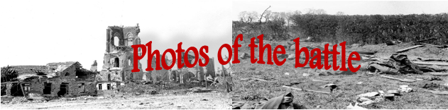

There is a school in Villers-Bretonneux that was built during 1923-1927 was a gift from children who lived in Victoria (Australia). This was to prove that they cared for France. When this school was made, the people in France decided to name the school the ‘Victoria school’. At this school there is a large sign near the playground that says ‘Do Not Forget Australia’ that same phrase is actually written in French within each classroom. Also at the Victoria School there is a plaque that stands. On the plaque the sentences written are ‘This school building is the gift of the school children of VICTORIA, Australia to the people of VILLERS-BRETONNEUX. As a proof of their love and good-will towards France TWELVE-HUNDRED Australian soldiers. The fathers and brothers of these children gave their lives in the heroic recapture of this town from the invader on 24th April 1918 and are buried near this spot. May the memory of great sacrifices in a common cause keep France and Australia together forever in bonds of friendship and mutual esteem.
Below is a picture of the sign and the plaque:
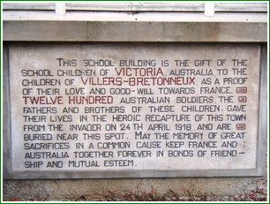  Plaque | 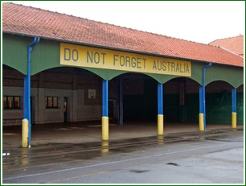  Sign
Also in Villers-Bretonneux there is a famous memorial known as the Australian National Memorial. This memorial shows gratitude and thankfulness towards all of those people who lost their lives in fighting to defend and take back Villers-Bretonneux. It is located in the Villers-Bretonneux military cemetery which is approximately two kilometres North of Villers-Bretonneux. In the battle of Villers-Bretonneux 1200 Australians lost their lives.
After the battle the Australian flag flew and still flies over Villers-Bretonneux. There is a plaque outside the Town Hall that tells the sad yet historical story of events that happened during the battle of Villers-Bretonneux in 1918. Pictures of kangaroos appear above the entrance to the Town Hall and through the garden lie statues of kangaroos. The main street is actually called Rue de Melbourne, named after Melbourne, Victoria. It means street Melbourne.
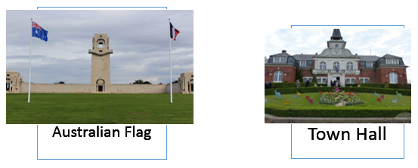
This enduring relationship teaches us that no matter what circumstances the ANZAC’s had to face, they would always face them head first as a united army.
The Anzac Spirit is a powerful characteristic that all Australian soldiers had. They were comrades, family and all of the soldiers had each other’s back. It is shown through great courage, spirit, and sacrifice. The soldiers would always put other companions first before themselves. Meaning that they would risk their lives out on the battlefields for another member of the Australia New Zealand Army Corps.
In The battle of Villers-Bretonneux, Australians, and British soldiers risked their lives for Frances freedom. Many people died, however they sacrificed themselves for a noble cause. I believe that all those soldiers, doctors, and other people out in Villers-Bretonneux are a true inspiration to the future of Australia.
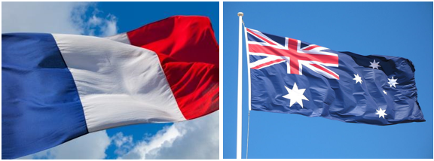
(923 words not including heading, 949 words including heading)

Bibliography
https://anzacday.org.au/spirit-of-anzac
http://www.ww1westernfront.gov.au/villers-bretonneux/visiting-villers-bretonneux.php
http://www.museeaustralien.com/en/?Victoria_school
http://www.awmlondon.gov.au/battles/villers-bretonneux
https://www.awm.gov.au/collection/E105/
http://www.abc.net.au/news/2014-06-06/battle-of-villers-bretonneux/5497598

