Read this document with the Drugs in schools policy and the Drug education guidelines.

Introduction
Northern Territory (NT) Government schools must be prepared for situations where students may be suspected of possession, supply or use of drugs. They must have written policy and procedures for managing the incident in ways that ensure the health and safety of the students, other students, school staff and the broader school community, in accordance with relevant legislation and Department of Education (department) policy.
These guidelines provide the requirements for managing drug-related incidents and will assist schools to develop drug policies that include clear consequences and roles and responsibilities that are tailored to the school’s context.
Under no circumstances are principals or school staff to dispose of suspected drugs or drug use implements. Where a student is found to be in possession of a suspected drug or drug use implement, the school must contact the police immediately to arrange collection and disposal.

Process
The Management of drug related incidents flowchart provides an overview of the process to be undertaken in situations where a student is suspected of drug use, possession or supply at school. Schools may wish to add additional steps or position titles or names to the flowchart for ease of use.
Ultimately, schools are responsible for providing a safe environment for students and staff. If there are reasonable grounds to suspect that a student is in possession of prohibited items such as illicit drugs and there is an immediate threat to safety, the principal has the authority to remove the bag until police can attend the scene and conduct a search.
At no point in time should a principal or school staff forcibly search a student’s bag, belongings, or pockets. Where students have failed to consent, the parents must be contacted. Where necessary, the police will be contacted to attend the premises and conduct the search.
At no point in time should a principal or school staff accuse the student of possession or use of a substance, licit or illicit.

Management of drug related incidents flowchart

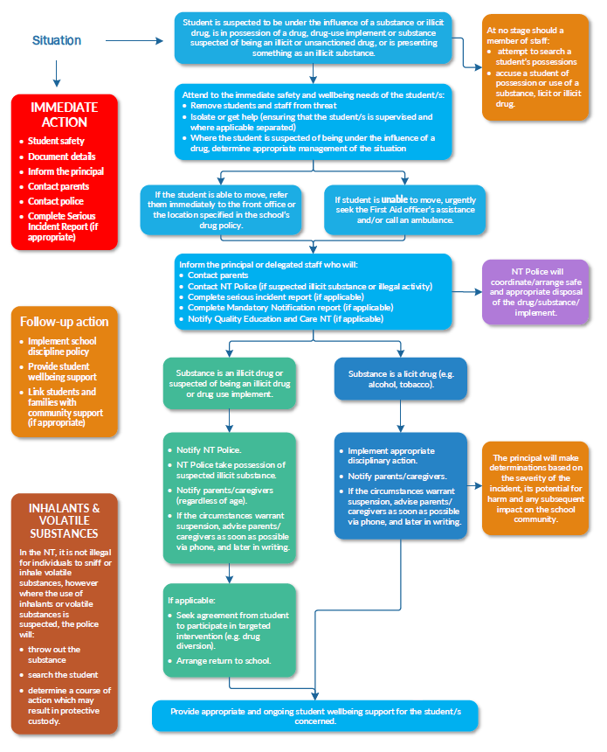

Roles and responsibilities

Principals
Principals are responsible for:
- developing and implementing school policy and procedures for managing drug-related incidents in schools that ensure the health and safety of the students, other students, school staff and the community and are in conjunction and consistent with department policy and relevant legislation
- ensuring that all school staff are aware of the process to follow when managing a drug-related incident and adhere to the relevant sections of department policy and legislation
- notifying Quality Education and Care NT (QECNT) where incidents have occurred in a regulated service, for example, preschool or outside school hours care attached to the school
- informing the police in circumstances where illicit drugs are found – school-based police officers where applicable
- ensuring that all handling of suspected drugs or drug implements by school staff is limited, and that the suspected drugs or drug use implements are safely secured until the police are able to arrange collection and disposal
- assessing the need for referral to other agencies or relevant professionals and agencies to provide support for students, staff and parents, for example, professional development opportunities, medical assessments, counselling and rehabilitation services
- monitoring and reviewing the implementation and effectiveness of responses to drug-related incidents
- reviewing school policy to ensure currency and alignment to government and department policies.

School staff
All school staff are responsible for:
- demonstrating positive role modelling to students and the school community
- responding to information or incidents involving student use, possession or supply of drugs at school in line with school policy and procedures
- informing the principal or nominated staff member when they have reasonable grounds to suspect that a student is involved in drug-related behaviours
- where they have reasonable suspicion that a student is in possession of drugs, following the school policy and procedures for the management of drug-related incidents
- recording all details of a drug-related incident, including any actions taken, and referring to the principal or nominated staff member for appropriate action
- referring media enquiries to the principal or nominated staff member
- reporting suspected abuse or neglect, that may be related to student drug use.

School based police officers
School based police officers are responsible for:
- operating in accordance with NT Police requirements and in collaboration with the department. Refer to Police in NT Government schools on the department’s website
- conducting interviews on school premises in exceptional circumstances only.

Definitions
Please also refer to the definitions provided in the Drugs in schools policy.
Term | Definition
Electronic cigarettes – e-cigarettes, vapes, electronic nicotine delivery systems, ENDS, e-shisha, e-cigars, e-pipes, e-Hookas, hookah-pens, vape-pipes and e-cigs | Devices designed to be used in a way that replicates or produces an experience similar to the use of a tobacco product. The electronic devices deliver vapourised liquids to the lungs when breathed in. The Tobacco Control Act 2002 applies to e-cigarettes as if they were tobacco products.
Illicit drug | A substance that the use, possession, cultivation or trafficking of is prohibited, or illegal by law. Illicit drug use occurs when drugs are used in an illegal manner, such as cannabis and methamphetamine. This can also include using a drug for an improper purpose or using a product or substance that is not intended to be a drug in a way which produces a drug like state.
Licit drug | Drugs that are able to be purchased legally such as alcohol, tobacco or e-cigarettes and caffeine. This can also include medication used to treat illness, over-the-counter drugs used as directed, and prescription medicines by the intended person for the prescribed usage. Licit drugs can be used illegally and procedures for managing incidents where students are suspected of possessing, using and selling licit drugs on school premises or during school activities or events should be included in school policy and procedures. Students purchasing or supplying licit substances illegally, for example alcohol, can be issued with a fine by the police.
Volatile substances | Volatile substances can include petrol or other engine fuel, lighter fluid – butane gas, spray and aerosol paints, glue or white-out – correction fluid, and aerosol deodorants. In the NT it is not illegal to inhale or sniff volatile substances but it is against the law to supply someone with a substance if you know they intend to sniff or inhale it. Any students suspected of supplying volatile substances for the purpose of sniffing or inhalation must be dealt with by the police as their actions constitute a breach of the Volatile Substance Abuse Prevention Act 2005.

Related legislation, policy and resources
Drug education guidelines – https://education.nt.gov.au/policies/health-safety/drugs-in-schools
Drugs in schools policy – https://education.nt.gov.au/policies/health-safety/drugs-in-schools
School policy template – https://education.nt.gov.au/policies/health-safety/drugs-in-schools
Volatile Substance Abuse Prevention Act 2005 – https://legislation.nt.gov.au/Legislation/VOLATILE-SUBSTANCE-ABUSE-PREVENTION-ACT-2005

Acronyms | Full form
NT | Northern Territory

Document title | Management of drug related incidents in schools – guidelines
Contact details | Inclusion and Engagement Services, Student Wellbeing and Inclusion Programs and Services, swipolicy.doe@education.nt.gov.au
Approved by | Executive Director Inclusion and Engagement Services
Date approved | 28 February 2023
TRM number | 50:D22:100760

Version | Date | Author | Changes made
1 | 20 September 2017 | Student Wellbeing and Inclusion | FILE 2017/1038, EDOC 2017/59235
2 | 28 February 2023 | Student Wellbeing and Inclusion Programs and Services | Administrative amendments to align roles and responsibilities to the structural alignment in effect from 1 July 2022, including NTG template and minor formatting and addition of electronic cigarettes definition

https://education.nt.gov.au/committees,-regulators-and-advisory-groups/quality-education-and-care-nt
https://education.nt.gov.au/policies/health-safety/police-in-nt-government-schools

