This document should be read in conjunction with the Complaints Management (Schools) policy.

- INTRODUCTION

Students, parents and members of the community affected by a decision or services provided by Northern Territory Government (NTG) schools are entitled to seek a resolution of their complaints/concern. These guidelines aim to provide a clear process for the management of complaints relating to NTG schools.

As outlined in the Complaints Management (Schools) policy, complaints relating to breaches of privacy, and those relating to early childhood education and care services, are to be handled using the specifically created processes.

- DEFINITIONS

Approved early childhood education and care services refer to long day care services, family day care services, outside school hours care services, preschool programs and early childhood programs.

Complainant is a student, parent, community member, business or any other person affected by the actions of the department and may include a departmental employee in their private capacity who has a complaint.

Complaint is the expression of dissatisfaction with any aspect of the service provided, or not provided or regulated by the department. It may include the behaviour or decisions of staff, or practices, policies or procedures. A complaint must contain sufficient detail to enable it to be recorded and addressed.

De-escalation, for the purpose of this policy, refers to the process of referring a complaint closer to the point of responsibility so that the likelihood of resolution is increased. In the majority of instances this will see the complaint referred to the relevant area of responsibility. This will occur when a complaint is lodged directly with the Chief Executive, Minister or Chief Minister, without first being addressed at the local level.

Local level refers to a school, preschool or departmental corporate workplace.

Parent signifies a child’s father, mother or any other person who has parental responsibility for the child, including a person who is regarded as a parent of the child under Aboriginal or Torres Strait Islander customary law or tradition.

Procedural fairness requires a fair and equitable procedure to be used when making a decision. This includes the right for all parties to be fully informed of allegations and to have the opportunity to respond prior to a decision being made.

Regional level refers to the section within the department responsible for the management of a school or corporate workplace.

Respondent refers to a person requested to respond to complaints made about them.

School representative bodies enable parents, teachers, the school principal, invited members and students (in secondary schools) to work collaboratively to achieve the best educational outcomes for students in their communities. There are three types of school representative bodies:
  - School council – a body of members for a government school
  - Independent public school board – a body of members for a government school that is an independent public school and
  - Joint school representative body – a body of members which represent two or more government schools.
Workplace manager refers to the immediate supervisor of a workplace.

- ROLES AND RESPONSIBILITIES

Complainants should:
- raise their concerns at the local level in the first instance
- be as clear as they can about the concerns they have, and the result they are seeking
- use every effort to raise their concerns in a courteous and respectful manner
- wherever possible, provide contact details to the staff member receiving the complaint so that the result can reported back to the complainant.

Staff receiving the complaint will:
- receive the complaint in a courteous and respectful manner
- if the complaint relates to one of the below, refer the complainant to the relevant pathway/body that can address their concerns:
  - privacy breaches are to be referred to the department via the email address detfoi.det@nt.gov.au
  - approved early childhood education and care services are to be managed in line with the information found here
  - vocational education and training (VET) quality and regulation complaints are to be referred to the Australian Skills Quality Authority
  - higher education complaints are to be referred to the Tertiary Education Quality Standards Agency (TEQSA)
  - non-government schools complaints are to be referred to the relevant non-government provider
  - complaints from departmental employees in relation to issues affecting them in the course of their employment. Departmental staff acting in an official capacity may raise their concerns with the person, workplace manager or seek advice from their Human Resources Consultant on how best to manage concerns or actions of another employee. Employees also have recourse under the Public Sector Employment and Management Act to the grievance provisions in section 59
- ascertain whether the complainant has discussed their concerns at the local level and, where possible, refer complainants back to the local level if it is established that this has not yet occurred, and that there are no circumstances preventing the complainant from doing this
- advise complainants of the complaints handling process, and where to gain access to the policy and relevant guidelines available here
- listen to the complainant’s concerns and record the details required to ensure that the complaint is able to be referred to the appropriate section of the school or department for action
- inform the complainant that a record of their initial contact has been made. It is important that staff acknowledge the complaint and confirm the accuracy of the complaint details taken verbally by reading back the written notes to the complainant
- refer the complaint to the appropriate area for action as soon as practicable after being received
- participate in the formal complaints process as required (see below for further information).

Staff responding to the complaint will:
- endeavour to resolve the complaint at the local level
- record and refer unresolved complaints for ongoing management in accordance with the policy and guidelines
- seek advice from the principal/workplace manager or the legal unit if there is any issue of concern or uncertainty, or the complaint has legal implications.

Principals will:
- ensure the development and implementation of a school complaints procedure that:
  - encourages complaint resolution at the local level
  - includes regular and appropriate communication with relevant stakeholders
  - articulates record keeping protocols in keeping with departmental standards
- ensure that information about the process for making a complaint is available to parents, students and members of the local community.

Workplace managers will:
- establish record keeping protocols in keeping with departmental standards that ensure monitoring and recording of complaints that enable improvements to be identified and implemented
- resolve complaints at the local level where possible
- record and refer unresolved complaints for ongoing management in accordance with the policy and guidelines.

School Operations (North and South) will:
- make provision for, and manage, departmental complaint lines for their respective regions
- establish record keeping protocols in keeping with departmental standards that ensure recording and monitoring of complaints to enable improvements to be identified and implemented
- record and refer unresolved complaints for ongoing management in accordance with the policy and guidelines.

Executive Directors and Regional Directors will:
- ensure that preschools have written policies, guidelines and procedures that meet the Education and Care Services National Law (NT) and Regulations
- ensure that schools apply consistency and fairness in managing complaints
- ensure that principals have followed correct procedures, and adhered to the requirements of this policy and the relevant guidelines when managing complaints
- review complaints, including those that have been previously resolved, in light of new information if required.

Executive Director School Support Services and Director Senior Years take the role of the Regional Directors and Executive Directors (North/South) for the schools that they directly line manage.

School Support Services will:
- handle complaints relating to Industry Engagement and Employment Pathways activities in schools
- handle complaints relating to the administration of home education applications
- handle complaints relating to decisions and services relating to students with disabilities.

Education Partnerships will:
- handle complaints in relation to compliance with the Education Act for the non-government school sector
- handle complaints in relation to international education services.

Human Resource Services will:
- handle complaints that have been referred to the department through the Ombudsman
- manage complaints between staff.

Freedom of Information and Privacy Officer will:
- handle complaints relating to breaches of privacy received by departmental staff in accordance with the Privacy Complaints Policy.

Chief Executive or delegate will:
- ensure monitoring mechanisms are in place to evaluate the management of complaints with the aim of reducing the occurrence of systemic and recurring issues
- investigate complaints in relation to independent public schools that have not been resolved at the local level
- determine when a formal investigation needs to be pursued and resolved.

- GUIDELINES/PROCEDURES

Complaints may be raised in person, by telephone or in writing.

4.1 Lodgment and escalation of a complaint
Appendix A provides a flowchart for the lodgment and escalation of complaints.

Whenever possible, complaints will in the first instance be referred for resolution at the local level.
4.1.1 Local level
All complainants should raise their concerns with the staff member or workplace supervisor that the complaint refers to in the first instance. In schools, this is the classroom teacher, senior staff member or ultimately the school principal.

Complaints about school representative body employees or decisions should be made to the school representative body via the chairperson or principal. School representative bodies are incorporated entities and separate legal entities to the department. As such, the extent to which complaints can be handled at the regional level is dependent on the context of the matter raised.

Complainants should be clear about the concerns they have and the outcome they are seeking.

Any staff member that receives a complaint should address the matter personally or refer it to the most appropriate officer for resolution e.g. the teacher or principal. If the matter cannot be resolved immediately, the complainant should have their complaint acknowledged and be advised of the timeframe in which they can expect a response.

If a complaint is complex and more time is required, the principal must ensure that:
- key timeframes for the complaint process are established and communicated clearly to the complainant
- adequate communication with the complainant on the status of their complaint is maintained throughout the complaint process.

When satisfactory resolution cannot be reached at the local level or a conflict of interest is perceived, the complaint may be referred to the regional level.

4.1.2 Regional level
Once the complainant has attempted to seek resolution at the local level and a satisfactory resolution cannot be reached, the complainant can then contact the relevant department complaints line (or email schoolops.det@nt.gov.au) or alternatively the principal may refer the matter directly to the most appropriate regional office or section of the department for action.

The appropriate regional office must ensure that:
- acknowledgement of the receipt of the complaint is provided to the complainant within five working days
- key timeframes for the complaint process are established and communicated clearly to the complainant
- adequate communication with the complainant on the status of their complaint is maintained throughout the complaint process.

If satisfactory resolution cannot be reached at the regional level through an investigation conducted by the Regional Director and/or Executive Director, the matter may be escalated to the Chief Executive.

4.1.3 Chief Executive level
Correspondence to the Chief Executive can be undertaken:

By post
Chief Executive
Department of Education
GPO Box 4821
Darwin NT 0801
By email
infocentre.det@nt.gov.au

As with the local and regional levels of complaint management, the Chief Executive must ensure that communication is maintained with the complainant including: acknowledgement of receipt of the complaint within five working days; and communication regarding the timeframes for the complaint process.

The Chief Executive will decide if any further action will be taken in response to the complaint.

In the event that a complaint is being referred to the department through the Ombudsman, it will be directed to the General Manager Human Resource Services for resolution.

4.2 De-escalation of a complaint
Where a complainant escalates a matter to the Chief Executive, Minister or Chief Minister without first lodging their complaint at the local level, the matter should be de-escalated by referring it to the appropriate level of responsibility in line with departmental and ministerial protocols.

In the event that a complainant directs their complaint to more than one level of responsibility, then the complaint is to be de-escalated to the relevant level of responsibility with one action officer identified to handle the resolution.

Appendix B provides a flowchart for the de-escalation of complaints.

4.3 Communication and timeframes
Acknowledgement of receipt of a complaint must be provided to the complainant within five working days of the complaint being lodged. Where a complaint cannot be resolved immediately, the workplace manager of the relevant business area is responsible for ensuring that:
- key timeframes for the complaint process are established and communicated clearly to the complainant
- adequate communication with the complainant on the status of their complaint is maintained throughout the complaint process.

The timeframe for resolving a complaint will depend upon the nature and complexity of the matter and whether the matter is being escalated to the regional level or Chief Executive. All departmental staff involved in the processing of a complaint must act to manage and resolve the complaint as a matter of priority to prevent unnecessary escalation.

4.4 Management of complaints
Complaints may be lodged with the department through the relevant school or regional office in accordance with the Complaints Management policy and these guidelines. If a verbal complaint is complex, the complainant may be asked to put the complaint in writing or sign a summary taken by the staff member receiving the complaint.

Complainants and respondents can have a support person or interpreter present during any discussion.

When complaints are made about the conduct of any employee, procedural fairness requires that the person that is the subject of the complaint know the details of the case against them and that they be given the opportunity to respond prior to any decision being made in relation to the complaint. Usually the name of the complainant will also be provided to the employee, unless a complainant’s identity needs to be withheld for safety or investigative reasons.

Where a complaint refers to a suspected criminal matter it should be referred to the Northern Territory Police/Child Protection Hotline.

4.5 Rejection of a complaint
In some circumstances it may be appropriate for a complaint to be rejected. For example if the complaint is without substance, without merit, contains personal abuse or inflammatory statements, or material that is clearly intended to intimidate. The complainant will be advised why the matter will not be addressed and a record of this should be kept in case there is a pattern of similar complaints that require action at a later date.

4.6 Withdrawal of a complaint
A person who has made a complaint may withdraw the complaint at any time. A complaint can be withdrawn verbally and a notation made to that effect by the relevant staff member. However, it is preferable to obtain a written withdrawal from the complainant.

The relevant staff member must then provide notice of the withdrawal to any parties affected by the complaint. Complaints may be pursued after a withdrawal if the department deems it necessary.

4.7 Remedial action
The department is committed to improving government education services. Remedial action at all levels may include, but is not limited to:

- an apology  - an explanation  - change in decision  - mediation  - review of policy  - staff training | - service improvement  - system change  - action in accordance with the disciplinary provisions of the Public Sector Employment and Management Act.

4.8 Appointment of an investigator
Where a complaint is referred for formal investigation, the Chief Executive or delegate will assign an investigator who has the appropriate experience, skills and attributes to enable them to effectively perform their investigative function. The investigator will be impartial and independent.

The investigator will determine the procedures for investigation, subject to any direction or terms of reference provided by the Chief Executive or delegate, and in accordance with procedural fairness.

4.8.1 Report by investigator
The investigator must report their finding of factual matters to the Chief Executive or delegate within the timeframes specified by the Chief Executive. The report must include details of the investigative process and factual findings.

4.8.2 Outcome of investigation
- Service, policy or administrative action
Once the factual findings of an investigation are provided to the Chief Executive, the Chief Executive will determine whether remedial action is required, and will delegate this to the most appropriate business area for action. The complainant will be advised of the outcome.
- Breaches of discipline
If a complaint has led to formal disciplinary action the complainant may be informed of this step. However, as disciplinary proceedings against an employee are strictly confidential between the employer and the employee, complainants will not be informed of the nature of any disciplinary action taken against the employee.

4.9 Records of complaints
Schools and regions must adopt a standard form to record the details of complaints, particularly where they are received over the phone or verbally. Attachment A provides a Complaint Form that may be adopted for this purpose.

Appropriate documentation of the complaint, any response to the complaint, and any action taken as a result of the complaint, must be created and managed in accordance with relevant departmental recordkeeping requirements. Relevant documentation includes, but is not limited to:
- records of the substance of the complaint (e.g. written complaint from the complainant, a written summary agreed to by the complainant such as the Complaint Form at Attachment A)
- copies of correspondence with the complainant regarding the complaint, including emails and notes of telephone communications
- records of internal correspondence or meetings regarding the complaint, including legal and/or operational advice obtained in relation to the matter
- records of any action taken, or agreed to be taken, as a result of the complaint, including expected timeframes
- records of any decision to not take further action in relation to a complaint, including reasoning as to why this decision has been made and whether the complainant is satisfied with this decision.

The school is responsible for maintaining appropriate records relating to complaints lodged at the local level. The relevant regional office is responsible for maintaining appropriate records relating to complaints lodged at the regional level.

Upon escalation of a complaint, the records maintained at the local and/or regional level will be forwarded to the new complaint resolution level. These records are required to ensure that the person taking over the investigation of the complaint is fully informed of the matter, history and handling.
Appendix A. Lodgment and escalation of internal complaints flowchart
- At each level outlined below, the recipient of a complaint must acknowledge receipt of the complaint within five working days. Where a complaint cannot be resolved immediately, regular communication with the complainant must be maintained until the complaint is resolved.
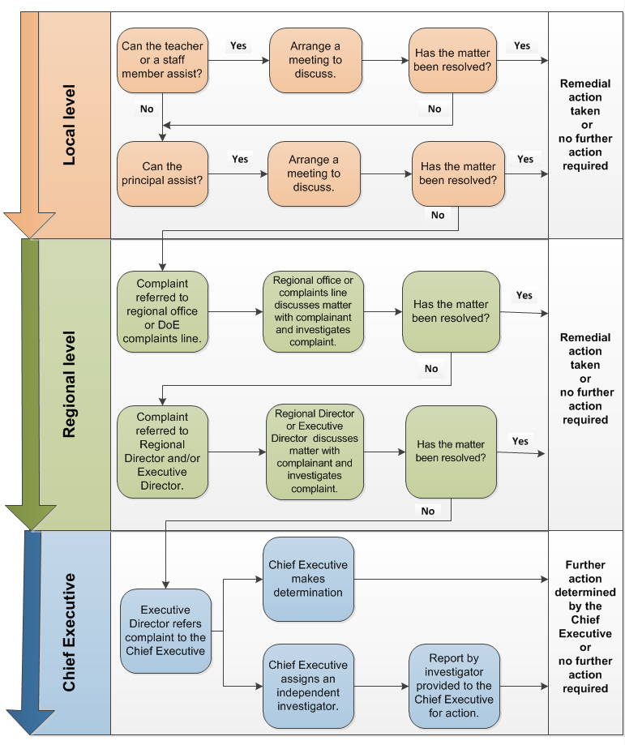
- Records of complaints must be maintained throughout the complaint lodgment and escalation process as outlined in section 4.1 of these guidelines.
Note: If a complaint is made in relation to an approved education or care service then Quality Education and Care NT must also be notified of the matter.
Phone: 8999 3561 or email qualityecnt.det@nt.gov.au
Appendix B. De-escalation of internal complaints flowchart
The following process is to be followed when a complaint is lodged directly to the Chief Executive, Minister, or Chief Minister without first being lodged at the local level.

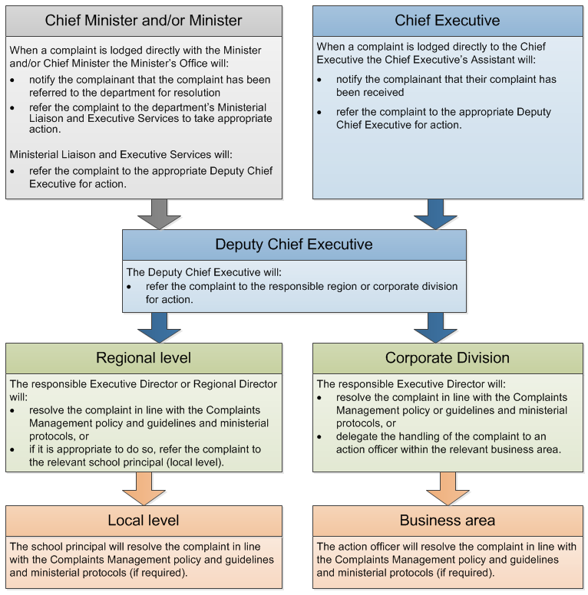

Note: In the event that a complainant directs their complaint to more than one level of responsibility then this complaint is to be de-escalated to the relevant level of responsibility with one action officer identified to handle the resolution.

Records of complaints must be maintained throughout the de-escalation process as outlined in section 4.2 of these guidelines.

