|  |  |  |  |
| --- | --- | --- | --- |
| **Emergency Shelter:** |  | **Date completed:** |  |

# Principles for rostering

* Split days into 2 shifts: day shift; 7am – 7:30pm, and night shift; 7pm – 7:30am.
* Handovers must be done in the 30-minute cross over between shifts.
* Shelter staff must ensure they have scheduled breaks during their shifts to prevent fatigue, for example, a 30-minute break every 4 hours.
* Shelter staff can work a maximum of 14 hours pershift before having a minimum of a 6 hour break between shifts.
* Include the appropriate example roster image in Appendix A of this template, for your reference.

| # | Staff name | Role at shelter | Monday | Tuesday | Wednesday | Thursday | Friday | Saturday | Sunday |
| --- | --- | --- | --- | --- | --- | --- | --- | --- | --- |
| 1. | <Jane Smith> | <Shelter Manager / Deputy Shelter Manager / Shelter Crew> | Group:  Day Shift  Night Shift  Off | Group:  Day Shift  Night Shift  Off | Group:  Day Shift  Night Shift  Off | Group:  Day Shift  Night Shift  Off | Group:  Day Shift  Night Shift  Off | Group:  Day Shift  Night Shift  Off | Group:  Day Shift  Night Shift  Off |
| 2. |  |  | Group:  Day Shift  Night Shift  Off | Group:  Day Shift  Night Shift  Off | Group:  Day Shift  Night Shift  Off | Group:  Day Shift  Night Shift  Off | Group:  Day Shift  Night Shift  Off | Group:  Day Shift  Night Shift  Off | Group:  Day Shift  Night Shift  Off |
| 3. |  |  | Group:  Day Shift  Night Shift  Off | Group:  Day Shift  Night Shift  Off | Group:  Day Shift  Night Shift  Off | Group:  Day Shift  Night Shift  Off | Group:  Day Shift  Night Shift  Off | Group:  Day Shift  Night Shift  Off | Group:  Day Shift  Night Shift  Off |
| 4. |  |  | Group:  Day Shift  Night Shift  Off | Group:  Day Shift  Night Shift  Off | Group:  Day Shift  Night Shift  Off | Group:  Day Shift  Night Shift  Off | Group:  Day Shift  Night Shift  Off | Group:  Day Shift  Night Shift  Off | Group:  Day Shift  Night Shift  Off |
| 5. |  |  | Group:  Day Shift  Night Shift  Off | Group:  Day Shift  Night Shift  Off | Group:  Day Shift  Night Shift  Off | Group:  Day Shift  Night Shift  Off | Group:  Day Shift  Night Shift  Off | Group:  Day Shift  Night Shift  Off | Group:  Day Shift  Night Shift  Off |
| 6. |  |  | Group:  Day Shift  Night Shift  Off | Group:  Day Shift  Night Shift  Off | Group:  Day Shift  Night Shift  Off | Group:  Day Shift  Night Shift  Off | Group:  Day Shift  Night Shift  Off | Group:  Day Shift  Night Shift  Off | Group:  Day Shift  Night Shift  Off |
| 7. |  |  | Group:  Day Shift  Night Shift  Off | Group:  Day Shift  Night Shift  Off | Group:  Day Shift  Night Shift  Off | Group:  Day Shift  Night Shift  Off | Group:  Day Shift  Night Shift  Off | Group:  Day Shift  Night Shift  Off | Group:  Day Shift  Night Shift  Off |
| 8. |  |  | Group:  Day Shift  Night Shift  Off | Group:  Day Shift  Night Shift  Off | Group:  Day Shift  Night Shift  Off | Group:  Day Shift  Night Shift  Off | Group:  Day Shift  Night Shift  Off | Group:  Day Shift  Night Shift  Off | Group:  Day Shift  Night Shift  Off |
| 9. |  |  | Group:  Day Shift  Night Shift  Off | Group:  Day Shift  Night Shift  Off | Group:  Day Shift  Night Shift  Off | Group:  Day Shift  Night Shift  Off | Group:  Day Shift  Night Shift  Off | Group:  Day Shift  Night Shift  Off | Group:  Day Shift  Night Shift  Off |
| 10. |  |  | Group:  Day Shift  Night Shift  Off | Group:  Day Shift  Night Shift  Off | Group:  Day Shift  Night Shift  Off | Group:  Day Shift  Night Shift  Off | Group:  Day Shift  Night Shift  Off | Group:  Day Shift  Night Shift  Off | Group:  Day Shift  Night Shift  Off |

# Appendix A -roster overview

Below are example rosters for urban and remote shelters. Delete the example roster that is not relevant to you.

## Urban shelter roster

* Urban shelters may be operational for approximately 48 hours prior to transitioning into recovery mode where residents will be moved to an evacuation centre.
* Urban shelters use 4 rotating roster groups, A – D, with 4-6 people per group depending on the maximum occupancy of the shelter. That is approximately 2 people per 50 shelter occupants.

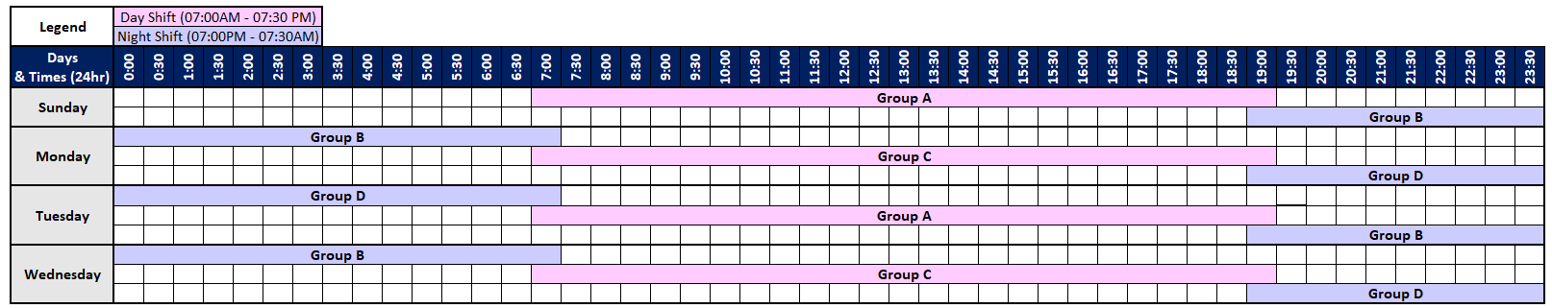

Figure 1 - Urban shelter example roster

## Remote shelter roster

* Remote shelters may be operational for up to 8 days depending on the emergency.
* Remote shelters use 2 rotating roster groups, A and B, with 2-4 people per group depending on the maximum occupancy of the shelter. This is approximately 2 people per 50 occupants.

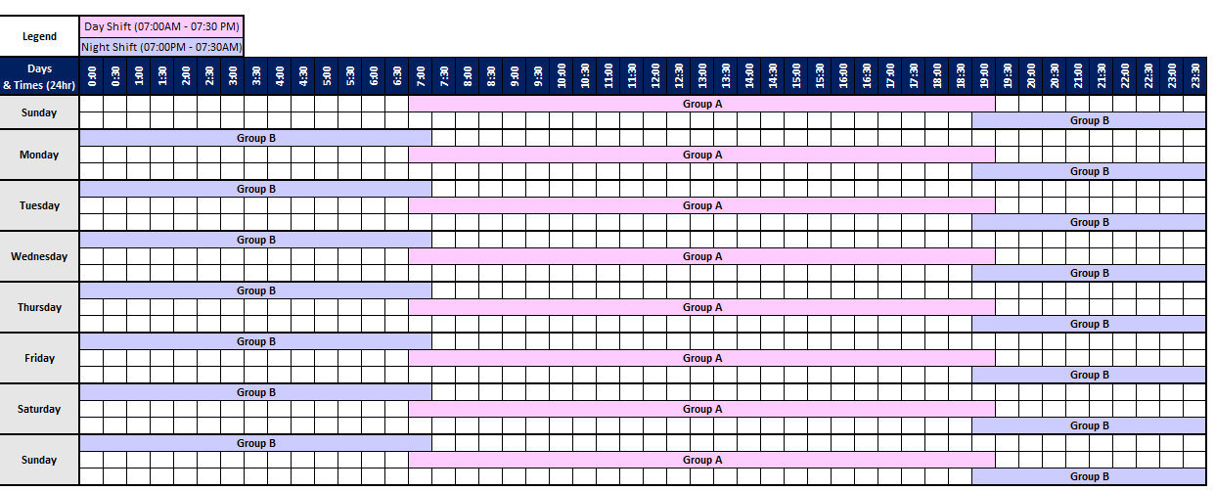

Figure 2 - Remote shelter example roster