Families as First Teachers – guidelines
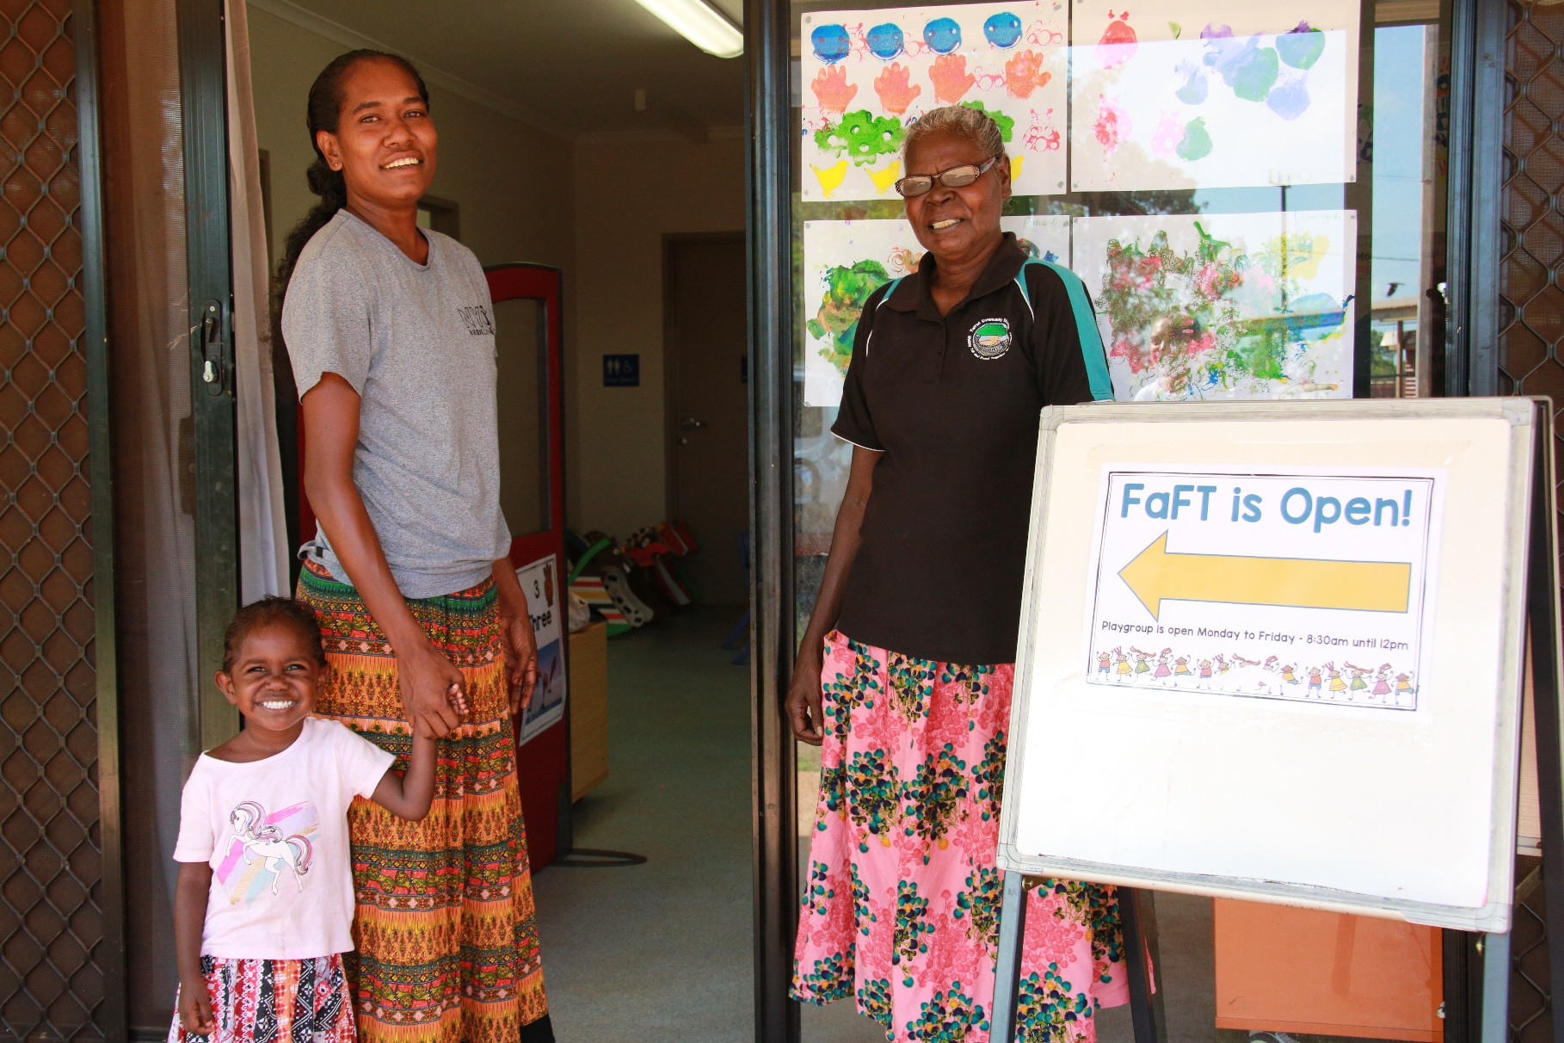
  - Teaching and Learning Services
Contents
1. Introduction 3
2. Guidelines 3
2.1. Program objectives 3
2.1.1. FaFT models 3
3. The five FaFT requirements 4
3.1. FaFT core elements 4
3.2. Abecedarian Approach Australia 5
3.3. Early Years Learning Framework 5
3.4. Co-delivered 5
3.5. Place-based program 6
4. Operational requirements 6
4.1. FaFT Enrolment 6
4.2. FaFT participation 6
4.3. Recording FaFT attendance and participation data 7
4.4. Hours of operation 7
4.5. Closure of a FaFT program 7
5. Funding obligations 7
6. Roles and responsibilities 8
6.1. Teaching and Learning Services 8
6.2. FaFT corporate team 8
6.3. Director FaFT 8
6.4. Senior Directors Education, Regional Services 9
6.5. School principals 9
6.6. FaFT program leaders 9
6.7. Family educators 10
6.8. Family liaison officers 10
6.9. School SAMS operators 11
7. Definitions 11
8. Related policy and legislation 12
8.1. Policy 12
8.2. Legislation 12

These guidelines are part of the Families as First Teachers (FaFT) information available on the Department of Education School policies webpage in the Families as First Teachers section. Read this document with the FaFT policy, the FaFT attendance recording procedures and the FaFT Book. The FaFT Book is a resource that provides information about FaFT and the theory that underpins the program.

Introduction
These guidelines outline the responsibilities and operational requirements that schools and corporate staff must follow to implement effective FaFT programs across the Northern Territory (NT).
An effective FaFT program provides quality early learning and family support programs to young children and their families. The program acknowledges the important role families play as their children’s first teachers. It develops place-based programs to engage families and communities and build parents’ capacity to give their children the best start in life.

Guidelines

Program objectives
The objective of every recognised FaFT program is to:
- optimise the developmental and learning outcomes for young children through quality early childhood educational programs
- enhance parents’ capacity and confidence as their children’s first teachers.
FaFT programs are delivered in a range of contexts and consist of three models:
- FaFT urban
- FaFT remote and very remote
- FaFT Stay Play Learn.
Every FaFT program has mandated program, staffing and operational requirements as outlined in the following table titled FaFT models.

FaFT models
FaFT remote and very remote | FaFT urban | FaFT Stay Play Learn
Program requirements
- FaFT core elements and the elements of 3a
- place-based programs which are culturally appropriate and responsive to community needs
- integrated service delivery
- delivered to families and children and concurrent with preschool
- transitioning plans
Staffing requirements
- certified 3a practitioners  - certified in ASQ-TRAK  - family educator is an experienced early childhood teacher with current TRB registration  - local Aboriginal family liaison officer | - certified 3a practitioners  - family educator is an experienced early childhood teacher with current TRB registration  - local Aboriginal family liaison officer | - certified 3a practitioners  - family educator is an experienced early childhood teacher with current TRB registration
Operational requirements
- minimum 20 hours per week of face-to-face group sessions  Non-group session times include:  - parenting capacity building  - home visiting  - ASQ-TRAK developmental screening  - data and reporting requirements including:  - daily attendance and participation data for child and parent  - developmental screening results and actions  - enrolment records | - minimum 20 hours per week of face-to-face group sessions  Non-group session times include:  - parenting capacity building  - home visiting  - data and reporting requirements including:  - daily attendance and participation data for child and parent  - developmental screening results and actions  - enrolment records | - minimum 15 hours per week of face-to-face group sessions  Non-group session times include:  - parenting capacity building  - home visiting  - data and reporting requirements including:  - daily attendance and participation data for child and parent  - developmental screening results and actions  - enrolment records

The five FaFT requirements

FaFT core elements
There are 3 core elements of FaFT that must be implemented in all FaFT programs:
- quality child centred early learning
- parent capacity building
- community engagement – working with community.
FaFT programs are place-based and able to respond appropriately to both the strengths and needs of individual communities. The 3 core elements of FaFT are implemented in partnership with families, community and stakeholders. Implementation relies on an informed understanding of the local cultural context.
FaFT educators provide quality early learning based on the principles, practices and outcomes of the EYLF and embed the 3a.
FaFT educators will provide individualised parent coaching as part of their program delivery. This will occur in a range of environments to support families and enhance their confidence in understanding child development and parent-child interaction. This is done through the 3a strategies and a range of health, nutrition, wellbeing and child development activities.
FaFT family educators work with the family liaison officers and other local FaFT staff in building networks with families and the community. Family liaison officers are cultural mentors and context experts who provide advice and guidance in the area of cultural appropriateness of program development and delivery, in consultation with other community members. Building networks with families and community enables FaFT programs to respectfully embed cultural identity and family and community knowledge.

Abecedarian Approach Australia
All FaFT educators delivering the program must be trained as 3a Practitioners and must maintain 3a accreditation annually.
FaFT educators will embed 3a strategies in their daily program models. This includes parent coaching and working with other educators to support young children’s ongoing learning and development. The program conforms with the department’s Curriculum, assessment, reporting and certification policy: early childhood to Year 12.

Early Years Learning Framework
The school principal and FaFT educators must ensure that the FaFT program delivers:
- an educational program that is based on the approved learning framework – the EYLF
- an educational program that is based on the developmental needs, interests and experiences of each child
- an educational program that is designed to consider the individual differences of each child
- an effective transitioning strategy that aligns with the NT Early childhood transitioning policy package.

Co-delivered
A FaFT program is co-delivered by a family educator, in partnership with a family liaison officer who is a local Aboriginal person with early childhood experience and relationships with local families to ensure the program is culturally appropriate. Where a school or a school representative body has engaged an assistant teacher, they take on the same role as a family liaison officer.
The family liaison officer is an integral member of the FaFT team and will be the primary source of advice to ensure that programs are respectful of Aboriginal parenting and cultural practices. The family liaison officer has a critical role in negotiating with community members and agencies in the development and delivery of a place-based program. The family liaison officer will also use relationships, knowledge and skills to engage families and community in the program.

Place-based program
FaFT educators, in partnership with the community, develop place-based programs that deliver quality early learning and parenting support. The mandatory core elements of a FaFT program are contextualised to ensure the program is responsive to the needs of families and the community in which the program operates and, is appropriate and respectful of local cultural practices.
A FaFT community includes the educators, families, community members, school principal and school staff.

Operational requirements
The principal must ensure the FaFT program in remote and very remote communities and urban areas meets the minimum staffing arrangements and qualifications of the model they deliver, which may include:
- a family educator and a family liaison officer
- a playgroup leader – a local staff member recruited by the school or external provider delivering the program, to support the delivery of the FaFT program
- the family liaison officer – a local Aboriginal person who has a thorough understanding and appreciation of Aboriginal child rearing practices and knowledge of early childhood development of families in remote communities
- the family educator and the family liaison officer who must be certified 3a Practitioners and maintain this certification.

FaFT Enrolment
All children attending a FaFT program are required to be enrolled at the school in which the program operates.
The principal and FaFT educators must ensure:
- SAMS enrolment forms for all children attending FaFT are completed and supporting documentation provided
- all enrolments are accurately entered into the SAMS and processed in accordance with the department’s Enrolment policy, procedures and guidelines. Information about the Enrolment policy is available on the department’s School policies website in the Enrolment section.

FaFT participation
FaFT plays a vital role in building children’s capabilities and developing strong, lasting patterns of engagement and attendance.
FaFT provides a quality early learning program and families are encouraged to attend every day.
Recording attendance and participation data accurately is vital to measuring the success and viability of the program.

Recording FaFT attendance and participation data
It is a mandatory requirement of the FaFT program that every attendance at FaFT is recorded in ECPAS in accordance with the ECPAS guide, no matter how brief or infrequent the attendances are. The FaFT corporate team provides ECPAS training and support to FaFT educators and completion of the training is required to gain access. For more information read the Families as First Teachers attendance recording procedures.

Hours of operation
The school principal and FaFT educators are responsible for:
- ensuring the FaFT program is operating and accessible every school day from Monday to Friday during school terms, while being responsive to community needs
- ensuring the FaFT program provides a minimum of 20 hours per week of face-to-face group sessions or 15 hours per week in a FaFT Stay Play Learn program. In addition, family and child engagement will occur through:
  - home visiting
  - outreach programs
  - parent capacity building
  - ASQ-TRAK developmental screening.

Closure of a FaFT program
There may be instances where a school is not able to continue to operate a FaFT program and may need to close the program temporarily or permanently.
Any closure of a FaFT program must be done in consultation with the Director FAFT.
All closures must be notified to the Director FaFT by email at faft.doe@education.nt.gov.au.

Funding obligations
The NT Government has partnered with the Australian Government to deliver FaFT in identified remote and very remote communities under the NT Remote Aboriginal Investment Strategy. All staff involved in the delivery of the FaFT program must comply with the obligations of related funding agreements and operational grants. In delivering the FaFT program, department employees must also abide by the Northern Territory Public Sector Code of Conduct and the general principles in the Public Sector Employment and Management Act 1993.
Financial management of the FaFT program must comply with the Financial Management Act 1995 and Regulations.

Roles and responsibilities

Teaching and Learning Services
The Early Years and Primary branch is responsible for:
- reviewing the department’s policies, procedures and guidelines that relate to the FaFT program to ensure the program is appropriately and consistently implemented
- financial and administrative accountability of the FaFT program
- providing capacity-building support to all staff involved in the delivery of the FaFT program to ensure the principles, practices and learning outcomes of Belonging, Being and Becoming: The Early Years Learning Framework for Australia are implemented effectively
- collecting data and preparing reports and other information about the FaFT program for the Australian Government, NT Minister for Education and the department’s Chief Executive and senior leadership team.

FaFT corporate team
The FaFT corporate team is responsible for:
- providing strategic direction and leading program development and information sharing with school leadership and staff across the regions
- providing pedagogical leadership in the planning, development and implementation of the FaFT program in consultation with schools and other key stakeholders
- ensuring the program meets reporting requirements on activities and deliverables, and drives and maintains data integrity for reporting purposes
- providing professional development and training and driving continuous improvement relating to staff capacity, delivery of 3a and data literacy
- developing and maintaining strong collaborative partnerships with communities, school principals, government agencies and other stakeholders
- providing clear messaging and communications to school leadership, school staff and regional FaFT program leaders
- engaging in research, evaluation and review.

Director FaFT
The Director FaFT is responsible for:
- reviewing and authorising, as appropriate, requests for late recording of attendance and participation data
- authorising school principal’s Early Childhood Program Attendance System (ECPAS) access requests for FaFT educators
- authorising the use of FaFT information and data
- consulting with FaFT communities.

Senior Directors Education, Regional Services
Senior Directors Education, Regional Services are responsible for:
- working with the FaFT corporate team and with school principals to ensure principals adhere to the requirements of the FaFT policy and guidelines
- ensuring the work of FaFT is part of school improvement conversations.

School principals
School principals are responsible for:
- ensuring a high quality FaFT program is delivered to young children and their families that includes implementation of 3a and the principles, practices and learning outcomes of the EYLF
- providing day-to-day operational management of the FaFT program to ensure the program operates daily and enables access to all families and children
- managing and supporting FaFT staff with recruitment, building staff capability through professional development and performance management and ensuring staff adhere to the requirements of these guidelines, the FaFT policy and procedures and other relevant department policies
- ensuring all children participating in FaFT are enrolled in the Student Administration Management System (SAMS) immediately upon commencement of the program using the Supplementary preschool enrolment form or the online student enrolment form
- ensuring accurate daily attendance and participation records are maintained and entered into ECPAS for all children enrolled in FaFT, in accordance with the ECPAS guide which is accessible to staff on the department’s intranet
- ensuring FaFT staff receive mandatory reporting of harm and exploitation of children training at the start of each semester and have a current Working with children clearance notice (Ochre card)
- ensuring the family educator’s role is dedicated exclusively to the FaFT program.

FaFT program leaders
FaFT program leaders are responsible for:
- ensuring that their FaFT teams are familiar with the responsibilities and requirements of these guidelines, the FaFT policy and the FaFT attendance reporting procedures
- providing program-focused pedagogical leadership, coaching in 3a strategies and feedback to the family educator and the family liaison officer
- providing professional learning opportunities to the family educator and the family liaison officer
- supporting the implementation of FaFT projects
- ensuring all core elements of FaFT are being followed
- supporting FaFT educators in accurate and timely data collection and reporting processes.

Family educators
Family educators are responsible for:
- maintaining current registration with the TRB
- ensuring the delivery of a quality FaFT program
- developing and delivering a range of culturally appropriate and place-based quality early learning programs which embed all core elements of FaFT
- participating in FaFT improvement projects
- completing training and maintaining certification in 3a
- mentoring family liaison officers and playgroup leaders and assisting them to complete accredited training or further study
- ensuring appropriate local processes and support mechanisms are in place to optimise child and family participation in FaFT
- developing and implementing strategies to engage children and families in FaFT
- providing targeted individual planning and coaching for parents in 3a and ASQ-TRAK
- engaging and partnering with the local community
- maintaining accurate, daily attendance and participation records in ECPAS and SAMS as required, and in accordance with the ECPAS guide and SAMS reporting requirements
- completing ASQ-TRAK practitioner training and implementing ASQ-TRAK developmental screening in remote and very remote FaFT programs
- developing and implementing transitioning plans in partnership with families and the preschool teacher.

Family liaison officers
Family liaison officers are responsible for:
- completing training and maintaining certification in 3a
- coaching families in learning activities
- ensuring the early learning programs are culturally respectful of Aboriginal parenting approaches
- assisting in the development and delivery of a range of culturally appropriate and place-based early learning programs
- supporting the delivery of all core elements of FaFT including 3a and ASQ-TRAK
- supporting the family educator to develop and implement strategies to engage children and families in FaFT.

School SAMS operators
School SAMS operators are responsible for:
- ensuring that all enrolments submitted via the FaFT program are processed as soon as possible and in the same way as other enrolments submitted to the school
- working with FaFT staff to ensure preschool and Stay Play Learn children participating in FaFT are correctly coded.

Definitions
For these guidelines, the following definitions apply:
Term | Definition
Abecedarian Approach Australia (3a) or the Abecedarian Approach | Evidence-based teaching and learning strategies implemented through individualised, planned and unplanned adult-child interactions to maximise children’s learning outcomes.
Ages and Stages Questionnaires | Talking about Raising Aboriginal Kids (ASQ-TRAK) – is a developmental screening tool for observing and monitoring the developmental progress of Australian Aboriginal children at 2 months, 6 months, 12 months, 18 months, 24 months, 36 months and 48 months of age.
Children | Babies, toddlers and 3 to 5-year-olds.
Early childhood development | The physical, cognitive, language, social and emotional development of children from birth to five years of age.
External provider | Non-NT Government provider that delivers a FaFT program under a funding arrangement with the NT Government.
Families as First Teachers (FaFT) | Evidence-based, quality early learning and family support program that aims to improve the lifelong education, health and wellbeing outcomes for young children and their families.
FaFT educator | Anyone who works in FaFT, including family educators, family liaison officers, playgroup leaders and assistant teachers.
Family educator | Qualified early childhood teacher who is registered with the Teacher Registration Board of the NT (TRB).
Family liaison officer | Local Aboriginal person with early childhood experience and relationships with local families. They are cultural mentors and context experts who provide advice and guidance in the area of cultural appropriateness of program development and delivery, in consultation with other community members.
Parent | A child’s father, mother or any other person who has parental responsibility for the child, including a person who is regarded as a parent of the child under Aboriginal customary law or Aboriginal tradition. The definition of parent does not include a person standing in place of the parent on a temporary basis.
Place-based programs | Provide community members and stakeholders with a framework for identifying and responding to local needs and improving social and economic wellbeing in a particular location. Services, programs and initiatives designed and implemented using a place-based approach will be unique to each community’s identified needs.
School principal | The principal of a school or the director of an external provider. This is the person directly responsible for administration and management of the program.

Related policy and legislation

Policy
Belonging, Being and Becoming: The Early Years Learning Framework for Australia
Curriculum, assessment, reporting and certification policy: early childhood to Year 12
Early childhood transitioning policy
Enrolment policy and guidelines
Families as First Teachers policy
Families as First Teachers attendance recording procedures
Mandatory reporting of harm and exploitation of children guidelines
Northern Territory Public Sector Code of Conduct
Working with children clearance notice (Ochre card) policy

Legislation
Care and Protection of Children Act 2007
Financial Management Act 1995
Public Sector Employment and Management Act 1993

Acronyms | Full form
3a | Abecedarian Approach Australia
ASQ-TRAK | Ages and Stages Questionnaires – Talking about Raising Aboriginal Kids
ECPAS | Early Childhood Program Attendance System
EYLF | Early Years Learning Framework
FaFT | Families as First Teachers
NT | Northern Territory
SAMS | Student Administration Management System
TRB | Teacher Registration Board of the Northern Territory
TRM | Territory Records Manager

Document title | Families as First Teachers – guidelines
Contact details | Teaching and Learning Services, Early Years and Primary, Families as First Teachers, faft.doe@education.nt.gov.au
Approved by | Executive Director Teaching and Learning Services
Effective date | 27 October 2022
TRM number | 50:D22:87171

Version | Date | Author | Changes made
1 | 12 August 2021 | Families as First Teachers | New guidelines
2 | 20 July 2023 | Quality Standards and Regulation – Operational Policy | Administrative amendments to align roles and responsibilities to the structural alignment in effect from 1 July 2022, including NTG template and minor formatting

https://education.nt.gov.au/policies/early-childhood-education-and-care
https://education.nt.gov.au/policies/curriculum
https://education.nt.gov.au/support-for-teachers/transitioning-package
https://education.nt.gov.au/policies/student-enrolment/enrolment
https://www.acecqa.gov.au/nqf/national-law-regulations/approved-learning-frameworks
https://nt.gov.au/learning/primary-and-secondary-students/enrol-your-child-at-school
https://education.nt.gov.au/policies/conduct/working-with-children-clearance-notices-ochre-cards
https://education.nt.gov.au/support-for-teachers/transitioning-package
https://education.unimelb.edu.au/3a
https://education.nt.gov.au/policies/student-enrolment/enrolment
https://education.nt.gov.au/policies/health-safety#mandatory_reporting
https://ocpe.nt.gov.au/employment-conditions-appeals-grievances/code-of-conduct
https://legislation.nt.gov.au/en/Legislation/CARE-AND-PROTECTION-OF-CHILDREN-ACT-2007
https://legislation.nt.gov.au/en/Legislation/FINANCIAL-MANAGEMENT-ACT-1995
https://legislation.nt.gov.au/Legislation/PUBLIC-SECTOR-EMPLOYMENT-AND-MANAGEMENT-ACT-1993

